TUBALAND
Laundry Management Application
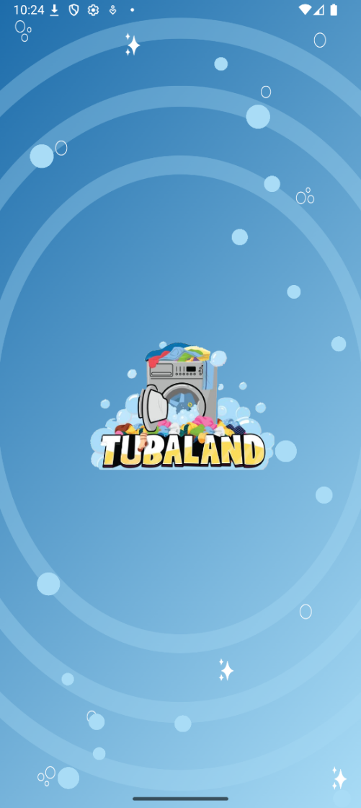
CASE STUDY CONTENT DRAFT
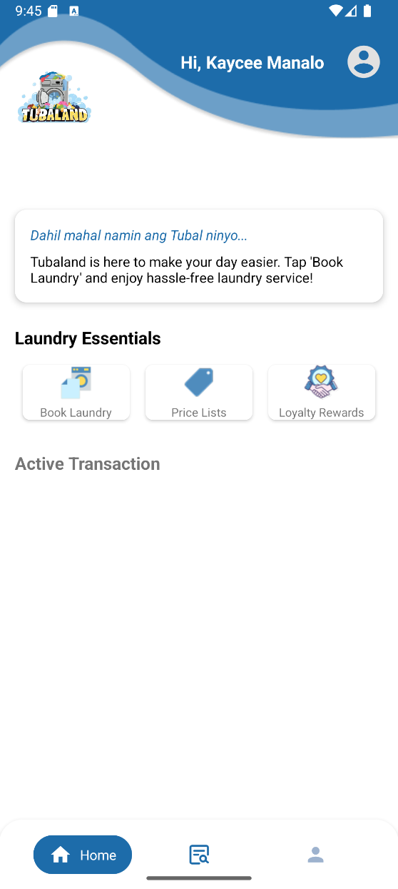

Project Information
My Role | UI/UX Designer · Front-End Developer
Project Type | Capstone Project
Year | 2025–2026
Team | 4 Members
Tech Stack | Java, Android Studio, HTML, CSS, JavaScript, MySQL, Node.js, Google Maps SDK, GitHub
Project Link | [INSERT GOOGLE PLAY STORE LINK]

01 — Project Overview
Tubaland is a laundry management application developed as our capstone project. The system combines a customer-facing mobile application with a web-based administrative interface to support the management of laundry services and transactions.
As part of the development team, I was primarily responsible for the UI/UX design and front-end development of the application. I worked on the user flows, wireframes, interface layouts, and visual design before translating the designs into functional Android screens.
EDIT / REPLACE: You can shorten or personalize this paragraph after reviewing your final project documentation.
[ INSERT TUBALAND LOGO + FINISHED APP HERO SCREENSHOT HERE ]

02 — The Challenge
Laundry operations can involve multiple manual processes, including managing orders, coordinating pickups and deliveries, communicating updates, and verifying payments.
Tubaland was created to bring these processes into a centralized digital platform while giving customers a more convenient way to manage their laundry services remotely.
EDIT / REPLACE: If your capstone manuscript has an official Statement of the Problem, replace the first two paragraphs with the official wording or a shorter portfolio-friendly version.
[ INSERT BEFORE VS. WITH TUBALAND VISUAL HERE ]

03 — The Goal
The goal was to design and develop an Android application that would make laundry services more convenient for customers while improving the efficiency of the laundry business.
- Convenient Booking — Provide an organized interface for accessing and booking laundry services.
- Order Management — Support booking management, order status updates, and administrative workflows.
- Pickup & Delivery — Use location-based functionality to support laundry pickup and delivery services.

04 — My Contribution

UI/UX Design
I led the overall UI/UX design of the Tubaland mobile application and web-based admin interface. I worked on user flows, wireframes, layouts, and visual design using Adobe XD.

Front-End Development
I developed the core Android application interface using Java and Android Studio, translating the UI/UX designs into functional screens.

Feature Integration
I integrated the Google Maps SDK to support location-based functionality for laundry pickup and delivery services.

Admin Interface
I designed the web-based administrative interface using HTML and CSS and worked on the structure of the system's administrative workflows.

Team Collaboration
I collaborated with the development team using GitHub for version control and Trello for task organization and feature tracking.

05 — Understanding the Users
Tubaland was designed around three user groups: customers, riders, and administrators. Each role has different responsibilities, so the interfaces and workflows were structured around their specific tasks.
Customer | Rider | Admin
Book laundry services | Manage deliveries | Manage operations
Track orders | Handle pickup/delivery | Manage orders
View service status | Update delivery status | Monitor activities
Submit payment proof | — | Verify payments

06 — Design Process
Before development, I worked on the application's user flows and interface designs to establish how users would navigate the system and interact with its features.
CONCEPT → USER FLOW → WIREFRAMES → UI DESIGN → PROTOTYPE → DEVELOPMENT → TESTING

07 — Concept & User Flow
Before designing the application, our team studied the existing laundry workflow and identified opportunities where a digital platform could improve booking, order management, delivery, and customer communication.
The team conducted on-site visits, interviewed the laundry shop owner, and observed the existing manual workflow during the concept phase.
[ INSERT USER FLOW / SYSTEM FLOW DIAGRAM HERE ]

08 — Prototyping
Once the core concept was established, I worked on the application's wireframes and high-fidelity interface designs. Adobe XD and Figma were used to visualize major components such as login, dashboard, and other system interfaces before development.

Selected Prototype Screens
The screens presented below are selected samples from the original project. The complete design file is not publicly available.

Prototype 01 — Welcome & Authentication
[ INSERT PROTOTYPE 01 — WELCOME & AUTHENTICATION HERE ]
The welcome screen introduces the Tubaland brand while providing users with a simple entry point to log in or create an account.

Prototype 02 — Login Experience
[ INSERT PROTOTYPE 02 — LOGIN EXPERIENCE HERE ]
The login interface was designed around a straightforward authentication flow, with clearly labeled fields, password recovery, and a prominent login action.

Prototype 03 — Customer Dashboard
[ INSERT PROTOTYPE 03 — CUSTOMER DASHBOARD HERE ]
The dashboard serves as the customer's central starting point, combining service shortcuts, active transaction status, and essential laundry information in one view.

09 — Visual Direction
The interface uses Tubaland's blue and yellow visual identity to create a friendly and approachable laundry service experience. Rounded cards, curved shapes, and illustrated elements were used to give the interface a welcoming and accessible feel.
[ INSERT SMALL VISUAL STYLE BOARD: COLORS, LOGO, ICONS, UI ELEMENTS HERE ]

10 — From Prototype to Product
The prototype served as a visual reference during development. I translated the approved interface designs into functional Android screens using Java and Android Studio.
[ INSERT PROTOTYPE SCREENSHOT HERE ]
[ INSERT MATCHING FINISHED-APP SCREENSHOT HERE ]
Comparing the prototype with the implemented application allowed us to check whether the final interface remained consistent with the intended layout and user experience.
EDIT / REPLACE: Use 2–3 strong prototype-to-final comparisons. These are more valuable than showing every screen.

11 — Key Features

User Authentication
Registration and login functionality for customers.
[ INSERT USER AUTHENTICATION SCREENSHOT HERE ]

Laundry Booking
Customers can book and manage laundry services through the mobile application.
[ INSERT LAUNDRY BOOKING SCREENSHOT HERE ]

Order Tracking
Customers can follow the status of their laundry order.
[ INSERT ORDER TRACKING SCREENSHOT HERE ]

Rider / Delivery Tracking
Location-based functionality supports pickup and delivery tracking.
[ INSERT RIDER / DELIVERY TRACKING SCREENSHOT HERE ]

GCash Payment Verification
Customers can pay using GCash and upload proof of payment for administrator verification.
[ INSERT GCASH PAYMENT VERIFICATION SCREENSHOT HERE ]

Notifications
Customers receive updates regarding their laundry service.
[ INSERT NOTIFICATIONS SCREENSHOT HERE ]

Admin Management
Administrators can manage orders, customers, and operational activities.
[ INSERT ADMIN MANAGEMENT SCREENSHOT HERE ]

12 — GCash Payment
Instead of directly integrating the GCash API, Tubaland uses a proof-of-payment workflow. Customers complete their payment through the official GCash application and upload their payment receipt to Tubaland for administrator verification.
GCASH PAYMENT → UPLOAD RECEIPT → ADMIN REVIEWS → APPROVED / REJECTED
[ INSERT PAYMENT / RECEIPT SCREENSHOT HERE ]

13 — Location & Tracking
Google Maps functionality was incorporated to support location-based tracking for laundry pickup and delivery. The feature was designed to provide customers with greater visibility into the status and movement of their orders.
[ INSERT GOOGLE MAPS / TRACKING SCREENSHOT HERE ]

14 — Admin Interface
Alongside the customer-facing mobile application, Tubaland includes a web-based administrative interface designed to support operational management.
[ INSERT ADMIN DASHBOARD HERE ]
[ INSERT ORDERS / TRANSACTIONS HERE ]
[ INSERT CUSTOMER MANAGEMENT HERE ]
[ INSERT REPORTS / OTHER ADMIN SCREEN HERE ]

15 — Development
The front end of the mobile application was developed using Android Studio and Java, while the web-based administrative interface used HTML, CSS, and JavaScript. MySQL was used for the database, with Node.js supporting the backend development. GitHub and Trello were used for collaborative development and task management.

Technology Stack
- Android — Java · Android Studio
- Web — HTML · CSS · JavaScript
- Backend — Node.js
- Database — MySQL
- Integration — Google Maps SDK
- Collaboration — GitHub · Trello

16 — Testing
Before deployment, the application underwent both manual and automated testing to evaluate functionality, reliability, usability, and compatibility across devices.
Playwright was used for automated end-to-end testing, while Android Studio supported APK builds and emulation. Physical Android devices and virtual devices were used for compatibility testing.

Example — Login Flow
EMPTY CREDENTIALS → VALIDATION → INCORRECT CREDENTIALS → ERROR HANDLING → VALID LOGIN
[ INSERT TESTING SCREENSHOT / TEST RESULT HERE ]

17 — Challenges

Designing for Multiple User Roles
Tubaland required separate experiences for customers, riders, and administrators. Designing around their different responsibilities required careful consideration of navigation and functionality.

Translating Designs Into a Functional Application
One of the challenges was maintaining consistency between the prototype and the implemented Android interface while working within the technical limitations of the development environment.

Building a Realistic Service Workflow
The application needed to connect several stages of the laundry process—from booking and processing to delivery, tracking, and payment verification—into a coherent user experience.

18 — Outcome
Tubaland was developed into a functional Android application supported by a web-based administrative interface. The completed system brings together laundry booking, order management, delivery tracking, payment verification, and role-specific interfaces into one platform.
[ INSERT BEST FINAL APPLICATION SCREENSHOTS / DEVICE MOCKUPS HERE ]
Try the Application
EDIT / REPLACE: Insert your Google Play Store button/link here.

19 — What I Learned
Tubaland gave me the opportunity to work across both design and development. I learned how to take an idea from an initial concept and user flow, turn it into an interface prototype, and translate that design into a functional mobile application.
Beyond UI/UX, the project strengthened my understanding of Android development, databases, location-based functionality, version control, testing, and team collaboration.
Most importantly, I learned that good interface design goes beyond creating visually appealing screens—it also needs to consider how users actually complete tasks and how the design can be implemented effectively.

20 — Project Reflection
Tubaland was one of the projects that allowed me to combine my interest in design with my technical background in Information Technology.
From designing the interface to helping bring it to life as a working application, the project gave me a better understanding of how design, development, and testing come together to create a complete digital product.

Project Links & Confidentiality
Source Code: Private Repository
The project's source code is not publicly available due to project confidentiality and access restrictions.
Application: [INSERT GOOGLE PLAY STORE LINK]
Prototype: Selected screens are presented in this case study. The complete design file is not publicly available.
EDIT / REPLACE: Replace all bracketed placeholders before publishing your portfolio.

