**Summary of Microsoft Access and SQL**

I basically use Microsoft Access to build a query, tables, forms and report. It has two views the data views and the design view. I used the design view for the structure of the objects while the data view is where you can view the finish product or finish objects.

We also need to change the structure of the table for example adding up fields, fix field etc.

I did fix the design view so that the user can fix all his or her data for example the datatype, fieldnames, and field sizes for each field.

Firstly, I did design a rental transaction (RENTAL) which involves one or more videos being rented to a member (MEMBERSHIP). A video RENTAL and VIDEO. DETAILRENTAL is a bridge table that was used to resolve this relationship. The relational model of this database is show below.

**Structure and the Content of the Database**

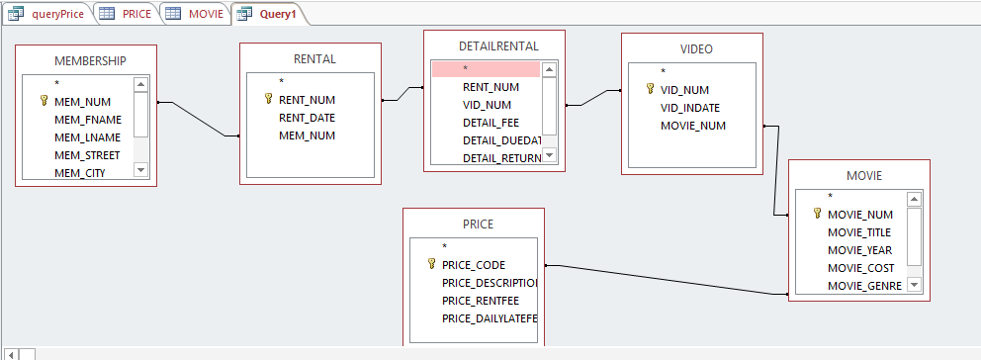

I also created all the tables as showed above from Membership, Rental, DetailRental, Video, Price and Movie. And Inserted the data in the tables using a simple INSERT command. For example

INSERT INTO MEMBERSHIP VALUES (102, 'TAMI', 'DAWSON', '2632 TAKLI CIRCLE', 'NORENE', 'TN', '37136', 11);

INSERT INTO MEMBERSHIP VALUES (103, 'CURT', 'KNIGHT', '4025 CORNELL COURT', 'FLATGAP', 'KY', '41219', 6);

INSERT INTO MEMBERSHIP VALUES (104, 'JAMAL', 'MELENDEZ', '788 EAST 145TH AVENUE', 'QUEBECK', 'TN', '38579', 0);

INSERT INTO MEMBERSHIP VALUES (105, 'IVA', 'MCCLAIN', '6045 MUSKET BALL CIRCLE', 'SUMMIT', 'KY', '42783', 15);

INSERT INTO MEMBERSHIP VALUES (106, 'MIRANDA', 'PARKS', '4469 MAXWELL PLACE', 'GERMANTOWN', 'TN', '38183', 0);

INSERT INTO MEMBERSHIP VALUES (107, 'ROSARIO', 'ELLIOTT', '7578 DANNER AVENUE', 'COLUMBIA', 'TN', '38402', 5);

INSERT INTO MEMBERSHIP VALUES (108, 'MATTIE', 'GUY', '4390 EVERGREEN STREET', 'LILY', 'KY', '40740', 0);

INSERT INTO MEMBERSHIP VALUES (109, 'CLINT', 'OCHOA', '1711 ELM STREET', 'GREENEVILLE', 'TN', '37745', 10);

INSERT INTO MEMBERSHIP VALUES (110, 'LEWIS', 'ROSALES', '4524 SOUTHWIND CIRCLE', 'COUNCE', 'TN', '38326', 0);

INSERT INTO MEMBERSHIP VALUES (111, 'STACY', 'MANN', '2789 EAST COOK AVENUE', 'MURFREESBORO', 'TN', '37132', 8);

INSERT INTO MEMBERSHIP VALUES (112, 'LUIS', 'TRUJILLO', '7267 MELVIN AVENUE', 'HEISKELL', 'TN', '37754', 3);

INSERT INTO MEMBERSHIP VALUES (113, 'MINNIE', 'GONZALES', '6430 VASILI DRIVE', 'WILLISTON', 'TN', '38076', 0);

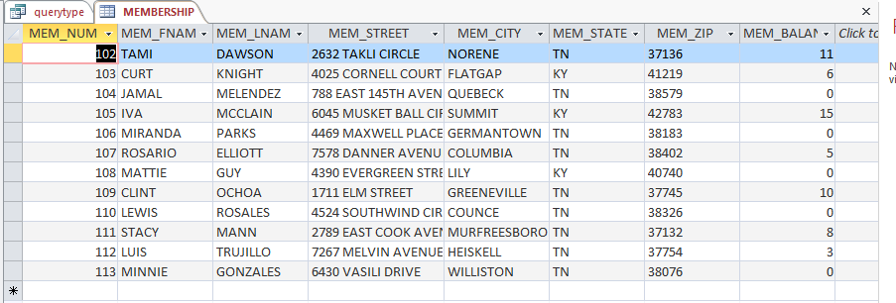

Lastily I was playing with the query statement using the SELECT statement to retrieve data from the table in the database.

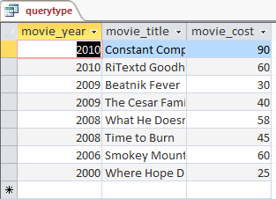

SELECT movie_year, movie_title, movie_cost

FROM movie

ORDER BY movie_year DESC;

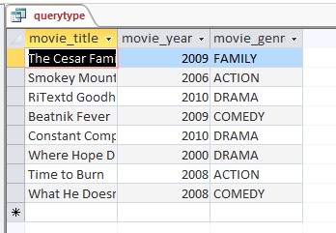

SELECT movie_title, movie_year, movie_genre

FROM movie;

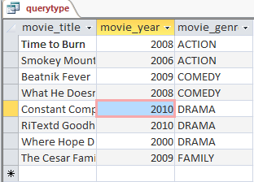

SELECT movie_title, movie_year, movie_genre

FROM movie

ORDER BY movie_genre asc, movie_year DESC;