**Visvesvaraiah** Technological University,



Belgaum

**A**

**SEMINAR REPORT ON**

**“3D ANIMATED HOUSE**”

###### **SUBMITTED IN PARTIAL FULFILLMENT OF THE REQUIREMENTS FOR**

###### **THE AWARD OF**

**BACHELOR OF ENGINEERING**

**IN**

**COMPUTER SCIENCE & ENGINEERING**

## SUBMITTED BY

***Muthanna K.C (1mj09cs035) Karthik.V (1mj09cs022)***

**UNDER THE GUIDANCE OF**

**Ms. MOTHI BHAVANI V Mr. MUTHAIAH.U**

***Asst. Professor, Dept. of CSE, MVJCE Asst. Professor, Dept. of CSE, MVJCE***



DEPARTMENT OF COMPUTER SCIENCE AND ENGINEERING

### MVJ COLLEGE OF ENGINEERING

**Channasandra, Near ITPL, Bangalore – 560 067**

Academic Year 2011-2012

**MVJ COLLEGE OF ENGINEERING**

**Channasandra, Near ITPB, Bangalore-67**



**DEPARTMENT OF COMPUTER SCIENCE & ENGINEERING**

**CERTIFICATE**

**This is to certify that the seminar entitled**

**“3D ANIMATED HOUSE”**

**Has been satisfactorily presented by**,

**MUTHANNA K.C (1MJ09CS035) KARTHIK.V(1MJ09CS022)**

**In the partial fulfillment for the award of Bachelor of Engineering in Computer Science & Engineering of the Visvesvaraiah Technological University, Belgaum during the semester VIII of academic year 2011-2012.**

**_______________________**   **________________________**

**(Signature of Internal Guide) (Signature of HOD)**

# ACKNOWLEDGEMENT

The satisfaction and euphoria that accompany the successful completion of any task would be incomplete without the mention of the people who made it possible, whose constant guidance and encouragement crowned our effort with success.

Salutations to our beloved and highly institute “**M V J COLLEGE OF ENGINEERING ”** for having well qualified staff and labs furnished with necessary equipments.

Our due thanks to *Dr****. K S Badarinarayan,*** the principal, for his inspiration throughout our professional course.

We express our wholehearted gratitude to ***Mrs.Avayambal****,* who is our respectable Head of Dept. of Computer Science. We wish to acknowledge her for her constant support & encouragement.

We express our sincere thanks to our beloved Asst. professors of CS Dept. ***Ms. Mothi Bhavani V*** and ***Mr. Muthaiah*** for giving us constant encouragement, support and valuable guidance throughout the course of the seminar. This acknowledgement is not complete without the mention of my parents and my brothers for their constant support and encouragement which made me to lead this phase of my life peacefully.

**KARTHIK.V**

**&**

**MUTHANNA.K.C**

**TABLE OF CONTENTS**

**TOPICS PAGE NOS:**

**Introduction 5**

**System Requirements and Specifications 6**

**Design 7**

**Flowchart 8**

**Implementation 9**

**Results & Snapshots 12**

**Final Conclusion 15**

**Bibliography 16**

**INTRODUCTION**

**About 3D House**

The 3D house project is basically based on modeling a house architecture based on its design both exterior and interior. The boundaries of the house are also showcased here. We have added menus for opening and closing the door as well.

In this particular 3D house project we have graphically designed the architecture of a house having a ground floor, a first floor as well as a terrace. For the inside of this house we have shown a hall with a clock running and a bedroom whose door can be opened and closed by accessing the menus provided. In fact the project has been made interactive such that all the doors of the house can be closed and opened. In the following pages below we have specified all the elements which was used and required by us to develop this particular project.

**SYSTEM REQUIREMENTS SPECIFICATION**

**HARDWARE REQUIREMENTS**

**Minimum hardware specification**

* Microprocessor: **1.0 GHz** and above CPU based on either AMD or INTEL
* Main memory : **512 MB RAM**
* Hard Disk : **40 GB**
* Keyboard: **QWERTY** Keyboard
* Mouse :**2 or 3** Button mouse
* Monitor : **1024 x 768** display resolution
* Graphics card: 128 MB

# SOFTWARE REQUIREMENTS

**Minimum software specification**

* Operating system : **Windows XP**
* Visual Basic 2006
* OPENGL
* Mouse Driver
* Graphics Driver

**DESIGN**

To achieve three dimensional effects, open GL software is proposed. It is software which provides a graphical interface. It is a interface between application program and graphics hardware. The advantages are:

1. Open GL is designed as a streamlined.
2. It’s a hardware independent interface i.e it can be implemented on many different hardware platforms.
3. With openGL we can draw a small set of geometric primitives such as points, lines and polygons etc.
4. It provides double buffering which is vital in providing transformations.
5. It is event driven software.
6. It provides call back function.

**FLOWCHART**

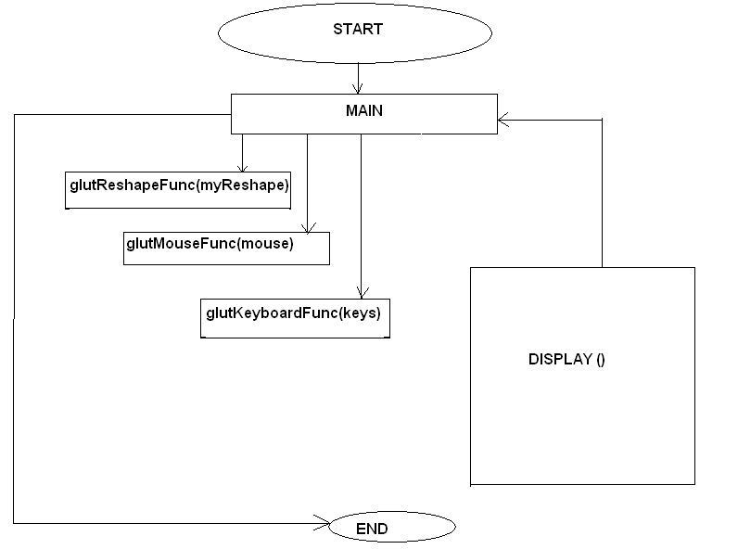

# IMPLEMENTATION

**Functions Used:**

The **glColor3f (float, float, float) :-** This function will set the current drawing color

**gluOrtho2D (GLdouble left, GLdouble right, GLdouble bottom,** **GLdouble top):-** which defines a two dimensional viewing rectangle in the plane z=0.

**glClear( ):-**Takes a single argument that is the bitwise OR of several values indicating which buffer is to be cleared.

**glClearColor ():-**Specifies the red, green, blue, and alpha values used by **glClear** to clear the color buffers.

**GlLoadIdentity( ):-**the current matrix with the identity matrix.

**glMatrixMode(mode):-**Sets the current matrix mode, mode can be **GL_MODELVIEW, GL_PROJECTION or GL_TEXTURE.**

**Void glutInit (int *argc, char**argv):-**Initializes GLUT, the arguments from main are passed in and can be used by the application.

**Void glutInitDisplayMode (unsigned int mode):-**Requests a display with the properties in mode. The value of mode is determined by the logical OR of options including the color model and buffering.

**Void glutInitWindowSize (int width, int height):-** Specifies the initial position of the top-left corner of the window in pixels

**Int glutCreateWindow (char *title):-**A window on the display. The string title can be used to label the window. The return value provides references to the window that can be used when there are multiple windows.

**Void glutMouseFunc(void *f(int button, int state, int x, int y):-**Register the mouse callback function f. The callback function returns the button, the state of button after the event and the position of the mouse relative to the top-left corner of the window.

**Void glutKeyboardFunc(void(*func) (void)):-**This function is called every time when you press enter key to resume the game or when you press ‘b’ or ‘B’ key to go back to the initial screen or when you press esc key to exit from the application.

**Void glutDisplayFunc (void (*func) (void)):-**Register the display function func that is executed when the window needs to be redrawn.

**Void glutSpecialFunc(void(*func)( void)):-**This function is called when you press the special keys in the keyboard like arrow keys, function keys etc. In our

program, the func is invoked when the up arrow or down arrow key is pressed for selecting the options in the main menu and when the left or right arrow key is pressed for moving the object(car) accordingly.

**glut PostReDisplay ( )** :-which requests that the display callback be executed after the current callback returns.

**Void MouseFunc (void (*func) void)):-**This function is invoked when mouse keys are pressed. This function is used as an alternative to the previous function i.e., it is used to move the object(car) to right or left in our program by clicking left and right button respectively.

**Void glutMainLoop ()**

Cause the program to enter an event-processing loop. It should be the last statement in main function.

**RESULTS & SNAPSHOTS**

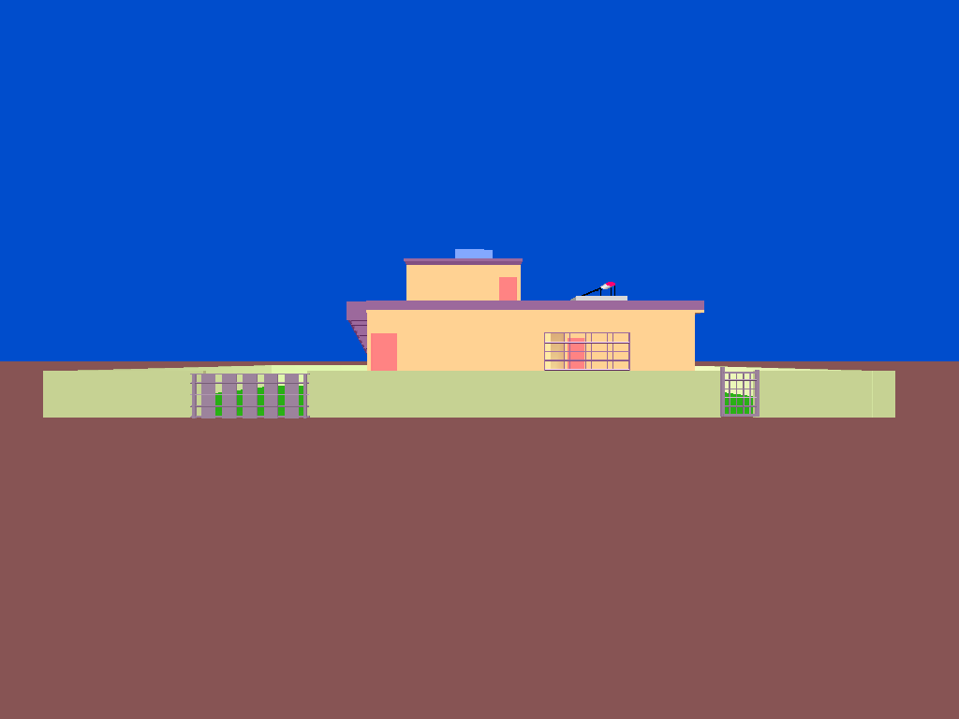

Figure 1: After Code is Run

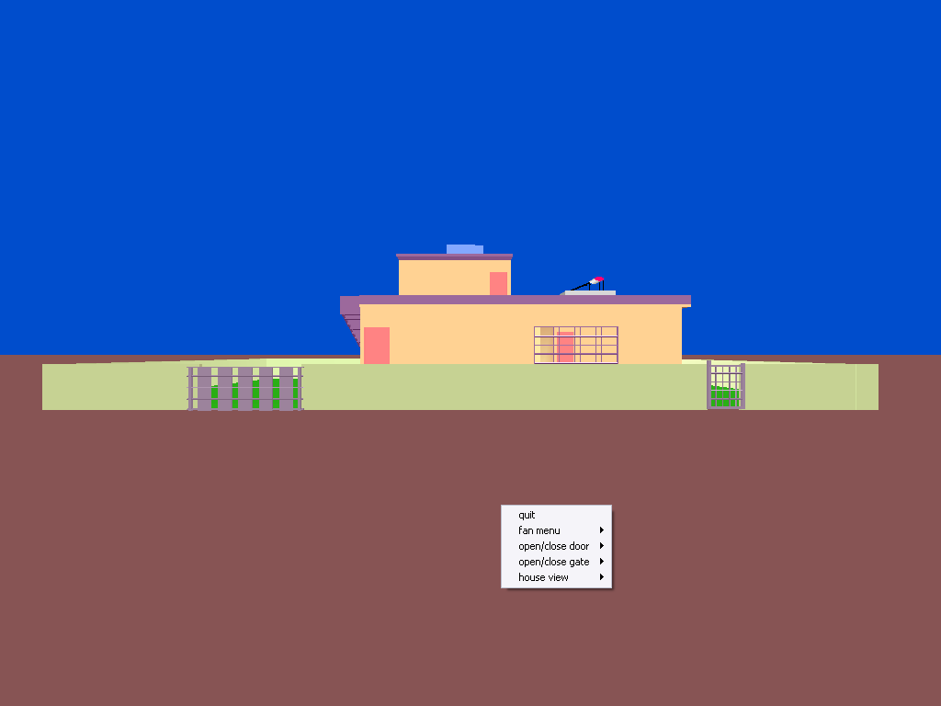

Figure 2: On Right Click menus and submenus are shown

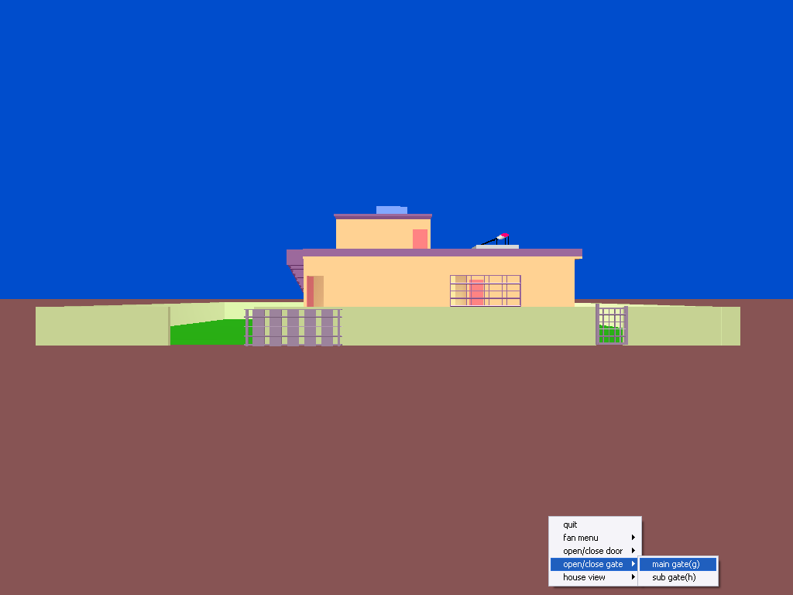

Figure 3: Selecting Main door to open

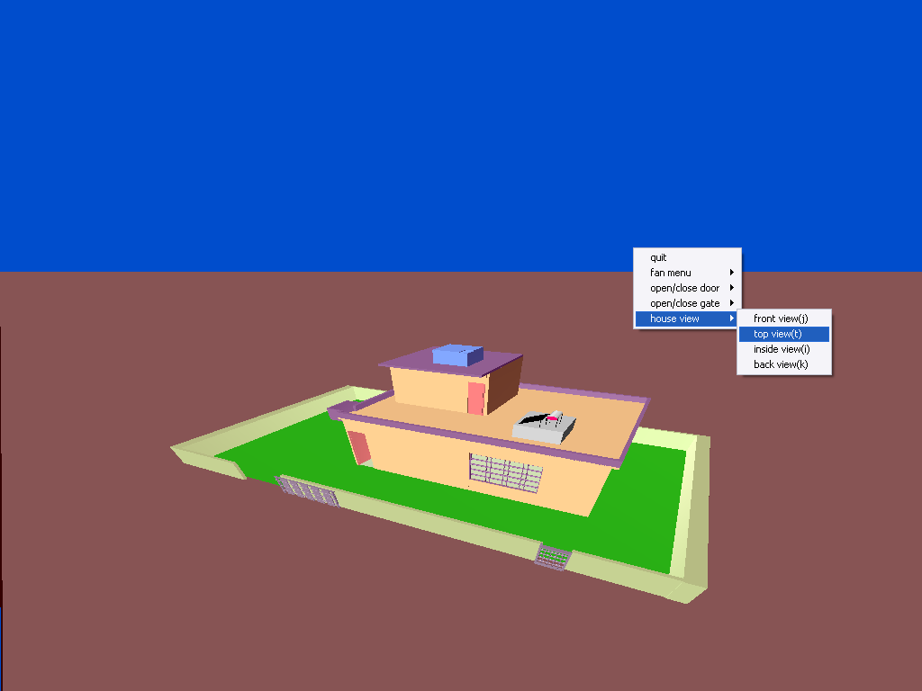

Figure 4: House Top view is showing

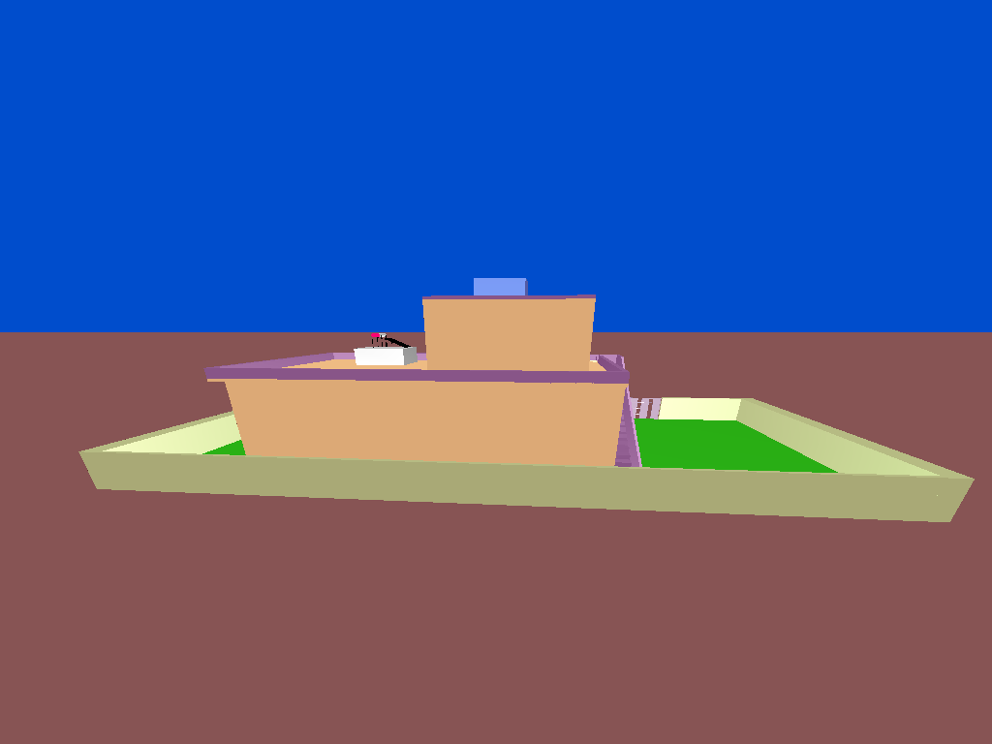

Figure 5: Back View of HOUSE

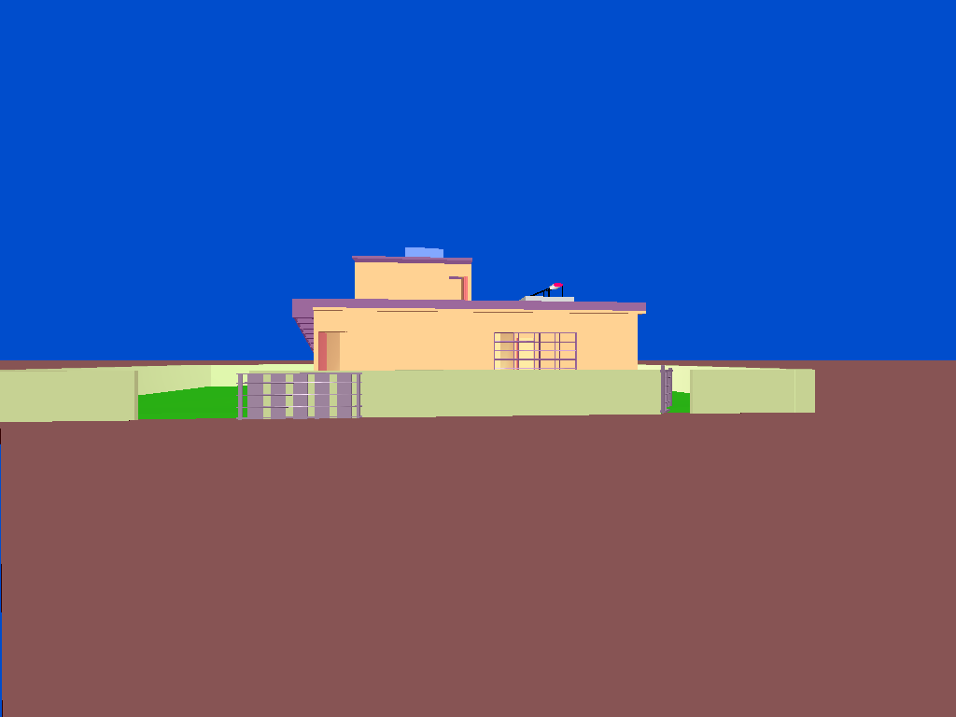

Figure 6: All the door’s opened

**FINAL CONCLUSION**

**CONCLUSION:**

The 3D House project has been tested under Windows XP and has been found to provide ease of use and manipulation to the user. The 3D house created for the Windows XP operating system can be used to draw lines, boxes, circles, ellipses, and polygons.

We found designing and developing this 3D House as a very interesting and learning experience. It helped us to learn about computer graphics, design of Graphical User Interfaces, interface to the user, user interaction handling and screen management. The graphics editor provides all and more than the features that have been detailed in the VTU syllabus.

**BIBLIOGRAPHY**

1. Edward Angel’s Interactive Computer Graphics Pearson Education 5th Edition

2.Interactive computer Graphics --A top down approach using open GL--by

Edward Angle

3. Jackie .L. Neider, Mark Warhol, Tom.R.Davis, "OpenGL Red Book", Second

Revised Edition, 2005.

4. Donald D Hearn and M.Pauline Baker, "Computer Graphics with OpenGL", 3rd Edition.