CHAPTER 1
INTRODUCTION
HAL-Edgewood (HETL) Bangalore is an extensive and emerging Avionics Design & development business. The company, with a pool of highly experienced engineers, has already marked its presence in Indian Aviation. Robust Design certifiable to Avionics standards, best process oriented approach, and breakthrough optimization technology are just a few of the cutting-edge features available to help increase your bottom line. In addition to its emerging product line, HETL takes an exciting new approach to develop Open System Architectures and Systems for Avionics & State of Art technologies to bring Avionics systems such as Maintenance and Health monitoring systems to new heights. HETL has taken special care in customer interaction & appeal to end-users by offering a warm, engaging environment, thus improving conversions.
HAL-Edgewood Technologies Private Limited is also a Joint venture of Hindustan Aeronautics Limited-Bangalore, Edgewood Technologies LLC-USA and Edgetech India-Bangalore. It is formed in the objectives of aiding influx of advance & new technologies in the area of electronics in Indian Aviation industries.
HAL-Edgewood is currently working on a live project which helps in building “DYNAMIC AVIONIC SYMBOLS” that provide real time situational awareness information to pilots through means of their cockpit display system. The display unit makes use of FUJITSU CORAL PA graphics hardware to generate the required symbols.
Currently the hardware design of the graphics hardware and the list of basic capabilities supported by the device driver is provided by the original equipment manufacturer.
Our aim is to understand the basic capabilities of the graphics hardware and add functions to the list of device drivers which would manipulate the registers of the GPU and demonstrate dynamic movement of basic avionic symbols, thereby improving the efficiency currently existing display system.

1.1 OBJECTIVE
To build and construct the attitude indicator and the symbols used within it by making use of a special kind of graphics card called CORAL PA Graphics card from the CREMSON GRAPHICS family of graphics card and visual studio.
1.2 OVERVIEW
The main purpose of our project is to design symbols used in the attitude indicator by harnessing the power of a MB86296S graphics card(CORAL PA). The graphics driver interface is used to render the objects on the display device. Fujitsu's MB86296 'Coral PA' is an enhanced version of MB86295 'Coral P' and adds several new features to address high-end graphics applications in embedded automotive and industrial applications. A new PCI host interface allows high-bandwidth transfers between the host CPU and the MB86296 'Coral PA' device. Its dual buffer architecture almost doubles the PCI transfer rate in comparison to MB86295 'Coral P'. Any CPU with a 32-bit PCI V2.1-compliant host interface clocked at 33MHz can be directly connected to MB86296 'Coral PA' (in peer-to-peer mode 66MHz is also possible). The device includes both master and slave functionality and an internal DMA controller for multi-burst transfers of large quantities of data between all combinations of PCI data space and MB86296 'Coral PA' internal areas. Additional functions provided by the host interface are General Purpose IO pins and a serial interface. MB86296 'Coral PA's new external video input accepts data which complies to the RBT-ITU656, RBT-ITU601 and native RGB666 and RGB888 standards. This allows video signals of various sources to be displayed together with generated graphics. In comparison to MB86295 'Coral P', MB86296 'Coral PA' captures RGB data and writes this to its internal buffer without prior conversion to YUV422. The video input unit is capable of accepting TV tuner, DVD player or camera signals in PAL or NTSC video formats. In addition, rendered graphics from any other display controller can be used as a video input source. The new video scaling implementation permits any combination of picture up- and downscaling. This makes it possible to display multimedia pictures with large resolutions in either picture-in-picture or full-screen mode. A set of general IO pins and a serial interface are also included for simple external resource control. Other new functions of 'Coral PA' include a programmable pixel-clock output

delay function, an upgraded ROM for the Geometry Engine and an additional bus-clock mode for a direct 33MHz clock input from any PCI bus source.
Six display layers can be used simultaneously with MB86296 'Coral PA'. Each layer can have a color depth of 8, 16 or 24 bits/pixel and can be changed in position, size and priority. The maximum logical layer size is 4096x4096 pixels. Using the Alpha map, specific layers can be blended together smoothly. The alpha map can be freely assigned to any of the six layers and allows the assignment of 8 bits per pixel, enabling each pixel to be mixed in order to control transparency to a higher extent. In addition, all layers can be blended at a fixed ratio of 256 levels.
One of MB86296 'Coral PA's new features is its dual display mode. The device can drive two connected displays individually. The displays must have the same resolution, scan rates and sync signals. They can be connected to the 'Coral PA' for use in one of the following modes:
- Single Mode: the chip outputs the same contents on RGB analog and digital
- Dual Mode: two different displays are output via RGB analog and digital
- Multiplexed Mode: two different displays can be connected via external demultiplexing logic (an FPGA) which receives a multiplexed RGB digital stream from Coral PA's RGB digital outputs. This method makes it possible to realize all kinds of dual display solutions such as rear-seat entertainment systems or dual monitor control units. In dual display mode, each layer can be programmed to appear on display 1, 2 or both on displays. This technique makes it possible to duplicate contents (such as a video picture) but also to have two individually composed pictures on the two displays.

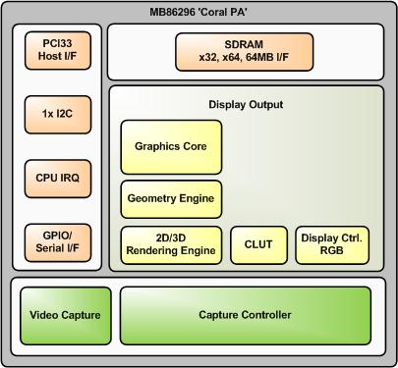
Fig 1.1 MB86296 'Coral PA' Block Diagram
Some of the symbols which we are going to design include:
- "miniature wings", horizontal lines with a dot between them representing the actual wings and nose of the aircraft.
- the center horizon bar separating the two halves of the display, with the top half usually blue in color to represent sky and the bottom half usually dark to represent earth.
- degree marks representing the bank angle. They run along the rim of the dial. On a typical indicator, the first 3 marks on both sides of the center mark are 10 degrees apart. The next is 60 degrees and the mark in the middle of the dial is 90 degrees.

CHAPTER 2
LITERATURE SURVEY
Literature survey is the most important step in software development process. Before developing the tool it is necessary to determine the time factor, economy n company strength. Once these things are satisfied, then the next step is to determine which operating system and language can be used for developing the tool. Once the programmers start building the tool the programmers need lot of external support. This support can be obtained from senior programmers, from book or from websites. Before building the system the above consideration are taken into account for developing the proposed system.
2.1 AIM
Our aim is to build the attitude indicator for the aircrafts which currently exist using analog methods. We propose to do so by using the CORAL PA graphics card extensively and by also making use of the visual studio.
2.2 SCOPE OF WORK
To ensure that proper graphics is harnessed throughout the project work we have made use of the CORAL PA graphics card. Extensive research has been done such that proper understanding of the graphics card is done and even a large chunk of work has been credited to the attitude indicator. Most of our time has gone into the coding of the meter. Below the features of the CORAL PA graphics card is given as well as the features of the attitude indicator.
2.2.1 CORAL PA GRAPHICS CARD
- Geometry Engine
The Geometry Engine supports the geometry processing that is basically compatible with ORCHID (MB86292). Display lists generated for ORCHID can be processed. Extensive geometric operation processing such as coordinate conversions or clipping which normally load the CPU dramatically can be reduced using the Geometry Engine.

(Floating point setup command is changed or deleted. G_BeginCont command is deleted. GMDR0 CF&DF table mapping is changed ... etc).
- 2D and 3D Drawing
MB86296's drawing functionality is compatible to the CREMSON (MB86290A). It can draw data using the display lists created for CREMSON (however internal texture RAM is deleted). The MB86296 also supports 3D rendering, such as texture mapping with perspective correction and Gouraud shading, alpha blending and anti-aliasing for drawing smooth lines.
- Digital video capture
The digital video capture function can store digital video data such as TV images in graphics memory; it can display drawn images and video images on the same screen.
- Display controller
The MB86296 has a display controller that is compatible with ORCHID.
In addition to the traditional XGA (1024 × 768 pixels) display, 4-layer overlay, left/right split display, wrap-around scrolling, double buffers, and translucent display, 6-layer overlay functionality, 4-siding for palette are expanded.
- Host CPU interface
The MB86296 has a 32 bit, 33MHz PCI interface fully compliant to PCI version 2.1.
- External memory interface
SDRAM and FCRAM can be connected.
- Optional function
Final device can be selected from the combination of geometry high-/low-speed version and video capture function provided/ not provided.
- Others
CMOS technology 0.18μm
BGA256 Package
Supply voltage:1.8 V (internal operation) /3.3 V (I/O)

Current consumption (TYPICAL)
1.8 V : 500mA
3.3 V : 100mA

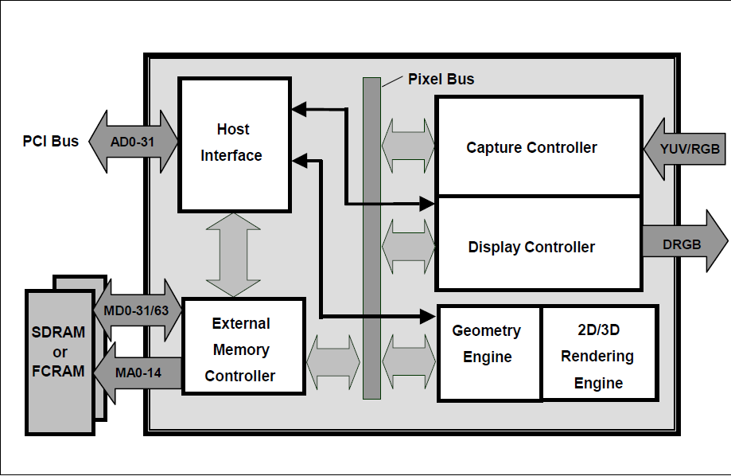
Fig 2.1:CORAL PA CARD

2.2.2 ATTITUDE INDICATOR
An attitude indicator (AI), also known as gyro horizon or artificial horizon or attitude director indicator (ADI, when part of a flight director display), is an instrument used in an aircraft to inform the pilot of the orientation of the aircraft relative to Earth's horizon. It indicates pitch (fore and aft tilt) and bank or roll (side to side tilt) and is a primary instrument for flight in instrument meteorological conditions. Attitude indicators also have significant application under visual flight rules (VFR), though most light aircraft are not required to have them installed for VFR operation. Attitude indicators are also used on manned spacecraft, where they indicate the craft's

yaw angle (nose left or right) as well as pitch and roll, relative to a fixed-space inertial reference frame.

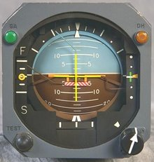
Fig 2.2: analog attitude indicator

If the symbolic aircraft dot is above the horizon line (blue background) the aircraft is nose up. If the symbolic aircraft dot is below the horizon line (brown background) the aircraft is nose down. Because it is the horizon that moves up and down and turns, while the symbolic aircraft is fixed relative to the rest of the instrument panel, trainees get confused; a standard corrective given by flight instructors is "Fly the little airplane, not the horizon."
A 45 degree bank turn is made by placing the indicator equidistant between the 30 and 60 degree marks.
The pitch angle is relative to the horizon. During instrument flight, the pilot must infer the total performance by using other instruments such as the airspeed indicator, altimeter, vertical speed indicator, directional gyro, turn rate indicator, and power instruments, e.g. an engine tachometer. "Performance = Attitude + Power".

Most Russian-built aircraft have a somewhat different design. The background display is colored as in a Western instrument, but moves up and down only to indicate pitch. A symbol representing the aircraft (which is fixed in a Western instrument) rolls left or right to indicate bank angle.
It was proposed that a hybrid version of the Western and Russian artificial horizon systems be developed that would be more intuitive than either, although this concept never caught on in.

2.3 EXISTING SYSTEM
As an existing system, the attitude indicator was intaially part of a larger display board placed in front of the pilot’s viewing area. This attitude indicator was in the analog form as shown in the diagram below.
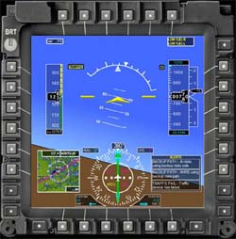
Fig 2.3: Existing ADI
The diagrammatic representation of the analog attitude indicator is represented below:

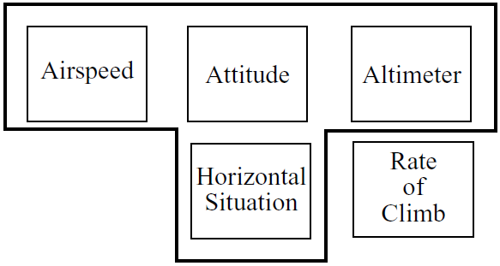
Fig2.4: Existing system

The attitude instrument was originally just the artificial horizon, but as systems grew more complex it became the ADI (Attitude Director Indicator)
An electromechanical version of this instrument is shown in the Figure. To relieve the pilot of the necessity to scan several instruments during an approach, several functions have been added to the artificial horizon. These include: Glide slope deviation indicator, speed deviation indicator, horizontal or localizer deviation indicator and a radar altimeter/decision height indicator.
In addition, there are so-called “Command bars” which indicate the difference between the current attitude and the attitude computed by the flight director required to put the aircraft back on course. Note: if the flight director is coupled to the autopilot, this is the error information being fed to the autopilot. In the “split cue” design coomands for the two axes are displayed separately. The ADI is probably the most complex electromechanical aircraft display instrument ever developed.
Another version of the ADI is shown in the above figure. This is a simplified ADI but it shows the “single cue” or “V bar” command bars. These two bars move together. They move up or down to indicate the correct pitch angle and they rotate to indicate the correct bank angle. The pilot simply banks and or pitches the aircraft to keep the yellow triangle “aircraft” in the triangle formed by the lower edges of the command bars as shown by the

hatched triangle. In the figure, the flight director is commanding a climbing turn to the right.
Since the attitude indicator was part of a bigger display, it was difficult for the pilot to make use of it as well as accessing it. Hence, the attitude indicator was removed and was placed in an independent smaller display in front of the pilot, hence making it easily accessible for the pilot.
Disadvantages
- The attitude indicator is in the center of the information screen, it leads to clustering of information on one screen, this inturn leads to confusion on the part of the pilot.
- The previous display included the maps, target area, the enemy aircraft indicator and the attitude indicatoron a single screen, so in order to turn the horizon, the entire display had to be rotated. This increases the complexity of perception of the pilot.
- Although an instrument may be required for only a very small percentage of time, the attitude indicator still occupies space on the instrument panel for the whole time.
- With instruments such as the attitude indicator, the limit of electromechanical complexity had been reached.
- There is little flexibility e.g. capability to change display colours depending on the situation.

2.4 PROPOSED SYSTEM
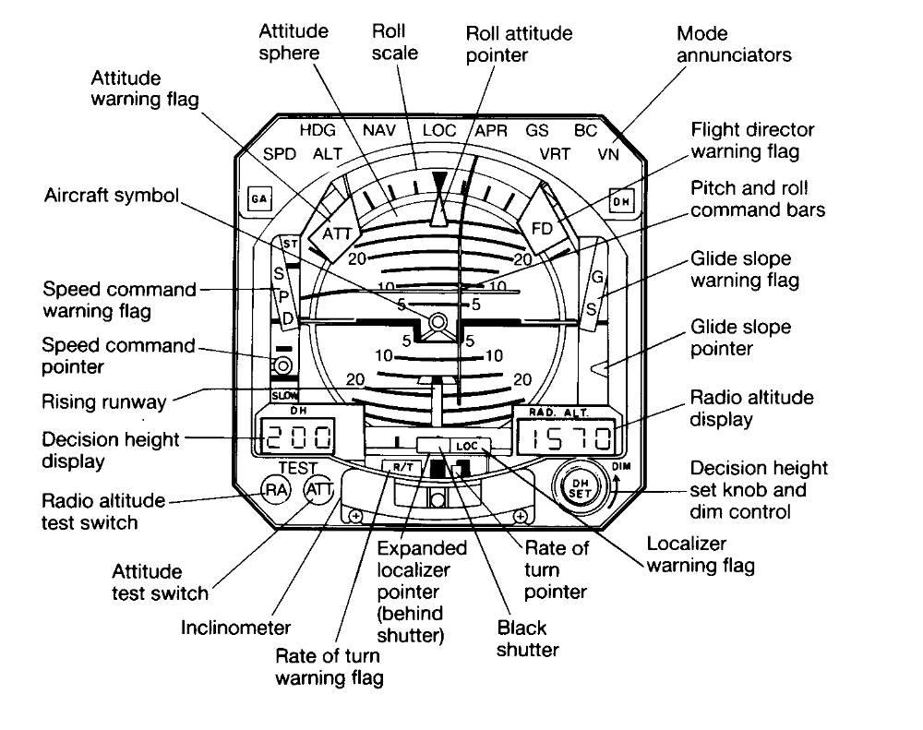
Fig 2.5: Proposed System ADI
In this project, we developed a dynamic display of avionic symbols such as the attitude indicator. A keen effort was put across to even develop the symbols contained or rather within the attitude indicator. This was done extensively with the help of the CORAL PA graphics card. The functional overview of the card is given below:
    - Host CPU interface
- Supported CPU
The MB86296 can be connected to any CPU with a 33MHz 32-bit PCI v2.1 host interface.

- Configuration
EEPROM configuration supported
Serial interface for external device control through PCI interface
- PCI Slave
Supports burst reads/writes of up to 8 double words (32 bytes).
Supports multi-burst transfers with automatic pre-fetch.
- PCI Master
Supports transfers of up to 224-1 double words in bursts of between 1 and 8 double words.
Supports all combinations of transfer (PCI->PCI, PCI->Internal, Internal->PCI)
Host notification on burst complete and/or transfer complete
Optional external burst initiation control
- Internal DMA
Supports transfers of up to 224-1 double words in bursts of between 1 and 8 double words.
- Interrupt
Vertical (frame) synchronous detection
Field synchronous detection
External synchronous error detection
Register update
Drawing command error
Drawing command execution end
Burst/Transfer complete
    - External memory interface
SDRAM or FCRAM can be connected.

64 bits or 32 bits can be selected for data bus.
Max. 133 MHz is available for operating frequency.
Connectable memory configuration is as shown below.
External Memory Configuration Type | Data bus width | Use count | Total capacity
FCRAM 16 Mbits (x16 Bits) | 32 Bits | 2 | 4 Mbytes
SDRAM 64 Mbits (x32 Bits) | 32 Bits | 1 | 8 Mbytes
SDRAM 64 Mbits (x32 Bits) | 64 Bits | 2 | 16 Mbytes
SDRAM 64 Mbits (x16 Bits) | 32 Bits | 2 | 16 Mbytes
SDRAM 128 Mbits (x32 Bits) | 32 Bits | 1 | 16 Mbytes
SDRAM 128 Mbits (x32 Bits) | 64 Bits | 2 | 32 Mbytes
SDRAM 128 Mbits (x16 Bits) | 32 Bits | 2 | 32 Mbytes
SDRAM 256 Mbits (x16 Bits) | 32 Bits | 2 | - bytes

2.4.3 Display controller
2.4.3.1 Layer configuration
Six-layer window display is performed. Layer overlay sequence can be set in any order. A four-layer display mode and left/right split display mode are also provided, supporting backward compatibility with previous products.

Fig 2.6: Configuration of Display Layers
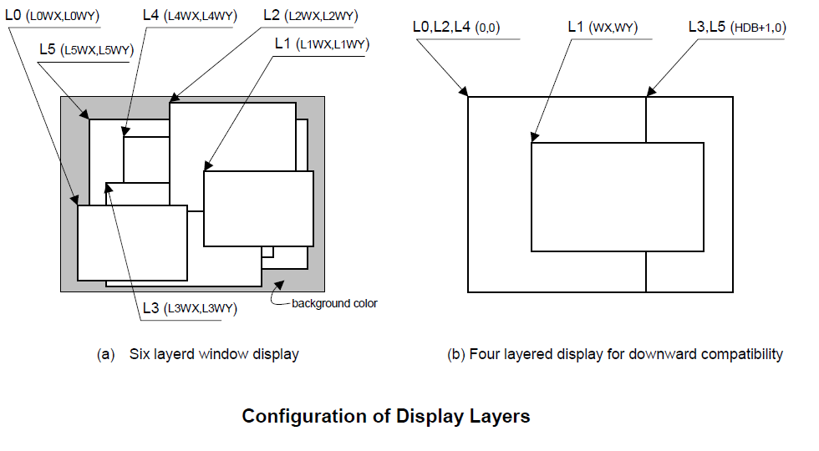
The correspondence between the display layers for this product and for previous products is shown below in the table:
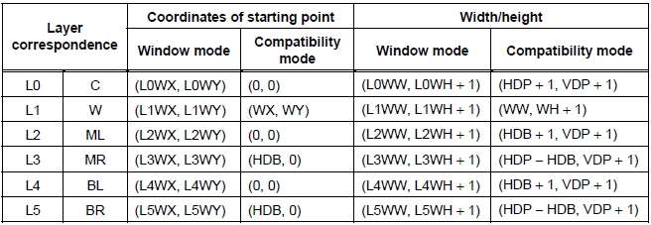

C, W, ML, MR, BL, and BR above mean layers for previous products. The window mode or the compatibility mode can be selected for each layer. It is possible to use new functions through minor program changes by allowing the coexistence of display modes instead of separating them completely.
However, if high resolutions are displayed, the count of layers that can be displayed simultaneously and pixel data may be restricted according to the graphics memory ability to supply data.
2.4.3.2 Overlay
- Overview
Image data for the six layers (L0 to L5) is processed as shown below in the next page:
The fundamental flow is: Palette → Layer selection → Blending. The palettes convert 8-bit color codes to the RGB format. The layer selector exchanges the layer overlay sequence arbitrarily. The blender performs blending using the blend coefficient defined for each layer or overlays in accordance with the transparent-color definition.
The L0 layer corresponds to the C layer for previous products and shares the palettes with the cursor. As a result, the L0 layer and cursor are overlaid before blend operation. The L1 layer corresponds to the W layer for previous products. To implement backward compatibility with previous products, the L1 layer and lower layers are overlaid before blend operation.

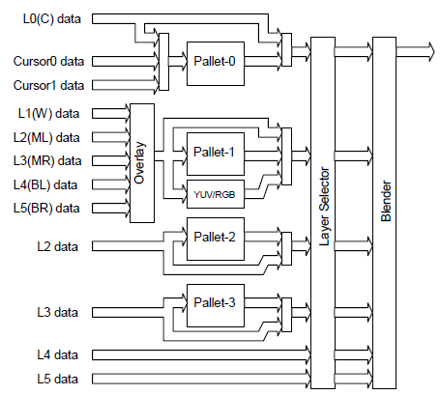

Fig 2.7: Image data for the six layers (L0 to L5)

The L2 to L5 layers have two paths; in one path, these layers are input to the blender separately and in the other, these layers and the L1 layer are overlaid and then are input to the blender. When performing processing using the extended mode, select the former; when performing the same processing as previous products, select the latter. It is possible to specify which one to select for each layer.
- Overlay mode
Image layer overlay is performed in two modes: simple priority mode, and blend mode. In the simple priority mode, processing is performed according to the transparent color defined for each layer. When the color is a transparent color, the value of the lower layer is used as the image value for the next stage; when the color is not a transparent color, the value of the layer is used as the image value for the next stage.

Dview = Dnew (when Dnew does not match transparent color)
= Dlower (when Dnew matches transparent color)
When the L1 layer is in the YCbCr mode, transparent color checking is not performed for the L1 layer; processing is always performed assuming that transparent color is not used.
In the blend mode, the blend ratio “r” defined for each layer is specified using 8-bit tolerance, and the following operation is performed:
Dview = Dnew*r + Dlower*(1 – r)
Blending is enabled for each layer by mode setting and a specific bit of the pixel is set to “1”. For 8 bits/pixel, the MSB of RAM data enables blending; for 16 bits/pixel, the MSB of data of the relevant layer enables blending; for 24 bits/pixel, the MSB of the word enables blending.
- Blend coefficient layer
In the normal blend mode, the blend coefficient is fixed for each layer. However, in the blend coefficient layer mode, the L5 layer can be used as the blend coefficient layer. In this mode, the blend coefficient can be specified for each pixel, providing gradation, for example. When using this mode, set the L5 layer to 8 bits/pixel, widow display mode and extend overlay mode.
2.4.4 Display parameters
The display area is defined according to the following parameters. Each parameter is set independently at the respective register.

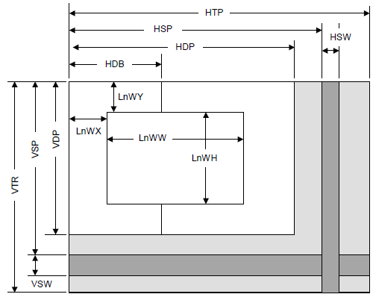

Fig 2.8: Display parameters
HTP | Horizontal Total Pixels
HSP | Horizontal Synchronize pulse Position
HSW | Horizontal Synchronize pulse Width
HDP | Horizontal Display Period
HDB | Horizontal Display Boundary
VTR | Vertical Total Raster
VSP | Vertical Synchronize pulse Position
VSW | Vertical Synchronize pulse Width
VDP | Vertical Display Period
LnWX | Layer n Window position X
LnWY | Layer n Window position Y
LnWW | Layer n Window Width
LnWH | Layer n Window Height

When not splitting the window, set HDP to HDB and display only the left side of the window. The settings must meet the following relationship:
0 < HDB ≤ HDP < HSP < HSP + HSW + 1 < HTP
0 < VDP < VSP < VSP + VSW + 1 < VTR
    - Display position control
The graphic image data to be displayed is located in the logical 2D coordinates space (logical graphics space) in the Graphics Memory. There are six logical graphics spaces as follows: L0 layer
- L1 layer
- L2 layer
- L3 layer
- L4 layer
- L5 layer
The relation between the logical graphics space and display position is defined as follows:
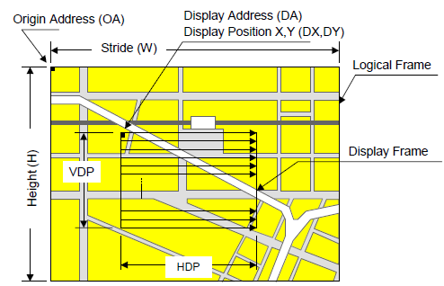

Fig 2.9 Display position parameters

OA | Origin Address | Origin address of logical graphics space. Memory address of top left edge pixel in logical frame origin
W | Stride | Width of logical graphics space. Defined in 64-byte unit
H | Height | Height of logical graphics space. Total raster (pixel) count of field
DA | Display Address | Display origin address. Top left position address of display frame origin
DX  DY | Display Position | Display origin coordinates.  Coordinates in logical frame space of display frame origin

MB86296S scans the logical graphics space as if the entire space is rolled over in both the horizontal and vertical directions. Using this function, if the display frame crosses the border of the logical graphics space, the part outside the border is covered with the other side of the logical graphics space, which is assumed to be connected cyclically as shown below:
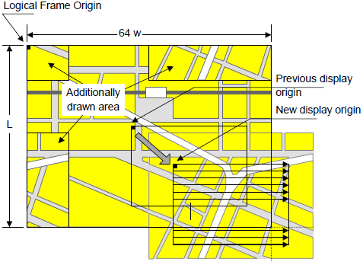

Fig 2.10: Wrap Around of Display Frame

The expression of the X and Y coordinates in the frame and their corresponding linear addresses (in bytes) is shown below.
A(x,y) = x × bpp/8 + 64wy (bpp = 8 or 16)
The origin of the displayed coordinates has to be within the frame. To be more specific, the parameters are subject to the following constraints:
0 ≤ DX < w × 64 × 8/bpp (bpp = 8 or 16)
0 ≤ DY < H
DX, DY, and DA have to indicate the same point within the frame. In short, the following relationship must be satisfied.
DA = OA + DX × bpp/8 + 64w × DY (bpp = 8 or 16)
2.4.6 Display Color
Color data is displayed in the following modes:
- Indirect color (8 bits/pixel)
In this mode, the index of the palette RAM is displayed. Data is converted to image data consisting of 6 bits for R, G, and B via the palette RAM and is then displayed.
- Direct color (16 bits/pixel)
Each level of R, G, and B is represented using 5 bits.
- Direct color (24 bits/pixel)
Each level of R, G, and B is represented using 8 bits.
- YCbCr color (16 bits/pixel)
In this mode, image data is displayed with YCbCr = 4:2:2. Data is converted to image data consisting of 8 bits for R, G, and B using the operation circuit and is then displayed.
The display colors for each layer are shown below.

Layer | Compatibility mode | Extended mode
L0 | Direct color (16, 24), Indirect color (P0) | Direct color (16, 24), Indirect color (P0)
L1 | Direct color (16, 24), Indirect color (P1), YCbCr | Direct color (16, 24), Indirect color (P1), YCbCr
L2 | Direct color (16, 24), Indirect color (P1) | Direct color (16, 24), Indirect color (P2)
L3 | Direct color (16, 24), Indirect color (P1) | Direct color (16, 24), Indirect color (P3)
L4 | Direct color (16, 24), Indirect color (P1) | Direct color (16, 24)
L5 | Direct color (16, 24), Indirect color (P1) | Direct color (16, 24)
“Pn” stands for the corresponding palette RAM. Four palettes are used as follows:
- Palette 0 (P0)
This palette corresponds to the C-layer palette for previous products. This palette is used for the L0 layer. This palette can also be used for the cursor.
- Palette 1 (P1)
This palette corresponds to the M/B layer palette for previous products. In the compatibility mode, this palette is common to layers L1 to 5. In the extended mode, this palette is dedicated to the L1 layer.
- Palette 2 (P2)
This palette is dedicated to the L2 layer. This palette can be used only for the extended mode.
- Palette 3 (P3)
This palette is dedicated to the L3 layer. This palette can be used only for the extended mode.

2.4.7 Video capture function
- Video input
The input format is either ITU RBT-656 or RGB666.
Video data is stored in graphics memory once and then displayed on the screen in synchronization with the display scan.
- Scaling
A scale-up factor 1 to 2 can be used. PAL or NTSC images can be displayed on a wide screen.
A scale-down factor 1 to 1/32 can be used.
Picture-in-picture can be used to display drawn images and video images on the same screen.
2.4.8 Geometry processing
The MB86296 has a geometry engine for performing the numerical operations required for graphics processing. The geometry engine uses the floating-point format for highly precise operations. It selects the required geometry processing according to the set drawing mode and primitive type and executes processing to the final drawing.
- Primitives
Point, line, line strip, independent triangle, triangle strip, triangle fan, and arbitrary polygon are supported.
- MVP Transformation
MVP Transformation
Setting a 4 × 4 transformation matrix enables transformation of a 3D model view projection. Two-dimensional affine transformation is also possible.
- Clipping
Clipping stops drawing of figures outside the window (field of view). Polygons (including concave shapes) can also be clipped.

- Culling
Backfacing triangles are not drawn.
- 3D-2D Transformation
This function transforms 3D coordinates (normalization) into 2D coordinates in orthogonal or perspective projections.
- View port transformation
This function transforms normalized 2D coordinates into drawing (device) coordinates.
- Primitive setup
This function automatically performs a variety of slope computations, etc., based on transforming vertex data into coordinates and prepares for rendering (setup).
- Log output of device coordinates
The view port conversion results are output to the local memory.
    - 2D Drawing
- 2D Primitives
MB86296S can perform 2D drawing for graphics memory (drawing plane) in direct color mode or indirect color mode.
Wide bold lines and broken lines can be drawn. Smooth diagonal lines can also be drawn using anti-aliasing.
A triangle can be tiled in a single color or 2D pattern (tiling) or mapped with a texture pattern by specifying coordinates of the 2D pattern at each vertex (texture mapping). With texture mapping, drawing/non-drawing can be set in pixel units. Moreover, transparent processing can be performed using alpha blending. When drawing in single color or tiling without Gouraud shading or texture mapping, high-speed 2DLine and high-speed 2DTriangle functions can be used. Only vertex coordinates are set for these primitives. High-speed 2DTriangle is also used to draw polygons.

2D Primitives Primitive type | Description
Point | Plots point
Line | Draws line
Bold line strip  (provisional name) | Draws continuous bold line  This primitive is used when interpolating the bold line joint.
Triangle | Draws triangle
High-speed 2DLine | Draws lines  Compared to line, this reduces the host CPU processing load.
Arbitrary polygon | Draws arbitrary closed polygon containing concave shapes consisting of vertices
- Arbitrary polygon drawing
Using this function, arbitrary closed polygons containing concave shapes consisting of vertices can be drawn (there is no restriction on the count of vertices, however, polygons with crossing sides are not supported.) In this case, a polygon drawing flag buffer is used on the graphics memory, as a work area for drawing. When drawing polygons, draw the triangles for the polygon drawing flag buffer using high-speed 2DTriangle. Decide on any vertex as a starting point to draw the triangle along the edge. You can draw the final polygon form in a single color or with tiling or with texture mapping in a drawing frame.
- BLT/Rectangle drawing
This function draws a rectangle using logic operations. It is used to draw pattern and copy the image pattern within the drawing frame. It is also used for clearing drawing frame and Z buffer.

BLT Attributes Attribute | Description
Raster operation | Selects two source logical operation mode
Transparent processing | Performs BLT without drawing pixel consistent with the transparent color.
Alpha blending | The alpha map and source in the memory is subjected to alpha blending and then copied to the destination.

- Pattern (Text) drawing
This function draws a binary pattern (text) in a specified color.
Pattern (Text) Drawing Attributes Attribute | Description
Enlarge | Vertically × 2  Horizontally × 2  Vertically and Horizontally × 2
Shrink | Vertically × 1/2  Horizontally 1/2  Vertically and Horizontally 1/2

    - Special effects
- Anti-aliasing
Anti-aliasing manipulates line borders of polygons in sub-pixel units and blend the pre-drawing pixel color with color to make the jaggies be seen smooth. It is used as a functional option for 2D drawing (in direct color mode only).
- Bold line and broken line drawing
This function draws lines of a specific width and a broken line.

Line Drawing Attributes Attribute | Description
Line width | Selectable from 1 to 32 pixels
Broken line | Set by 32 bit or 24 bit of broken line pattern

Supports the verticality of starting and ending points.
Supports the verticality of broken line pattern.
Interpolation of bold line joint supports the following modes: (1) Broken line pattern reference address fix mode
→ The same broken line pattern is kept referencing for the period of some pixels starting from the joint and the starting point for the next line.
(2) No interpolation
Supports the equalization of the width of bold lines.
Supports the bold line edging.
Not support the Anti-aliasing of dashed line patterns.
For a part overlaid due to connection of bold lines, natural overlay can be represented by providing depth information. (Z value).
- Shading
Supports the shading primitive.
Drawing is performed to the body primitive coordinates (X, Y) with an offset as a shade. At this drawing, the Z buffer is used in order to differentiate between the body and shade.
- Alpha blending
Alpha blending blends two image colors to provide a transparent effect. CORAL supports two types of blending; blending two different colors at drawing, and blending overlay planes at display. Transparent color is not used for these blending options.
There are two ways of specifying alpha blending for drawing:

(1) Set a transparent coefficient to the register; the transparent coefficient is applied for transparency processing of one plane.
(2) Set a transparent coefficient for each vertex of the plane; as with Gouraud shading, the transparent coefficient is linear-interpolated to perform transparent processing in pixel units.
In addition to the above, the following settings can be performed at texture mapping. When the most significant bit of each texture cell is 1, drawing or transparency can be set. When the most significant bit of each texture cell is 0, non-drawing can be set.

Alpha Blending Type | Description
Drawing | Transparent ratio set in particular register  While one primitive (polygon, pattern, etc.), being drawn, registered transparent ratio applied  A transparent coefficient set for each vertex. A linear-interpolated transparent coefficient applied.  This is possible only in direct color mode.
Overlay display | Blends top layer pixel color with lower layer pixel color  Transparent coefficient set in particular register  Registered transparent coefficient applied during one frame scan

- Gouraud Shading
Gouraud shading can be used in the direct color mode to provide 3D object real shading and color gradation.
- Gray Scale Gouraud Shading
Gray scale gouraud shading can be used in the in-direct color mode to draw a blend coefficient layer.

- Texture mapping
MB86296 supports texture mapping to map a image pattern onto the surface of plane. For 2D pattern texture mapping, MB86296 has a built-in pattern memory for a field of up to 64 × 64 pixels (at 16-bit color), which performs high-speed texture mapping. The texture pattern can also be laid out in the graphics memory. In this case, max. 4096 × 4096 pixels can be used.
Drawing of 8-/16-bit direct color is supported for the texture pattern. For drawing 8-bit direct color, only point sampling can be specified for texture interpolation; only decal can be specified for the blend mode.

Texture Mapping Function | Description
Filtering | Point sample Bi-linear filter
Coordinates correction | Linear Perspective
Blend | Decal Modulate Stencil
Alpha blend | Normal Stencil Stencil alpha
Wrap | Repeat Cramp  Border

Advantages
- The attitude indicator is shifted to an individual panel, this is done so that the complexity of the system is reduced when the pilot views it.
- The necessity of the pilot putting an input to determine the attitude of the plane is removed because the system would automatically determine the attitude level in which the aircraft is gliding in.

CHAPTER 3
DEVELOPMENT METHODOLOGY
The waterfall model has been structured on multiple phases especially to help out the software construction companies to develop an organized system of construction. By following this method, the project will be divided into many stages thus easing out the whole process. For example you start with Phase I and according to this model, one only progress to the next phase once the previous one has been completed. This way one moves progressively to the final stage and once that point is reached, you cannot turn back similar to the water in a waterfall.
The waterfall model is a model which was developed for software development that is to create software. It is called as such because the model develops systematically from one phase to other in a downward fashion, like a waterfall.
3.1 Stages of the Waterfall Model
- Requirement Analysis and Definition
All possible requirements of the system to be developed are captured in this phase. Requirements are a set of functions and constraints that the end user (who will be using the system) expects from the system. The requirements are gathered from the end user at the start of the software development phase. These requirements are analyzed for their validity, and the possibility of incorporating the requirements in the system to be developed is also studied. Finally, a requirement specification document is created which serves the purpose of guideline for the next phase of the model.
- System and Software Design
Before starting the actual coding phase, it is highly important to understand the requirements of the end user and also have an idea of how should the end product looks like. The requirement specifications from the first phase are studied in this phase and a system design is prepared. System design helps in specifying hardware and system requirements and also helps in defining the overall system architecture. The system design specifications serve as an input for the next phase of the model.

- Implementation and Unit Testing
On receiving system design documents, the work is divided in modules/units and actual coding is started. The system is first developed in small programs called units, which are integrated in the next phase. Each unit is developed and tested for its functionality; this is referred to as unit testing. Unit testing mainly verifies if the modules/units meet their specifications.
- Integration and System Testing
As specified above, the system is first divided into units which are developed and tested for their functions. These units are integrated into a complete system during integration phase and tested to check if all modules/units coordinate with each other, and the system as a whole behaves as per the specifications. After successfully testing the software, it is delivered to the customer.
- Operations & Maintenance
This phase of the waterfall model is virtually a never-ending phase. Generally, problems with the system developed (which are not found during the development life cycle) come up after its practical use starts, so the issues related to the system are solved after deployment of the system. Not all the problems come into picture directly but they arise from time to time and need to be solved; hence this process is referred to as maintenance.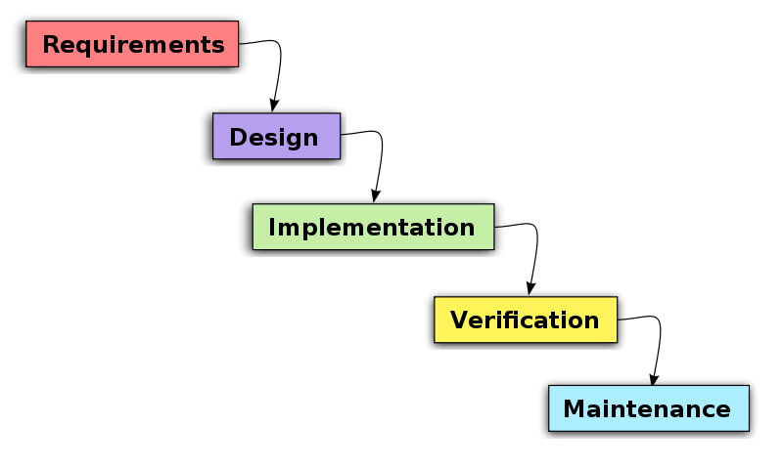 Fig 3.1: Waterfall Model.

CHAPTER 4
SYSTEM REQUIREMENTS AND ANALYSIS
4.1 HARDWARE REQUIREMENTS
- MB86296S graphics card
- 12V,5V,3.3V power supply
- RGB video source
- RGB Display
- PCI to PMC Adapter Card
- CPU
- Video Cables
4.2 SOFTWARE REQUIREMENTS
- Windows XP or later.
- Microsoft Visual Studio
- GDC software library
4.3 SOFTWARE ENVIRONMENT
Microsoft Visual Studio is an integrated development environment (IDE) from Microsoft. It is used to develop console and graphical user interface applications along with Windows Forms or WPF applications, web sites, web applications, and web services in both native code together with managed code for all platforms supported by Microsoft Windows, Windows Mobile, Windows CE, .NET Framework, .NET Compact Framework and Microsoft Silverlight.

Visual Studio includes a code editor supporting IntelliSense as well as code refactoring. The integrated debugger works both as a source-level debugger and a machine-level debugger. Other built-in tools include a forms designer for building GUI applications, web designer, class designer, and database schema designer. It accepts plug-ins that enhance the functionality at almost every level—including adding support for source-control systems (like Subversion andVisual SourceSafe) and adding new toolsets like editors and visual designers for domain-specific languages or toolsets for other aspects of the software development lifecycle (like the Team Foundation Server client: Team Explorer).
Visual Studio supports different programming languages by means of language services, which allow the code editor and debugger to support (to varying degrees) nearly any programming language, provided a language-specific service exists. Built-in languages include C/C++^{[5]} (via Visual C++), VB.NET (via Visual Basic .NET), C# (via Visual C#), and F# (as of Visual Studio 2010). Support for other languages such as M, Python, and Ruby among others is available via language services installed separately. It also supports XML/XSLT, HTML/XHTML, JavaScript and CSS. Individual language-specific versions of Visual Studio also exist which provide more limited language services to the user: Microsoft Visual Basic, Visual J#, Visual C#, and Visual C++.
Microsoft provides "Express" editions of its Visual Studio 2010 components Visual Basic, Visual C#, Visual C++, and Visual Web Developer at no cost. Visual Studio 2012, 2010, 2008 and 2005 Professional Editions, along with language-specific versions (Visual Basic, C++, C#, J#) of Visual Studio Express 2010 are available for free to students as downloads via Microsoft's DreamSpark program.
4.3.1 Features OF Visual Studio

Code editor
Like any other IDE, it includes a code editor that supports syntax highlighting and code completion using IntelliSense for not only variables, functions and methods but also language constructs like loops and queries. IntelliSense is supported for the included languages, as well as for XMLand for Cascading Style Sheets and JavaScript when

developing web sites and web applications. Autocomplete suggestions are popped up in a modeless list box, overlaid on top of the code editor. In Visual Studio 2008 onwards, it can be made temporarily semi-transparent to see the code obstructed by it. The code editor is used for all supported languages.
The Visual Studio code editor also supports setting bookmarks in code for quick navigation. Other navigational aids include collapsing code blocks and incremental search, in addition to normal text search and regex search. The code editor also includes a multi-item clipboard and a task list. The code editor supports code snippets, which are saved templates for repetitive code and can be inserted into code and customized for the project being worked on. A management tool for code snippets is built in as well. These tools are surfaced as floating windows which can be set to automatically hide when unused or docked to the side of the screen. The Visual Studio code editor also supports code refactoring including parameter reordering, variable and method renaming, interface extraction and encapsulation of class members inside properties, among others.
Visual Studio features background compilation (also called incremental compilation). As code is being written, Visual Studio compiles it in the background in order to provide feedback about syntax and compilation errors, which are flagged with a red wavy underline. Warnings are marked with a green underline. Background compilation does not generate executable code, since it requires a different compiler than the one used to generate executable code. Background compilation was initially introduced with Microsoft Visual Basic but has now been expanded for all included languages.

Debugger
Visual Studio includes a debugger that works both as a source-level debugger and as a machine-level debugger. It works with both managed code as well as native code and can be used for debugging applications written in any language supported by Visual Studio. In addition, it can also attach to running processes and monitor and debug those processes. If source code for the running process is available, it displays the code as it is being run. If source code is not available, it can show the disassembly. The Visual Studio debugger can also create memory dumps as well as load them later for debugging. Multi-

threaded programs are also supported. The debugger can be configured to be launched when an application running outside the Visual Studio environment crashes. The debugger allows setting breakpoints (which allow execution to be stopped temporarily at a certain position) and watches (which monitor the values of variables as the execution progresses). Breakpoints can be conditional, meaning they get triggered when the condition is met. Code can be stepped over, i.e., run one line (of source code) at a time. It can either step into functions to debug inside it, or step over it, i.e., the execution of the function body isn't available for manual inspection. The debugger supports Edit and Continue, i.e., it allows code to be edited as it is being debugged (32 bit only; not supported in 64 bit). When debugging, if the mouse pointer hovers over any variable, its current value is displayed in a tooltip ("data tooltips"), where it can also be modified if desired. During coding, the Visual Studio debugger lets certain functions be invoked manually from the Immediate tool window. The parameters to the method are supplied at the Immediate window.

Designer
Visual Studio includes a host of visual designers to aid in the development of applications. These tools include:
Windows Forms Designer

The Windows Forms designer is used to build GUI applications using Windows Forms. Layout can be controlled by housing the controls inside other containers or locking them to the side of the form. Controls that display data (like textbox, list box, grid view, etc.) can be bound to data sources like databases or queries. Data-bound controls can be created by dragging items from the Data Sources window onto a design surface. The UI is linked with code using an event-driven programming model. The designer generates either C# or VB.NET code for the application.
WPF Designer

The WPF designer, codenamed Cider, was introduced with Visual Studio 2008. Like the Windows Forms designer it supports the drag and drop metaphor. It is used to author user interfaces targeting Windows Presentation Foundation. It

supports all WPF functionality including data binding and automatic layout management. It generates XAML code for the UI. The generated XAML file is compatible with Microsoft Expression Design, the designer-oriented product. The XAML code is linked with code using a code-behind model.
Web designer/development
Visual Studio also includes a web-site editor and designer that allows web pages to be authored by dragging and dropping widgets. It is used for developing ASP.NET applications and supports HTML, CSS and JavaScript. It uses a code-behindmodel to link with ASP.NET code. From Visual Studio 2008 onwards, the layout engine used by the web designer is shared with Microsoft Expression Web. There is also ASP.NET MVC support for MVC technology as a separate download and ASP.NET Dynamic Data project available from Microsoft.
Class designer
The Class Designer is used to author and edit the classes (including its members and their access) using UML modeling. The Class Designer can generate C# and VB.NET code outlines for the classes and methods. It can also generate class diagrams from hand-written classes.
Data designer
The data designer can be used to graphically edit database schemas, including typed tables, primary and foreign keys and constraints. It can also be used to design queries from the graphical view.
Mapping designer
From Visual Studio 2008 onwards, the mapping designer is used by LINQ to SQL to design the mapping between database schemas and the classes that encapsulate the data. The new solution from ORM approach, ADO.NET Entity Framework, replaces and improves the old technology.

Open Tabs Browser
The open tabs browser is used to list all open tabs and to switch between them. It is invoked using CTRL+TAB.

Properties Editor

The Properties Editor tool is used to edit properties in a GUI pane inside Visual Studio. It lists all available properties (both read-only and those which can be set) for all objects including classes, forms, web pages and other items.
Object Browser
The Object Browser is a namespace and class library browser for Microsoft .NET. It can be used to browse the namespaces (which are arranged hierarchically)
in managed assemblies. The hierarchy may or may not reflect the organization in the file system.
Solution Explorer
In Visual Studio parlance, a solution is a set of code files and other resources that are used to build an application. The files in a solution are arranged hierarchically, which might or might not reflect the organization in the file system. The Solution Explorer is used to manage and browse the files in a solution.
Team Explorer
Team Explorer is used to integrate the capabilities of Team Foundation Server, the Revision Control System into the IDE (and the basis for Microsoft's CodePlex hosting environment for open source projects). In addition to source control it provides the ability to view and manage individual work items (including bugs, tasks and other documents) and to browse TFS statistics. It is included as part of a TFS install and is also available as a download for Visual Studio separately^{[34][35]} Team Explorer is also available as a stand-alone environment solely to access TFS services.
Data Explorer
Data Explorer is used to manage databases on Microsoft SQL Server instances. It allows creation and alteration of database tables (either by issuing T-SQL commands or by using the Data designer). It can also be used to create queries and stored procedures, with the latter in either T-SQL or in managed code via SQL CLR. Debugging and IntelliSense support is available as well.
Server Explorer
The Server Explorer tool is used to manage database connections on an accessible computer. It is also used to browse running Windows Services, performance counters, Windows Event Log and message queues and use them as a datasource.
Dotfuscator Software Services Community Edition
Visual Studio includes a free 'light' version of PreEmptive Solutions' Dotfuscator product for code obfuscation and application-size reduction. Starting with Visual Studio 2010, this version of Dotfuscator will include Runtime Intelligence capabilities that allow authors to gather end-user usage, performance, and stability information from their applications running in production.
Text Generation Framework
Visual Studio includes a full text generation framework called T4 which enables Visual Studio to generate text files from templates either in the IDE or via code.
ASP.NET Web Site Administration Tool
The ASP.NET Web Site Administration Tool allows for the configuration of ASP.NET websites.

Extensibility
Visual Studio allows developers to write extensions for Visual Studio to extend its capabilities. These extensions "plug into" Visual Studio and extend its functionality. Extensions come in the form of macros, add-ins, and packages. Macros represent repeatable tasks and actions that developers can record programmatically for saving, replaying, and distributing. Macros, however, cannot implement new commands or create tool windows. They are written using Visual Basic and are not compiled. Add-Ins provide access to the Visual Studio object model and can interact with the IDE tools. Add-Ins can be used to implement new functionality and can add new tool windows. Add-Ins are plugged into the IDE via COM and can be created in any COM-compliant languages. Packages are created using the Visual Studio SDK and provide the highest level of extensibility. They can create designers and other tools, as well as integrate other programming languages. The Visual Studio SDK provides unmanaged APIs as well as a managed API to accomplish these tasks. However, the managed API isn't as comprehensive as the unmanaged one. Extensions are supported

in the Standard (and higher) versions of Visual Studio 2005. Express Editions do not support hosting extensions.
Visual Studio 2008 introduced the Visual Studio Shell that allows for development of a customized version of the IDE. The Visual Studio Shell defines a set of VSPackages that provide the functionality required in any IDE. On top of that, other packages can be added to customize the installation. The Isolated mode of the shell creates a new AppId where the packages are installed. These are to be started with a different executable. It is aimed for development of custom development environments, either for a specific language or a specific scenario. The Integrated mode installs the packages into the AppId of the Professional/Standard/Team System editions, so that the tools integrate into these editions. The Visual Studio Shell is available as a free download.
After the release of Visual Studio 2008, Microsoft created the Visual Studio Gallery. It serves as the central location for posting information about extensions to Visual Studio. Community developers as well as commercial developers can upload information about their extensions to Visual Studio .NET 2002 through Visual Studio 2010. Users of the site can rate and review the extensions to help assess the quality of extensions being posted. RSS feeds to notify users on updates to the site and tagging features are also planned.

4.4 SYSTEM REQUIREMENTS

Processor |  | Personal computer (PC) with a Pentium II-class processor, 450 megahertz (MHz)
Operating System |  | - Microsoft Windows® XP Professional  - Microsoft Windows XP Home Edition*  - Microsoft Windows 2000 Professional  - Microsoft Windows 2000 Server  - Microsoft Windows NT® 4.0 Workstation  - Microsoft Windows NT 4.0 Server  (Note: Microsoft Windows Millennium Edition and Windows NT 4.0 Terminal Server are not supported)
Memory |  | - Microsoft Windows XP Professional  160 megabytes (MB) of RAM  - Windows 2000 Professional  96 MB of RAM  - Windows 2000 Server  192 MB of RAM  - Windows NT 4.0 Workstation  64 MB of RAM  - Windows NT 4.0 Server  160 MB of RAM
Hard Disk |  | - Standard Edition  2.5 gigabytes (GB) on installation drive, which includes 500 MB on system drive  - Professional and Enterprise Editions  3.5 GB on installation drive, which includes 500 MB on system drive
Drive |  | CD-ROM or DVD-ROM drive
Display |  | Super VGA (800 x 600) or higher-resolution monitor with 256 colors
Mouse |  | Microsoft Mouse or compatible pointing device

4.5 VERSIONS OF VISUAL STUDIO

Visual Studio 2008
Visual Studio 2008, and Visual Studio Team System 2008 codenamed Orcas (a reference to Orcas Island, also an island in Puget Sound, like Whidbey for the previous 2005 release), were released to MSDN subscribers on 19 November 2007 alongside .NET Framework 3.5. The source code for the Visual Studio 2008 IDE is available under a shared source license to some of Microsoft's partners and ISVs. Microsoft released Service Pack 1 for Visual Studio 2008 on 11 August 2008. The internal version number of Visual Studio 2008 is version 9.0 while the file format version is 10.0. Visual Studio 2008 is the last version to support targeting Windows 2000 for C++ applications.
Visual Studio 2008 is focused on development of Windows Vista, 2007 Office system, and Web applications. For visual design, a new Windows Presentation Foundation visual designer and a new HTML/CSS editor influenced by Microsoft Expression Web are included. J# is not included. Visual Studio 2008 requires .NET 3.5 Framework and by default configures compiled assemblies to run on .NET Framework 3.5, but it also supports multi-targeting which lets the developers choose which version of the .NET Framework (out of 2.0, 3.0, 3.5, Silverlight CoreCLR or .NET Compact Framework) the assembly runs on. Visual Studio 2008 also includes new code analysis tools, including the new Code Metrics tool (only in Team Edition and Team Suite Edition). For Visual C++, Visual Studio adds a new version of Microsoft Foundation Classes (MFC 9.0) that adds support for the visual styles and UI controls introduced with Windows Vista. For native and managed code interoperability, Visual C++ introduces the STL/CLR, which is a port of the C++ Standard Template Library (STL) containers and algorithms to managed code. STL/CLR defines STL-like containers, iterators and algorithms that work on C++/CLI managed objects. Visual Studio 2008 features include an XAML-based designer (codenamed Cider), workflow designer, LINQ to SQL designer (for defining the type mappings and object encapsulation for SQL Server data), XSLT debugger, JavaScript Intellisense support, JavaScript Debugging support, support for UAC manifests, a concurrent build system, among others. It ships with an enhanced set of UI widgets, both for Windows Forms and WPF. It also includes a multithreaded build engine (MSBuild) to compile multiple source files (and build the

executable file) in a project across multiplethreads simultaneously. It also includes support for compiling PNG-compressed icon resources introduced in Windows Vista. An updated XML Schema designer will ship separately some time after the release of Visual Studio 2008.
The Visual Studio debugger includes features targeting easier debugging of multi-threaded applications. In debugging mode, in the Threads window, which lists all the threads, hovering over a thread will display the stack trace of that thread in tooltips. The threads can directly be named and flagged for easier identification from that window itself. In addition, in the code window, along with indicating the location of the currently executing instruction in the current thread, the currently executing instructions in other threads are also pointed out. The Visual Studio debugger supports integrated debugging of the .NET 3.5 Framework Base Class Library (BCL) which can dynamically download the BCL source code and debug symbols and allow stepping into the BCL source during debugging. As of 2010 a limited subset of the BCL source is available, with more library support planned for later.

Targeting Windows XP with C++ in Visual Studio
- Background
The C++ runtime and libraries that accompany Visual Studio 2012 contain dependencies on several Windows API functions that exist only on Windows Vista and higher versions of the OS. This means that applications built with Visual Studio 2012’s C++ compiler will fail to load and execute on Windows XP. Developers wishing to target Windows XP can use Visual Studio’s C++ multi-

targeting feature, which enables the use of the Visual Studio 2010 compiler from within the new IDE. Multi-targeting enables developers to take advantage of the new features of the IDE without migrating projects to the new compiler or to use the Visual Studio 2010 compiler to build applications that target Windows XP.
- Assessing--Multi-targeting
The Beta release of Visual Studio 2012 offered us an opportunity to evaluate the

effectiveness of C++ multi-targeting, particularly among developers that wish to target Windows XP. Feedback from customers cited two key scenarios they wanted Visual Studio 2012 to support in order to best meet their needs for Windows XP targeting:
- The ability to target Windows XP and higher from a single compiler and tools chain rather than resort to separate builds for XP and for Vista+.
- The ability to target Windows XP and higher from a single code base that employs modern C++11 language features.
In order to better meet customer needs relative to build configuration and XP targeting, we have made the decision to enhance multi-targeting to support Windows XP targeting directly from the Visual Studio 2012 C++ compiler and libraries.
- Enhancing--Multi-targeting
Later this fall, Microsoft will provide an update to Visual Studio 2012 that will enable C++ applications to target Windows XP. This update will make the necessary modifications to the Visual C++ 2012 compiler, runtime, and libraries to enable developers to create applications and DLLs that run on Windows XP and higher versions as well as Windows Server 2003 and higher. This update will also be included in the recently-announced Visual Studio Express 2012 for Windows Desktop.
CHAPTER 5
SYSTEM DESIGN
The System design is mainly divided into modules which are harnessed together to render the navigation of cockpit system. The Graphics Driver is assuming the system composed of two or more tasks. The Graphics Driver is a mechanism that maintains the context and the DL buffer of each drawing task to make it draw separately with two or more drawing tasks (task that uses the function for the drawing control) in the primitive.
Drawing is asynchronously enabled from each drawing task with this mechanism.
Because the Driver Command other than the drawing control commands doesn’t correspond to a reentrant call, the task that uses this Driver Command can’t be asynchronously executed. Do not execute it by another task when using only by one task or using it by two or more tasks until it controls exclusively, and processing ends completely.
5.1 INITIALISATION MODULE
This module consists of the sequence of steps which are needed to be used to enrich the driver control of coral pa and activate the graphics card . it renders all the CORAL PA features and its syntax and uses are given below.
5.1.1 Initialise DL buffer
/* Initialize display list buffer */
GDC_DLBUF_STRUCT *InitializeDisplayListBuffer()
{
int i;
for(i = 0; i < DLBUF_NUM; i++){
dlbuf_info[i].top = &dlbuf[i][0];

dlbuf_info[i].bottom = &dlbuf[i][DLBUF_SIZE];
}
return &dlbuf_info[0];
}
Allocate DL buffer
Allocate DL buffer in the main memory or the graphics memory.
[Example of allocating DL buffer]
/* Allocate the three DL buffers whose size is DLBUF_SIZE*/
#define DLBUF_SIZE (4096 * 32)
GDC_ULONG dlbuf[3][DLBUF_SIZE];

The allocating area of DL buffer depends on the transfer method of the display list. Use the main memory when you use the CPU or DMA display list transfer, and use the graphics memory when you use the local display list transfer
Allocate DL buffer structure information area
Allocate DL buffer structure information area in the main memory.
The example is below.
Specify the total number of DL buffer in the array elements. The number in which the array element is specified is DL buffer number.

[Example of allocating DL buffer structure information area]
/* Allocate DL buffer structure information’s for three DL buffers */
GDC_DLBUF_STRUCT dlbuf_info[3];
Set DL buffer structure information

Set the following information to DL buffer structure information. Set this information only once
.[DL buffer structure information]
• Top address of each DL buffer (top)
• Bottom address +1 of each DL buffer (bottom)
Do not set the display list write address by application programs because this area is managed by the Graphics Driver.

[Example for setting to DL Buffer information]
#include “gdc.h"
#define DLBUF_SIZE (4096 * 32)
/* Allocate three DL Buffer whose size is DLBUF_SIZE */
GDC_ULONG dlbuf[3][DLBUF_SIZE];
/* Allocate three DL Buffer structure information area */
GDC_DLBUF_STRUCT dlbuf_info[3];
dlbuf_info[0].top = &dlbuf[0][0];
dlbuf_info[0].bottom = &dlbuf[0][DLBUF_SIZE];
dlbuf_info[1].top = &dlbuf[1][0];
dlbuf_info[1].bottom = &dlbuf[1][DLBUF_SIZE];
dlbuf_info[2].top = &dlbuf[2][0];
dlbuf_info[2].bottom = &dlbuf[2][DLBUF_SIZE];

5.1.2 Initialize the Graphics Driver (GdcInitialize command)
It is necessary to initialize the Graphics Driver to call the Driver Command and to draw the primitive. Call the GdcInitialize command without fail before calling other Driver Command and initialize the Graphics Driver.
Interface:
GDC_BOOL GdcInitialize (const GDC_INITPARAM *initparam, int flag)

Arguments: initparam Pointer to Initialize Parameter Table flag Specify any of the following

GDC_INIT_START Executes initialization

GDC_INIT_RESET Executes software reset

Code snippet :
/* Initializes driver */
GDC_BOOL InitializeDriver(int type, int memtype)
{
int ret;
// char key;
GDC_INITPARAM initparam;

initparam.cputype = GDC_CPU_WINDOWS;
initparam.gdctype = GDC_TYPE_MB86294;
switch(memtype)
{
case '0': initparam.memorymode = 0x11d7fa12; break;
case '1': initparam.memorymode = 0x11d7fa13; break;
default : initparam.memorymode = 0x11d7fa12; break;
}
initparam.disp.mode = 0x0f00;

initparam.geoclock = GDC_CLOCK_166MHZ;
initparam.otherclock = GDC_CLOCK_133MHZ;
Open_Cremson();
initparam.gdcbase = Get_FrameAddress();
/* Initializes the Graphics Driver */
ret = GdcInitialize(&initparam, GDC_INIT_START);
if (ret != GDC_TRUE){
return GDC_FALSE;
}
return ret;}

/* for DLTRANSMODE_CPU */
/* for DLTRANSMODE_DMA */
/* Display list buffer */
GDC_ULONG dlbuf[DLBUF_NUM][DLBUF_SIZE];
5.1.3 Set display frame (GdcDispDimension command)
It is necessary to allocate display frame area in the graphics memory according to the size and the number of layers of screens used. Call the GdcDispDimension command so that the Graphics Controller can use the allocated display frame area. Call the hali n panda
GdcDispDimension command as many times as thenumber of using layer to set display frame.

Interface
GDC_BOOL GdcDispDimension (GDC_UCHAR layer, GDC_UCHAR enable,
GDC_UCHAR cmode, GDC_UCHAR fmode,
GDC_ULONG loa0, GDC_ULONG loa1,
GDC_USHORT lw, GDC_USHORT lh)
Arguments
layer Layer selection
GDC_DISP_LAYER_C Layer C
GDC_DISP_LAYER_W Layer W
GDC_DISP_LAYER_ML Layer ML
GDC_DISP_LAYER_MR Layer MR
GDC_DISP_LAYER_BL Layer BL
GDC_DISP_LAYER_BR Layer BR
[In MB86293 or later, following macros are available]
GDC_DISP_LAYER_L0 Layer L0
GDC_DISP_LAYER_L1 Layer L1
GDC_DISP_LAYER_L2 Layer L2
GDC_DISP_LAYER_L3 Layer L3
GDC_DISP_LAYER_L4 Layer L4
GDC_DISP_LAYER_L5 Layer L5
enable Layer display enable/disable
GDC_ENABLE Layer display enable
GDC_DISABLE Layer display disable
cmode Color mode selection
GDC_24BPP_FORMAT 24-bit color mode
GDC_16BPP_FORMAT 16-bit color mode
GDC_8BPP_FORMAT 8-bit color mode
fmode Flipping mode selection
GDC_FLIPMODE_0 Display bank 0
GDC_FLIPMODE_1 Display bank 1
GDC_FLIPMODE_AUTO Display both banks
Alternately

loa0 Top address of logical frame of bank 0, specify offset from top of
the graphics memory
loa1 Top address of logical frame of bank 1, specify offset from top of
the graphics memory
lw Logical frame width, in pixels (*1)
Range from "16" to "4096", in 16 pixel unit, in 24-bit color mode
Range from "32" to "4096", in 32 pixel unit, in 16-bit color mode
Range from "64" to "4096", in 64 pixel unit, in 8-bit color mode
lh Logical frame height, in pixels, range from "1" to "4096" (*1)

Return value
GDC_TRUE Complete
GDC_FALSE Incomplete
Error code
GDC_ERR_INVALID_LAYER Invalid layer has been specified
GDC_ERR_INVALID_PARAMETER Invalid layer has been specified
Target GDC

Description:
Sets attributes of logical frame. Attributes are independent with each display
layer (C, W, ML, MR, BL and BR).
If this command is called, the display origin address of the specified layer will be
set as the same value as the specified display frame top address. (Sets to upper left
corner of the frame.)

When layer C or layer L0 is specified, fmode and loa1 are not used.
When layer W or layer L1 is specified, fmode, loa1 and lh is not used.
Either "Macros for standard display" or "Macros for extended display" can be used
to specify a layer when MB86293 or later Graphics Controller is used. If both
"Macros for standard display" and "Macros for extended display" are used in the
application program, the result is not guaranteed.

5.1.4 Set display attributes (GdcDispPos command, etc.)

Call the commands to set display attributes according to the following procedure.
1. GdcDispPos command Set display starting position for each layers.
2. GdcDispDividePos command Set the position where the display is divided into left and
right.
3. GdcColorTransparent command Set transparent color for each layers.
4. GdcColorZeroMode command Set whether the color code "0" treats as transparency or not for each layer.
5. GdcOverlayPriorityMode command Set whether to display layer C (layer L0) prioritized in the highest order or to display layer C in blended with the result
of prioritizing layers excluding layer C.
6. GdcDispLayerOn command Set display layer.
7. GdcDispOn command Permit the output of the video signal so that the screen
display may begin.

Interface
GDC_BOOL GdcDispPos (GDC_UCHAR layer, GDC_UCHAR bank,
GDC_USHORT dx, GDC_USHORT dy)
Arguments
layer Layer selection
GDC_DISP_LAYER_C Layer C
GDC_DISP_LAYER_ML Layer ML
GDC_DISP_LAYER_MR Layer MR
GDC_DISP_LAYER_BL Layer BL
GDC_DISP_LAYER_BR Layer BR
[In MB86293 or later, following macros are available]
GDC_DISP_LAYER_L0 Layer L0
GDC_DISP_LAYER_L2 Layer L2
GDC_DISP_LAYER_L3 Layer L3
GDC_DISP_LAYER_L4 Layer L4
GDC_DISP_LAYER_L5 Layer L5

bank Logical frame bank selection
GDC_DISP_BANK_0 Bank 0
GDC_DISP_BANK_1 Bank 1
dx x coordinate of display start position, range from "0" to "4095"
dy y coordinate of display start position, range from "0" to "4095"
The value of parameter is not checked of the range, specify a value within the decided range.
Return value
GDC_TRUE Complete
GDC_FALSE Incomplete
Error code
GDC_ERR_INVALID_LAYER Invalid layer has been specified
GDC_ERR_INVALID_BANK Invalid bank has been specified
Target GDC

Description:
Sets the display start position relatively from the base position of logical frame. After this command execution, it set as the target of display of the bank specified by bank. Either "Macros for standard display" or "Macros for extended display" can be used to specify a layer when MB86293 or later Graphics Controller is used. If both "Macros for standard display" and "Macros for extended display" are used in the application program, the result is not guaranteed.
[Macros for standard display]
• GDC_DISP_LAYER_C
• GDC_DISP_LAYER_ML
• GDC_DISP_LAYER_MR
• GDC_DISP_LAYER_BL
• GDC_DISP_LAYER_BR
[Macros for extended display]
• GDC_DISP_LAYER_L0
• GDC_DISP_LAYER_L2
• GDC_DISP_LAYER_L3

• GDC_DISP_LAYER_L4
• GDC_DISP_LAYER_L5
The range check of the parameter is not performed, set a valid value.

5.2 DISPLAY MODULE

The display task is a task of controlling the screen display It is the second step in the driver control and render the avionic symbols using coral pa graphics card.

5.2.1 Create context (XGdcCreateContext command)
It is necessary to create context before calling the drawing command. Call the XGdcCreateContext command to create and initialize context.

int main(){
int ret;
int errcode;
ret = GdcInitialize(...); /* Initialize the Graphics Driver */
if(ret != GDC_TRUE){
/* Error process */
return GDC_FALSE;
}
ret = XGdcCreateContext(...); /* Create context */
if(ret != GDC_TRUE){
/* Error process */
return GDC_FALSE;
}

The context is the area where the execution state and drawing attribute of the Graphics Driver are stored, and allocates an area by the application program side. The XGdcCreateContext command generates a context. Since the command for system control, the command for drawing control, and the command for display list control use a context, do not change the value of this area by application programs (since the

Graphics Driver manages this area, explanation of the data structure is omitted).
The "context" is the data that stores the status and rendering attribute of the Graphics Driver. Before the use of the Driver Command for the graphics drawing, the context needs to be generated by the XGdcCreateContext command first Application programs have to allocate the memory area for the context. When creating two or more tasks which perform a drawing, by generating the context individually by each task, drawing processing of these tasks does not need exclusion control, but can be performed simultaneously.DL buffer structure information is used with the XGdcCreateContext command in order to register the structure of DL buffer into context.

The contents of a setting of the data structure of DL buffer structure information and each parameter are shown below.

[GDC_DLBUF_STRUCT structure]
typedef struct{
GDC_ULONG *top; /* Top address of DL buffer */
GDC_ULONG *bottom; /* Bottom address of DL buffer + 1 */
GDC_ULONG *cur; /* Display list writing address */
GDC_ULONG ext_data; /* Extend data area */
} GDC_DLBUF_STRUCT;
[Content of each parameter setting]
The top address of DL buffer is specified.
The address of the last address +1 of DL buffer is specified.
The address in which a display list is written next is set up by the Driver Command.
For this reason, do not change the value of this area by application programs.
ext_data
Set up the value of this area by application programs if needed. Since the Graphics Driver does not perform reference or setup of this area, user can use this area freely

5.3 DRAWING MODULE
Select DL buffer (XGdcSetDLBuf command)
It is necessary to select DL buffer before call the drawing control commands to make the display list.
Call the XGdcSetDLBuf command to select DL buffer number that stores the display list.

5.3.1 Set drawing frame (XGdcDrawDimension command)

It is necessary to set drawing frame before draw a primitive. Set color mode, the origin address and the size of the drawing frame. Call the XGdcDrawDimension command to set the drawing frame. This command creates the display list.

5.3.2 Set drawing attributes (XGdcColor command, etc.)

Set drawing attributes before calling the drawing commands. Set vertex color/foreground color and the drawing attribute of the line width, etc. The drawing attributes are set by calling the "Drawing Attribute Setting Commands" and the "Attribute Setting Commands for Object Coordildonate System("y "). These commands create the display list.
Since the Graphics Driver doesn’t have the initial values for the drawing attributes, set all of the necessary attributes.

5.3.3 Call the Driver Command to draw the primitive (XGdcPrimType command, etc.)

Call the driver command to draw the primitive of the triangle or the line, etc. To draw the primitive, call the Driver Command such as the "Primitive Drawing Commands for Device Coordinate System . The drawing attributes after transferring the display list to the Graphics Controller in the same task are not necessarily the same as previous one. This is because there is a possibility that the other drawing task changes the drawing attribute after transmitting the display list to the Graphics Controller.

XGdcSetDLBuf(...);/* Select the DL Buffer */
XGdcDrawDimension(...);/* Set the drawing frame */
/* Start the drawing triangle */
XGdcSetAttrSurf(...);
XGdcColor(...);
XGdcPrimType(...);
XGdcDrawVertex2Di(...);
XGdcDrawVertex2Di(...);
XGdcDrawVertex2Di(...);
XGdcPrimEnd(...);
/* End of drawing triangle */
/* Error check of drawing triangle */
errcode = XGdcGetErrCode(...);/* Get error code */
if(errcode == GDC_ERR_INVALID_ATTRIBUTE){
/* Processing corresponding to error code */
The combination of xGdcPrimType and Hali are provided with a code snippet and a small
Example in the code below.
The combination between the XGdcPrimType command and the XGdcPrimEnd command.
Use the XGdcPrimType command a pair with the XGdcPrimEnd command.
<Correct example>
XGdcPrimType
XGdcDrawVertex3D
XGdcDrawVertex3D
XGdcPrimEnd
<Wrong example 1>
The XGdcPrimEnd command is not called.
XGdcPrimType
XGdcDrawVertex3D
XGdcDrawVertex3D
XGdcPrimType
XGdcDrawVertex3D
XGdcDrawVertex3D
<Wrong example 2>
The XGdcPrimType command is not called.
XGdcDrawVertex3D
XGdcDrawVertex3D
XGdcPrimEnd

The other implementation and changing drawing attributes are given below which gives a clear and sure and prominent understanding of the coral pa driver control and the navigation of the cock pit system.
The figure is given below in the two tasks of classification and it helps in the correct and accurate render of drawing avionic symbols
[refer fig below].

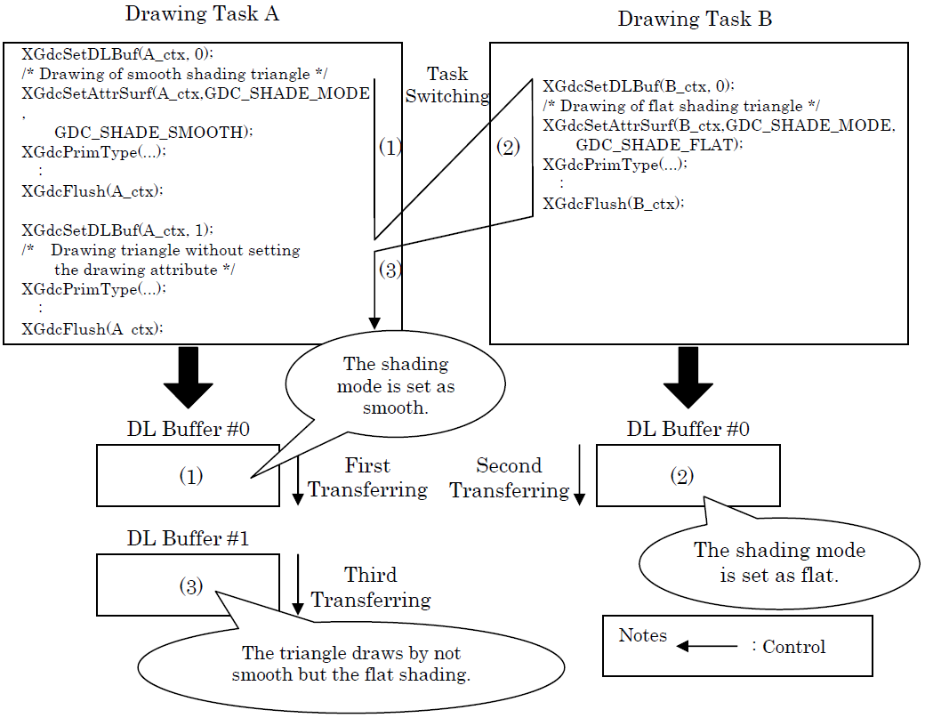
Fig 5.1: changing drawing attribute

Consequently, it might be necessary to set the drawing attributes again in multitask environment after transferring the display list. The drawing attributes can be set by calling the drawing control commands individually. Moreover, it is also possible to set two or more drawing attributes again at a time by using the drawing attributes maintained
in the context with the drawing control commands last. To restore the drawing attributes, call the XGdcRestoreAttr command. It is more efficient to call this command than to call

the individual drawing control commands when restoring the state with a lot of drawing attributes to the previous state where the display list is not transferred.
5.3.4 Transfer display list (XGdcFlush command or XGdcFlushEx command)
It is necessary to transfer the display list to the Graphics Controller to start drawing by the Graphics Controller. Call the XGdcFlush command or the XGdcFlushEx command, and transfer the display list to the Graphics Controller.

XGdcFlushEx [Transfers Display List in Specified DL Buffer]
Interface
GDC_ULONG XGdcFlushEx (GDC_CTX *drvctx, GDC_ULONG bufNo)
Arguments
drvctx Pointer to context
bufNo The number of a DL buffer
Return value
Bytes of transferred display list
Error code
GDC_ERR_ILLEGAL_DL_BUF_NO Illegal DL buffer number has been specified.
Description
Transfers display list in the DL buffer specified by bufNo to the Graphics
Controller. This command returns immediately without waiting for the transmission when
DMA or local display list transfer is used. When transmission by CPU is used, this command returns after the transmission. This command returns the number of transferred bytes of display list.

5.4 UseCase Diagram

The usecase diagram below explains how the pilot interacts with the attitude directional indicator. As mentioned earlier in the report the attitude indicator consistes of miniature wings, horizontal bar and the degree markings. These three are the most important parts of the attitude indicator with which user interaction is done by the pilot. The figure is shown below for an easier understanding.

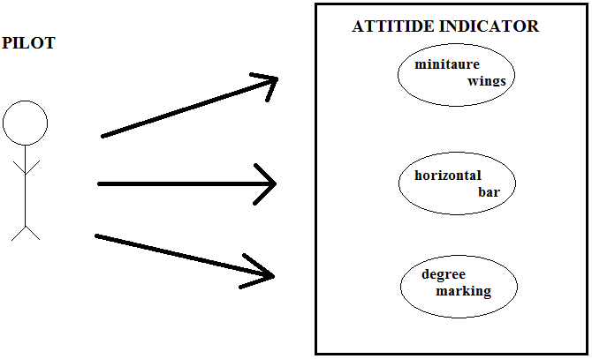
Fig 5.2: usecase diagram

CHAPTER 7
SYSTEM TESTING
7.1 BASICS
The purpose of testing is to discover errors. Testing is the process of trying to discover every conceivable fault or weakness in a work product. It provides a way to check the functionality of components, sub assemblies, assemblies and/or a finished product It is the process of exercising software with the intent of ensuring that the
Software system meets its requirements and user expectations and does not fail in an unacceptable manner. There are various types of test. Each test type addresses a specific testing requirement.

7.2 TYPES OF TESTS

7.2.1 Unit Testing

Unit testing involves the design of test cases that validate that the internal program logic is functioning properly, and that program inputs produce valid outputs. All decision branches and internal code flow should be validated. It is the testing of individual software units of the application .it is done after the completion of an individual unit before integration. This is a structural testing, that relies on knowledge of its construction and is invasive. Unit tests perform basic tests at component level and test a specific business process, application, and/or system configuration. Unit tests ensure that each unique path of a business process performs accurately to the documented specifications and contains clearly defined inputs and expected results.
7.2.2 Integration Testing
Integration tests are designed to test integrated software components to determine if they actually run as one program. Testing is event driven and is more concerned with the basic outcome of screens or fields. Integration tests demonstrate that although the components were individually satisfaction, as shown by successfully unit testing, the

combination of components is correct and consistent. Integration testing is specifically aimed at exposing the problems that arise from the combination of components.

7.2.3 Functional Testing

Functional tests provide systematic demonstrations that functions tested are available as specified by the business and technical requirements, system documentation, and user manuals.
Functional testing is centered on the following items:
Valid Input : identified classes of valid input must be accepted.
Invalid Input : identified classes of invalid input must be rejected.
Functions : identified functions must be exercised.
Output : identified classes of application outputs must be exercised.
Systems/Procedures: interfacing systems or procedures must be invoked.
Organization and preparation of functional tests is focused on requirements, key functions, or special test cases. In addition, systematic coverage pertaining to identify Business process flows; data fields, predefined processes, and successive processes must be considered for testing. Before functional testing is complete, additional tests are identified and the effective value of current tests is determined.

7.2.4 System Testing
System testing ensures that the entire integrated software system meets requirements. It tests a configuration to ensure known and predictable results. An example of system testing is the configuration oriented system integration test. System testing is based on process descriptions and flows, emphasizing pre-driven process links and integration points.

7.3 TEST STRATEGY AND APPROACH
Field testing will be performed manually and functional tests will be written in detail.
7.4 TEST OBJECTIVES
- All avionic symbols must be displayed.
- Hanging of the system should be solved.
- Replacement of the .dll files should be done.

7.5 FEATURES TO BE TESTED
- Proper display of the avionic symbols must be tested.
- Rotation of the attitude indicator is to be tested.
- Dynamacity of the avionic symbols are to be tested.

7.6 INTEGRATION TESTING
Software integration testing is the incremental integration testing of two or more integrated software components on a single platform to produce failures caused by interface defects.
The task of the integration test is to check that components or software applications, e.g. components in a software system or – one step up – software applications at the company level – interact without error.
Test Results: All the test cases mentioned above passed successfully. No defects encountered.
7.7 ACCEPTANCE TESTING
User Acceptance Testing is a critical phase of any project and requires significant participation by the end user. It also ensures that the system meets the functional requirements.

7.8 TEST RESULTS:
All the test cases mentioned above passed successfully. Defects were encountered during the intial stages of testing the system. At the starting stages There was indication of the absence of XGdc command entry points. The first solution was to delete the .dll files to overcome this problem. But this resulted in failure. The next solution we came up with was to replace the .dll files replaced dll files from C:\Documents and Settings\admin.HALL\Desktop\Coral_pa_samples\Template_XGA\out\microsoft
Status: no error wait for graphics card. We tried changing memory modes: took input twice, the system showed 480*600 output and hung the system. This problem has been overcome by changing the chrontel to include coral_pa ,error and uninitialized drvctx.
Finally during the final testing no errors were encountered and the test cases were passed successfully.

CHAPTER 9
APPLICATIONS

HAL-Edgewood Technologies Limited had asked us to develop the avionic symbols mainly keeping in mind the jaguar series of aircrafts used in the IAF. India had been approached as a possible customer for the Jaguar as early as 1968, but had declined, partly on the grounds that it was not yet clear if the French and British would themselves accept the aircraft into service. However, a decade later they would become the largest single export customer, with a $1 billion order for the aircraft in 1978, the Jaguar being chosen ahead of the Dassault Mirage F1 and the Saab Viggen after a long and difficult evaluation process. The order involved 40 Jaguars built in Europe at Warton, and 120 licence-built aircraft from Hindustan Aeronautics Limited (HAL) under the local name Shamsher ("Sword of Justice").
As an interim measure, 18 Royal Air Force Jaguars were loaned to the Indian Air Force, with the first two loaned aircraft operational with Western Air Command on 27 July 1979. The second batch of aircraft for the Indian Air Force were 40 Jaguar Internationals built at Warton, the first aircraft being delivered in March 1981. Batch Three was the assembly of another 45 aircraft by HAL of kits shipped from the United Kingdom, the first kit being shipped to India in May 1981. In the following phases more aircraft would be built in India with less European content. Indian Jaguars were used to carry out reconnaissance missions in support of the Indian Peace Keeping Force in Sri Lanka between 1987 and 1990. They later played an active role in the 1999 Kargil War with Pakistan, dropping both unguided and laser-guided bombs, the IAF defining its role as a "deep penetrating strike aircraft". The Jaguar is also used in small numbers for the anti-ship role, equipped with the Sea Eagle missile. The Jaguar remains an important element of the Indian military as, along with the Mirage 2000, the Jaguar has been described as one of the few aircraft capable of performing the nuclear strike role with reasonable chances of success. However, it has been alleged that the Indian military rejected developing the Jaguar into an active nuclear platform due to a lack of ground clearance for deploying India's gravity-dropped nuclear bombs.

As the aircraft aged, the avionics were viewed as lacking suitable components for the ground attack mission such as terrain-following radar, GPS navigation, and modern night-flight systems; consequently, several upgrades were carried out in the mid-1990s, including the addition of the Litening targeting pod. India placed an order for 17 additional upgraded Jaguar aircraft from Hindustan Aeronautics in 1999 and a further 20 in 2001–2002. The Indian Air Force plans to upgrade up to 120 Jaguars by fitting more powerful engines, either Adour Mk821s or Honeywell F125IN to improve performance, particularly at medium altitudes.
A major attraction of Jaguar has been its avionics suite, though similar equipement was available in the other two contenders as well. RAF’s Jaguars were fitted with the NAVWASS(NAVigation Attack Weapon Aiming Sub-System) from Marconi-Elliot Avionics Systems Ltd, with a Head-Up display from Smiths. RAF had let India know that the Marconi Equipment had very low reliability to the extent that during operations no aircraft could be expected on the flight line after just six(or so) sorties each. In 1975 Aircraft & Systems Testing Establishment(ASTE) in Bangalore had tested the full NAVWASS on an HF-24 and rejected it. But the NAVWASS was the standard equipment on the loaned Jaguars and there was no quick way to replace it on the DS aircraft. The RAF wanted to upgrade the Inertial Navigation System(INS) with the Ferranti FIN 1024 INS and share development costs with IAF. But the IAF was offered its export version FIN 1024E. The catch was in the E, which meant the gyros used in the system were inferior to those for the RAF. This led India to consider an upgrade on its own as early as possible.
The major application here is as mentioned in the previous paragraph about an upgrade of the gyroscope. HAL-Edgewood Technologies Ltd.are developing the gyro and our project is making a contribution to the work taken up by them in developing the entire gyro. Below is the figure of the cocpit of the jaguar aircraft. In the figure the application is mentioned.

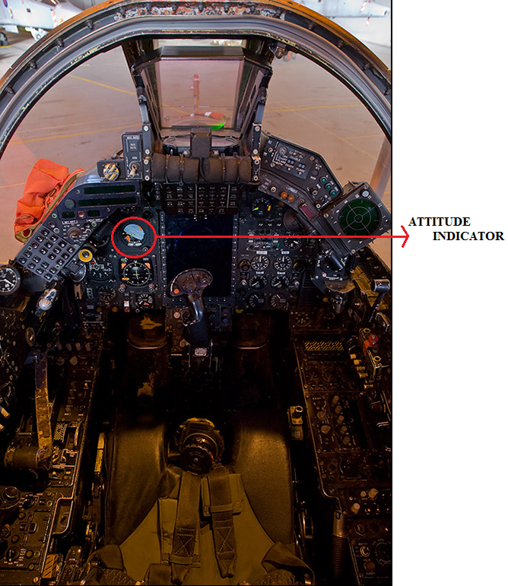

Fig 9.1: cockpit of jaguar aircraft.

CHAPTER 11
FUTURE ENHANCEMENTS
As mentioned in the applications chapter, the attitude directional indicator is used in the jaguar series of aircrafts. The same concept or idea can be applied on to all the upcoming jaguar aircrafts that are being assembled by the RAF and the Russian airforce. The same technology can be further used in aircrafts where there is a complexity in cockpit in recognizing the attitude directional indicator.
It is not necessary that the advanced ADI should be used only for defensive purposes. The ADI that has been developed can also be used in commercial airplanes so that there is a huge work load that is being cut out for the co-pilot as well. But it would take a lot of time to actually be able to commercialize the independence of the attitude directional indicator. With ongoing innovation, a growing array of controls, functions and capabilities are placed at your fingertips for easy touchscreen access. Everything from available onboard digital color radar to ads-B enhanced traffic alerting to worldwide connectivity links for weather, phone calls, text/email messaging, and more – all are options that can now be incorporated, viewed and controlled right from your display. Combining the latest in multi-function display features with highresolution tft optics, detailed mapping and a new graphical pilot interface, the gtn design makes everything easy to locate and access. Page navigation is more intuitive, with a “shallow” menu structure and helpful home and back keys to simplify orientation. In fact, you’re rarely more than two taps away from all primary pages and functions. You can quickly pan across the map display by simply swiping your finger across the screen and integration capability for a wide array of avionics and sensors not only streamlines tuning and mode selection – but, in effect, lets pilots utilize the touchscreen as a virtual flight management system. This is the future of “all-in-one” avionics design as we know it.

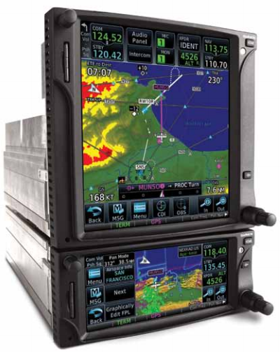
Fig 11.1: Touchscreen avionics

CHAPTER 12
CONCLUSION
Looking at the Jaguar series of aircrafts given to the IAF by the RAF, the cockpit is to conjusted and complexity arises. For a pilot to operate all the avionics present in the cockpit would be difficult and there would be a lot of confusion about where each avionic part is placed and what they are. So to provide the pilot a better ease of access to the avionics in the cockpit modifications are to be done. One such modification that is done is with respect to the attitude indicator. We in our project made the attitude directional indicator an independent system so that no problem would arise for the pilot in this aspect. The attitude directional indicator designed by us is relatively simple and easier to understand. We believe that this design would help the pilot in every way it is meant to do so. In conclusion, we would like to state that by making the attitude indicator an independent system we have achieved our objective of reducing the complexity of the avionics in the cockpit.

CHAPTER 13
Screen SHOTS

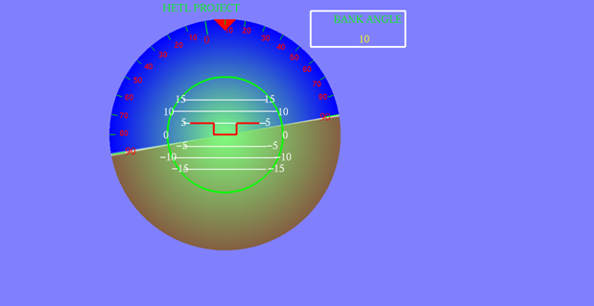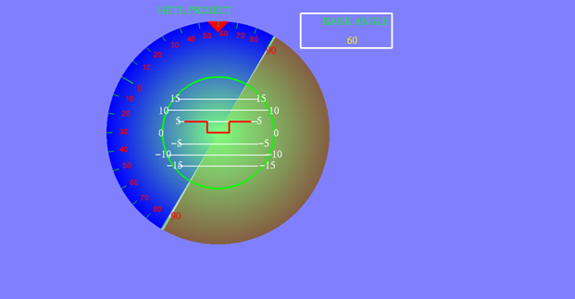
Fig 13.7: attitude indicator Fig 13.8: Rotation with bank
with rotation of dials angle 60 degrees

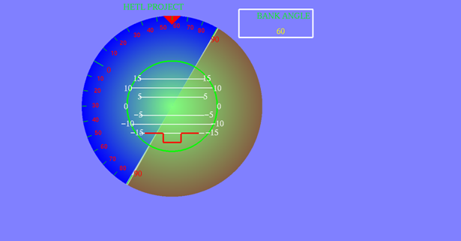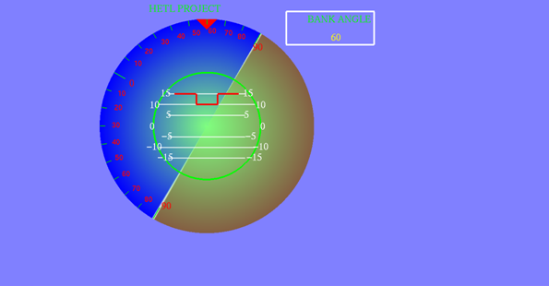
Fig 13.9: nose below the horizon Fig 13.10: rotation with nose above
marking the horizon

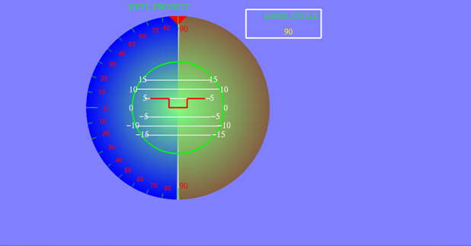
Fig 13.11: rotation with bank
angle at 90

CHAPTER 14
REFERENCES
  - MB86290 Series Graphics Driver V02 User’s Manual Rev 3.0 by Fujitsu Limited. Copyright©FUJITSU LIMITED 1999-2006.
  - ADV7401 Integrated multi-format SDTV/HDTV Video decoder and RGB Graphics Digitizer. Datasheet manual dated October 2006.
  - CORAL series Application Note Drwaing Edit Rev 0.1 dated 30 June, 2003, FUJITSU.
  - Chrontel CH 7025/CH 7026 TV/VGA Encoder.
  - Chrontel CH 7025/CH 7026 SDTV/VGA Encoder.
  - MB86296S <CORAL PA> PCI Graphics Controller Specification Revision 1.1 dated 25 September, 2007, FUJITSU.
  - Avionics and Flight Technology GTN 650 and GTN 750 series.
  - R.P.G Collinson, “ Introduction to Avionics System”.

