Project Proposal

Project Description

Name: Maparoni-n-cheese

Description: Maparoni-n-cheese is a basic 2D map-maker. Maps can be made custom, random, or a combination.

Competitive Analysis

Other map editors have many features, and most similar to mine. For example, [Inkarnate](https://inkarnate.com/) has map editing (forest, mountain, path brushes) as well as random *land* generation. My map will have map editing, random land generation, *and* random map object generation. I will not be implementing paths (but plan on rivers) however. Something like [Wonderdraft](https://www.wonderdraft.net/) has very similar specifications as well, but it also has naming (of oceans, mountain ranges, etc.). Inkarnate has this as well, and I do not plan on adding this feature at the moment, but may consider it if time allows.

Structural Plan

Main class: map_maker

event methods:

on_mouse_scroll 🡪 change size of cursor (for size of objects mainly)

on_mouse_press 🡪 carry out cursor action

on_mouse_motion 🡪 for updating cursor position

on_mouse_drag 🡪 for carrying out multiple cursor actions

on_draw 🡪 for drawing everything on the screen

on_resize 🡪 for updating everything on a resize event

utility methods:

make_map_object 🡪 for creating specific map objects based on args

change_cursor_type 🡪 for changing the action of the cursor

make_random_map 🡪 using Voronoi to create random regions

Map object classes (tree; mountain; river; etc):

most-useful methods:

make_components (generalized) 🡪 making geometric shapes of object

intersects 🡪 to test if intersects with another map object

draw 🡪 if individual object needs to be drawn

GUI:

Notable attributes:

buttons 🡪 list of Button instances to hold a function for calling

Layer:

Notable attributes:

regions 🡪 list of Regions to hold map objects

Notable Methods:

add 🡪 add a map object to region

add_if_not_intersecting 🡪 add if not intersecting any objects on map

update 🡪 updates regions list if resized

Algorithmic Plan

Voronoi Diagrams:

[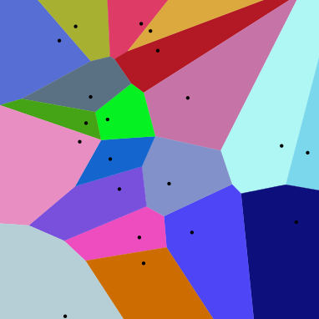](https://en.wikipedia.org/wiki/Voronoi_diagram#Algorithms)Voronoi diagram looks like this:

From [Wikipedia](https://en.wikipedia.org/wiki/Voronoi_diagram%23Algorithms)

It’s use in this project is to split the map into regions (biomes, essentially) for random map generation. The regions will define things like forest, mountain ranges, etc.; and rivers may appear on the borders of these regions or sometimes inside them.

This is by far the most algorithmically-complex part of the project, as it may involve something like [Fortune’s algorithm](https://en.wikipedia.org/wiki/Fortune%27s_algorithm) to compute these areas.

Timeline Plan

April 18: GUI complete with buttons/help

April 21: Voronoi (or similar/variant of) working

April 23: Random map generation working (and consequently manual map making)

Version Control Plan

I am using a GitHub [repository](https://github.com/kcmw3e/maparoni-n-cheese/tree/GUI) to back up my code. I use Git to interface with GitHub so that I can work on multiple devices as well as back it up.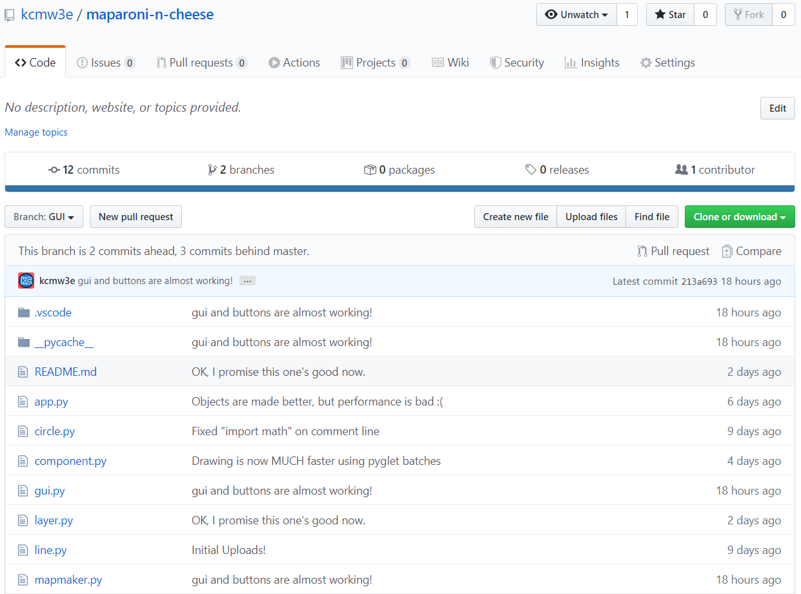

Module List

[pyglet](http://pyglet.org/)