I would like to use MIMICIII database which comprises 61,532 intensive care unit stays: 53,432 stays for adult patients and 8,100 for neonatal patients. The data spans June 2001 - October 2012. I would like to use the inpatient data to create a model for predicting patients mortality based on their diagnosis.

I am choosing this project

1. To get access to the database as it requires a separate certification from MIT which I have obtained. The certification be verified at:

<https://www.citiprogram.org/verify/?wdaa12831-082f-468d-ae23-cfbf79ffa343-39172810>

See screen shot below

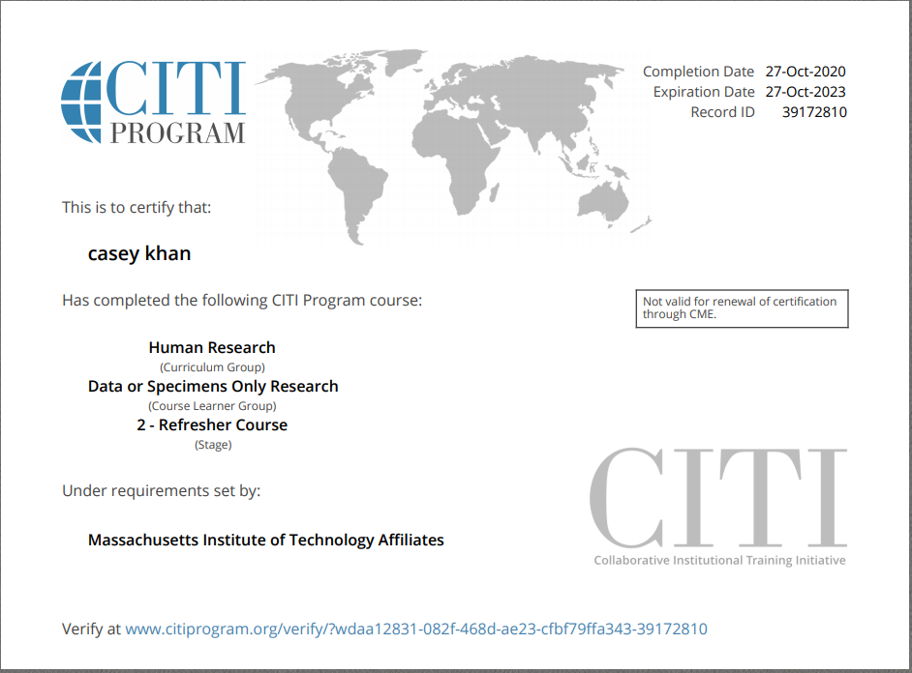

1. Getting access to this database is/was important as I want to apply it to a project at work.
2. I work for Optum and we are healthcare company. As a product manager I have worked with my data science team to build
   1. Disease imputation models
   2. Physician Burnout models

However, they have built a re-admission prediction model. We want to use this data set to see how our company’s algorithm performs on an outside data set.

In short this data set will be used to test the efficacy of our model.

After initial analysis we came to realize that we don’t the elements that can help us identify readmissions so the project was altered to predict mortality.