Effects of Opportunity Zones (OZs) on Census Tract Economic Well-Being

by

Kevin Coleman

A capstone submitted to Johns Hopkins University in conformity with the

requirements for the degree of Master of Science in Data Analytics and Policy

Baltimore, Maryland

May 2025

Table of Contents

1. Abstract 3

2. Introduction 3

3. Background and Previous Literature 6

3.1 Economic Impacts 6

3.2 Political Literature 7

3.3 Investment Impacts 8

3.4 Economic Distress Index 9

3.5 Literature Critiques 10

4. Theoretical Development and Hypotheses 11

4.1 Economic Index Concept 11

4.2 DiD and IPW 12

5. Data Methods and Discussion 13

5.1 Software 14

5.2 Covariates 14

5.3 Economic Well-being Index DV 15

5.4 Modeling 15

5.5 Results 16

6. Conclusion 27

7. References 29

# Abstract

This study assesses the Opportunity Zone (OZ) program’s impact on census tract–level economic well-being, addressing a gap in prior research that was focused on investment and market trends using early OZ data. A custom economic well-being index based on median income, the employment-to-population ratio, and median housing costs was constructed to measure the OZ program’s impact. To estimate the OZ program’s impact, the study applied inverse-probability-weighted Difference-in-Differences and quantile regression models to tract-level American Community Survey (ACS) 5-year and Housing and Urban Development (HUD) data (2014–2023). The models controlled for educational attainment, homeownership, race/ethnic identity, and disability status. Results show that OZ-designated tracts experienced statistically significant but modest improvements relative to non-OZ tracts, with larger effects at higher quantiles of the distribution. These uneven gains suggest that refining tract nomination procedures and tightening eligibility criteria could better focus OZ tax incentives on the most economically distressed communities.

# Introduction

Opportunity Zones (OZs) were established by the 2017 Tax Cuts and Jobs Act (TCJA) to encourage investment in economically distressed communities. The OZ program offers tax incentives to investors who invest their capital gains in designated ‘distressed’ census tracts (OZs). The intent behind the OZ program is to stimulate economic growth and jobs (Internal Revenue Service [IRS] 2022). Previous research on the topic offered mixed findings, with some studies suggesting no real change. This study builds on previous research by measuring whether OZ designated tracts witnessed economic improvement using a difference-in-differences (DiD) model and quantile regression at the 25th, 50th, and 75th percentiles.

Amid the re-election of President Donald Trump and a renewed focus on economic policy, this study seeks to understand how economic policies, such as Opportunity Zones, affect the financial well-being of Americans. President Trump has expressed interest in extending the TCJA, which is scheduled to expire on December 31, 2025 (Picchi 2024). In December 2017, the TCJA was signed into law, establishing Qualified Opportunity Funds (QOFs) as a mechanism to channel investments into designated Opportunity Zones. The Opportunity Zone (OZ) program was created to stimulate economic growth and job creation in the most economically distressed neighborhoods. As of April 2022, over 8,700 tracts across the U.S. had been designated as OZs (IRS 2022). The goal of the OZ program was to provide investors an incentive to invest in these economically distressed areas through tax deferments. However, these tax deferments remain valid only until either an “inclusion event” occurs—rendering the investment ineligible—or until December 31, 2026. According to Public Law 115-97, a low-income census tract, along with certain contiguous tracts, may qualify for OZ designation. The number of census tracts in a state cannot exceed 25% of the number of low-income tracts (115th Congress 2017). Generally, a low-income community is a tract where the poverty rate is at least 20% (IRS 2004). State governors nominate tracts within their state for nomination, provided they meet the baseline requirements and approval by the U.S. Treasury Secretary.

Much of the existing literature is dated and acknowledges that early analyses may not fully capture the long-term socio-economic impacts of the OZ program. Despite this, the literature focuses on property investments, real estate fluctuations, and other indirect economic conditions that do not directly address the core reason behind the existence of the OZ program. By focusing on fundamental indicators of economic growth—median income, employment levels, and housing costs—this analysis offers a more grounded assessment of how OZs have affected the economic well-being of census tracts. This study will begin with a nationwide analysis on OZ’s impact on economic well-being at the tract level, followed by a localized study focused on the Akron, OH metropolitan area. The localization study will help ground the analysis into something more tangible. Akron, OH is significant for multiple reasons, it represents small to mid-sized cities that are often overshadowed by larger cities, and its struggling transition to a post-industrial economy is key to understanding how economic turmoil affects its citizens. Notably, Akron contains some of the poorest communities in the nation, with an average total annual income of just $25,933 (US Census Bureau 2023).

This raises an important question: will the expiration of the TCJA have a tangible impact on the average American’s finances, or is the push for its extension primarily political in nature? This paper examines the TCJA’s OZ program which was designed to benefit impoverished communities through private investment incentives. This analysis contributes to the existing literature by examining a recent economic policy aimed at disadvantaged communities, using a unique economic well-being indicator to capture everyday impacts, and incorporating both national and localized perspectives with ACS and HUD data from 2014 to 2023. The research question will seek to answer how OZs affect a tract’s well-being, since the premise of the OZ program was to spur job creation and economic activity.

# Background and Previous Literature

Previous research and analysis of Opportunity Zones tends to focus on why tracts are selected for OZ status and if the OZ nomination encourages real investment. The OZ literature only contained a few scholarly articles investigating whether OZs generate a positive effect on job creation, median earnings, and poverty rates. Much of the scholarly literature focuses on the political and macro-economic aspects of the OZ program rather than the direct economic impact that is felt on everyday Americans. A couple of examples include the political tendencies of governors to pick tracts for OZ designation based on political party affiliation or property and real estate values based on OZ investments. However, the literature does provide a baseline and context for other impacts of the OZ program that this study does not cover.

## 3.1 Economic Impacts

The OZ literature on direct economic effects used DiD models to analyze job growth and poverty rates. In the Arefeva et al. (2024) study, the researchers found that Opportunity Zones increased job growth by 3–4.5% in metro areas during the program’s first two years. However, most of the observed job growth was attributed to individuals living outside the designated OZ tracts, and used data from 2013-2021. The study incorporated various socio-economic covariates such as race, education, income, housing tenure, and poverty measures. Freedman et al. (2021) similarly used a DiD framework with ACS micro-data from 2013–2019 to examine OZ effects on employment, earnings, and poverty. Because their DiD model violated the parallel trends assumption, they applied inverse probability weighting (IPW) to construct a more comparable control group. Although their results showed small positive changes in earnings and employment, the effects were statistically insignificant, and poverty rates slightly increased. Both studies highlight the short-term impacts of the OZ program, yet the studies are limited by short post-treatment windows and, in Freedman’s case, restricted data access. They fail to capture the longer-term effects of the OZ program.

## 3.2 Political Literature

The following studies show that OZ tracts are selected by both the level of economic distress and political affiliation, with shared party control increasing selection odds. OZ designation was found to mostly align with the goals of the OZ program according to Alm et al. (2021). The strongest determinants of OZ selection were signs of economic distress such as high rates of unemployment, welfare recipients, low median incomes, etc. While economic-distress metrics were the strongest determinants for OZ selection, political alignment is significant. Their study found that tracts with the same political party affiliation in both the state’s lower legislative assembly and executive branch are 2.7 percentage points more likely to be associated with an OZ designation. Additionally, Republican governors were more likely to designate OZs that had higher ratios of non-high school graduates, whereas Democrat governors were more likely to designate OZs if the tract contained a higher ratio of bachelor’s degree holders.

A second article by Frank et al. (2021) shows a 7.6% higher probability of selection when governors and state representatives share the same political party, with a 13.2% increased probability for Republican-run states. Although some governors sought to make the OZ selection process less biased by spreading their selection geographically across their states or by delegating OZ selection to local jurisdictions. The political literature does not account for the economic effects of the OZ program, but rather the selection process, and the studies are limited in scope covering years before the OZ program was implemented.

## 3.3 Investment Impacts

Analyses of investment flows in OZs produced mixed results on whether OZs created new capital. Sage et al. (2019) conducted a DiD analysis on property investments in OZ eligible and designated tracts. They used propensity score matching (PSM) to create a synthetic control group similar to the treated tract group, since the parallel trends assumption likely does not hold. They found that properties in OZ tracts traded 6.3% less compared to properties in eligible but not designated OZ tracts. The Corinth and Feldman (2024) article found that OZ designated tracts received substantial investment. However, the researchers are unsure if the additional investment would have occurred regardless. They claim that OZs have no obligation to invest in economically distressed projects, nor does the OZ program incentivize investment. The Tax Foundation journal from Eastman and Kaeding (2019) supports Corinth and Feldman’s claim that the investments put into OZ tracts would have occurred regardless. The journal estimates that Opportunity Zones will cost the federal government $1.6 billion in foregone revenue between 2018 and 2027, yet offer limited evidence of benefit to the low-income communities the program was intended to support. Their research suggests that the OZ program redistributes wealth rather than creating new economic opportunity, resulting in the displacement of low-income earners. Despite these claims, most of the studies used data from 2019, only one year after the OZ program was officially implemented. Additionally, the studies do not measure the intended effect of the OZ program (job creation and direct economic growth).

The housing market is an additional aspect of OZ implementation researched by Chen et al. (2019). The researchers found that a tract’s OZ status increased housing prices by less than 1% in 2018 compared to previous years before OZ implementation. Of note, is the researchers use of propensity-score weighting and inverse probability weighting (IPW) to reweight the control tracts due to the parallel trends assumption likely not holding. The researchers assert that the parallel trend does not hold due to selected OZ tracts and eligible tracts having different observable characteristics. Overall, the researchers determined that the housing market would remain stable in OZ tracts. Notable gaps in Chen et al.’s study is the lack of mature data, and OZ’s effect between home-owners and renters. Much like other OZ literature, this study does not analyze the intended effects of the OZ program, choosing to focus on an indirect effect through the housing market.

## 3.4 Economic Distress Index

Another contribution to the OZ literature is the economic distress index developed by Looney and Gelfond (2018), which evaluates whether OZ designations were targeted toward the most distressed communities. In their study on how to improve the targeting of OZs on economically distressed communities, the researchers created an economic distress index variable. The index variable is on a scale of 0 to 100, with 0 being the least distressed and 100 being the most distressed. The index comprises poverty rates, child poverty rates, educational attainment, home prices, and family income for each tract across all 50 states. The researchers used the economic distress index to measure if states targeted their OZ designation to the most economically distressed communities. They found, on average, that states nominated the most economically distressed tracts for OZ designation. The article argues that many states prioritize gentrification efforts over economically distressed communities, and that better OZ targeting is needed. Given the article was published in 2018, Looney and Gelfond focused on evaluating how well states targeted economically distressed communities for OZ designation. They noted that it was too early to assess the program’s actual outcomes, so their conclusions were based on historical and similar tax incentive programs.

## 3.5 Literature Critiques

Fikri and Glasner (2023) provide a broader synthesis of OZ literature, highlighting several methodological limitations that inform this study’s design. Their article evaluates the existing literature on OZs with the goal of guiding future researchers. They note that most OZ studies examine a short time window and often fail to assess long-term impacts, as many papers do not extend beyond 2019. According to their analysis, 2020 marked the first full year of OZ implementation, since the designation process was not completed until mid-2018 and unfolded in three waves through late 2019. While this study includes over three years of post-implementation data, Fikri and Glasner argue that revitalization efforts often take four to ten years or more to manifest. Their work also critiques the widespread use of difference-in-differences (DiD) models, noting that the non-random assignment of OZ tracts violates the parallel trends assumption. As a result, they recommend the use of synthetic control methods, such as propensity score matching or inverse probability weighting (IPW), to better approximate causal inference. These insights directly inform the methodology and scope of the present analysis.

While existing literature provides insight into OZ tract selection criteria, real estate trends, political influences, and short-term economic impacts, most analyses rely on data that predate 2021. As a result, they fail to capture the long-term effects of OZ designation on a tract’s economic well-being. This study addresses that gap by analyzing post-implementation trends through both a national and localized lens, using updated socio-economic data, constructing an index measuring economic well-being at the tract level, and incorporating recommendations from Fikri and Glasner.

# Theoretical Development and Hypotheses

To examine how Opportunity Zones (OZs) affect a tract’s economic well-being, this study introduces two testable hypotheses. The primary hypothesis proposes that OZ designation leads to increased economic growth and job creation in census tracts between 2018 and 2023, relative to their own pre-OZ trends from 2013 to 2017, while controlling for changes in non-OZ tracts during the same period. This hypothesis captures broader national trends and evaluates the overall impact of the OZ program across the United States. The secondary hypothesis takes a more localized approach, focusing on the Akron, OH metropolitan area. It similarly proposes that OZ designation in Akron leads to increased economic growth and job creation in affected tracts between 2018 and 2023, compared to their own trends from 2013 to 2017, again controlling for changes in non-OZ tracts. By combining both macro-level and localized analyses, this study provides a more comprehensive assessment of whether the OZ program fulfills its intended goal of stimulating economic development in economically distressed communities.

## 4.1 Economic Index Concept

Building on Looney and Gelfond’s (2018) composite economic distress index variable, this study adapts their concept by constructing a related index based on economic well-being to assess tract-level impacts of OZ implementation. The intent behind the dependent variable, is to measure the economic well-being of a census tract. Similar to Looney and Gelfond, the sub-variables related to home and rent prices were combined. In addition to incorporating median rent and mortgage values, the economic well-being index developed in this study also includes median income and employment levels. Like the Looney and Gelfond index, it uses a 0–100 scale; however, while their index defines 0 as least distressed and 100 as most distressed, this index inverts the scale—assigning 0 to economically distressed tracts and 100 to those with the highest levels of well-being. The inversion focuses on positive economic well-being rather than distress.

## 4.2 DiD and IPW

One of the major methodological challenges highlighted in the literature is model selection, particularly the use of difference-in-differences (DiD) models despite non-random treatment assignment. Fikri and Glasner (2023) argue that, because OZ designations are made by state governors rather than through true randomization, researchers must validate the parallel trends assumption. While they note that this assumption often does not hold, since treated (OZ) and control (non-OZ) tracts may follow diverging pre-treatment trends, they also acknowledge that DiD remains a valuable tool for directly measuring change over time. To mitigate issues with non-random assignment, they recommend the creation of a synthetic control group such as propensity score matching or inverse probability weighting (IPW). Based on the recommendations of Fikri and Glasner, this study employs a DiD model with non-OZ tracts as the control group and OZ tracts as the treatment group. To account for potential violations of the parallel trends assumption, an IPW model is also implemented. The IPW method assigns weights to non-treated tracts with a high propensity for OZ designation, thereby simulating a more randomized experiment. While this study does not capture long-term effects beyond three years, the use of extended post-treatment data builds upon prior analyses conducted by Freedman et al. (2021), Arefeva et al. (2024), and Looney and Gelfond (2018).

This study builds upon the modeling strategies used by Arefeva et al. (2024) and Freedman et al. (2021) to evaluate the impact of OZs on economic outcomes. Many of the variables used in this analysis such as race/ethnicity, education levels, income, rent, and employment—mirror those included in Arefeva et al.’s framework. To address concerns regarding non-random treatment assignment, this study also implements an IPW model, as used by Freedman et al. and recommended by Fikri and Glasner, to simulate a more balanced and random comparison between OZ and non-OZ tracts. In contrast to Freedman’s use of restricted micro-ACS data, this study relies on publicly available ACS tract-level data and extends the observation period through 2023. An initial attempt to use micro-ACS data was not realized due to limited tract coverage for smaller populations. This study also differs by introducing an economic well-being index as the dependent variable, offering a more comprehensive and tract-level measure of economic well-being beyond employment and earnings alone.

Although this study does not directly replicate of Chen et al.’s (2019) analysis, it builds on their findings by incorporating housing costs into the economic well-being index, and by distinguishing home-owners and renters within the covariates. By attempting to capture housing cost’s effects within a broader dependent variable, this study provides a more comprehensive analysis of the OZ program’s impact on a tract’s economic well-being than analyses focusing solely on employment or income.

This study seeks to address the limitations identified in the literature by implementing several methodological improvements: the use of a combined economic well-being index as the dependent variable, a DiD model combined with IPW to address potential violations of the parallel trends assumption, additional covariates to better control socio-economic impacts, and an extended post-treatment observation window to better capture longer-term effects often missed by prior research.

# Data Methods and Discussion

The data used in this analysis comes from the ACS 5-year estimates (US Census Bureau 2014-2023) consisting of two distinct time periods. The 2014-2018 represents pre-OZ implementation data and the 2019-2023 period covers post-OZ implementation data. While there is overlap, depending on how OZ implementation is defined, the 2019-2023 time period captures at least 3 full years of post-OZ implementation data. The OZ tract information was captured from the Department of Housing and Urban Development (2023). The two datasets were merged together by their census tract’s unique GEOID. In the OZ column, 1 represents tracts that are designated OZs and 0 represents non-OZ tracts.

## 5.1 Software

All analyses were conducted in R version 4.4.1 (R Core Team 2024) using the following packages: tidyverse (Wickham et al. 2019) for data wrangling and plotting; tidycensus (Walker and Herman 2024) for retrieving ACS data; scales (Wickham et al. 2023) for axis plot formatting; kableExtra (Zhu 2024) for table formatting; quantreg (Koenker 2025) for quantile regression modeling; and stargazer (Hlavac 2022) for creating the regression tables.

## 5.2 Covariates

Based on prior literature, the analysis includes socio-economic control variables for racial and ethnic identity (percent white, black, Asian, and Hispanic), educational attainment (percent of adults with a high school diploma, bachelor’s, or master’s degree), home ownership (percent renter and owner-occupied houses), and the disability rate status. Due to perfect collinearity constraints, the models omitted the rent-occupied homes covariate. However, the statistical significance of rent-occupied homes would remain unchanged, since it’s the same statistical effect as owner-occupied homes in the opposite direction. These variables are consistent with those used in prior OZ literature, including Arefeva et al. (2024) and Freedman et al. (2021), and help control for socio-economic conditions that may influence tract-level outcomes. While the disability status variable was not included in these previous studies, it was incorporated here to account for potential economic disadvantages associated with higher proportions of disabled residents within a tract. To create the interaction term needed for the DiD analysis, a binary variable called ‘Post’ was constructed to represent the post-implementation period of 2019-2023.

## 5.3 Economic Well-being Index DV

As discussed previously, the dependent variable is an index variable comprised of 4 sub-variables (median income, employment, median rent, and median mortgage) on a ranking scale of 0 – 100 with 0 representing the lowest economic well-being score and 100 the highest. To construct the DV index, a correlation matrix was used to determine the appropriate weight for each sub-variable. Based on the correlation-matrix, median rent, median mortgage, and median income each carried weights of .28-.29, whereas employment’s weight was only .135. All sub-variables were normalized to a 0–100 scale to enhance interpretability. Median rent and mortgage values were annualized by multiplying them by twelve, and median income values for the pre-OZ period (2014–2018) were adjusted to 2023 dollars using the Consumer Price Index (CPI), calculated by dividing the 2023 CPI average by the 2018 average. A penalty was applied to the rent and mortgage sub-variables for tracts where the median income-to-housing cost ratio exceeded 30%, in alignment with the U.S. Department of Housing and Urban Development's definition of affordable housing. The penalty was determined by multiplying the raw rent/mortgage value by its own income-to housing cost ratio. This adjustment was intended to better capture housing burden as a component of economic well-being.

## 5.4 Modeling

This analysis consists of several IPW weighted models, based on the work of Freedman et al. (2021). IPW helps address potential violations of the parallel trends assumption, given that OZ designations were made by state governors rather than assigned randomly. All models use the economic well-being index scaled 0-100. Model 1 (OLS DiD) captures the nation-wide change in economic well-being for OZ tracts in the post period, relative to non-OZ tracts. Models 2-4 (quantile regression) capture the conditional economic well-being distribution at the 25th, 50th, and 75th percentiles to assess how and if the treatment effect varies (heterogeneity). Model 5 provides a localized analysis of the Akron, OH metro area to help ground the nation-wide analysis. Together, these models evaluate whether a tract’s OZ designation in the post-implementation period led to an increased economic well-being score relative to its baseline in the pre-implementation period. The primary model (nation-wide DiD OLS) is structured as follows:

EWit  ​=β0​+β1​OZi​+β2​Postt​+β3​(OZi​×Postt​)+β4​Whitei​+β5​Blacki​+β6​Asiani​+β7​Hispanici​+β8​HSGradi​+β9​BAi​+β10​MAi​+β11​OwnerOcci​+β12​Disabilityi​+ ϵ

## 5.5 Results

Table 1 shows the descriptive statistics for the analysis using the raw data, not the IPW method (See note in Table 1). The main highlight of this table is the slight right-skewness of the dependent variable, Economic Well-being Index. The DV has a mean of 14.37 and a median of 12.96. This suggests that there are tracts with significantly higher economic well-being scores that are pulling the distribution positively. The relatively low economic well-being scores of 14.37 for the mean and 12.96 for the median also indicate that most tracts across the country are either not economically well-off, or there are extremely affluent tracts that is skewing the economic well-being score. However, this is beyond the scope of this study. The rest of the covariates are relatively normally distributed, with the exception of the black and Hispanic populations, indicating that certain tracts have much higher proportions of blacks and Hispanics than others.

|  |  |  |  |  |  |  |
| --- | --- | --- | --- | --- | --- | --- |
|  | | | | | | |
| Table 1: Variable Descriptive Statistics | | | | | | |
| Statistic | | Min | Median | Mean | St. Dev. | Max |
|  | | | | | | |
| Economic Well-being Index | | 0.00 | 12.96 | 14.37 | 7.35 | 100.00 |
| OZ Tract (1 = Yes) | | 0 | 0 | 0.09 | 0.29 | 1 |
| White Population | | 0.00 | 0.68 | 0.60 | 0.30 | 1.00 |
| Black Population | | 0.00 | 0.04 | 0.13 | 0.21 | 1.00 |
| Asian Population | | 0.00 | 0.02 | 0.05 | 0.09 | 1.00 |
| Hispanic Population | | 0.00 | 0.08 | 0.17 | 0.22 | 1.00 |
| High School Graduate | | 0.00 | 0.16 | 0.16 | 0.07 | 1.00 |
| Bachelor's Degree | | 0.00 | 0.12 | 0.14 | 0.08 | 1.00 |
| Master's Degree | | 0.00 | 0.05 | 0.06 | 0.05 | 1.00 |
| Owner-Occupied Housing | | 0.00 | 0.70 | 0.64 | 0.23 | 1.00 |
| Disabled Population | | 0.00 | 0.12 | 0.13 | 0.06 | 1.00 |
|  | | | | | | |
| IPW re-weighting changed raw means by less than 1% across all variables, indicating well-balanced treatment (OZ) and control groups (Non-OZ).  Source: 5-Year ACS, US Census Bureau & Housing Urban Development | | | | | | |
|  |

Table 2 displays the results of the inverse probability weighted (IPW) Difference-in-Differences (DiD) model estimated using ordinary least squares (OLS). This model captures the OZ treatment effect on a tract’s economic well-being across the country from the time period of 2014-2018 and the time period of 2019-2023. Almost all of the covariates except the post time indicator, the proportion of Black residents, and the proportion of adults with a high school diploma were statistically significant. The model explained a substantial portion of the variance in economic well-being, with an R² value of approximately 0.39, indicating that it accounts for about 39% of the variation in the dependent variable. There are likely many other variables that affect the economic well-being of a tract, but adding more covariates runs the risk of overfitting the model or capturing the noise and not general trends.

Since the model includes an interaction term between OZ designation (OZ) and the post-period (Post), both the OZ and Post coefficients must be interpreted conditionally. The OZ coefficient of -.9, indicates that OZ designated tracts and tracts that had a high probability of being an OZ were nearly 1 point lower on the economic well-being index than non-OZ tracts during the 2014-2018 time period. This suggests that the parallel trends assumption was likely violated as the coefficient was highly significant and both groups of tracts were on different economic well-being courses before the implementation of the OZ program. The Post variable coefficient represents non-OZ tracts in the 2019-2023 post-implementation period. Non-OZ tracts were associated with a negative economic well-being coefficient in the post-implementation period; however, it is not statistically significant.

The primary coefficient of interest is the interaction term between OZ designation and the post-implementation period (OZ * Post). This coefficient indicates that OZ-designated tracts experienced a greater improvement in economic well-being during the post-period compared to non-OZ tracts. Although statistically significant at the 1% level, the effect size was relatively modest (0.274), suggesting that the benefits of the OZ program were limited in magnitude. The F statistic is both highly significant and has a high F statistic value of 7,742 indicating that the model captures a large amount of the overall variance and is a better fit compared to a model predicting only the economic well-being index with no predictors.

|  |  |
| --- | --- |
|  | |
| Table 2: OLS IPW Difference-in-Differences Model: Impact of OZ Policy | |
|  | *Dependent variable:* |
|  |  |
|  | Economic Well-being Index |
|  | |
| OZ (OZ = 1, Non-OZ = 0) | -0.902*** |
|  | (0.030) |
| Post (2019-2023 = 1, 2014-2018 = 0) | -0.037 |
|  | (0.030) |
| White Population | 1.486*** |
|  | (0.136) |
| Black Population | -0.078 |
|  | (0.133) |
| Asian Population | 12.076*** |
|  | (0.227) |
| Hispanic Population | 4.140*** |
|  | (0.133) |
| High School Graduate | 0.196 |
|  | (0.208) |
| Bachelor's Degree | 23.592*** |
|  | (0.287) |
| Master's Degree | 26.545*** |
|  | (0.506) |
| Owner-Occupied Housing | 2.956*** |
|  | (0.057) |
| Disabled Population | -19.806*** |
|  | (0.188) |
| OZ * Post (DiD Effect) | 0.274*** |
|  | (0.042) |
| Constant | 7.050*** |
|  | (0.138) |
|  | |
| Observations | 146,286 |
| R2 | 0.388 |
| Adjusted R2 | 0.388 |
| Residual Std. Error | 1.724 (df = 146273) |
| F Statistic | 7,742.820*** (df = 12; 146273) |
|  | |
| *Note:* | *p<0.1; **p<0.05; ***p<0.01 |
| Source: 5-Year ACS, US Census Bureau & Housing Urban Development |  |

|  |
| --- |
|  |

Figure 1 provides a visual of the average predicted economic well-being scores from the DiD model in Table 2 across each time period and for OZ and non-OZ tracts. OZ designated and tracts with high propensity scores are represented by the red line and show a clear positive economic well-being trend between the two time periods, whereas non-OZ tracts witnessed a slight decrease in economic well-being in the same two time periods. Notably, the average economic well-being score for non-OZ tracts was only about one point higher than that of OZ tracts prior to implementation. This gap narrowed to roughly half a point in the post period, suggesting a modest relative improvement for OZ-designated tracts.

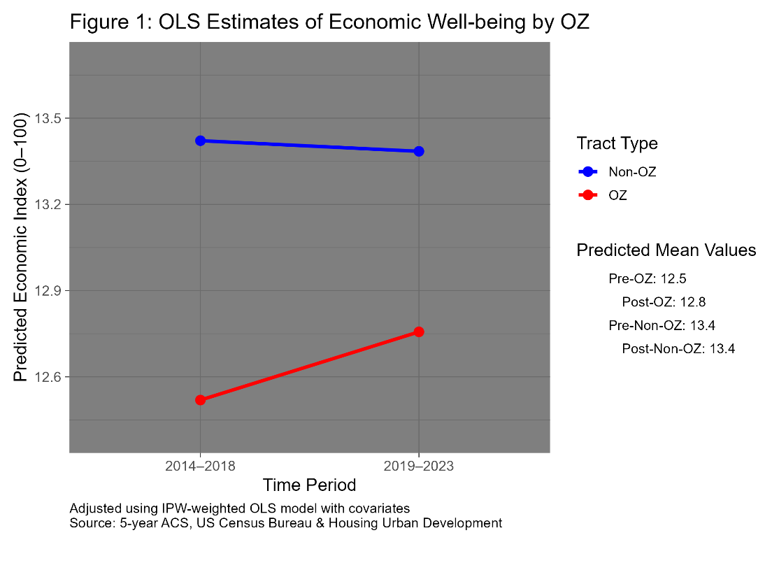

Table 3 presents the results of three quantile regression models estimated at the 25th, 50th, and 75th percentiles of the conditional distribution of the economic well-being index. The percentiles were selected to capture potential heterogeneity in the OZ program’s effects across tracts with different baseline levels of economic well-being. The significance of the variables is almost the same as the general OLS model from Table 2, with the exception of High School Graduate, where a tract’s proportion of high school graduates was significant in the 25th and 50th percentiles, but not the 75th percentile. This may suggest that higher proportions of high school graduates in a tract increases its economic well-being for tracts with lower economic well-being.

Another highlight is the positive coefficient for the Post variable, or non-OZ tracts in the post period; however, this effect is only slightly significant in the 50th percentile quantile regression model. This suggests that, for a non-OZ tract, with average characteristics, the median predicted economic well-being score slightly increased over time. Meanwhile, tracts at the lower and upper conditional quantiles did not show meaningful changes. The negative coefficient for non-OZs in the post period, as shown in the OLS model (Table 2 and Figure 1), was likely influenced by extreme values pulling the overall average down. In contrast, quantile regression is more robust to outliers, which may explain the difference in the estimated coefficients.

Across all three percentiles, the DiD Effect’s coefficient (OZ * Post) was highly significant and increased with higher percentiles. This suggests that OZ-designated tracts experienced a greater improvement in economic well-being relative to the change observed in non-OZ tracts between the pre- and post-implementation periods. Due to the increasing effect across the higher percentiles, this suggests that the OZ program had a larger impact on more economically well-off tracts, and a comparatively smaller impact on more economically distressed tracts. These findings provide evidence of treatment effect heterogeneity, indicating that the program’s impact varies significantly depending on a tract’s initial level (pre-period) of economic well-being.

| Table 3: 25th, 50th, and 75th Quantile Regression Results with IPW *Dependent Variable: Economic Well-being Index* | | | |
| --- | --- | --- | --- |
| **Term** | **25th** | **50th** | **75th** |
| Intercept | 3.429*** | 5.754*** | 8.099*** |
|  | (0.215) | (0.24) | (0.284) |
| OZ (OZ = 1, Non-OZ = 0) | -0.515*** | -0.726*** | -1.004*** |
|  | (0.048) | (0.056) | (0.07) |
| Post (2019-2023 = 1, 2014-2018 = 0) | 0.034 | 0.08* | 0.012 |
|  | (0.041) | (0.042) | (0.06) |
| White Population | 2.474*** | 1.654*** | 1.247*** |
|  | (0.216) | (0.26) | (0.243) |
| Black Population | 0.091 | -0.4 | 0.035 |
|  | (0.21) | (0.246) | (0.261) |
| Asian Population | 10.55*** | 12.772*** | 14.534*** |
|  | (0.526) | (0.658) | (0.65) |
| Hispanic Population | 3.395*** | 3.847*** | 5.326*** |
|  | (0.221) | (0.254) | (0.274) |
| High School Graduate | 1.768*** | 1.583*** | 0.233 |
|  | (0.421) | (0.43) | (0.523) |
| Bachelor's Degree | 19.636*** | 24.028*** | 28.293*** |
|  | (0.565) | (0.649) | (0.795) |
| Master's Degree | 18.337*** | 22.997*** | 31.352*** |
|  | (1.093) | (1.195) | (1.428) |
| Owner-Occupied Housing | 3.586*** | 3.914*** | 3.76*** |
|  | (0.121) | (0.121) | (0.185) |
| Disabled Population | -16.694*** | -19.221*** | -20.877*** |
|  | (0.343) | (0.483) | (0.594) |
| OZ * Post (DiD Effect) | 0.189** | 0.224*** | 0.272** |
|  | (0.078) | (0.086) | (0.116) |

Source: 5-Year ACS, US Census Bureau & Housing Urban Development

Figure 2 provides a visual of the predicted economic well-being scores from the DiD quantile regression model, shown in Table 3, across the three conditional percentiles (25th, 50th, and 75th). OZ designated and tracts with high propensity scores are represented by the red lines and show a positive economic well-being trend across the two time periods, whereas non-OZ tracts, represented by the blue lines, observed largely stagnant growth in their economic well-being across the two time periods. Similar to Figure 1, the gap between OZ and non-OZ tracts narrowed in the post implementation period. Again, suggesting relative improvements for OZ tracts across the conditional distribution.

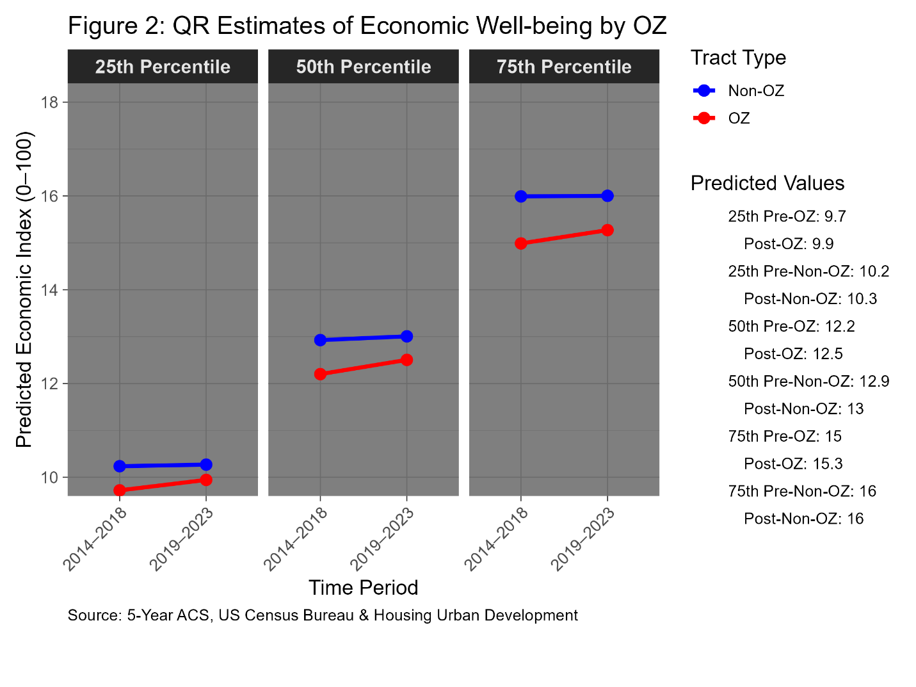

Table 4 demonstrates the localized Akron, OH regression summary. For the Akron, OH metropolitan, only some of the covariates were statistically significant. While, OZ designated and non-OZ tracts with high propensity scores saw an increased economic well-being change going into the post implementation period relative to non-OZ tracts, the OZ and Post variables and the interaction term were not statistically significant. This model highlights the potential key distinctions and regional varieties that effect economic well-being. The adjusted R2 score captured 74% of the total variance in economic well-being, and also had a highly significant F statistic. This likely suggests that to truly measure and capture the economic well being impacts in different metropolitan areas, the model must capture a metro area’s unique characteristics.

|  |  |
| --- | --- |
|  | |
| Table 4: OLS IPW Difference-in-Differences Model: Impact of OZ Policy in Akron, OH (Summit County) | |
|  | *Dependent variable:* |
|  |  |
|  | Economic Well-being Index |
|  | |
| OZ (OZ= 1, Non-OZ = 0) | 0.860 |
|  | (0.870) |
| Post (2019-2023 = 1, 2014-2018 = 0) | -0.195 |
|  | (0.408) |
| White Population | 3.155 |
|  | (5.506) |
| Black Population | 0.412 |
|  | (5.541) |
| Asian Population | 14.616** |
|  | (6.569) |
| Hispanic Population | -7.519 |
|  | (9.876) |
| High School Graduate | -2.217 |
|  | (4.255) |
| Bachelor's Degree | 12.852*** |
|  | (4.694) |
| Master's Degree | 32.545*** |
|  | (8.692) |
| Owner-Occupied Housing | 8.960*** |
|  | (1.355) |
| Disabled Population | -18.154*** |
|  | (5.323) |
| OZ * Post (DiD Effect) | 0.293 |
|  | (1.164) |
| Constant | 3.031 |
|  | (5.221) |
|  | |
| Observations | 262 |
| R2 | 0.753 |
| Adjusted R2 | 0.741 |
| Residual Std. Error | 2.884 (df = 249) |
| F Statistic | 63.389*** (df = 12; 249) |
|  | |
| *Note:* | *p<0.1; **p<0.05; ***p<0.01 |
| Source: 5-Year ACS, US Census Bureau & Housing Urban Development |  |

Figure 3 displays the predicted average economic well-being scores from the IPW-weighted OLS DiD regression (Table 4) for tracts in the Akron, OH metropolitan area. OZ tracts (red line) began the pre-implementation period with a higher average economic well-being score than non-OZ tracts (blue line). Additionally, OZ tracts observed a greater increase in economic well-being during the post-implementation period, while the non-OZ tracts saw a decline. Instead of converging trends, as seen in Figures 1 and 2, the gap between OZ and non-OZ tracts widened. Unexpectedly, the OZ program’s treatment effect appears to make the OZ tracts more economically well-off than their non-OZ counterparts. Despite the increase in OZ tracts, the DiD term was not statistically significant, suggesting that the OZ program did not impact the economic well-being of tracts in Akron, OH. This finding may allude to the Alm et al. (2021) and Frank et al. (2021), who argue that political considerations influenced the selection of OZ tracts. Their analyses suggest that tracts were not always chosen based on economic distress alone, which may explain why OZ tracts in this localized study appear, on average, more economically well-off than their non-OZ counterparts. However, the OZ selection process lies beyond the scope of this study.

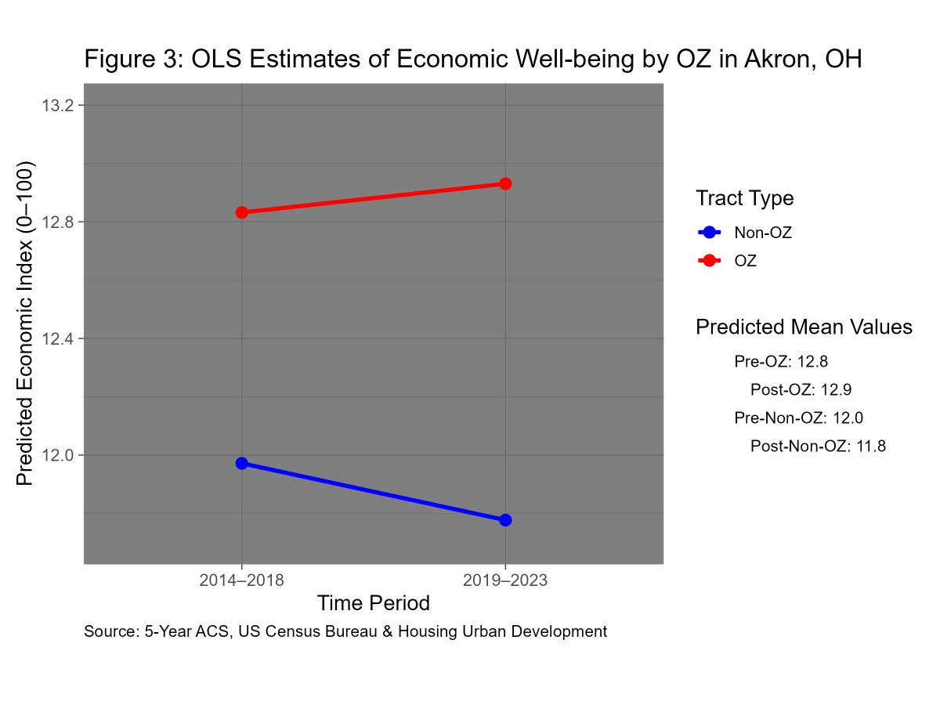

Overall, the OZ program had a statistically significant positive impact on tract-level economic well-being in the post-implementation period compared to non-OZ tracts. However, the magnitude of this effect was modest, with an average increase of only 0.274 points on the economic well-being index. Quantile regression results show that the estimated impact of the OZ program increases across the conditional distribution, suggesting that more economically advantaged tracts experienced greater benefits. Still, the predicted economic well-being difference between the 25th and 75th percentile conditional outcomes is only about six points (ranging from 10 to 16), indicating that extreme outliers may be skewing the overall economic well-being distribution. In the Akron, OH metro area, the OZ treatment effect was not statistically significant, implying that the program’s impact may vary regionally and that other socio-economic factors likely play a larger role in shaping a tract’s economic well-being.

# Conclusion

This study is relevant to policymakers at both the federal and local levels. Federal decision-makers and advisors could collaborate with local governments to refine the Opportunity Zone (OZ) nomination process, particularly in cities like Akron, OH, where OZ designation did not produce statistically significant results. Better targeting could help ensure that the OZ program benefits the most economically distressed communities rather than those already relatively stable. Despite some limitations, the program did demonstrate a positive impact on economic well-being overall.

The tract nomination criteria are broad, policymakers could refine the criterion to better target the most economically distressed communities. Something akin to the economic well-being index could be used to refine the nomination process. Additionally, policy makers could refine the selection process. Instead of permitting state governors to select tracts within their state, state legislatures could propose a list of tracts for OZ selection with governor approval or vice-versa. This may alleviate political affiliation bias in the OZ selection process.

Several limitations should be noted. The dependent variable—an economic well-being index—relies on composite indicators, including median income, employment rate, and housing costs. These variables may not fully capture the economic complexity within tracts. For example, the employment rate does not distinguish between full- and part-time work or income level, and housing cost burdens may overlook multi-earner households. The penalty on the housing-to-income ratio may misrepresent a tract’s true economic well-being, especially amid rising housing costs and not accounting for multi-earner households. This approach could understate a tract’s actual economic well-being. Additionally, important predictors such as crime rates and the share of residents without a high school diploma were not included, which may limit the explanatory power of the model. While quantile regression helped mitigate the influence of outliers, the conditional predictions were close together (10-16 points), suggesting that extreme positive outliers skewed the index. Finally, while the study captures short- to mid-term effects, it cannot yet assess long-term impacts beyond the 3–5-year mark, as the definition of OZ implementation varies.

As more post-implementation data become available, future research should assess the long-term effects of OZ designation, ideally over a 5- to 10-year period. Adding more covariates and composite variables to the DV index such as crime rates, real estate trends, and small business growth could improve the model’s variance and coefficients. The economic well-being index itself can be refined to better reflect regional or local contexts. Its flexibility makes it suitable for adaptation in city-specific studies, such as for Akron, OH. This adaptability enables future research to capture the full breadth of what defines economic well-being while preserving its conceptual integrity.

The nation-wide OLS DiD model rejects the primary null hypothesis that the OZ designation for a tract did not increase economic growth. The p-value for the DiD effect was highly significant at the 1% level when compared to non-OZ tracts across the two time periods. The quantile regression DiD models reject the null hypothesis as well. The DiD coefficients were positive and highly significant at the 1% level for all three measured outcome percentiles in the conditional distribution. Combined, the models provide evidence that the OZ program did benefit OZ designated tracts’ economic well-being. The OLS DiD model for Akron, OH metro area had a positive DiD coefficient, but it was not significant. There is little evidence for the secondary hypothesis since the localized model failed to reject the secondary null hypothesis.

# References

115th Congress. “Public Law 115–97—Dec. 22, 2017.” PUBLIC LAW 115–97—DEC. 22, 2017, December 22, 2017. <https://www.congress.gov/115/plaws/publ97/PLAW-115publ97.pdf>.

Alm, James, Trey Dronyk-Trosper, and Sean Larkin. “In the Land of Oz: Designating Opportunity Zones.” Public Choice 188, no. 3–4 (October 19, 2020): 503–23. <https://doi.org/10.1007/s11127-020-00848-9>.

Arefeva, Alina, Morris A. Davis, Andra C. Ghent, and Minseon Park. “The Effect of Capital Gains Taxes on Business Creation and Employment: The Case of Opportunity Zones.” Management Science, September 17, 2024. <https://doi.org/10.1287/mnsc.2022.03223>.

Bureau, United States Census. “2023: ACS 1-Year Estimates Subject Tables.” Explore census data, 2023. <https://data.census.gov/map?q=EMP&layer=VT_2023_040_00_PP_D1&loc=43.3751%2C-113.1138%2Cz2.6270>.

Chen, Jiafeng, Edward Glaeser, and David Wessel. “The (Non-) Effect of Opportunity Zones on Housing Prices.” NBER WORKING PAPER SERIES, NATIONAL BUREAU OF ECONOMIC RESEARCH, December 2019. <https://doi.org/10.3386/w26587>.

Corinth, Kevin, and Naomi Feldman. “Are Opportunity Zones an Effective Place-Based Policy?” Journal of Economic Perspectives 38, no. 3 (August 1, 2024): 113–36. <https://doi.org/10.1257/jep.38.3.113>.

Eastman, Scott, and Nicole Kaeding. “Opportunity Zones: What We Know and What We Don’t.” Tax Foundation, January 2019.

Fikri, Kenan, and Benjamin Glasner. “Are Opportunity Zones Working? What the Literature Tells Us.” *Economic Innovation Group*, October 2023.

Frank, Mary Margaret, Jeffrey L. Hoopes, and Rebecca Lester. “What Determines Where Opportunity Knocks? Political Affiliation in the Selection of Opportunity Zones.” Journal of Public Economics 206 (December 28, 2021). <https://doi.org/10.2139/ssrn.3534451>.

Freedman, Matthew, Shantanu Khanna, and David Neumark. “Jue Insight: The Impacts of Opportunity Zones on Zone Residents.” Journal of Urban Economics 133 (March 2021). <https://doi.org/10.3386/w28573>.

Hlavac, Marek (2022). stargazer: Well-Formatted Regression and Summary Statistics Tables. R package version 5.2.3. https://CRAN.R-project.org/package=stargazer

HUD. “Opportunity Zones.” HUD Open Data Site, July 2023. https://hudgis-hud.opendata.arcgis.com/datasets/ef143299845841f8abb95969c01f88b5_13/about.

IRS. “Opportunity Zones.” Internal Revenue Service, April 2022. <https://www.irs.gov/newsroom/opportunity-zones>.

IRS. “TITLE 26—INTERNAL REVENUE CODE.” U.S.C. title 26 - internal revenue code, 2004. <https://www.govinfo.gov/content/pkg/USCODE-2020-title26/html/USCODE-2020-title26-subtitleE-chap53-subchapB-partI-sec5842.htm>.

Koenker R (2025). _quantreg: Quantile Regression_. R package version 6.1, <https://CRAN.R-project.org/package=quantreg>.

Looney, Adam, and Hilary Gelfond. “Learning from Opportunity Zones: How to Improve Place-Based Policies.” The Brookings Institution, November 8, 2018. <https://www.brookings.edu/articles/learning-from-opportunity-zones-how-to-improve-place-based-policies/>.

Picchi, Aimee. “Trump Wants to Extend His 2017 Tax Cuts - and More. Here’s What That Could Mean for You.” Edited by Alain Sherter. CBS News, December 16, 2024. <https://www.cbsnews.com/news/trump-tax-cuts-brackets-salt-tax-child-tax-credit-2025/>.

R Core Team (2024). _R: A Language and Environment for Statistical Computing_. R Foundation for Statistical Computing, Vienna, Austria. <https://www.R-project.org/>.

Sage, Alan, Mike Langen, and Alex Van de Minne. “Where Is the Opportunity in Opportunity Zones? Early Indicators of the Opportunity Zone Program’s Impact on Commercial Property Prices.” *SSRN Electronic Journal*, 2019. [https://doi.org/10.2139/ssrn.3385502Links to an external site.](https://doi.org/10.2139/ssrn.3385502)

Walker K, Herman M (2024). _tidycensus: Load US Census Boundary and Attribute Data as 'tidyverse' and 'sf'-Ready Data Frames_. R package version 1.6.6, <https://CRAN.R-project.org/package=tidycensus>.

Wickham H, Averick M, Bryan J, Chang W, McGowan LD, François R, Grolemund G, Hayes A, Henry L, Hester J, Kuhn M, Pedersen TL, Miller E, Bache SM, Müller K, Ooms J, Robinson D, Seidel DP, Spinu V, Takahashi K, Vaughan D, Wilke C, Woo K, Yutani H (2019). “Welcome to the tidyverse.” _Journal of Open Source Software_, *4*(43), 1686. doi:10.21105/joss.01686 <https://doi.org/10.21105/joss.01686>.

Wickham H, Pedersen T, Seidel D (2023). _scales: Scale Functions for Visualization_. R package version 1.3.0, <https://CRAN.R-project.org/package=scales>.

Zhu H (2024). _kableExtra: Construct Complex Table with 'kable' and Pipe Syntax_. R package version 1.4.0, <https://CRAN.R-project.org/package=kableExtra>.