Abstract:
Curiosity about the evolution of the video game industry, one of the most dynamic and economically significant sectors in entertainment, motivated the development of an interactive timeline dashboard that visualizes trends from 1971 to 2020. Leveraging D3.js and Kaggle sales data, this project enables exploration of cumulative and annual revenue by brand, as well as decade-level breakdowns of genre, console, and regional performance. Users can “zoom in” on any decade to analyze prominent titles, shifting genre popularity, and dominant publishers. The dashboard reveals clear generational shifts in platform dominance and consumer preferences, providing insight into how technological innovation and cultural trends have shaped the gaming landscape over time.
Intro:
The video game industry has undergone an incredible transformation since its inception in the early 1970s. Once considered a niche hobby, it has evolved into one of the most economically and culturally influential sectors in global entertainment, driving innovation in not just interactive storytelling but also hardware, software, graphics, and artificial intelligence. This project began not with a conventional problem but with curiosity: how has the gaming landscape changed over time, and what patterns can be revealed through the lens of data visualization? While thousands of games have been released across multiple generations and platforms, comprehensive visual tools for exploring these shifts remain limited. Questions such as "Which genres dominated each decade?" or "When did specific consoles or brands rise to market leadership?" remain difficult to answer without sifting through fragmented datasets. By developing a timeline-based interactive dashboard that enables users to zoom in by decade, compare cumulative revenue estimates, and analyze sales breakdowns by genre, region, console, and publisher, this work offers a scalable tool for navigating the historical arc of the gaming industry. It allows not only enthusiasts and researchers but also developers and designers to reflect on the trends and inflection points that have shaped the gaming ecosystem over time.

Related Works:
Due to the nature of the project, not much research was needed in terms of the dataset and the industry itself. One applied element of research however, was estimating game revenue by brand using pricing assumptions grounded in market behavior. This involved sourcing average pricing data for games released by major publishers like Nintendo, Sony, and Microsoft. While pricing varies across region, platform, and release format, aggregated pricing heuristics allowed for reasonable approximations in total revenue per title. The dataset itself was obtained from Kaggle [1], which aggregates video game sales data globally and provides categorical breakdowns by title, platform, genre, publisher, and region.
Further research focused on adapting D3 techniques for each visualization component. The stacked bar chart utilized d3.stack() and d3.scaleBand() to structure and lay out cumulative brand-level revenues by year. Prior work by Heer and Meeks [2] informed the aesthetic and geometric choices for representing multivariate, time-series data with stacked shapes.
The pie charts applied d3.pie() and d3.arc() to break down categorical distributions across brands and genres. Tutorials and API references [3][4] helped guide the use of centroid calculations and arc annotations, especially for small slice label readability and hover-based interactivity.
The sortable tables were implemented with dynamic column configuration and table-body generation via D3’s data joins. Techniques outlined in previous work on tabular visual encoding [5][6] emphasized the need for accessible, filterable comparison views—particularly for missing sales data and outliers.
The project also explored tooltip behaviors, radial label rotation, and chart composition inspired by best practices from the D3 Graph Gallery [7], Observable notebooks [8], and peer-reviewed visualization studies. These techniques together form the basis for a flexible, exploratory framework that can be extended to highlight rating distributions, publisher dynamics, or genre shifts across time.
Detailed Description
The primary interface of the dashboard is a stacked bar chart timeline spanning 1971 to 2020, divided by decade using vertical dotted lines. Each bar represents either cumulative (default) or annual approximated revenue generated by video game releases, selectable via a dropdown menu. Brands are color-coded using recognizable identity palettes, Microsoft (green), Sony (blue), and Nintendo (red), leveraging brand familiarity to promote visual intuitiveness. These brand-associated colors are consistently applied across all components to support continuity and mental mapping throughout the dashboard.
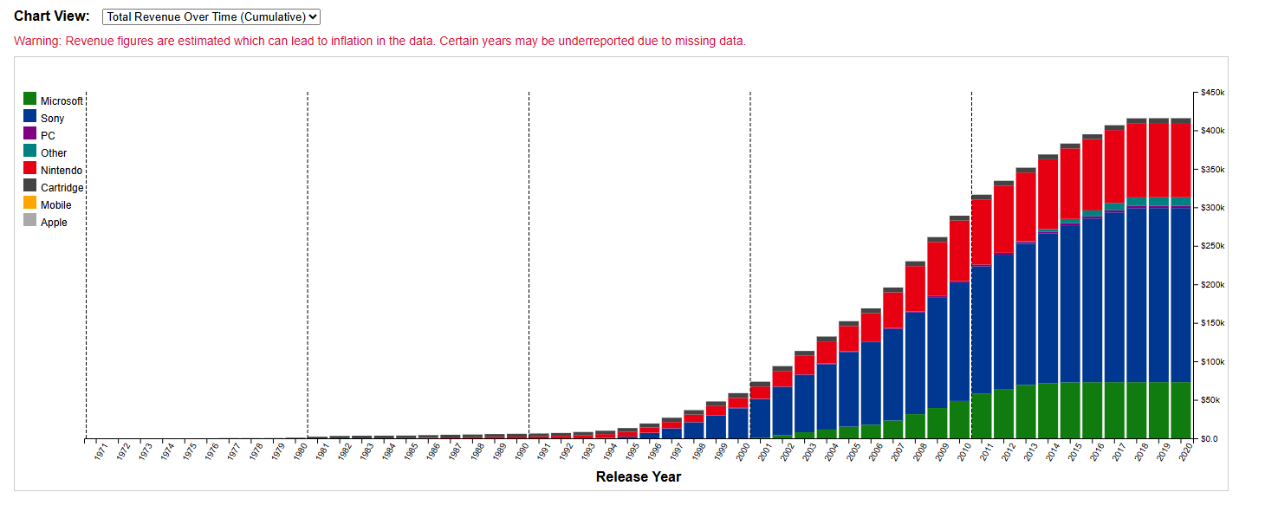
Figure 1: Default Page cumulative view
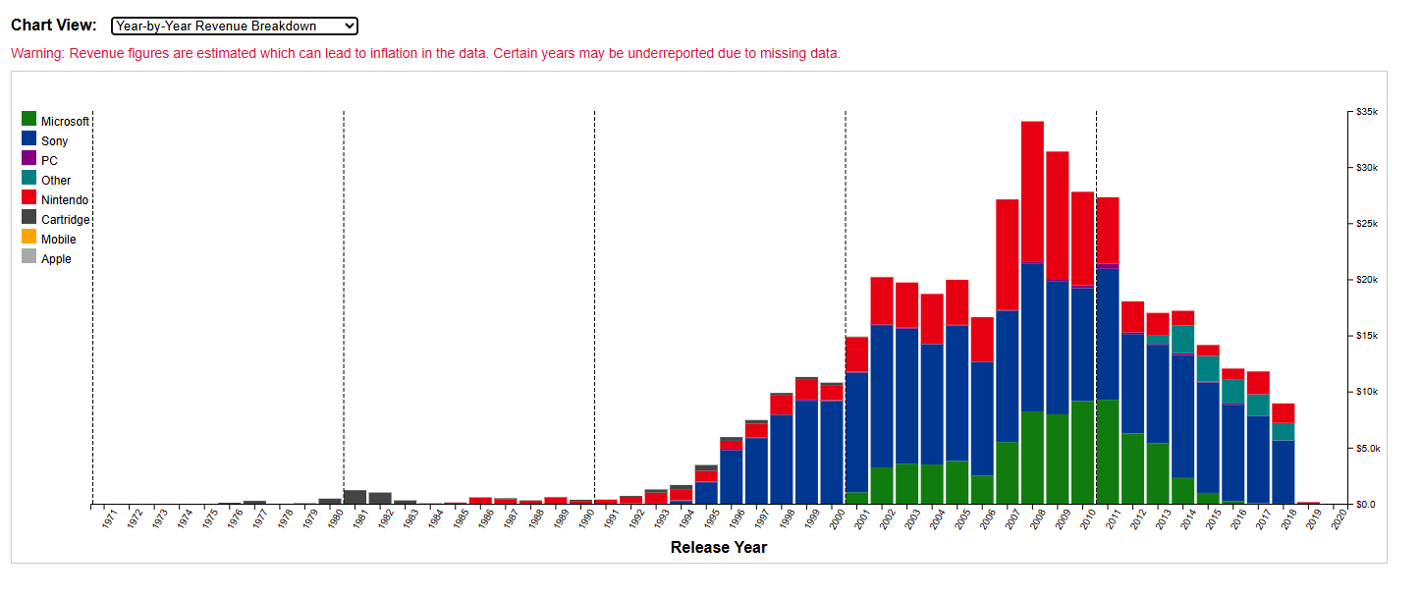
Figure 2: Annual view, missing data much more obvious
Emphasizing accessibility and intuitive interaction, the dashboard removes traditional menus in favor of direct selection. Users can click on a decade segment to zoom into that window, triggering a switch to annual revenue and revealing decade-specific breakdowns across key categories: brand, console, genre, and ratings with a highlight on the most sold game by total sales and the highest rated game by average score. This decoupled view provides focused context while preserving the historical arc.
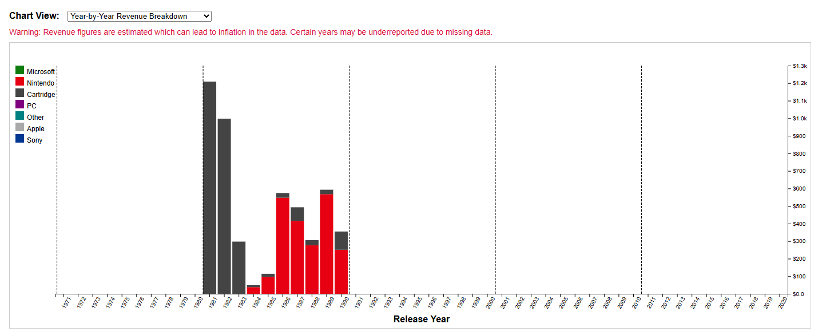
Figure 3: Decade Window for main visual
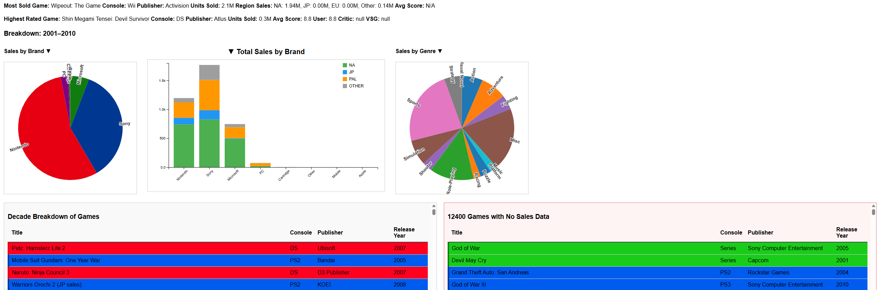
Figure 4: Decade Breakdown view
To account for games with missing sales data, a significant portion of the dataset, each breakdown includes paired visualizations which can cycled to by selecting the title. On the left, a pie chart shows both “Sales by Brand” and “Releases by Brand,” allowing users to compare commercial impact with overall publishing activity. This design ensures that titles lacking complete data remain represented in the visual narrative, supporting comprehensiveness and inclusivity.
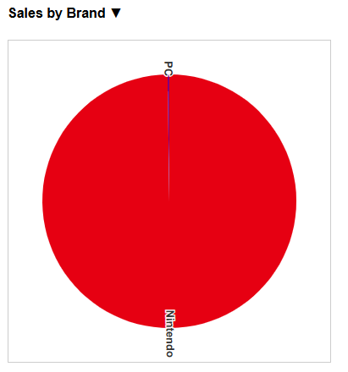
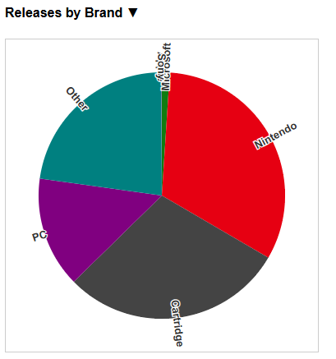
Figure 5: Pie chart, both views 1981-1990
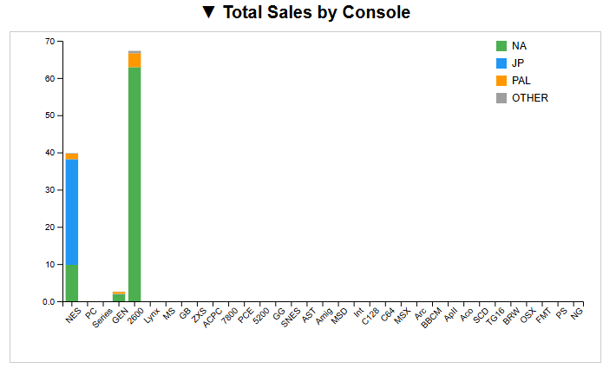
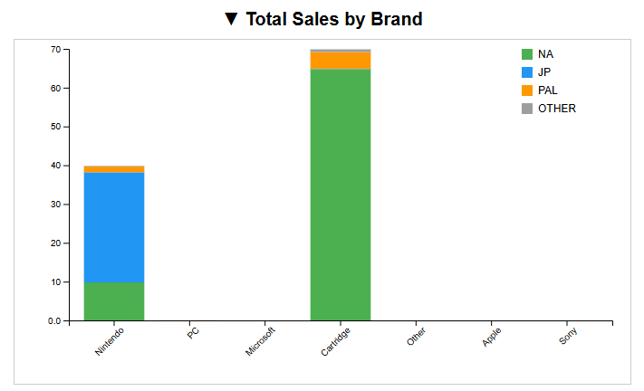
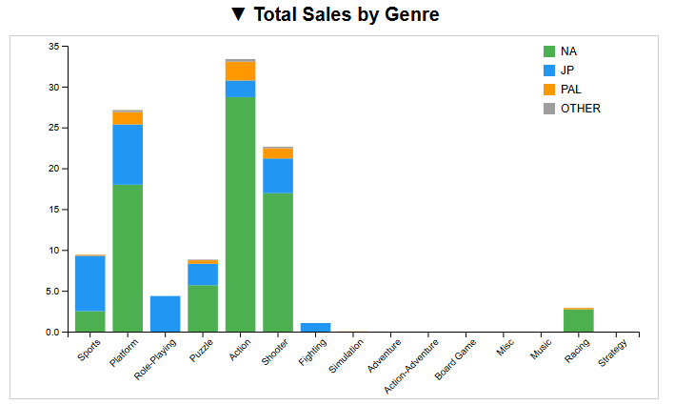
Adjacent to this chart is an interactive bar chart featuring three switchable views: sales by brand, by genre, and by console. Region-specific color encoding allows users to see how market performance varies geographically, offering insights into regional preferences and disparities. Cycling through perspectives reinforces the dashboard’s goal of multidimensional exploration—showing not just which games sold well, but where and in what form.

Figure 6: Bar chart views 1981 - 1990
The genre pie chart mirrors the brand pie chart for symmetry and visual balance, reflecting both sales and release counts by genre. Hover tooltips reveal percentage shares, enhancing interpretability. The genre chart uses a standardized color palette due to the lack of universally recognized genre-brand associations.

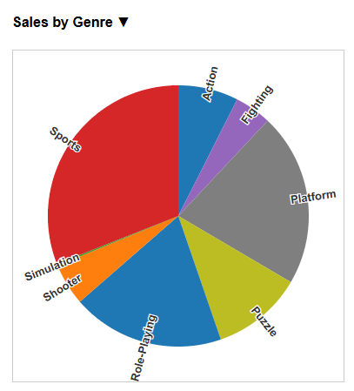
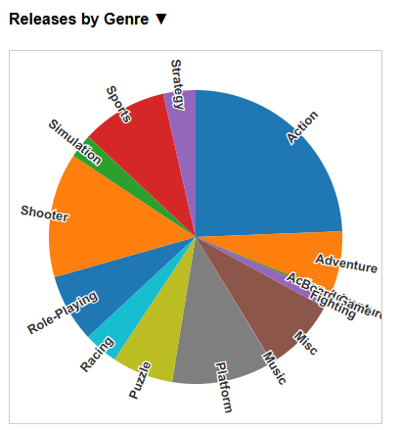
Figure 7: Genre Pie Chart both views, 1981 - 1990
Below the chart row are two sortable data tables showing individual game-level records. The left table contains games with sales data, while the right lists titles with missing sales figures. Each row is color-coded by brand, aligning with the timeline above. This tabular representation enables granular inspection, linking back to the high-level visuals and supporting tasks such as verification, comparison, and recall.
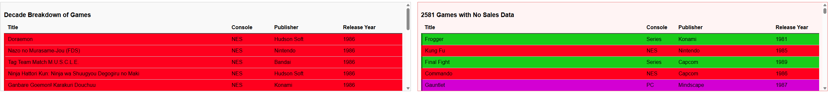
Figure 8: Data tables, default views, 1981- 1990
Overall, each visual module was designed to balance clarity, engagement, and inclusivity—enabling users of varying expertise to explore the evolution of the gaming industry through layered, accessible views.

What was found
Across the timeline visualization, several historical and industry patterns emerged, highlighting both market dominance and data irregularities over time. In the earliest decade (1971–1980), the dataset was sparse, composed primarily of cartridge-based platforms. Due to limited sales records, both pie charts appeared empty by default. However, secondary chart views proved valuable, revealing that lesser-known consoles and early PC titles received game releases despite gaps in commercial data. Genre diversity was present even in this early stage, with sports, action, and miscellaneous games appearing prominently while shooter games appear to be the most profitable.
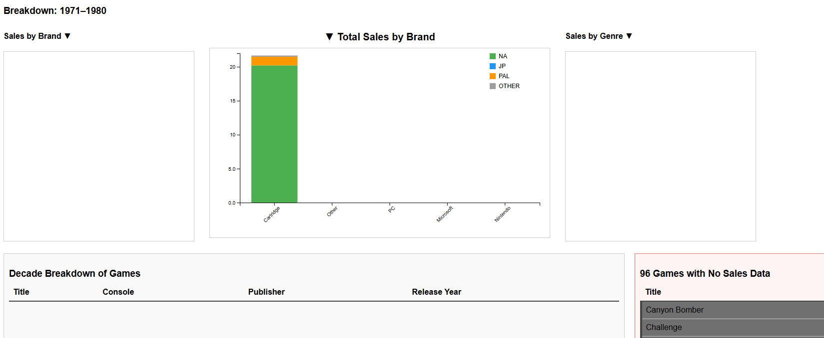
Figure _: Empty Pie Charts
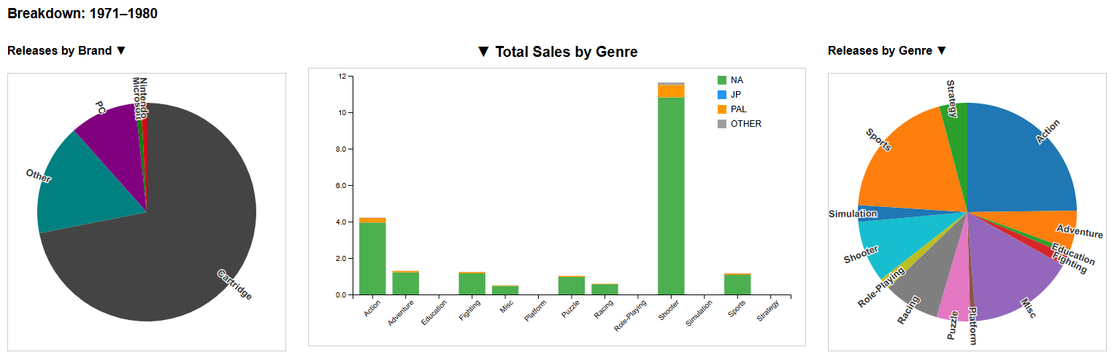
Figure _: comprehensive view of 1971-1980
From 1981 to 1990, Nintendo entered the scene and quickly dominated the available sales data, particularly in North America. While this suggests strong market performance, the missing data across other regions and platforms complicates interpretation. Secondary views again illuminated ongoing releases for cartridge systems and growing activity in PC publishing. Notably, brands such as Sony and Microsoft began appearing, albeit with limited early catalogues. R.B.I. Baseball emerged as the highest-selling game (with available data) of the decade, while genres such as platformers, shooters, and adventure games began to gain traction.
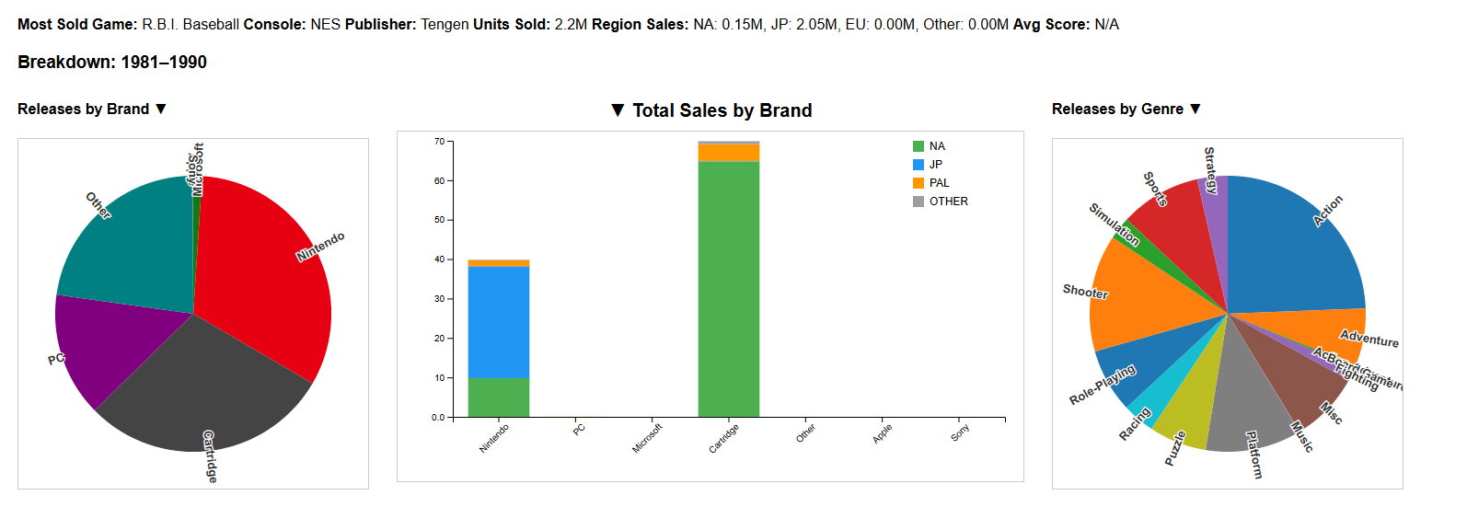
Figure _: 1981 – 1990 Summary
The 1991–2000 decade marked Sony’s rise, likely accelerated by the PlayStation’s popularity. Visual bias may be present, however, due to richer data coverage for Sony games in the dataset. Sales and releases were led by Sony, Nintendo, cartridges, and PC, with Microsoft still in its infancy. Regional sales were largely dominated by North America and PAL (European) territories, with Europe appearing especially prominent in Sony’s catalog. Genre representation widened, although educational, party, and visual novel games saw limited releases.
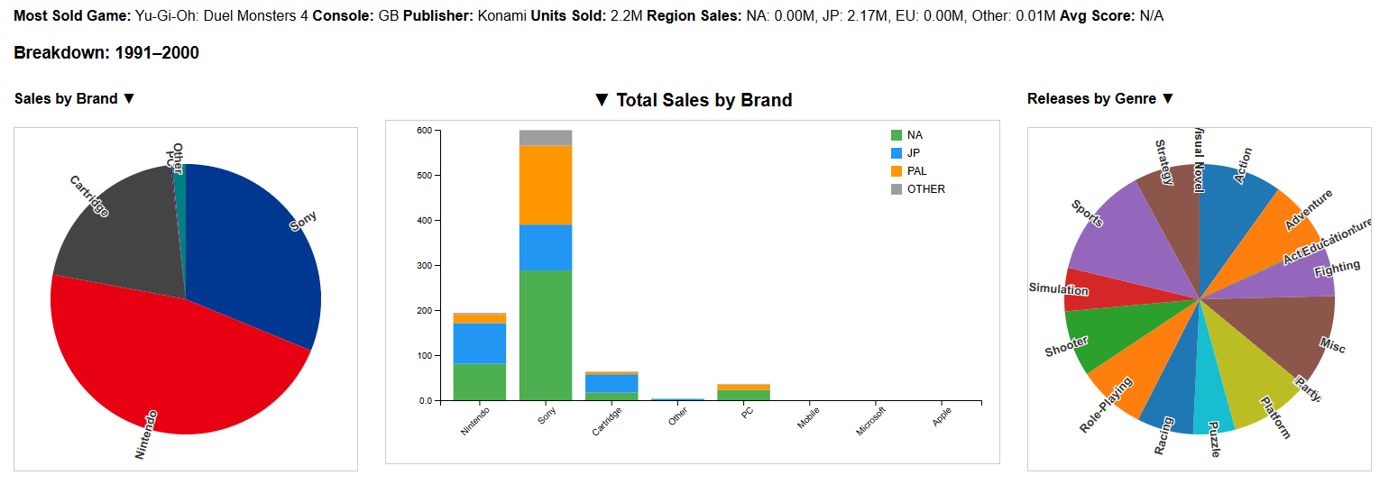
Figure _: 1991-2000 Summary
Between 2001 and 2010, cartridge technology largely disappeared from active use. The most sold game was Wipeout: The Game for the Wii, while the highest rated was Shin Megami Tensei: Devil Survivor for the DS. Microsoft saw significant growth, likely aligned with the Xbox’s rise, and Apple and mobile platforms began to surface. Genre data showed a resurgence in adventure titles alongside steady contributions from action, shooter, sports, and miscellaneous categories. Regional sales continued to be led by North America and Europe, with their contribution likely leading to the rise in action and sporting games again.
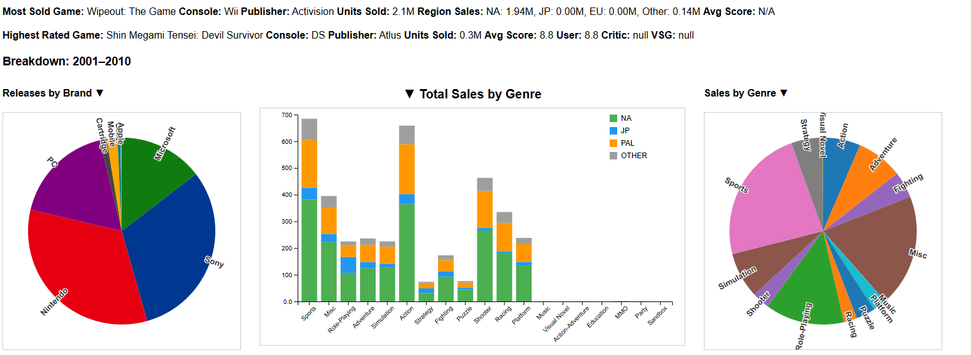
Figure _: 2001- 2010 Summary
In the final examined decade (2011–2020), Sony again led in total reported sales, though potential bias from missing data remains. Game releases, however, were more evenly distributed across Sony, Nintendo, and PC. Cartridges were nearly obsolete. Regionally, sales were more balanced between North America and Europe, with Japan showing concentrated sales in visual novel genres. The top-selling game was Dragon Quest XI for the 3DS, while Okami HD for the Switch earned the highest rating in this period. Genre trends revealed role-playing, sports, shooters, and action games as commercially dominant, supported both by sales and release volume.
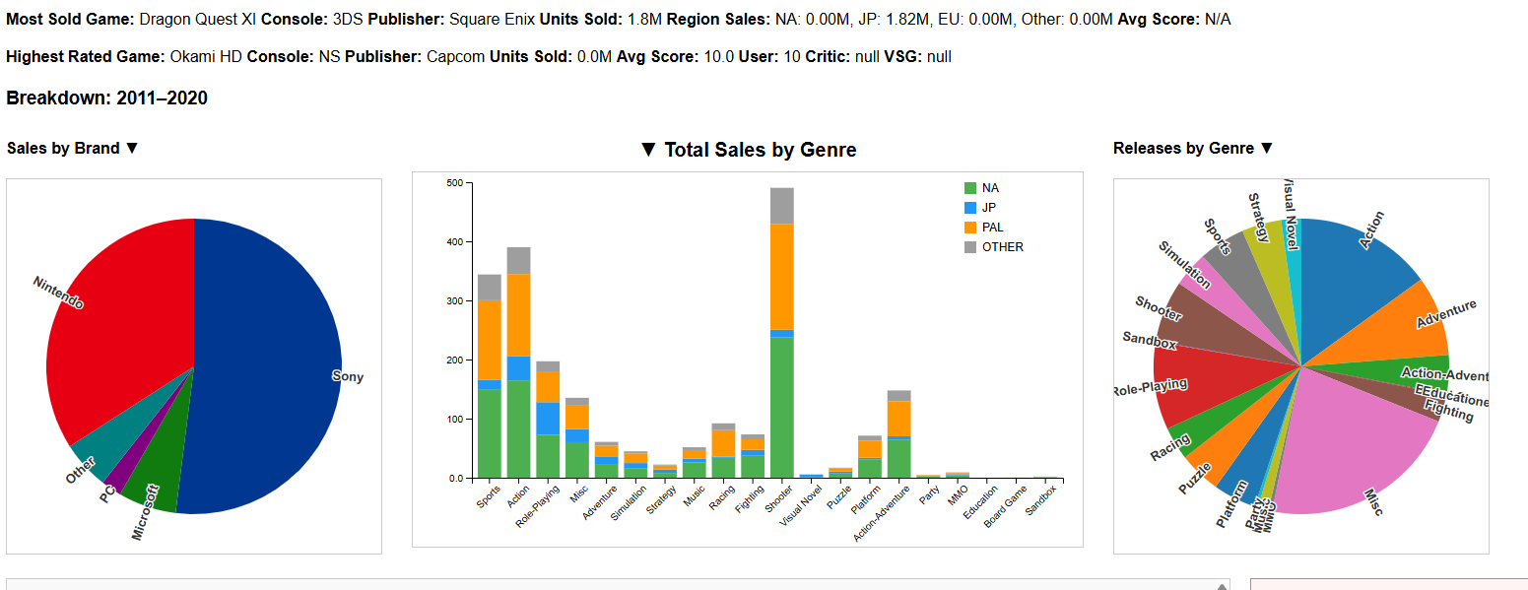
Figure _: 2011-2020 Summary
These findings underscore the importance of visual flexibility when working with incomplete datasets. By pairing primary and secondary views, the dashboard exposes structural trends in platform dominance, genre evolution, and regional variation, even in cases of missing or partial data. The visual storytelling model offers both clarity and nuance, accommodating exploration across commercial success, cultural impact, and design legacy.
[1] B. Brannen, “Video Game Sales 2020 Dataset,” Kaggle, 2020. [Online]. Available: https://www.kaggle.com/datasets/baynebrannen/video-game-sales-2020
[2] E. Meeks and M. Heer, “Stacked Graphs—Geometry & Aesthetics,” IEEE Transactions on Visualization and Computer Graphics, vol. 14, no. 6, pp. 1245–1252, 2008.
[3] “How to Create Impactful Data Visualizations with D3.js,” Data Science Council of America (DASCA), Jan. 2025. [Online]. Available: https://www.dasca.org/world-of-data-science/article/how-to-create-impactful-data-visualizations-with-d3js
[4] “Best Practices for Creating Interactive Visualizations with D3.js,” CodezUp, Dec. 2024. [Online]. Available: https://codezup.com/building-interactive-visualizations-with-d3-js-and-javascript/
[5] N. Kong, M. Hearst, and M. Agrawala, “Graphical Histories for Visualization: Supporting Analysis, Communication, and Evaluation,” IEEE TVCG, vol. 17, no. 12, pp. 2376–2385, 2011.
[6] S. Kandel et al., “Research Directions in Data Wrangling: Visualizations and Transformations for Usable Data,” IEEE TVCG, vol. 18, no. 12, pp. 2739–2748, 2012.
[7] “D3 Graph Gallery – Pie Chart Examples,” [Online]. Available: https://d3-graph-gallery.com/graph/pie_basic.html
[8] M. Bostock, “Stacked Bar Chart – Observable Notebook,” [Online]. Available: https://observablehq.com/@d3/stacked-bar-chart

