**Medical Device Voice Authentication**

**Josh Corbin, Devin Kloos, Kevin Copper, Patrick Donavan, Donald Taylor**

**Team 7 (Voice)  
April 25, 2017**

**ABSTRACT**

This project involves taking the requirements of a client who needs voice authentication for their medical device so that an authenticated doctor can gain access to the device to retrieve medical information pertaining to their patients. The goal is to provide effective, accurate, and secure means of authentication for the doctor to ensure that only the authorized personnel can gain access to the confidential data. This has been accomplished by utilizing the VoiceIt libraries, combined with a C++ wrapper. Upon implementation of the VoiceIt libraries, C++ wrapper, and our other customizations, we have created an effective voice authentication program to fulfill the client’s needs. Using this voice authentication software, healthcare settings can now securely utilize this medical device and ensure that only authorized individuals will be able to gain access to the confidential patient data to ensure strict adherence to HIPPA.

**TABLE OF CONTENTS**

**INTRODUCTION 4**

**REQUIREMENTS 5**

**ANALYSIS 9**

**DESIGN 11**

**IMPLEMENTATION 19**

**TESTING 20**

**CONCLUSION 21**

**REFERENCES 22**

**INTRODUCTION**

A medical device which is constantly reading and storing confidential data from a patient must only be accessible by an authorized user – that patient’s doctor. The healthcare industry must adhere to strict policies and regulations such as HIPPA, and Team 7’s Voice Authentication software will do just that. The software was built utilizing the 5-stage design method: Requirements, Analysis, Design, Implementation, Testing, and we will cover all of these design workflows throughout this paper. By conducting interviews with our client, analyzing all of his needs, and then implementing the correct solution, you will see that Team 7’s Voice Authentication software for this medical device will cover all areas of effectiveness, usability, and security.

**REQUIREMENTS**

**Application Domain:** Health care, doctor’s office, hospital

**Need:** Voice detection is used to authenticate a user (doctor) so that he/she can read out the vitals, data, and information for that patient (from their medical device).

**Perform:** Doctor inputs voice into device for authentication. If the voice patterns match the user who has access privileges to that medical device, then authenticate that user and begin moving on to the next module (i.e. reading off vitals, data, etc).

**Users:** People using this software will be the doctor of that patient (HIPPA / privacy).

**Deadline:** April 27th, 2017

**Reliability:** Product must be operational 99% of the time or the mean time between failures must be at least 4 months.

**Is the software affordable / profitable:** Yes. Needed in health care industry.

**Glossary:** "Confidential Information" means all business-related information, written or oral, that the Customer discloses or makes available to the Developer, directly or indirectly, through any means of communication or observation. "Software" means the programs created/used for the medical device voice detection system, and all associated documentation and other instructions.

**Business Model:** With the application domain defined, you can build a business model using UML diagrams to describe the client’s business processes. The business model is used to determine client’s initial requirements, then iteration.

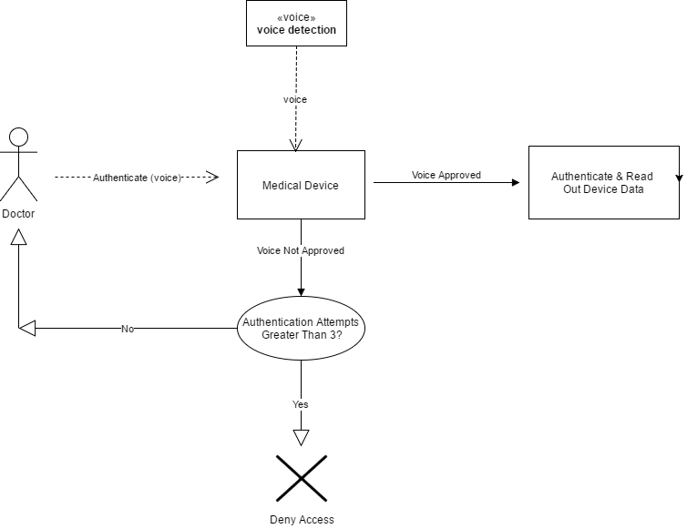

**Use Case models:** show interaction between software product and environment (i.e. Customer -> [banking software] -> Teller).

**Use Case 1 (Doctor Successfully Authenticated):**

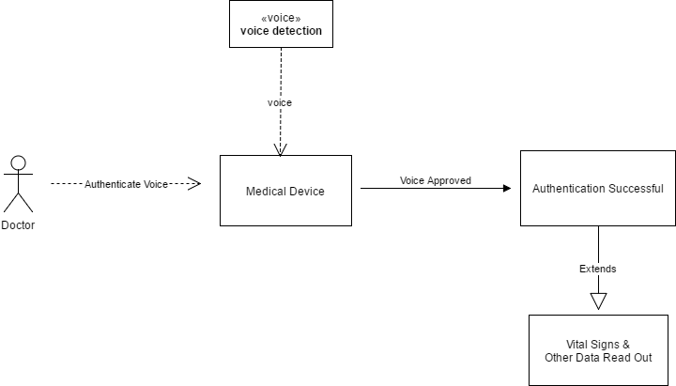

**Use Case 2 (Authentication Failed 3+ Times(Access Denied)):**

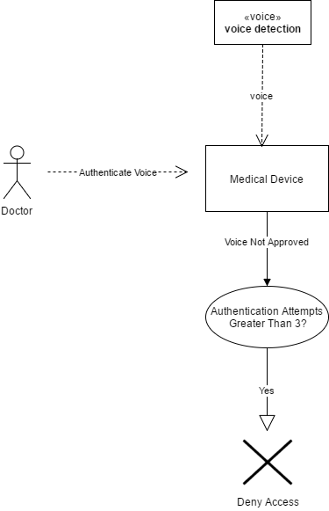

**Use Case 3 (Authentication Failed Less Than 3 Times (Reattempt Authentication)):**

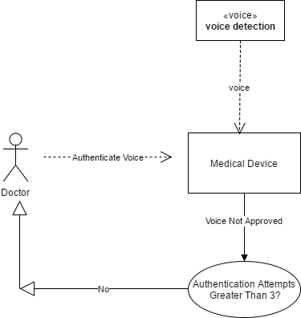

**ANALYSIS**

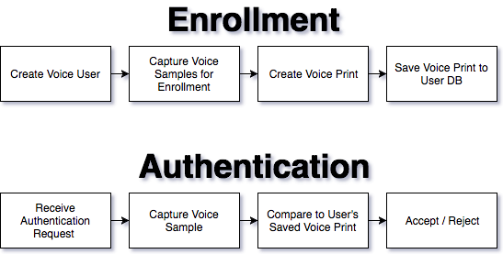

This is the basic process that must take place for voice authentication above.

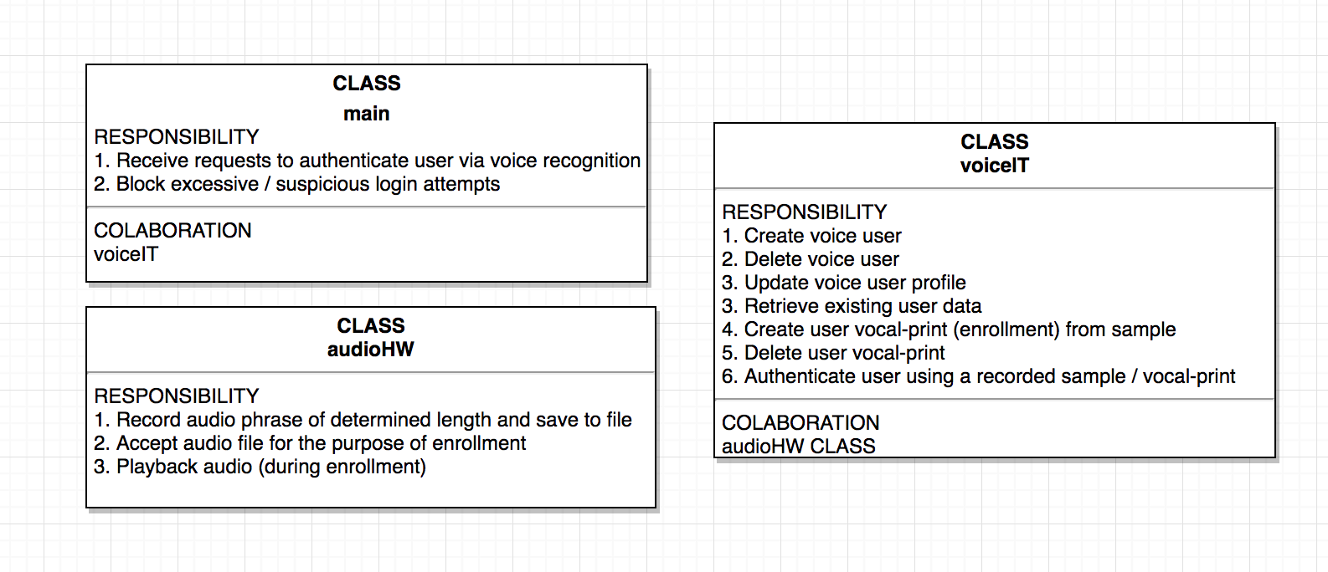

From our layman term requirements I drew out this high level class requirements diagram.



This is the general data flow we can expect between the classes above.

**DESIGN**

**Class Diagram**



**Methods in Detail**

Class Name VoiceIt

Method name WriteCallback

Return type size_t

Input argument(s) char *contents, size_t size, size_t nmemb, void *userp

Output argument(s) None

Error messages None

Files accessed None

Files changed None

Methods invoked readBuffer

Narrative

Method name read_callback

Return type size_t

Input argument(s) void *ptr, size_t size, size_t nmemb, void *userp

Output argument(s) None

Error messages None

Files accessed None

Files changed None

Methods invoked WriteThis, writeBuffer

Narrative

Method name getUser

Return type string

Input argument(s) string email, string password

Output argument(s) None

Error messages fprintf(stderr, "curl_easy_perform() failed: %s\n", curl_easy_strerror(res));

Files accessed None

Files changed None

Methods invoked readBuffer, CURL, CURLcode, curl_easy_strerror, curl_easy_perform, curl_slist_free_all, curl_easy_cleanup, curl_easy_init, clear

Narrative

This REST API call is used to retrieve an existing user profile within the Voiceprint Developer Portal (VPDP) service. It retrieves an existing user profile record from the VPDP service database and returns true or false.

Method name setUser

Return type string

Input argument(s) string email,string password,string firstName,string lastName

Output argument(s) None

Error messages fprintf(stderr, "curl_easy_perform() failed: %s\n", curl_easy_strerror(res));

Files accessed None

Files changed None

Methods invoked readBuffer, CURL, CURLcode, curl_easy_strerror, curl_easy_perform, curl_slist_free_all, curl_global_init, curl_easy_init, curl_easy_setopt, curl_easy_cleanup

Narrative

This REST API call is used to update an existing user profile within the Voiceprint Developer Portal (VPDP) service. It updates an existing user profile record within the VPDP service database and returns true or false.

Method name createUser

Return type string

Input argument(s) string email,string password,string firstName,string lastName, string phone1, string phone2, string phone3

Output argument(s) None

Error messages fprintf(stderr, "curl_easy_perform() failed: %s\n", curl_easy_strerror(res));

Files accessed None

Files changed None

Methods invoked CURL, CURLcode, curl_easy_strerror, curl_easy_perform, curl_slist_free_all, curl_global_init, curl_easy_init, curl_easy_setopt, curl_easy_cleanup, readBuffer

Narrative:

Registers a new user profile within the Voiceprint Developer Portal (VPDP) service. Creates a new user profile record in the VPDP service database and returns true or false. Newly registered user profiles are enabled by default. Your DeveloperID is in the Welcome email you received when you registered.

Method name createUser

Return type string

Input argument(s) string email,string password,string firstName,string lastName

Output argument(s) email, password, firstName, lastName, "","",""

Error messages None

Files accessed None

Files changed None

Methods invoked createUser

Narrative

Registers a new user profile within the Voiceprint Developer Portal (VPDP) service. Creates a new user profile record in the VPDP service database and returns true or false. Newly registered user profiles are enabled by default. Your DeveloperID is in the Welcome email you received when you registered.

Method name deleteUser

Return type string

Input argument(s) string email,string password

Output argument(s) None

Error messages fprintf(stderr, "curl_easy_perform() failed: %s\n", curl_easy_strerror(res));

Files accessed None

Files changed None

Methods invoked curl_easy_strerror, curl_easy_perform, curl_slist_free_all, curl_global_init, curl_easy_init, curl_easy_setopt, curl_easy_cleanup, readBuffer clear

Narrative

This REST API call is used to delete an existing user profile within the Voiceprint Developer Portal (VPDP) service. Deletes an existing user profile record from the VPDP service database and returns true or false.

Method name createEnrollment

Return type string

Input argument(s) string email,string passwrd, string pathToEnrollmentWav, string contentLanguage

Output argument(s) None

Error messages None

Files accessed fd

Files changed fd

Methods invoked clear, curl_easy_init, curl_slist_append, curl_easy_setopt, curl_easy_perform, curl_slist_free_all, c_str, curl_easy_cleanup, sha256, fopen, fstat, fileno

Narrative

This REST API call is used to create a new enrollment template for the specified user profile within the Voiceprint Developer Portal (VPDP) service. It creates a new enrollment template for the specified user profile in the VPDP service database and returns true or false. We recommend a minimum of three (3) enrollment templates per Voiceprint Phrase (VPP). Please Note: The Voiceprint Phrase's (VPP's) are Text-Dependent. The Minimum length of a VPP is 1.2 second. **Please note: You cannot use enrollment sound file for authentication. This is because of our anti- spoofing technology.** To manage the VPPs associated with your DeveloperID, please login to the developer portaland navigate to Voiceprint Phrases section. Please note: You can use DetectedVoiceprintText and DetectedTextConfidence to help decide which enrollmentID to keep or throw out and have the user record again based on text detected and its confidence.

Method name createEnrollment

Return type string

Input argument(s) string email,string passwrd, string pathToEnrollmentWav

Output argument(s) email,passwrd, pathToEnrollmentWav, ""

Error messages None

Files accessed fd

Files changed fd

Methods invoked createEnrollment

Narrative

This REST API call is used to create a new enrollment template for the specified user profile within the Voiceprint Developer Portal (VPDP) service. It creates a new enrollment template for the specified user profile in the VPDP service database and returns true or false. We recommend a minimum of three (3) enrollment templates per Voiceprint Phrase (VPP). Please Note: The Voiceprint Phrase's (VPP's) are Text-Dependent. The Minimum length of a VPP is 1.2 second. **Please note: You cannot use enrollment sound file for authentication. This is because of our anti- spoofing technology.** To manage the VPPs associated with your DeveloperID, please login to the developer portaland navigate to Voiceprint Phrases section. Please note: You can use DetectedVoiceprintText and DetectedTextConfidence to help decide which enrollmentID to keep or throw out and have the user record again based on text detected and its confidence.

Method name createEnrollmentByWavURL

Return type string

Input argument(s) string email,string passwrd, string urlToEnrollmentWav, string contentLanguage

Output argument(s) None

Error messages None

Files accessed None

Files changed None

Methods invoked CURL, CURLcode, clear, curl_easy_init, curl_slist_append, curl_easy_setopt, curl_easy_perform, curl_slist_free_all, curl_easy_cleanup

Narrative

This REST API call is used to create a new enrollment template for the specified user profile within the Voiceprint Developer Portal (VPDP) service via a pre-recorded sound file. It creates a new enrollment template for the specified user profile in the VPDP service database and returns true or false. We recommend a minimum of three (3) enrollment templates per Voiceprint Phrase (VPP). Please Note: The Voiceprint Phrase's (VPP's) are Text-Dependent. The Minimum length of a VPP is 1.2 second. **Please note: You cannot use enrollment sound file for authentication. This is because of our anti- spoofing technology.** To manage the VPPs associated with your DeveloperID, please login to the developer portal and navigate to Voiceprint Phrases section. Please note: You can use DetectedVoiceprintText and DetectedTextConfidence to help decide which enrollmentID to keep or throw out and have the user record again based on text detected and its confidence.

Method name createEnrollmentByWavURL

Return type string

Input argument(s) string email,string passwrd, string urlToEnrollmentWav

Output argument(s) email,passwrd, urlToEnrollmentWav, ""

Error messages None

Files accessed None

Files changed None

Methods invoked createEnrollmentByWavURL

Narrative

This REST API call is used to create a new enrollment template for the specified user profile within the Voiceprint Developer Portal (VPDP) service via a pre-recorded sound file. It creates a new enrollment template for the specified user profile in the VPDP service database and returns true or false. We recommend a minimum of three (3) enrollment templates per Voiceprint Phrase (VPP). Please Note: The Voiceprint Phrase's (VPP's) are Text-Dependent. The Minimum length of a VPP is 1.2 second. **Please note: You cannot use enrollment sound file for authentication. This is because of our anti- spoofing technology.** To manage the VPPs associated with your DeveloperID, please login to the developer portal and navigate to Voiceprint Phrases section. Please note: You can use DetectedVoiceprintText and DetectedTextConfidence to help decide which enrollmentID to keep or throw out and have the user record again based on text detected and its confidence.

Method name getEnrollments

Return type string

Input argument(s) string email,string password

Output argument(s) None

Error messages fprintf(stderr, "curl_easy_perform() failed: %s\n", curl_easy_strerror(res));

Files accessed None

Files changed None

Methods invoked clear, curl_easy_init, curl_slist_append, curl_easy_setopt, curl_easy_perform, curl_slist_free_all, c_str

Narrative

This REST API call is used to retrieve the existing enrollment template(s) for the specified user profile within the Voiceprint Developer Portal (VPDP) service. It retrieves the existing enrollment template(s) for the specified user profile from the VPDP service database and returns true or false.

Method name deleteEnrollment

Return type string

Input argument(s) string email,string password,string enrollmentId

Output argument(s) None

Error messages None

Files accessed None

Files changed None

Methods invoked clear, curl_easy_init, curl_slist_append, curl_easy_setopt, curl_easy_perform, curl_slist_free_all, c_str

Narrative

This REST API call is used to delete an existing enrollment template for the specified user profile within the Voiceprint Developer Portal (VPDP) service. It deletes an existing enrollment template for the specified user profile from the VPDP service database and returns true or false.

Method name authentication

Return type string

Input argument(s) string email,string passwrd, string pathToAuthenticationWav, string confidence, string contentLanguage

Output argument(s) None

Error messages None

Files accessed None

Files changed None

Methods invoked clear, curl_easy_init, curl_slist_append, curl_easy_setopt, curl_easy_perform, curl_slist_free_all, c_str, curl_easy_cleanup, sha256, fopen, fstat, fileno

Narrative

This REST API call is used to authenticate the specified user profile within the Voiceprint Developer Portal (VPDP) service. It authenticates the specified user profile in the VPDP service database and returns success or failure. Please Note: The Voiceprint Phrase's (VPP's) are Text-Dependent. The Minimum length of a VPP is 1.5 second. **Please note: You cannot use enrollment sound file for authentication. This is because of our anti- spoofing technology.** To manage the VPPs associated with your DeveloperID, please login to the developer portaland navigate to Voiceprint Phrases section. We recommend starting with 85% for the confidence parameter during testing. After becoming familiar with the API, you can tweak the confidence parameter (with a maximum around 91) in order to decrease false positives. Please note: You can use DetectedVoiceprintText and DetectedTextConfidence to help decide which authentication to keep or throw out and have the user record again based on speech text detected and its confidence.

Method name authentication

Return type string

Input argument(s) string email,string passwrd, string pathToAuthenticationWav, string confidence

Output argument(s) email,passwrd,pathToAuthenticationWav,confidence,""

Error messages None

Files accessed None

Files changed None

Methods invoked authentication

Narrative

This REST API call is used to authenticate the specified user profile within the Voiceprint Developer Portal (VPDP) service. It authenticates the specified user profile in the VPDP service database and returns success or failure. Please Note: The Voiceprint Phrase's (VPP's) are Text-Dependent. The Minimum length of a VPP is 1.5 second. **Please note: You cannot use enrollment sound file for authentication. This is because of our anti- spoofing technology.** To manage the VPPs associated with your DeveloperID, please login to the [developer portal](https://siv.voiceprintportal.com/developerlogin.jsp)and navigate to Voiceprint Phrases section. We recommend starting with 85% for the confidence parameter during testing. After becoming familiar with the API, you can tweak the confidence parameter (with a maximum around 91) in order to decrease false positives. Please note: You can use DetectedVoiceprintText and DetectedTextConfidence to help decide which authentication to keep or throw out and have the user record again based on speech text detected and its confidence.

Method name authenticationByWavURL

Return type string

Input argument(s) string email,string passwrd, string urlToAuthenticationWav, string confidence, string contentLanguage

Output argument(s) None

Error messages None

Files accessed None

Files changed None

Methods invoked clear, curl_easy_init, curl_slist_append, curl_easy_setopt, curl_easy_perform, curl_slist_free_all, c_str, curl_easy_cleanup, sha256

Narrative

This REST API call is used to authenticate the specified user profile within the Voiceprint Developer Portal (VPDP) service via a pre-recorded sound file. It authenticates the specified user profile in the VPDP service database and returns success or failure. Please Note: The Voiceprint Phrase's (VPP's) are Text-Dependent. The Minimum length of a VPP is 1.2 second. **Please note: You cannot use enrollment sound file for authentication. This is because of our anti- spoofing technology.** To manage the VPPs associated with your DeveloperID, please login to the developer portal and navigate to Voiceprint Phrases section. We recommend starting with 85% for the confidence parameter during testing. After becoming familiar with the API, you can tweak the confidence parameter (with a maximum around 91) in order to decrease false positives. Please note: You can use DetectedVoiceprintText and DetectedTextConfidence to help decide which authentication to keep or throw out and have the user record again based on speech text detected and its confidence.

Method name authenticationByWavURL

Return type string

Input argument(s) string email,string passwrd, string urlToAuthenticationWav, string confidence

Output argument(s) email,passwrd,urlToAuthenticationWav,confidence,""

Error messages None

Files accessed None

Files changed None

Methods invoked authenticationByWavURL

Narrative

This REST API call is used to authenticate the specified user profile within the Voiceprint Developer Portal (VPDP) service via a pre-recorded sound file. It authenticates the specified user profile in the VPDP service database and returns success or failure. Please Note: The Voiceprint Phrase's (VPP's) are Text-Dependent. The Minimum length of a VPP is 1.2 second. **Please note: You cannot use enrollment sound file for authentication. This is because of our anti- spoofing technology.** To manage the VPPs associated with your DeveloperID, please login to the developer portaland navigate to Voiceprint Phrases section. We recommend starting with 85% for the confidence parameter during testing. After becoming familiar with the API, you can tweak the confidence parameter(with a maximum around 91) in order to decrease false positives. Please note: You can use DetectedVoiceprintText and DetectedTextConfidence to help decide which authentication to keep or throw out and have the user record again based on speech text detected and its confidence.

**IMPLEMENTATION**

**TESTING**

**CONCLUSION**

The Voice Authentication software created by Team 7 is what will be needed for this medical device to create a layer of security, ensuring that only authorized users (i.e. the patient’s doctor) will have access to the patient’s confidential medical data. The Voice Authentication software includes all of the client’s requirements, implements those requirements and properties effectively, has been tested and proven for accuracy, usability, and security, and can easily be integrated into the overall medical device. Team 7’s Voice Authentication software is the perfect solution for your medical device’s security and authentication, ensuring that your patient’s healthcare privacy is never sacrificed, and HIPPA is at all times adhered to when extracting data from this medical device.

**REFERENCES**

(2016, April 14). VoiceItTech – VoiceIt-cpp. Retrieved April 25, 2017, from https://github.com/voiceittech/voiceit-cpp/blob/master/VoiceIt.h

Schach, Stephen R. Object-Oriented Software Engineering. 1st ed. New York: McGraw-Hill Higher Education, 2008. Print.

**Copyright Information** © 2017, Team 7 (Voice). All Rights Reserved.