Function of Machine Code

Kevin Creasy
Department of Computer Science, Indiana Tech University
CS 3700: Object Orientation
Dr. Femi Ojo
May 31, 2026

This library management system(LMS) will catalog new books added to the library, keep track of patrons, along with monitoring book due dates, and total dues (Soutron, n.d.). A superclass called Library will be implemented with subclasses Patrons, Books, and Dues. Patrons and Dues will have an Association relationship, and the Books class will have a Generalization relationship with the Categories class.
So far, the shell of the Library class, along with the Books, Patrons, and Dues class have been coded. The Categories class has yet to be included in the code, but this will come after the Books class has been filled out more. Emphasis will need to be placed on testing for the correct monitoring of dues and how they accumulate. It is likely a time system will need to be established to flag when patrons are late with books returns. Once the classes are filled out more, the Main method can take shape.
More documentation will need to be included to help keep track of how classes will be utilized, along with their variables. Some classes may use similar names so it will be important to ensure they are unique. Little testing has been performed at this point. Further Unit testing will need to be done once more code is added and then Integration testing can be performed.
The UML class diagram is included below:
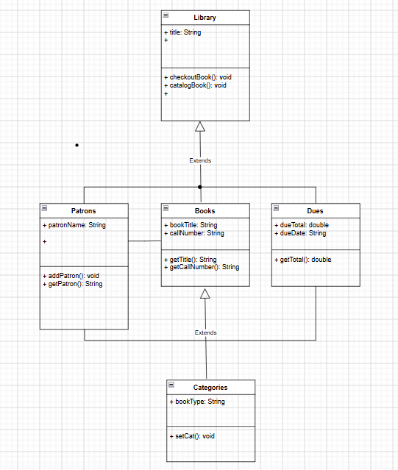

References
Soutron. (n.d.). Integrated library system. Soutron. https://www.soutron.com/en_us/blog/general/integrated-library-system/

