RepResearchCourseProject1

K C Saelee

August 2, 2017

What is the mean total number of steps taken per day?

Load and read dataset and create histogram of steps by day

##unzipped file in working directory. Made wd the folder.   
act<- read.csv("activity.csv")  
head(act)

## steps date interval  
## 1 NA 2012-10-01 0  
## 2 NA 2012-10-01 5  
## 3 NA 2012-10-01 10  
## 4 NA 2012-10-01 15  
## 5 NA 2012-10-01 20  
## 6 NA 2012-10-01 25

stepsbyday<-aggregate(steps~date, act, sum)  
hist(stepsbyday$steps)

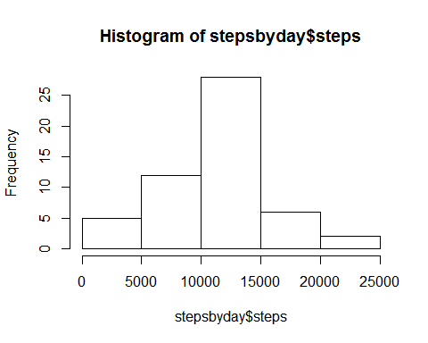

meansteps<-mean(stepsbyday$steps)  
mediansteps<-median(stepsbyday$steps)

What is the average daily activity pattern?

steppattern<-aggregate(steps~interval, act, mean)  
plot(steppattern$interval, steppattern$steps, type ="l", main="Average daily activity pattern")

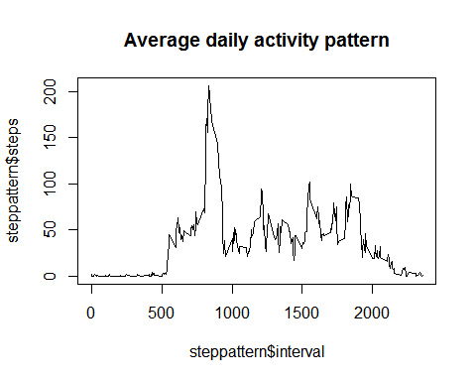

which.max(steppattern$steps)

## [1] 104

Imputting missing values

##calculate total missing values  
sum(is.na(act$steps))

## [1] 2304

##create new data set with missing values filled in  
act2<-act  
missval<-is.na(act2$steps)  
actinterval<-tapply(act2$steps, act2$interval, mean, na.rm=TRUE) ##used mean to fill  
act2$steps[missval]<-actinterval[as.character(act2$interval[missval])]  
head(act2)

## steps date interval  
## 1 1.7169811 2012-10-01 0  
## 2 0.3396226 2012-10-01 5  
## 3 0.1320755 2012-10-01 10  
## 4 0.1509434 2012-10-01 15  
## 5 0.0754717 2012-10-01 20  
## 6 2.0943396 2012-10-01 25

##make histogram and compute mean and median  
stepsbyday2<-aggregate(steps~date, act2, sum)  
hist(stepsbyday2$steps)

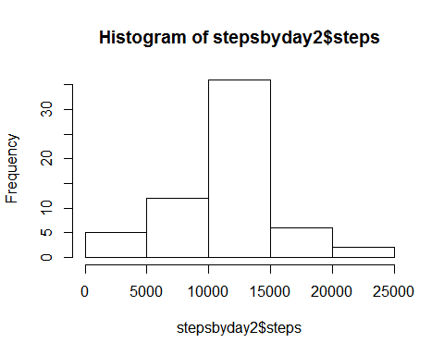

meansteps2<-mean(stepsbyday2$steps)  
mediansteps2<-median(stepsbyday2$steps)  
## > meansteps2  
##[1] 10766.19  
##> mediansteps2  
##[1] 10766.19  
## mean and median steps are lower than previous pre-imputed dataset

Are there differences in activity patterns between weekdays and weekends?

weekdayact<-c("Monday","Tuesday","Wednesday","Thursday","Friday")  
weekendact<-c("Saturday","Sunday")  
act2$week<-ifelse(is.element(weekdays(as.Date(act2$date))  
 ,weekdayact), "Weekdayact", "Weekendact")  
act3<-aggregate(steps~interval+week,act2, mean)  
head(act3)

## interval week steps  
## 1 0 Weekdayact 2.25115304  
## 2 5 Weekdayact 0.44528302  
## 3 10 Weekdayact 0.17316562  
## 4 15 Weekdayact 0.19790356  
## 5 20 Weekdayact 0.09895178  
## 6 25 Weekdayact 1.59035639

library(ggplot2)  
weekplot<-ggplot(act3, aes(interval, steps,fill=week))+  
 geom_line()+  
 facet_wrap(~week,nrow=2)+ ggtitle("Average daily steps by week type")  
weekplot

