91.460-530.203 Cyber Crime Investigation
Assignment 4 Logs

(10 points + 10 bonus points)

Instructions:
- Note: Blue text points to a web link. Ctrl + Click to follow link.
- This is an individual assignment.
- Answers to all questions including hands-on project with screen shots must be put into ONE document. That is, every time, each student can only submit one report document, answering all questions of this assignment.
- Students must put answers following each question in this assignment. The instructor will not grade a report with only answers in it and the student gets zero for such an assignment. An assignment report must include original questions.
- Students MUST submit the finished assignment in either Microsoft Word or pdf format to Blackboard. The doc must be submitted as a standalone file and cannot be tarred or zipped into a container.
- All Hands-on exercise that operates some software is required with screenshots of the actions to prove that the project is performed. The required screenshots must be put into the doc at appropriate place with explanation.
- Refer to Print screen on how to take a screenshot. Pressing the Alt key in combination with PrtSc will capture the currently selected window.

Questions:
- Please read the introduction to Ubuntu logging at https://help.ubuntu.com/community/LinuxLogFiles. Analyze /var/log/auth.log at the team’s metasploitable 2 VM on noon of May 1, 2017. Answer the followings questions:
  - How many different types of login messages do you see? (3 points)
  - Draw a curve, chart or some graph in excel to show the frequency of the login or each type of login. The horizontal axis refers to weeks or days along the time, for example, Day 1, Day 2, Day 3, …. Please specify the date of Day 1. The vertical axis is the frequency (4 points)
  - Can attacks be detected from auth.log and other logs? (3 points)

Solution :
a. When we analysed the auth.log file, we could figure out following kinds of messages:
- Session opened for user <username>
- Session closed for user <username>
- Groupadd, sudo,useradd,userdel
- Cron session opened
- last (this basically showed the repetition of the previous messages)

we have provided screenshots of the login messages:

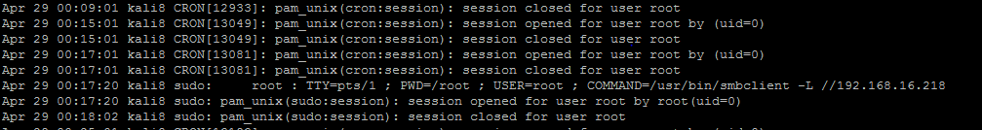

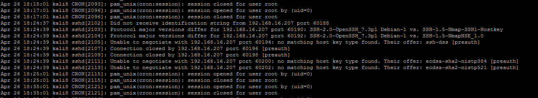

Solution b :

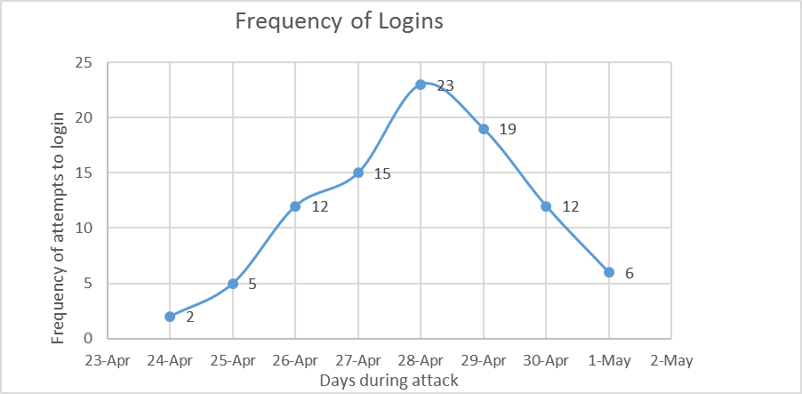

We tried to plot in an exponential way since the attemps frequency was varying as the attack phase came to an end, also our system was crashed in between,with the help of back up files and logs, we could manage to get frequency of login attempts.

Solution c. Yes.apart from auth.log file, we can also use other log files like;
- /var/log/user; /var/log/btmp, /var/log/faillog we can detect the failed login attempts ;
- we can determine the user levels; we can view the time stamp in the logs to determine the last recent attempt to login;
- ,/var/log/apache2 , /var/log/samba ; all these provide information about the attacks possibly made via network access or web server attacks

- Please set up remote logging so that logs can be sent from the team’s metasploitable 2 VM to the team’s Kali VM. Document the setup procedure and provide a screen shot of the corresponding remote log messages at the team’s Kali VM. (10 bonus points)
Solution:
Remote logging to Kali VM from Metasploitable8 VM:
Check the ip address of Kali8 VM and Metasploitable8 VM by using the command
> ifconfig
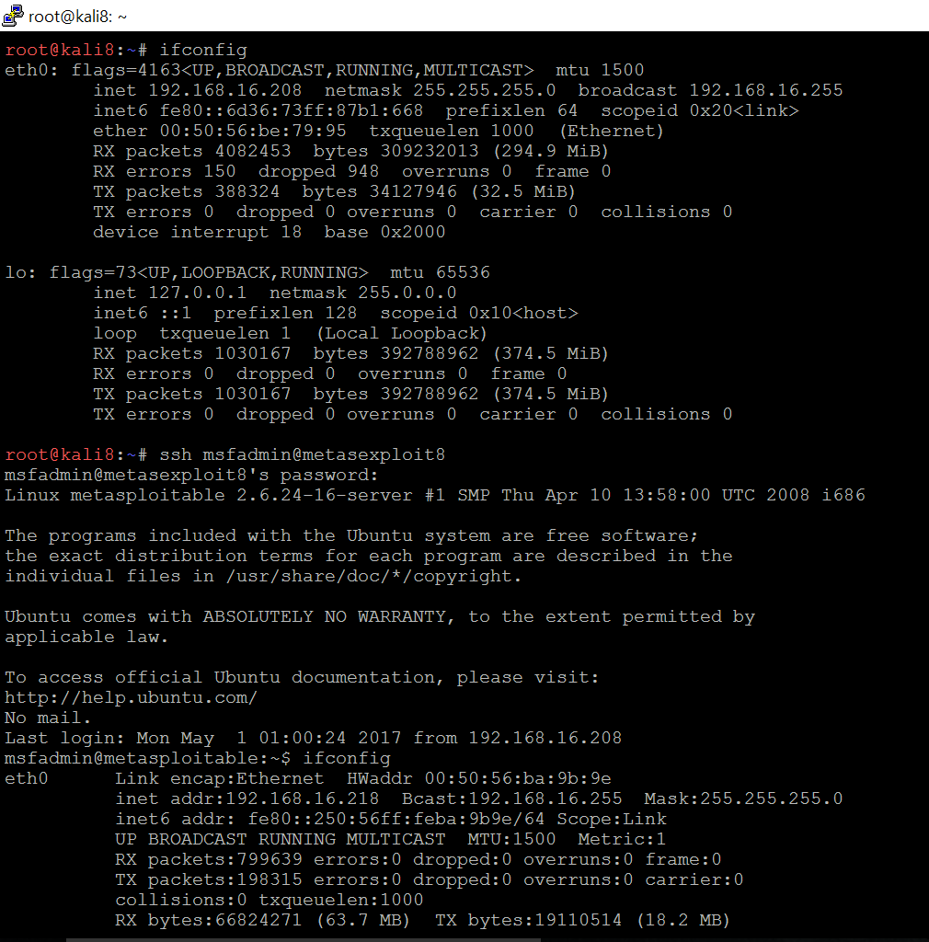
Use the command below and navigate to rsyslog.conf file and modify it:
> nano /etc/rsyslog.conf
Modification screenshot is provided after the below screenshot.
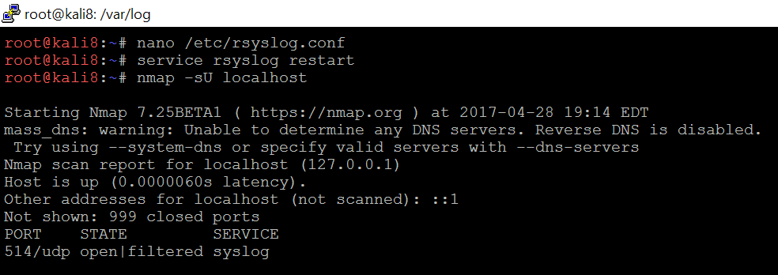

Navigate to > /etc/rsyslog.conf and modify the file. The modified data is highlighted.
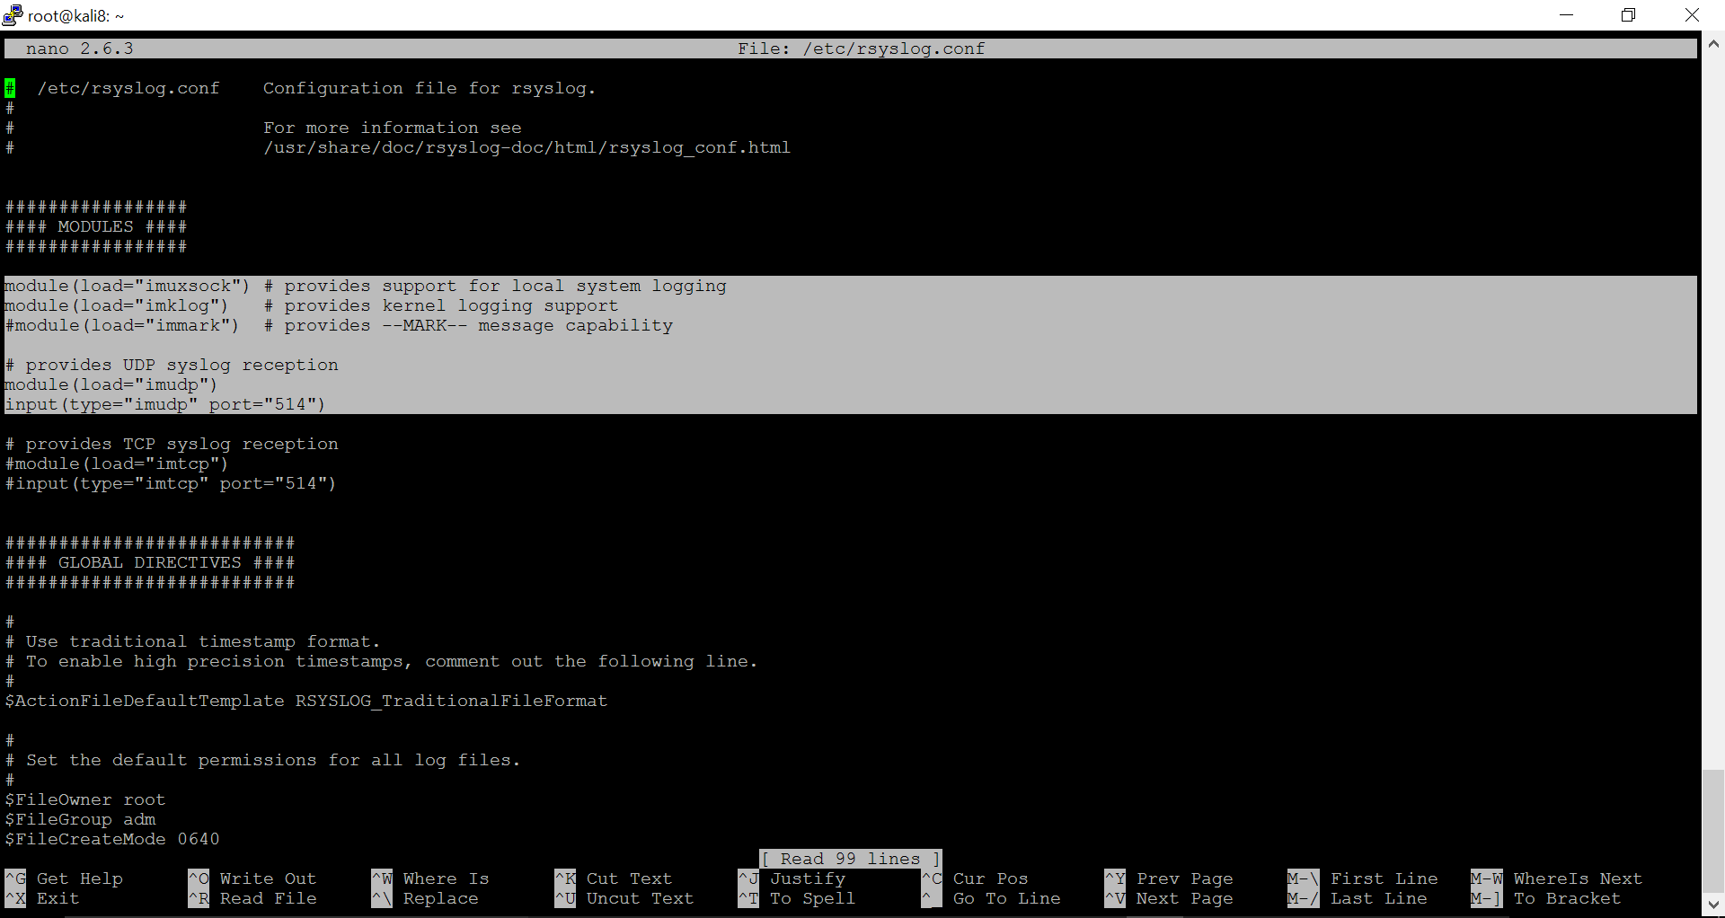
Then we use the below commands
> service rsyslog restart
> nmap -sU localhost

Later ssh to metasploitable8 VM and use the commands below
> pgrep syslogd
We will kill the pid-of-syslogd as shown below. The process is 4440.
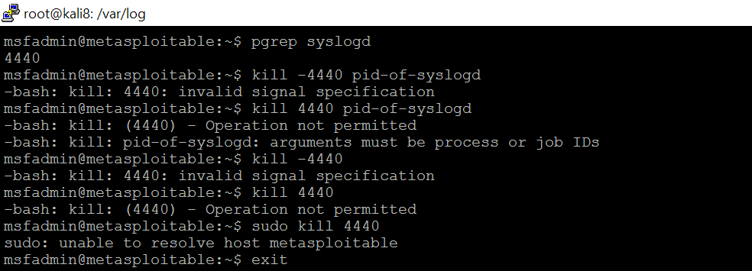

We add root@Kalis8 VM’s ip address into > /etc/syslog.conf as shown below
The necessary changes made in the file are highlighted in the screenshot below.
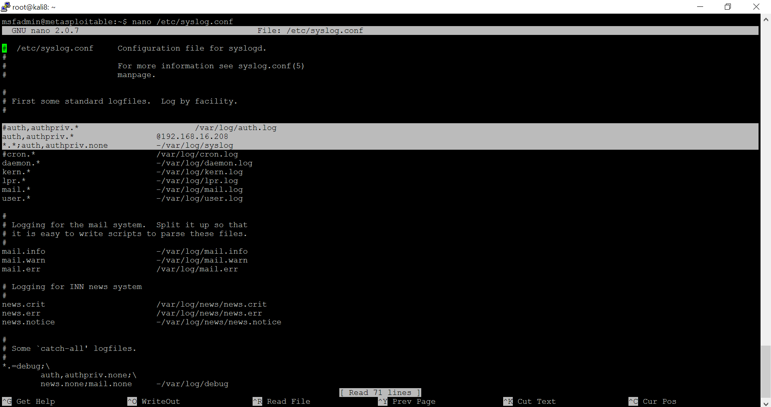

Go back to root@Kali8 VM and run the command below
> tail auth.log | grep kali8
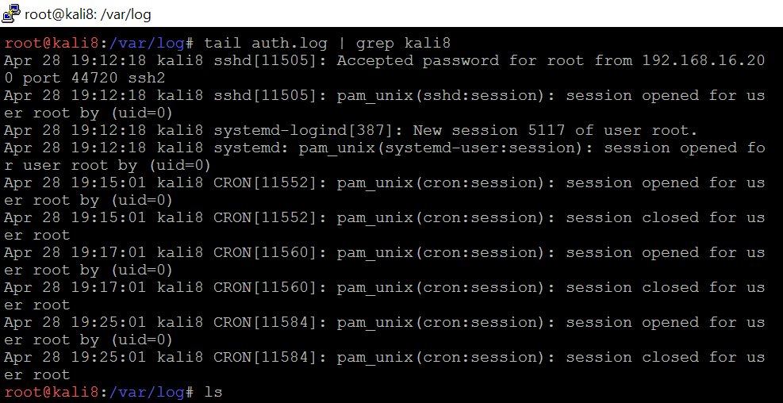

Check the auth.log file from the Kali8 VM and we confirm the set-up of remote logging. So, the logs can be sent from the team’s metasploitable 2 VM to the team’s Kali VM
