**IoT Security and Privacy**

**Assignment 4 – AWS IoT**

**10 points**

### Instructions:

1. Note: Blue text points to a web link. Ctrl + Click to follow link.
2. This is a team assignment. However, each member of the team has to submit the finished assignment. Those who do not submit will get zero for this assignment.
3. Answers to all questions must be put into **ONE** document. That is, every time, each student can only submit one report document, answering all questions of this assignment.
4. Students must put answers following each question in this assignment. The instructor will not grade a report with only answers in it and the student gets zero for such an assignment. An assignment report must include original questions.
5. Students MUST submit the finished assignment in either Microsoft Word or pdf format to Blackboard. The doc must be submitted as ONE standalone file and cannot be tarred or zipped into a container.
6. Refer to [Print screen](http://en.wikipedia.org/wiki/Print_screen) on how to take a screenshot. Pressing the Alt key in combination with PrtSc will capture the currently selected window.

**Questions:**

In this assignment, students are required to connect Raspberry Pi to Amazon AWS IoT and update the state of the connected sensor continuously with the AWS IoT thing shadow. The data such as the state generated by the sensor should be written into Amazon DynamoDB. Note: be careful not to exceed the free account quota of data for AWS IoT. Please refer to the references [1][3][4][5][6][7][8][8], particularly [1], if necessary for this assignment.

**Team members:**

1. **Kiran Shettar**
2. **Tarun Jaykumar Moorjani**
3. **Omkar Salunke**
4. **Rohan Girase**

**Requirements**:

1. Document in detail the procedures connecting Raspberry Pi to Amazon AWS IoT. (3 points)

* Go to https://aws.amazon.com/iot/ and click on **Sign In to the Console**
* Create an account and sign in with your account
* Click on **AWS IoT** under **Internet of Things**
* Go to **Registry** > **Things**. Then give a name for your thing **(pi_assn4)**. Then click on create a thing. After creating a thing Go to **Interact** and copy the **data under HTTPS** and paste it under **mqttsubscriber.py** file to **update our Thing Shadow** using this. It’s shown in below image:

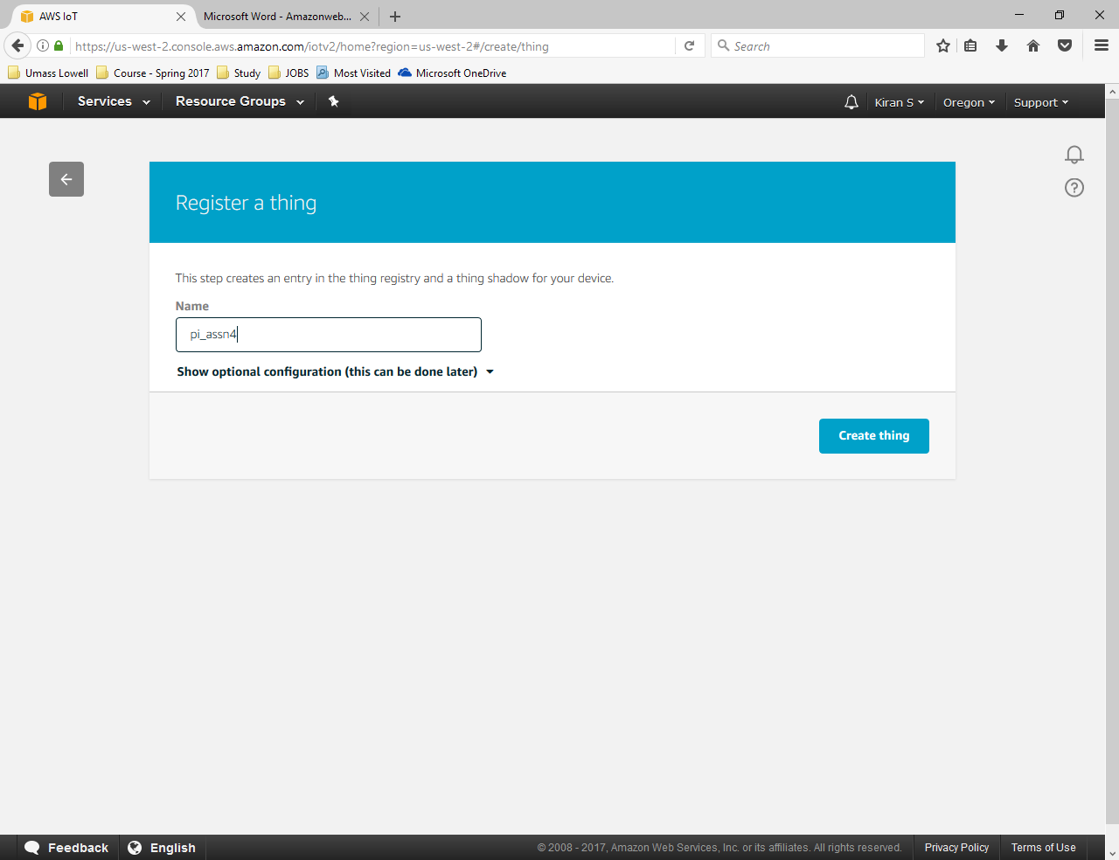

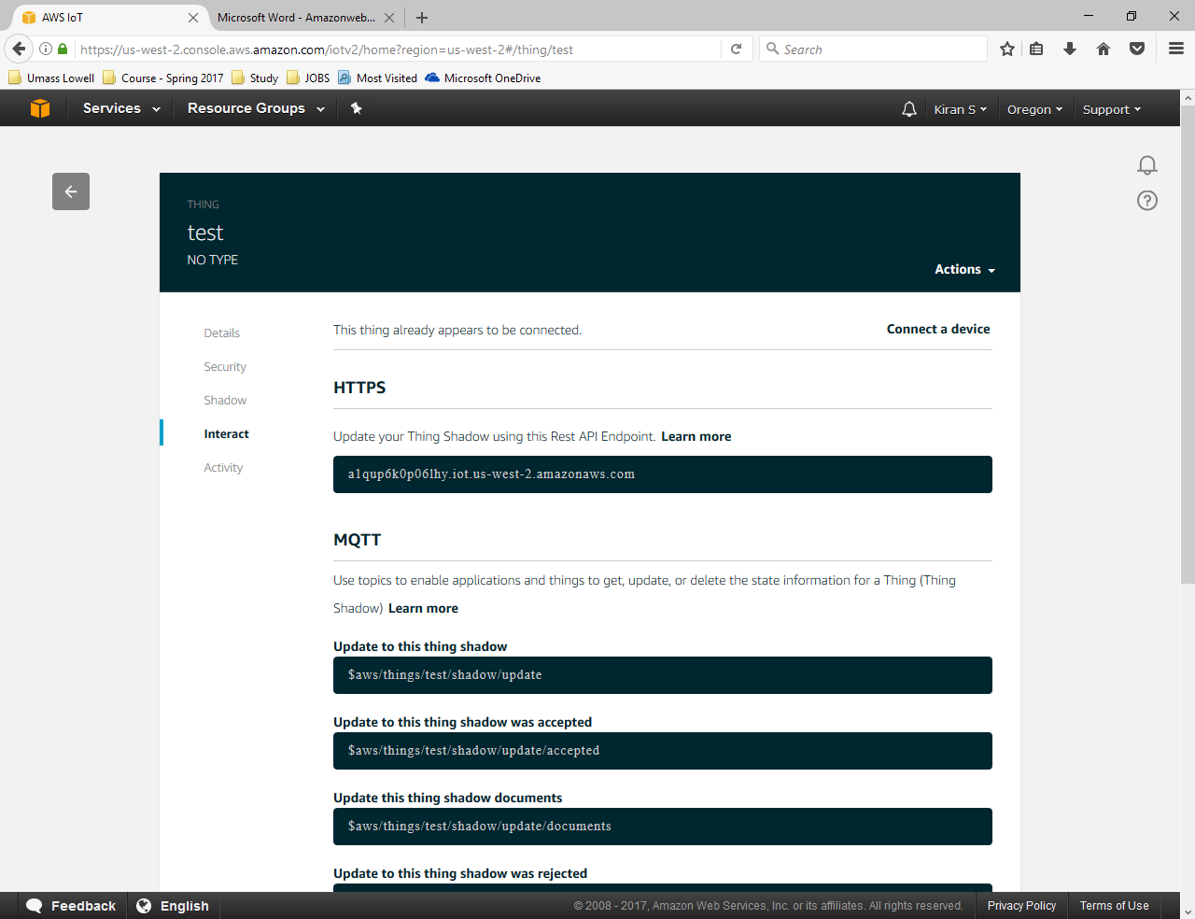

* Go to **Security** > **Create a certificate**. You’ve to download different files. Those files will be **A certificate for this thing**, **A public key**, **A private key** and **A root CA for AWS IoT (from Symantec)**. Then click on **Activate** as shown in below image:

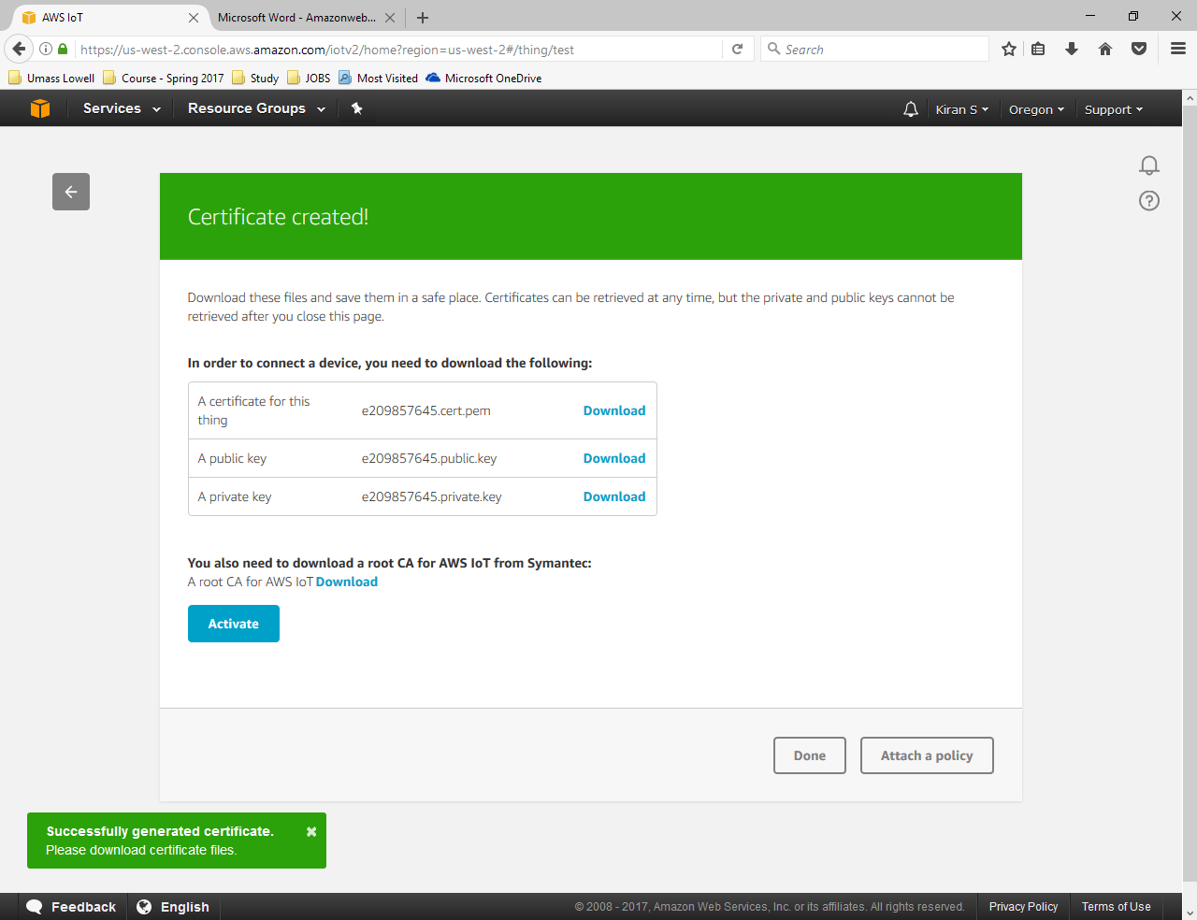

* Go to **AWS IoT** > **Security** > **Policies** then click on **Create.** Give a policy **name, Action: iot\*** and **Resource ARN:** *and then click **Create (assn4)** as shown in below image:

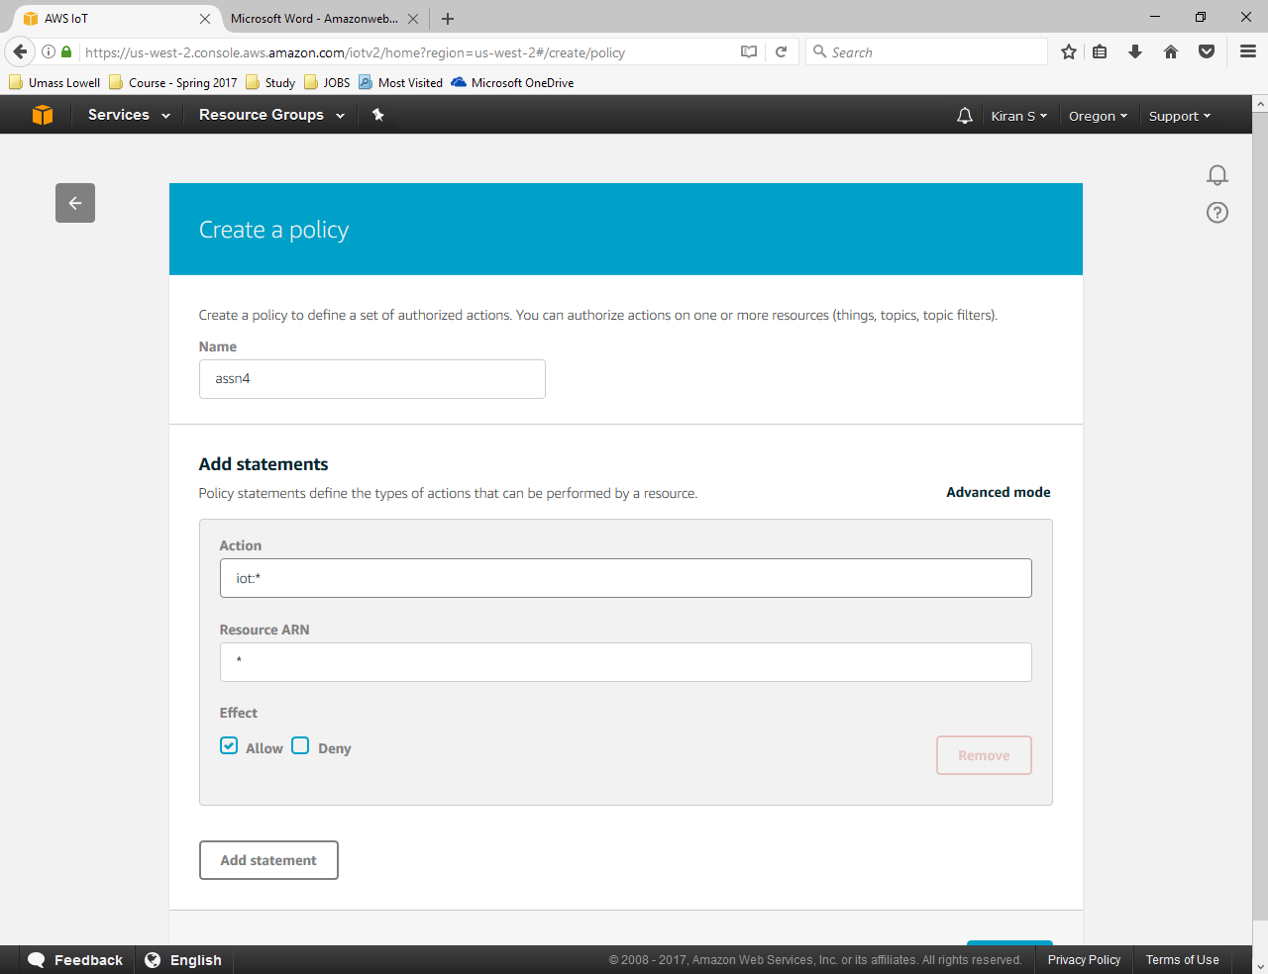

* Go to **Security** > **Certificates**. You will find a certificate that’s already created. Go to **more options** under the **certificate** created. Then click on **Attach policy**. Then attach the policy that is already created **(assn4)**. Again, in more options under the certificate, click on **Attach thing** then choosethe **thing** created **(pi_assn4)** as shown in below image:

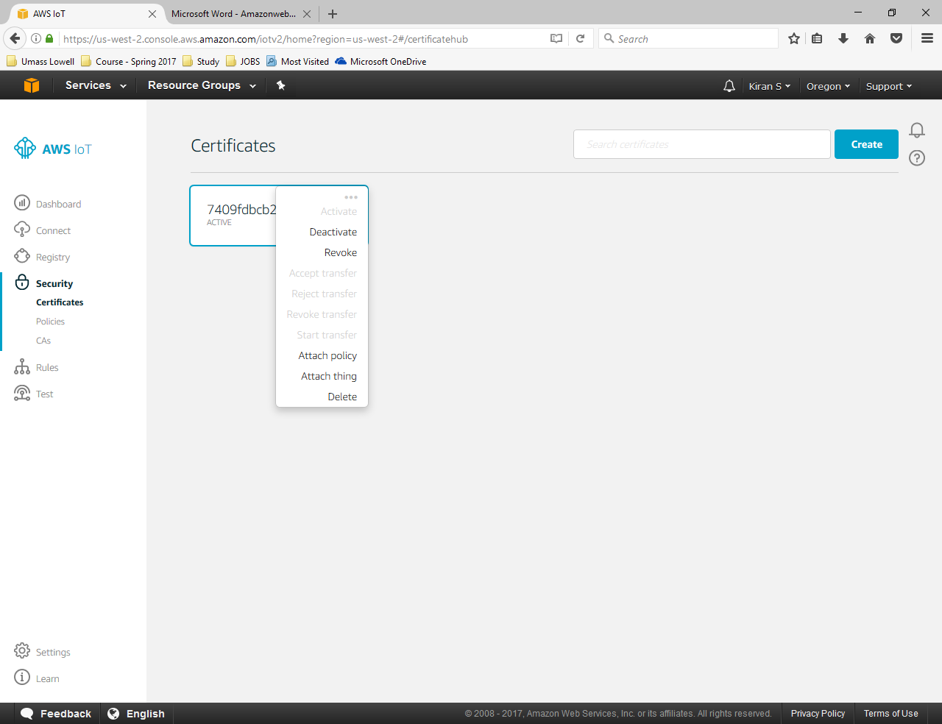

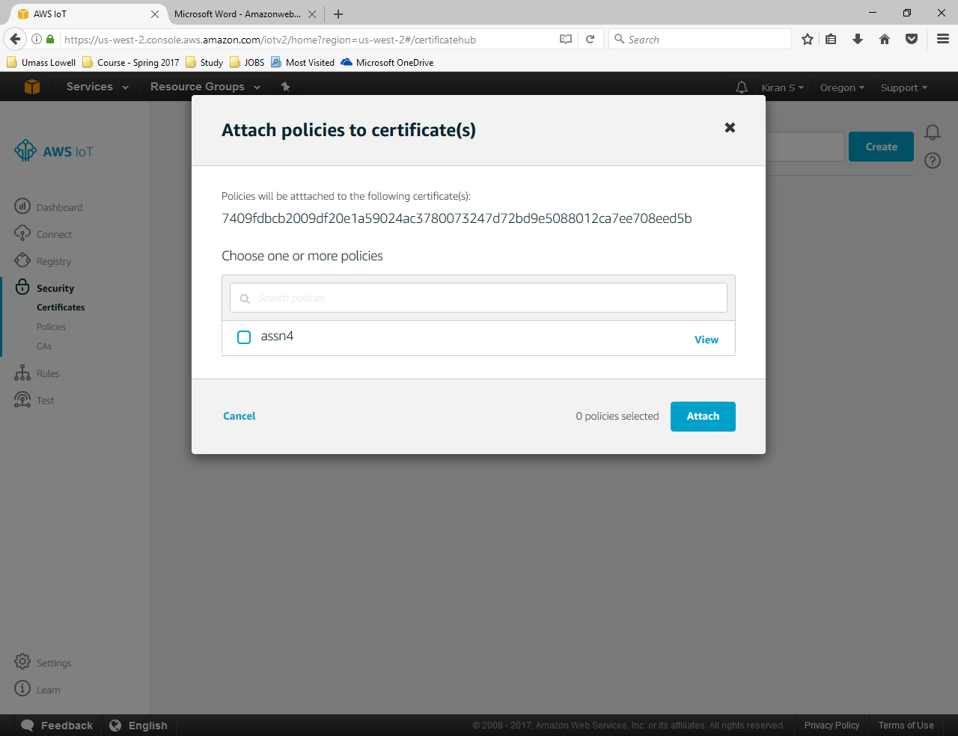

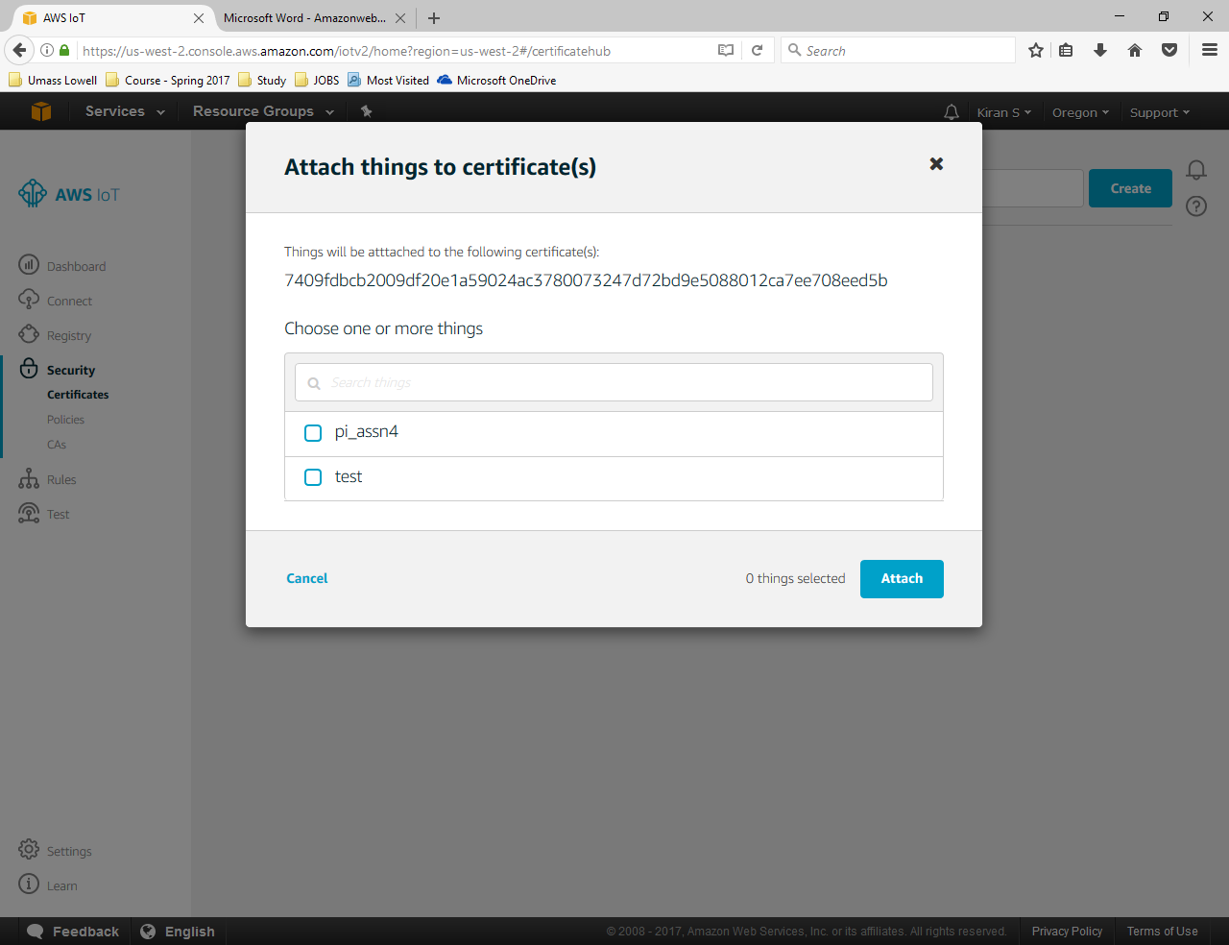

* Once we are done with all the above things i.e AWS IoT setup, we should connect the Raspberry Pi to AWS IoT. To begin with this, we should install required python library (MQTT Client and Server). We should download a script “iot-mqtt-subscriber.py” for AWS IoT MQTT Subscriber from <http://www.cs.uml.edu/~cgao/Pi/iot-mqtt-subscriber.py>
* The subscriber will listen to an AWS IoT topic for messages. We have to make a couple of changes in the code like: **thing name**, **certificate path** and the data we had downloaded **under** **HTTPS** before.
* The **modified script** for the **mqttsubscriber.py** looks as follows:

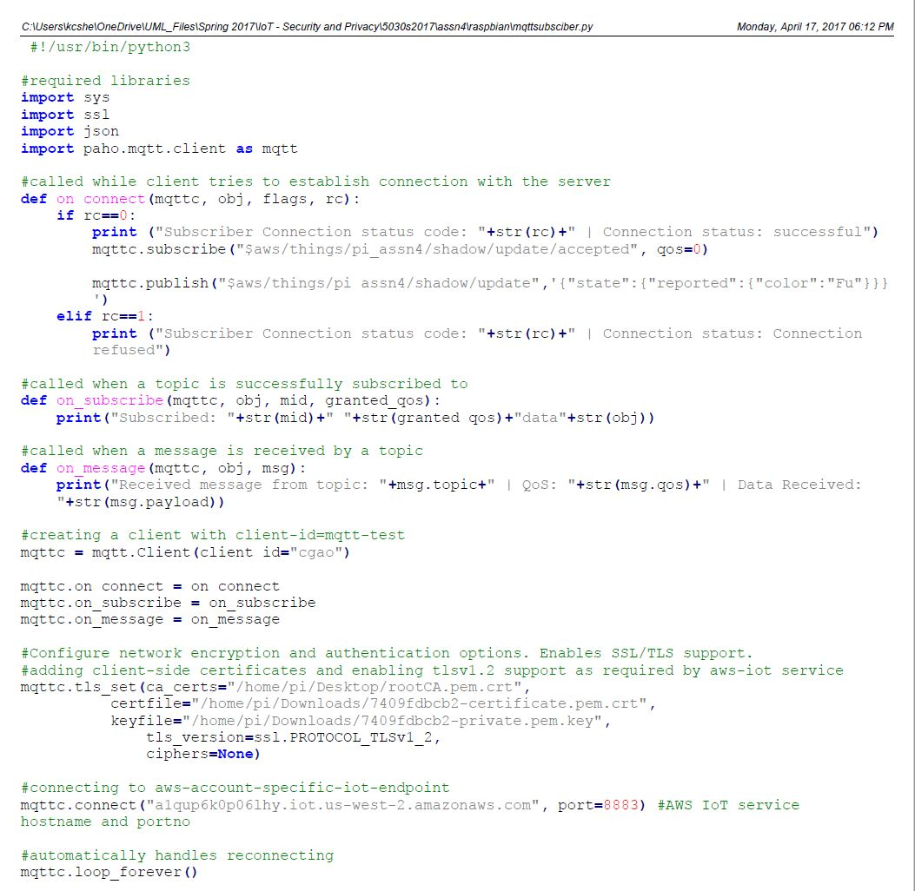

* Then we should run the mqttsubscriber.py file using the command below  
  **sudo python3 mqttsubscriber.py**  
  Later you will see the connection status as it is shown in the below image:

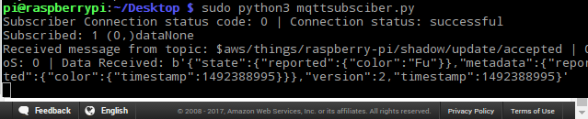

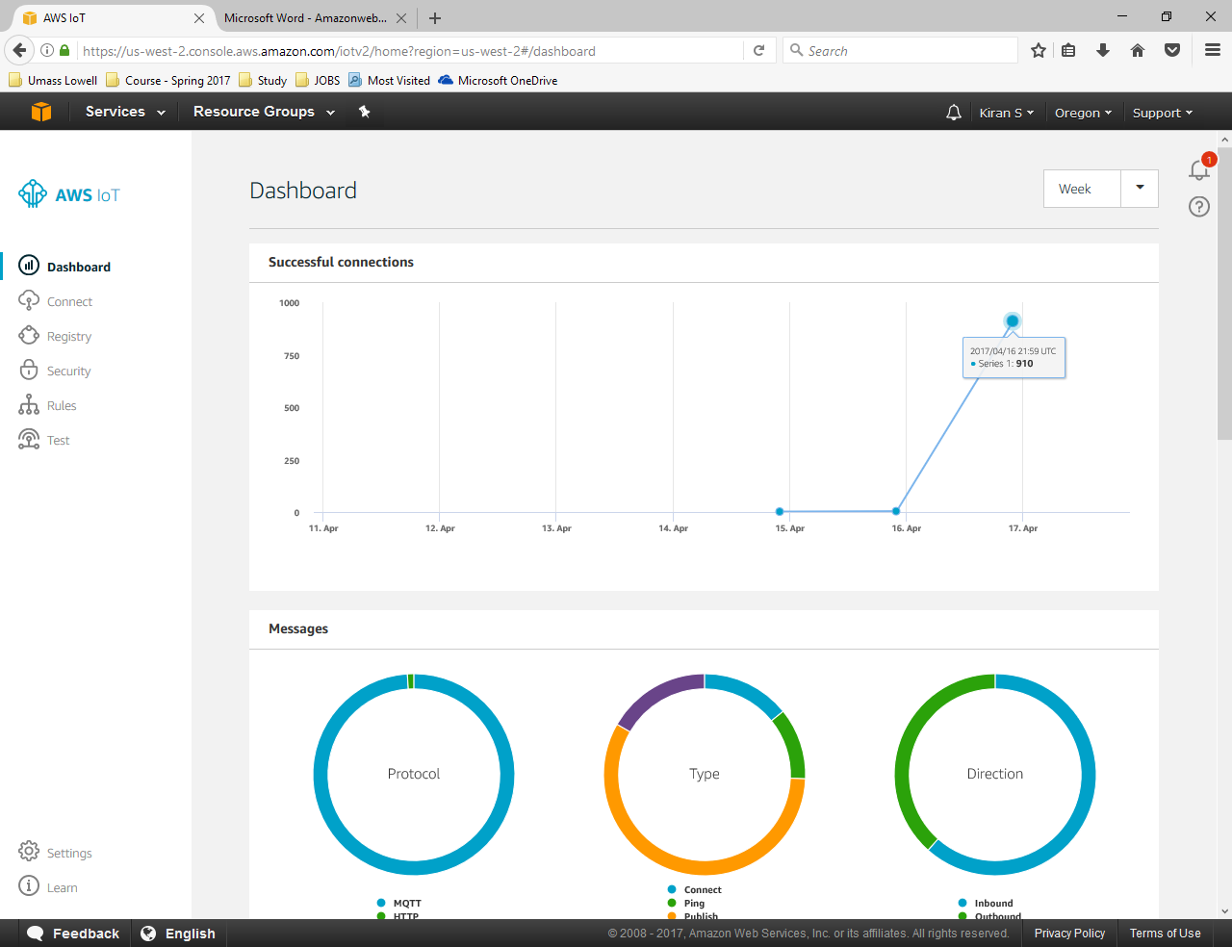

* Hence we make sure that the Raspberry Pi is connected and we update the sensor data with AWS IoT thing shadow. **Continued in next answer**

1. Document in detail the procedures updating the state of the connected sensor continuously with the AWS IoT thing shadow. (3 points)

* Once we make sure that the Raspberry Pi is connected, we update the sensor data with AWS IoT thing shadow. For that we update the sensor code in **iot-mqttpublisher.py** file. We run this script in a separate terminal as soon as we run the **mqttsubscriber.py** file to detect the motion. We run the below command:  
  **sudo python3 iot-mqtt-publisher.py**
* The messages received by the subscriber will be shown on the console. As everything worked fine, we can see the status of device on IoT console as shown in below image:

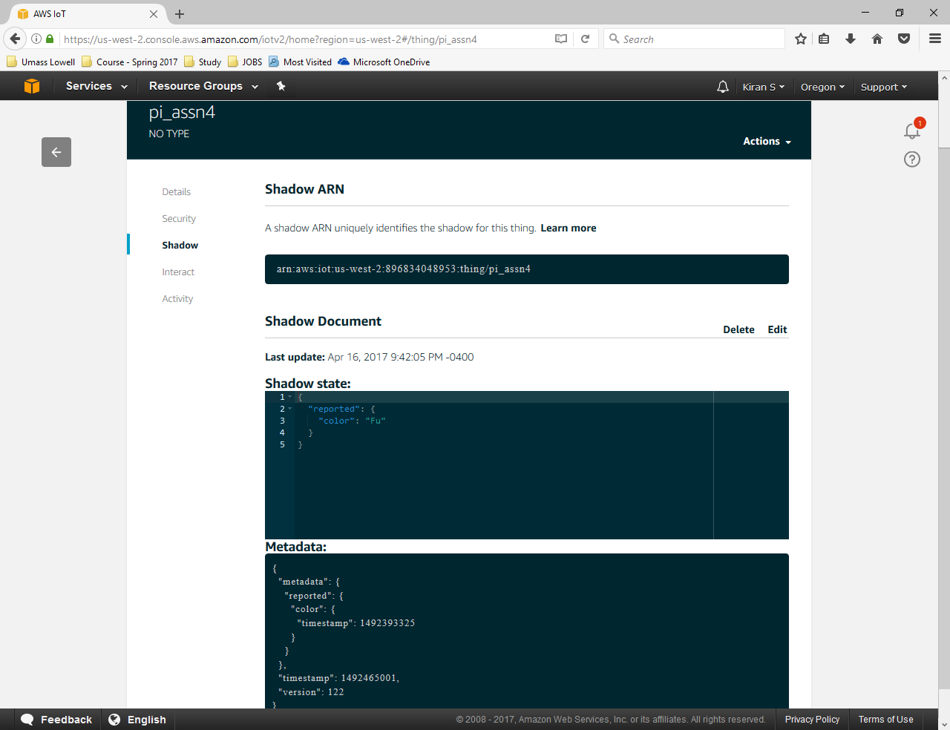

* **PIR sensor motion detection result** looks as follows, when we run the publisher script:

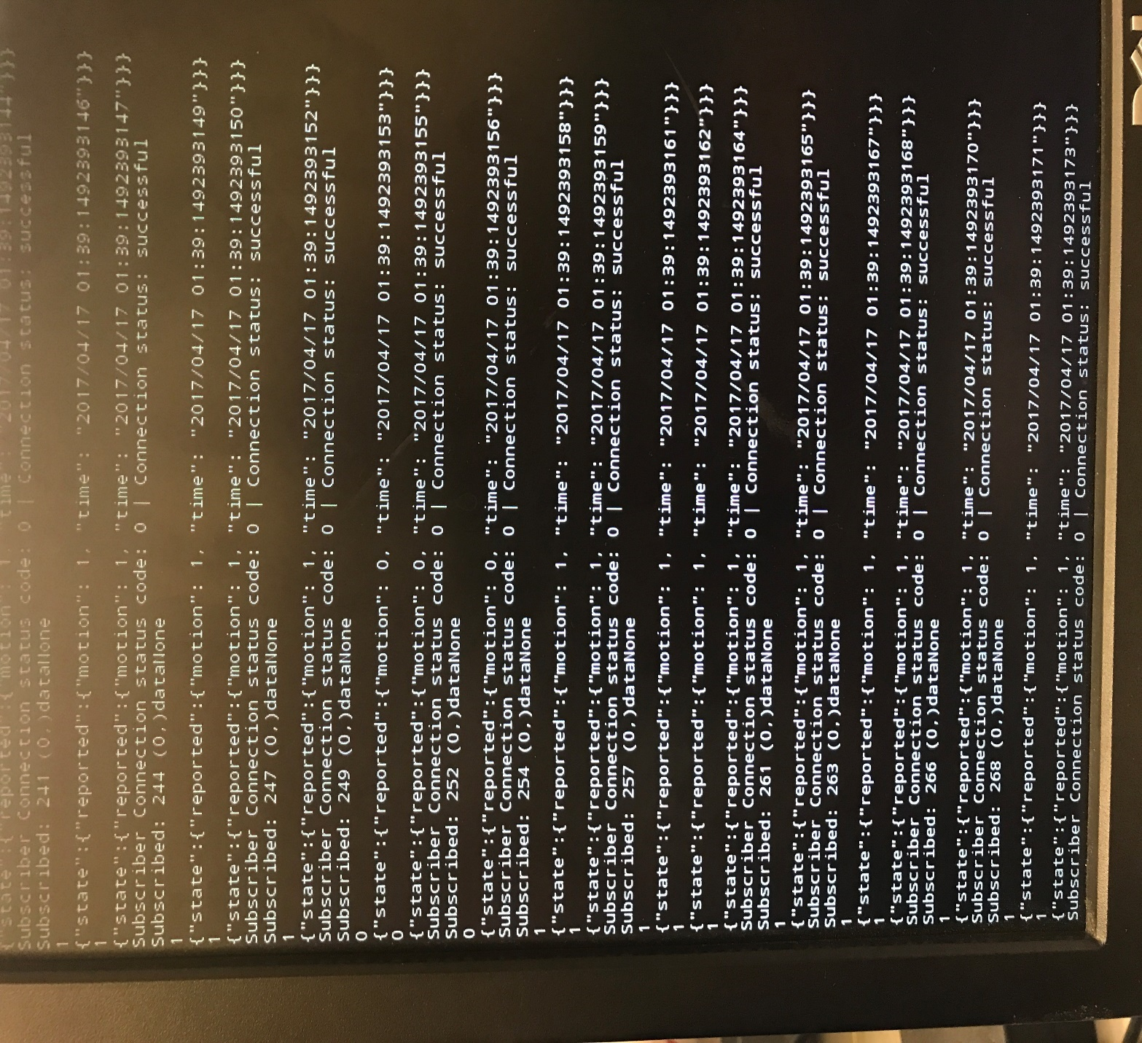

* We are using PIR sensor in our project. Hence we have updated the PIR sensor code. The sensor data is stored on AWS IoT thing shadow.
* Below is the **PIR motion detection sensor connection to the Raspberry Pi:**

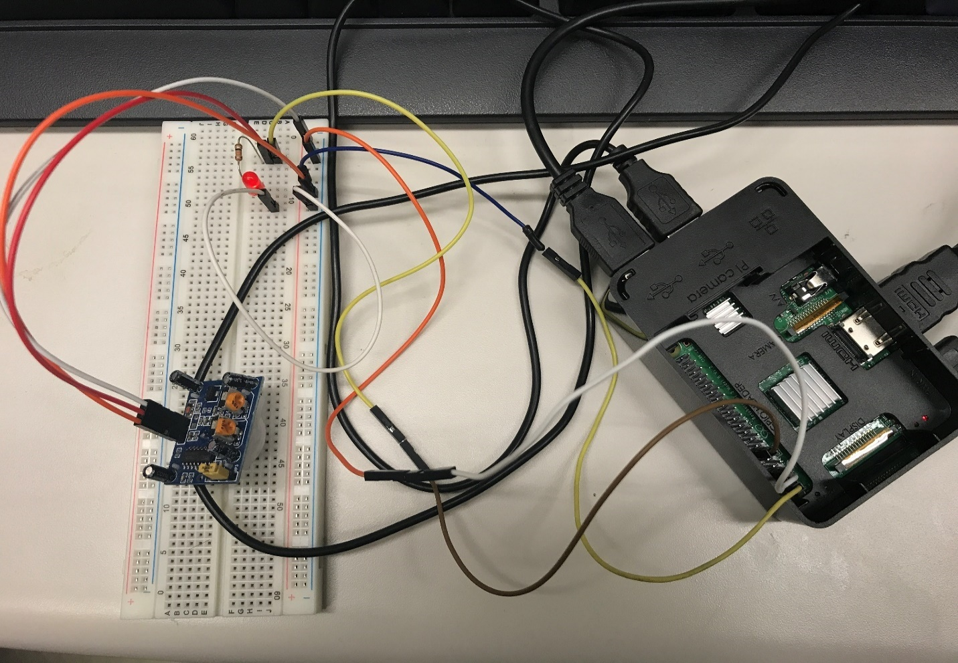

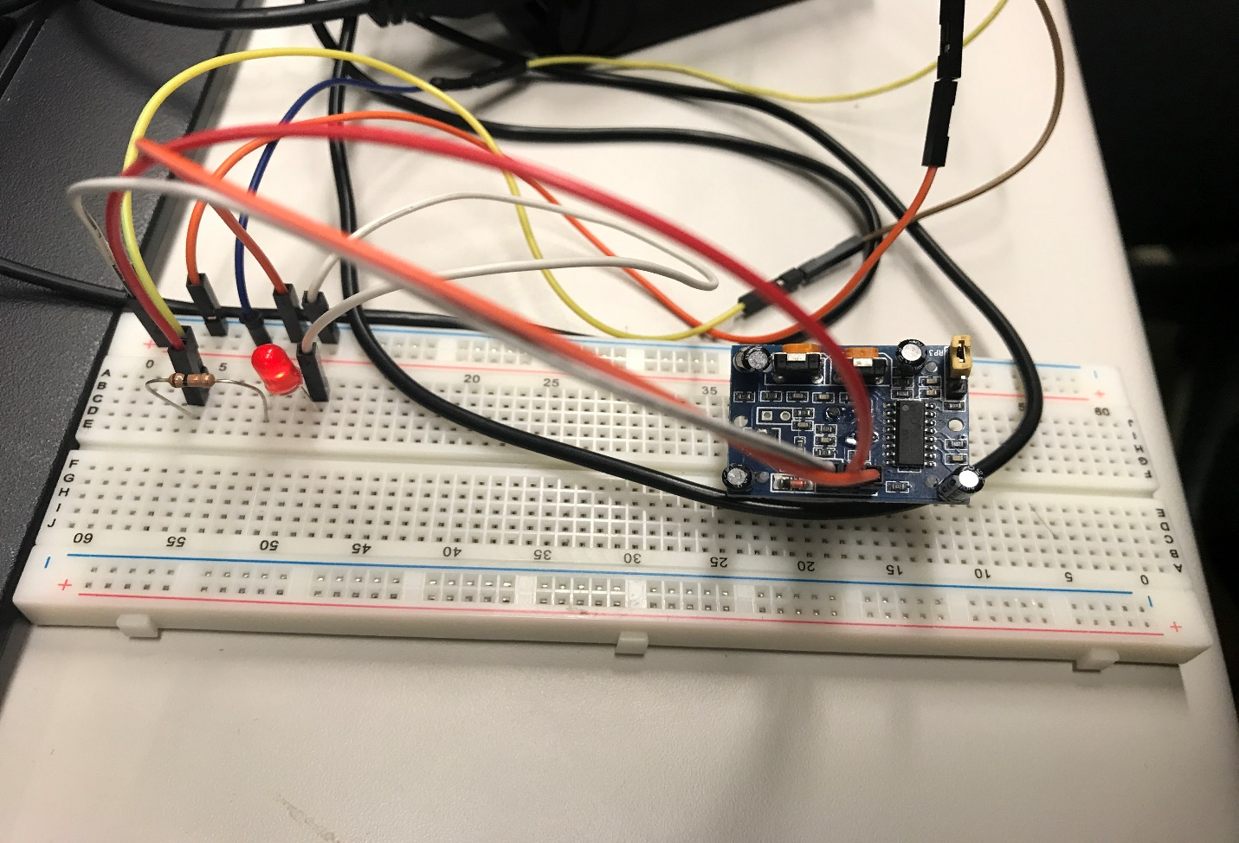

* The **modified script** for the **iot-mqtt-publisher.py** looks as follows:

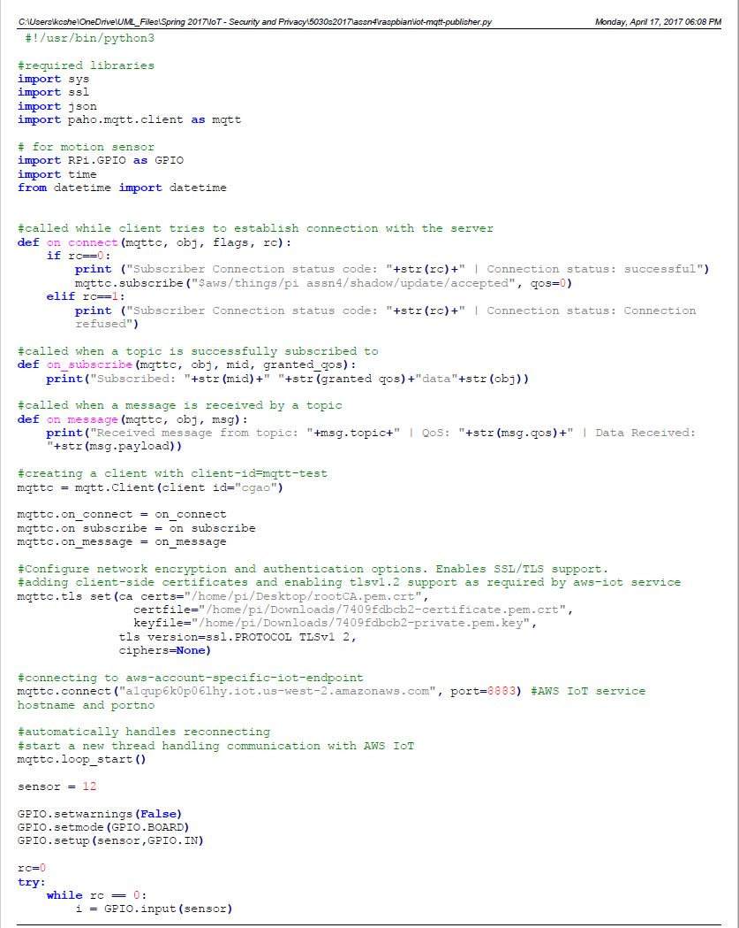

1. Document in detail the procedures writing sensor data into Amazon DynamoDB. (3 points)

* To save sensor’s data into AWS database, we should create a rule first. So, we go to **Rules** and click on **Create**. Give some name **(assn4_dynamoDB)** and provide a small Description **(PIR Sensor)** for creating a rule. In **Attribute** area type **#** and in Topic filter area type **\***. Then click on **Add Action** > **Insert a message into DynamoDB table** > **Configure action** > **Create rule** > **Choose a role** > **Add action** > **Choose a resource** > **Create a new resource**.
* The below image shows that the **rule and resource is created**:

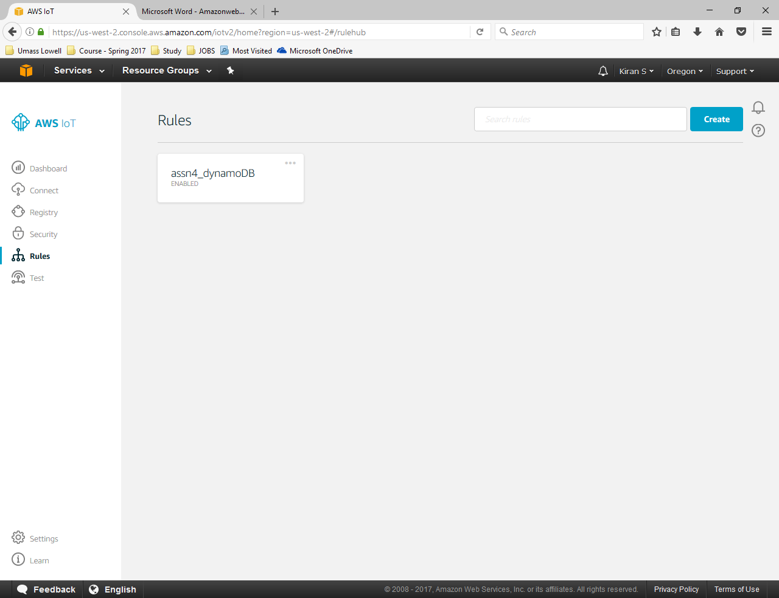

* Click on **Create table** > **Table name (motion-sensor)** > **Primary Key** fill **topic** and **timestamp.**
* Insert **Hash key value** as **${topic()}** and **Range key value** as **${timestamp()}**
* Go to **Create a new role**,then in IAM management console, choose **Create a new IAM Role** > **Role name** as **aws_iot_motion_sensor_data**. Then click on Allow.

* In the below image, we can see that the table is created:

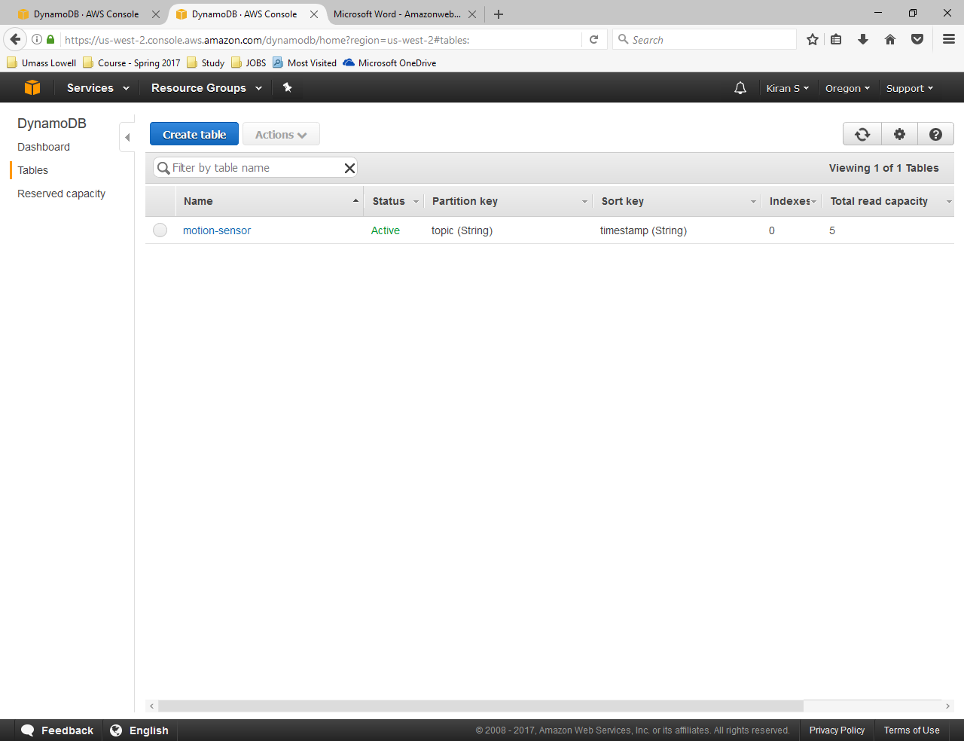

* Click on **motion-sensor** > **Items**.Here we can see the captured metadata and the data being written on the AWS IoT DynamoDB table as pictured below:

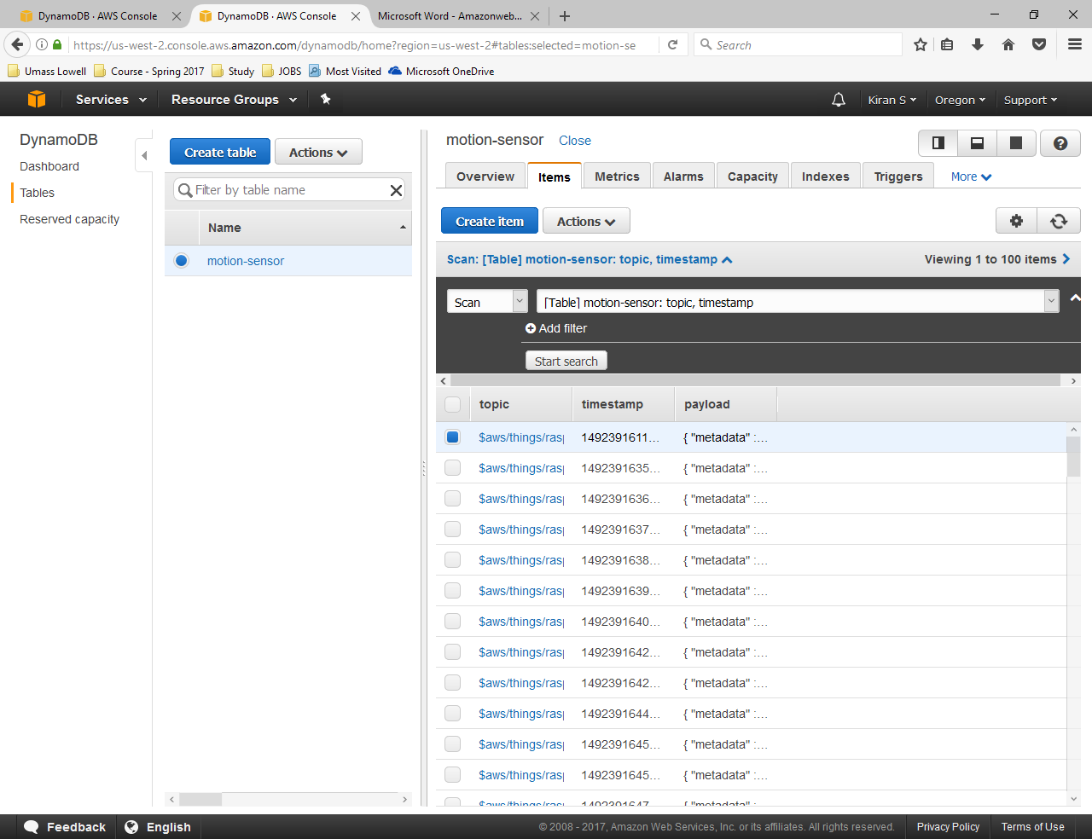

* Hence we can see writing sensor data into Amazon DynamoDB.

1. Post the code for this project into this report. Students should try to write the code for the proposed project in this assignment. (1 point)

As discussed in Previous assignment about our project topic ‘Intelligent Door.’ We are going to capture a video of Door being open/closed several times using the camera sensor on raspberry pi and use this as a test-set to train our machine. This video will be sent using WCF Service to another Machine where the video will be processed. This will allow machine to train our model.

Below is the code for capturing video (test set):

Camera.start_recording(‘video.h264’)

Sleep(500000)

Camera.stop_recording()

Once we have trained/tested our machine, we will use raspberry pi again to capture still images and send those images to the Machine using Service every 10 seconds. This image will be compared with the trained test-set we processed earlier to determine whether the door is open/closed.

Currently we have tried to write a python code that will capture an image every 10 seconds.

camera.start_preview()

for i in range(10):

sleep(10)

camera.capture('/home/pi/Desktop/image%s.jpg' % i)

upload_form3('/home/pi/Desktop/image%s.jpg'% i)

os.remove('/home/pi/Desktop/image%s.jpg'% i)

camera.stop_preview()

def upload_form3(fileToUpload):

try:

url = 'http://localhost:47176/snapshot.svc/DoFileUpload'

with open(fileToUpload,'rb') as finput:

r = requests.post(url, data=finput)

print(r.text)

except Exception as e:

print('upload_form3. Error...', e)

It will take one picture every 10 seconds and store them on the path mentioned in above code

Once the tenth picture is taken, the preview will close.

We are in process to write a machine learning algorithm to detect whether door is opened/closed. We will be using Microsoft CNTK for implementing the same.

**References:**

1. Chao Gao, [Amazon AWS IoT](http://www.cs.uml.edu/~xinwenfu/IoT/AmazonAWSIoTWithPi-ChaoGao.pdf), 2016
2. [AWS IoT developer guide](http://docs.aws.amazon.com/iot/latest/developerguide/what-is-aws-iot.html), 2016
3. Onur ŞALK, [Amazon Web Services IoT](http://www.awsomeblog.com/amazon-web-services-iot/), November 02, 2015

1. [Get Started with AWS IoT and Raspberry Pi](http://blog.getflint.io/blog/get-started-with-aws-iot-and-raspberry-pi), Oct. 18, 2015

1. [AWS Identity and Access Management User Guide](http://docs.aws.amazon.com/IAM/latest/UserGuide/id_roles.html), 2016

1. [paho-mqtt 1.1](https://pypi.python.org/pypi/paho-mqtt/1.1), 2016

1. [Introducing JSON](http://www.json.org/), 2016