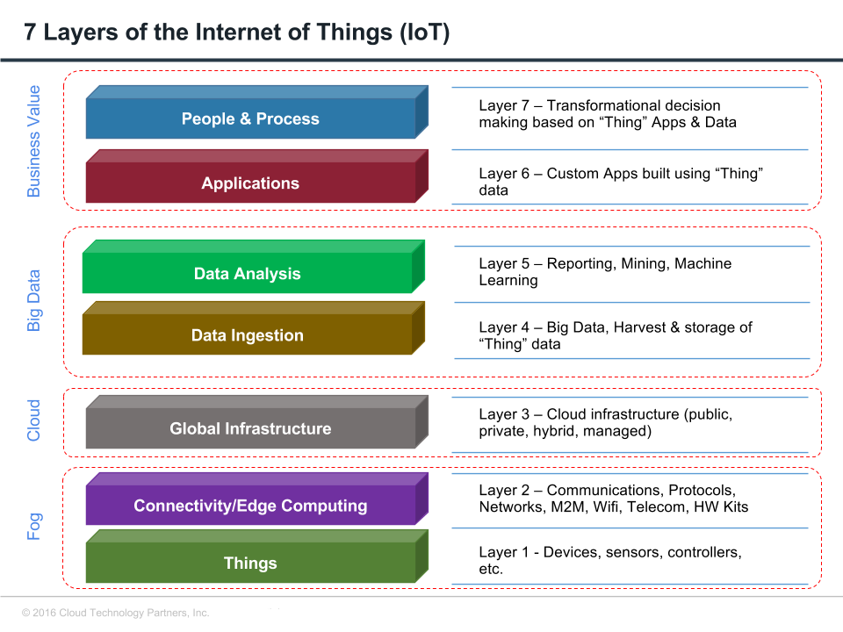

What is IOT?

* Short for Internet of Things
* System of interrelated computing devices, mechanical and digital machines provided with unique identifiers (UIDs) and the ability to transfer data over a network without requiring human-to-human or human-to-computer interaction
* Devices that are always available and always connected
* System consists of sensors/devices which “talk” to the cloud through some kind of connectivity
* Once the data gets to the cloud, software processes it and then might decide to perform an action, such as sending an alert or automatically adjusting the sensors/devices without the need for the user

What are the 3 parts of IOT?

1. Power
2. Communications
3. Information

Power Solutions

1. Standard Grid Power Available
   1. Manufacturing
   2. Home
2. Battery Power
   1. Remote applications
   2. Mobile Applications
3. Energy Harvesting
   1. Really Remote Applications
   2. Really Mobile Applications

Communication Solutions

1. Wired
   1. Many networks use standard LAN
   2. Some use RS-232 or other low speed serial
   3. Some auto/manufacturing applications use CANBUS.
2. Wireless
   1. 915 MHz dedicated Link
   2. Bluetooth
   3. WLAN
   4. Zigbee

Information Solutions

1. Spectrum Representation
2. Fourier Series
3. Sampling
4. DSP
   1. Spectrum Analysis
   2. DFT
   3. FIR Filter
   4. Examples