Functions and Their Graphs
Section 2.2

The following functions are basic algebraic functions that you will be expected to know. You should be able to draw the graph of each function without plotting points and if shown the graph, you should recognize the function.
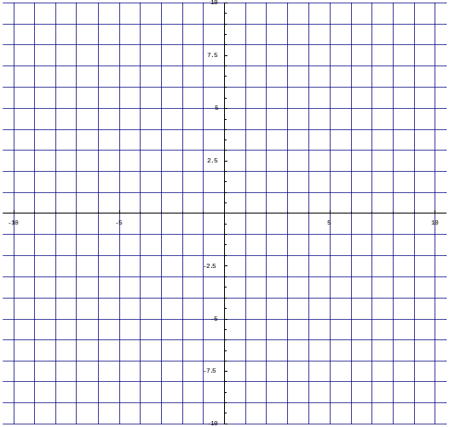
- Graph .

Domain:
Range:
Increasing:
Decreasing:
Important points: (0, )
(1, )
(-1, )

- Graph .

Domain:
Range:
Increasing:
Decreasing:
Important points: (0, )
(1, )
(-1, )

- Graph 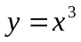.

Domain:
Range:
Increasing:
Decreasing:
Important points: (0, )
(1, )
(-1, )
- Graph 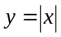.

Domain:
Range:
Increasing:
Decreasing:
Important points: (0, )
(1, )
(-1, )

- Graph 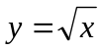.

Domain:
Range:
Increasing:
Decreasing:
Important points: (0, )
(1, )
(-1, )

- Graph 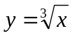.

Domain:
Range:
Increasing:
Decreasing:
Important points: (0, )
(1, )
(-1, )

- Graph 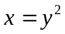.

Domain:
Range:
Increasing:
Decreasing:
Important points: (0, )
(1, )
(-1, )

- Graph 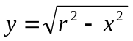.

Domain:
Range:
Increasing:
Decreasing:
Important points: (0, )
(1, )
(-1, )

