Data Preprocessing and Clustering

### CSE 450 - Machine Learning & Data Mining

With Module 01 behind us, you’re now an expert pandas [data wrangler](https://en.wikipedia.org/wiki/Data_wrangling).

Here’s how Module 02 (and every subsequent module) will go:

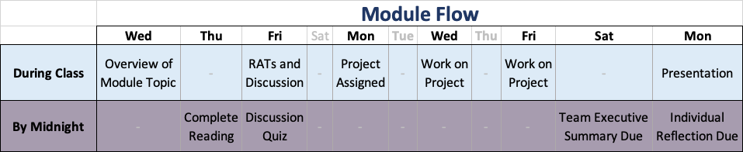

Before class on Friday, you’ll need to complete the [Preparation Reading Assignment](http://docs.google.com/reading.html). Complete [Readiness Assurance Test](http://docs.google.com/RAT-02.pdf).

You might also want to review the introduction to this [module’s case study](http://docs.google.com/intro.html).

[Case Study Project](http://docs.google.com/project.html)