* Introduction
* Stakeholders
* Dataset

# CSE 450 - Machine Learning & Data Mining

## Module 02 — Case Study Introduction

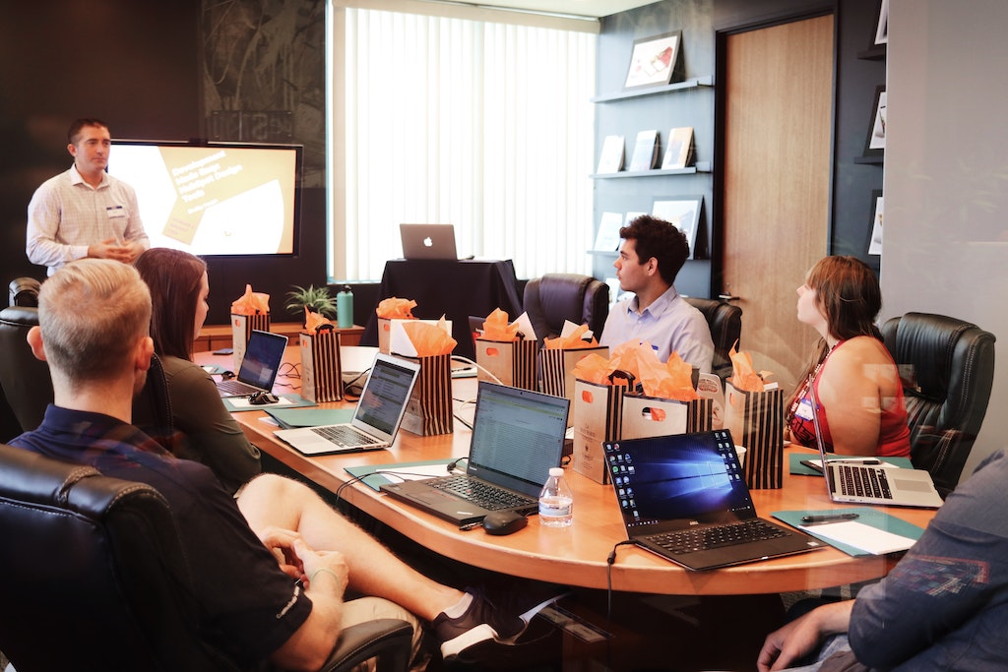 [*Photo by Campaign Creators on Unsplash*](https://unsplash.com/photos/gMsnXqILjp4)

## Introduction

You’re working as a data analyst for Red Mic LLC, a company that specializes in manufacturing professional grade microphones for musicians and newscasters.

Recently, a rival company (Green Audio Inc) announced that they were launching a set of initiatives to take their organization into the twenty-first century.

After a heated shareholders meeting, the board of directors has tasked the CEO with making sure Red Mic LLC isn’t left behind.

## Stakeholders

These are the individuals your team will be helping during the case study.

##### 

Cecil, the VP of Human Resources

Hello, I'm Cecil the Vice President of Human Resources. If you have any questions about benefits or workplace culture, please let me know. I look forward to working with you.

Cecil came to Red Mic three years ago and has revolutionized employee on-boarding and retention. She's excited to see what data science can bring to the table.

##### 

William, the VP of Finance

Charmed.

William has always been skeptical of data science. He likes his data kept in Excel spreadsheets where he can keep an eye on it.

##### 

Devon, the CEO

It's good to finally have you on the team. I can't wait to see what you can do for Red Mic

Devon graduated from Stanford five years ago, launched a VC-backed startup that was later acquired by Red Mic, and was named the CEO by the new board of directors.

##### 

Johnny, the data science intern

Welcome to Red Mic! I'm so glad you're here, now I'm officially not the newest person on the team! What's your favorite Python library?

Johnny is very, very excited about all things data science.

Stakeholder Focus Areas

The shareholders are particularly interested in the following areas:

1. Making sure Red Mic LLC has a diverse workforce.
2. Ensuring that employees with similar positions and experience are receiving equitable pay, regardless of race, gender, or marital status.
3. Striving to reduce employee turnover by actively measuring employee satisfaction and engagement, as well as engaging employees in special projects.
4. Analyzing what work-life balance issues might exist in the workforce that could be negatively impacting employee performance and longevity.

You're about to go into a strategy meeting with the CEO, Vice President of Human Resources, and Vice President of Finance. They want to make sure you have the data required to answer the questions they're most interested in.

## Dataset

Spend some time with your team evaluating [the data](https://raw.githubusercontent.com/byui-cse/cse450-course/master/data/hr.csv). Be sure to look at data types, ranges, and meanings of each feature from the [data dictionary](http://docs.google.com/hr-dictionary.txt).

You can use the following Google Colab notebook to assist you:



1. [CEO photo by Oz Seyrek on Unsplash](https://unsplash.com/photos/-Ir03_pgpMU)  ↩
2. [VP of HR photo by Christina @ wocintechchat.com](https://unsplash.com/photos/SJvDxw0azqw) ↩
3. [VP of Finance photo by steffen Wienberg on Unsplash](https://unsplash.com/photos/ml-pxK0Ovmw) ↩
4. [Data Science Intern photo by Fábio Lucas on Unsplash](https://unsplash.com/photos/iczrMDNuvzkml-pxK0Ovmw) ↩