* Introduction
* Stakeholders
* Dataset

# CSE 450 - Machine Learning & Data Mining

## Module 03 — Targeted Marketing, Case Study Introduction

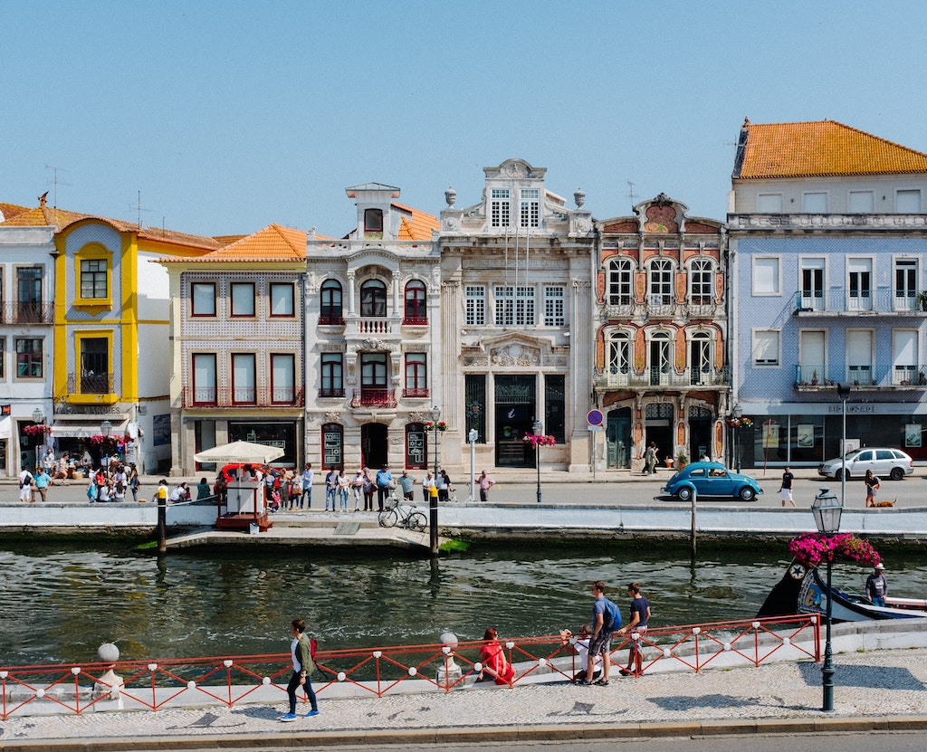 [*Photo by Ricardo Resende on Unsplash*](https://unsplash.com/photos/swivynstICo)

## Introduction

You've just been hired as a junior data scientist for Banco Federal de Finanças in Aveiro, Portugal. They just finished a major telemarketing campaign and management was not happy with the results.

They feel like machine learning could help them create a more targeted campaign. You and your team have been brought in to discuss the situation.

## Stakeholders

These are the individuals your team will be helping during the case study:

##### 

Senhor Ferreira, Chairman of the Board

Olá, I'm Senhor Ferreira.

You can call me...Senhor Ferreira.

I believe in old fashioned banking practices — reaching out to customers with a personal touch.

My son, Senhor Ferreira II, thinks we might be able to do better with computers. He is a smart boy, but I don't know...

##### 

Miguel Ferreira, Bank President

Obrigado, Senhor Ferreira.

I'm Miguel, president of the bank. Like my father said, reaching out to customers with a personal touch is important. But, I believe we can learn a lot from what AI has to offer, so I'm excited to have you on the team.

##### 

Francisco, VP of Marketing

Olá, I'm Francisco. It's a pleasure to meet you.

We're planning some major growth initiatives over the next quarter, and I'm excited to see how AI can help.

##### 

Beatriz, Senior Data Scientist

Bem vindo ao time.

I've been assigned as your mentor for your first three months here. I'll try to answer any questions you might have about the bank or data science in general.

Stakeholder Focus Areas

The shareholders are particularly interested in the following areas:

1. Finding interesting customer segments based on their previous marketing campaign.
2. Finding a way to identify the types of customers most likely to respond favorably to future marketing campaigns.
3. Proving to a skeptical Senhor Ferreira that a targeted campaign based on data science will significantly outperform a campaign made up of randomly selected customers.

You've been invited to dinner tomorrow night with the President of the bank, VP of Marketing, and the Senior Data Scientist. They're planning to discuss the marketing campaign and would like your input on a few key points.

## Dataset

Spend some time with your team evaluating [the data](https://raw.githubusercontent.com/byui-cse/cse450-course/master/data/bank.csv). Be sure to look at data types, ranges, and meanings of each feature from the [data dictionary](http://docs.google.com/bank-dictionary.txt).

You can use the following Google Colab notebook to assist you:



1. [Chairman of the Board photo by Portuguese Gravity on Unsplash](https://unsplash.com/photos/oMF2q4tlhDg) ↩
2. [President photo by Roland Samuel on Unsplash](https://unsplash.com/photos/MZ5A24H1JqU) ↩
3. [VP of Marketing photo by Mehrad Vosoughi on Unsplash](https://unsplash.com/photos/iUQmEFtfdLw) ↩
4. [Head of Data Science photo by Mateus Campos Felipe](https://unsplash.com/photos/WnPJft0DJpk)  ↩