- Overview
- Introduction
- Assignment
- Teacher's Solution

CSE 450 - Machine Learning & Data Mining

Exploration 05: Covid-19
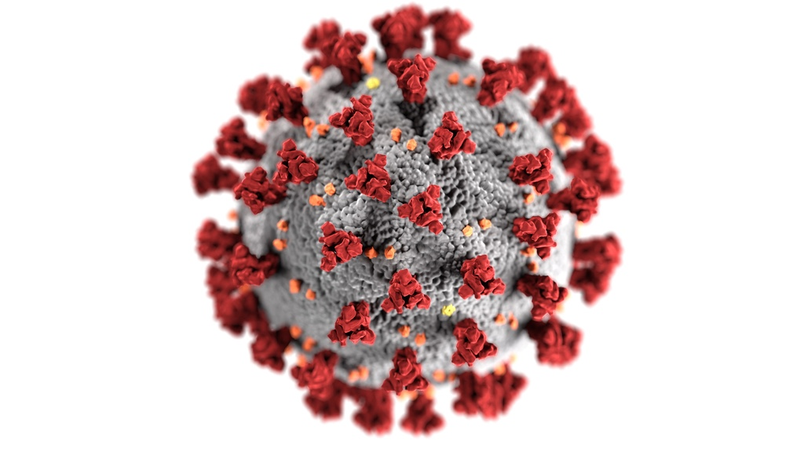 Image by CDC on Unsplash

Overview
In this data exploration, you will:
- Explore Naive Bayesian Classification
- Learn to handle missing data
- Learn to encode textual data for machine learning
- Be introduced to SciKit Learn
Throughout this exploration, when you're asked to use a new function or library, we'll usually provide a link to that function's documentation, or a tutorial related to it.

Introduction
As with our previous data explorations, this assignment uses Google Colab. For more information on using Google Colab, including how to submit assignments with it, please see the information in Data Exploration 01

Assignment
The data analyst firm you work for has been contracted by a local Health Authority to conduct a risk assessment of Covid-19.
Your research supervisor has asked you to use the latest CDC case data to preform a Bayesian analysis to calculate the probability of death from Covid-19 among certain demographics.
Click on the Open In Colab button below to open a Google Colab notebook with the template for this assignment. Once you've completed the assignment, don't forget to take the corresponding quiz in Canvas.

Teacher's Solution
Once you have absolutely exhausted all of your best efforts in solving the data exploration problems, and you are stuck on where to go next, you can view the teacher's solution here.

