Data Preprocessing and Clustering

CSE 450 - Machine Learning & Data Mining
With Module 01 behind us, you’re now an expert pandas data wrangler.
Here’s how Module 02 (and every subsequent module) will go:
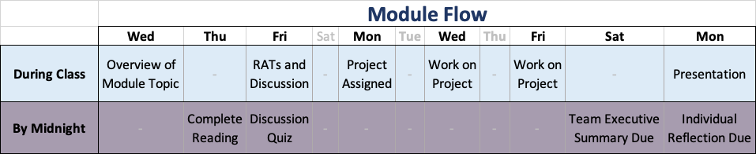
Before class on Friday, you’ll need to complete the Preparation Reading Assignment. Complete Readiness Assurance Test.
You might also want to review the introduction to this module’s case study.
Case Study Project

