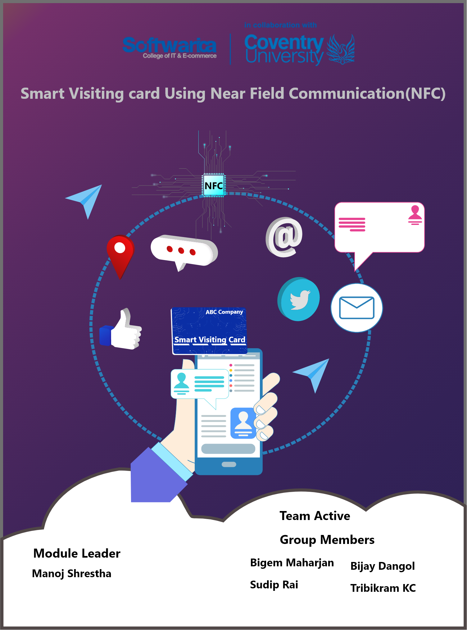

**Contents**

Introduction 3

Aim 4

Objectives 4

Personal Objective 4

Academic Objective 5

Technical Objective 5

Justification 5

Problem Statement 5

Solution Statement 5

Ethical Consideration 5

Literature review 6

**Table of Figures**

Figure 1: Introduction Picture 3

Figure 2: Aims and Objectives 4

Figure 3: Ethical Considerations 6

# Introduction

**“Information technology and business are becoming inextricably interwoven. I don’t think anybody can talk meaningfully about one without the talking about the other.”** **–Bill Gates**

The aim of the activity expresses in this Report is to provide a smart visiting card which will be beneficial for the professionals and business organizations. Business card or visiting card is one of the important thing needed by any business person or an organization. With technology driving our society to become more interconnected it makes us wonder whether as the business cards are still relevant. When establishing a marketing campaign the creation of business cards provides a vital touch point for client interaction, carefully thought out business card can leave a long lasting impression. More than business cards just being a proper formality it provides conversation between business organization and their clients. This interaction will bolster the business relationship. Putting a unique touch on business cards can make all the differences for your clients and company. On top of this, great business card can further your business by positive word of mouth down the pipeline. These positive comments not only make the company stand out but can increase the likelihood of people of coming to the company. Most of the organizations use the old traditional paper card which has a lots of limitations and drawbacks. It cannot hold the detailed contact information and need to print from time to time. It is also difficult to update the information in the card. There will be the need of reprint the card if any updates have to be made which will cost more. Smart visiting card can solve all the problems mentioned above and make it more effective and efficient.

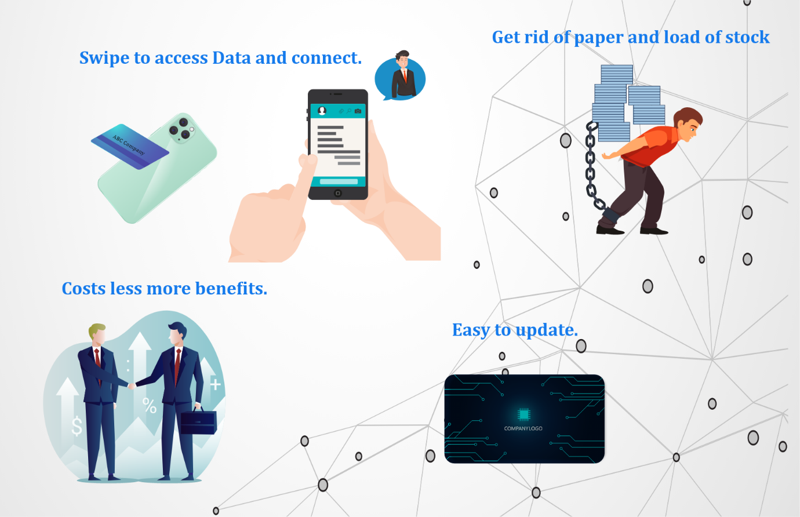

Figure : Introduction Picture

Smart card is a unique form of card which consist of microcircuit chip installed on it. It is used to deliver fast, secure transactions and protect personal information. In smart visiting card professional profile is integrated which allows to network with people more efficiently by providing important information about the company and personnel. Smart business card allows you to share information with the profile you build with single tap and it works with most mobile phones out there making the simplest way to exchange information. Why carry the stacks of documents or bundle of paper cards when it is more efficient and easy with the smart card. In this project, we are going to develop smart visiting card by using the Near Field Communication Technology (NFC). It will provide a lots of benefits to the business person and business organizations by overcoming the limitation of tradition paper visiting card. In addition, it works when this card is tap against the smartphone that support the NFC technology and it share the details like the contact and social media detail. This smart visiting card not only replace the business card which need to be order constantly but also it make sure to deliver the first impression every time when it shows to visitor. This report will show all the cons and pros of smart visiting card, risk and issues during the project, challenges of project management, tools and technology used, methods, evaluation and the results.

# Aim

To provide easy access to biometrics, authentication, data storage, application processing and encryption with less use of paper and less costs.

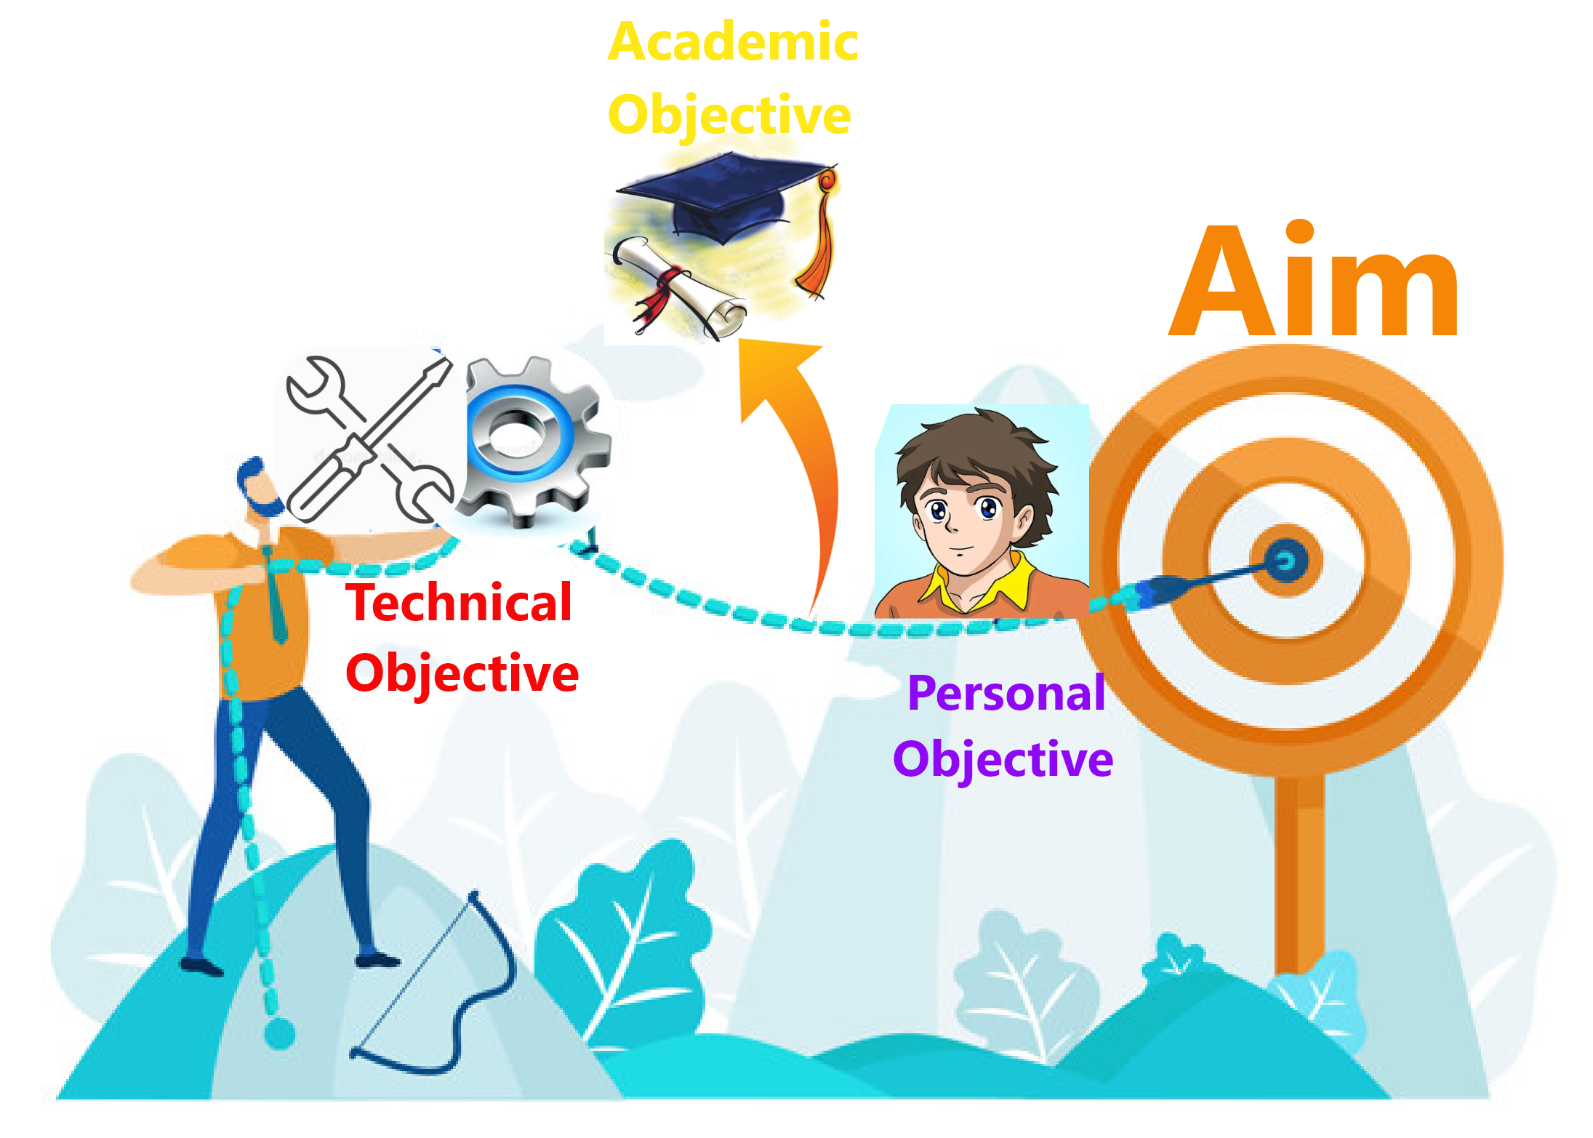

Figure : Aims and Objectives

# Objectives

## Personal Objective

* Learn about the new technologies and development tools.
* Build experience of using database.
* To learn how to use NFC technology to solve the real world problems.

## Academic Objective

* Finish the requirements given by Coventry University.
* Learn about the smart card and its algorithm and methodologies.
* Accomplishment of fourth semester with good grade.

## Technical Objective

* Delivering the consistently positive user experience.
* Providing the portability to store data with high storage capacity.
* Protecting the information with fast access to it and secure transaction.
* Educating the enterprises, service providers, and developers on using NFC technology to deliver solutions for real world problems and grow their businesses.
* Providing smooth and clean interface design to deliver the complete profile including picture, social media profile, education, experiences and other essential documents.
* Easily update and manage the profile. Eliminates the problem of reprint to change any details.

# Justification

## Problem Statement

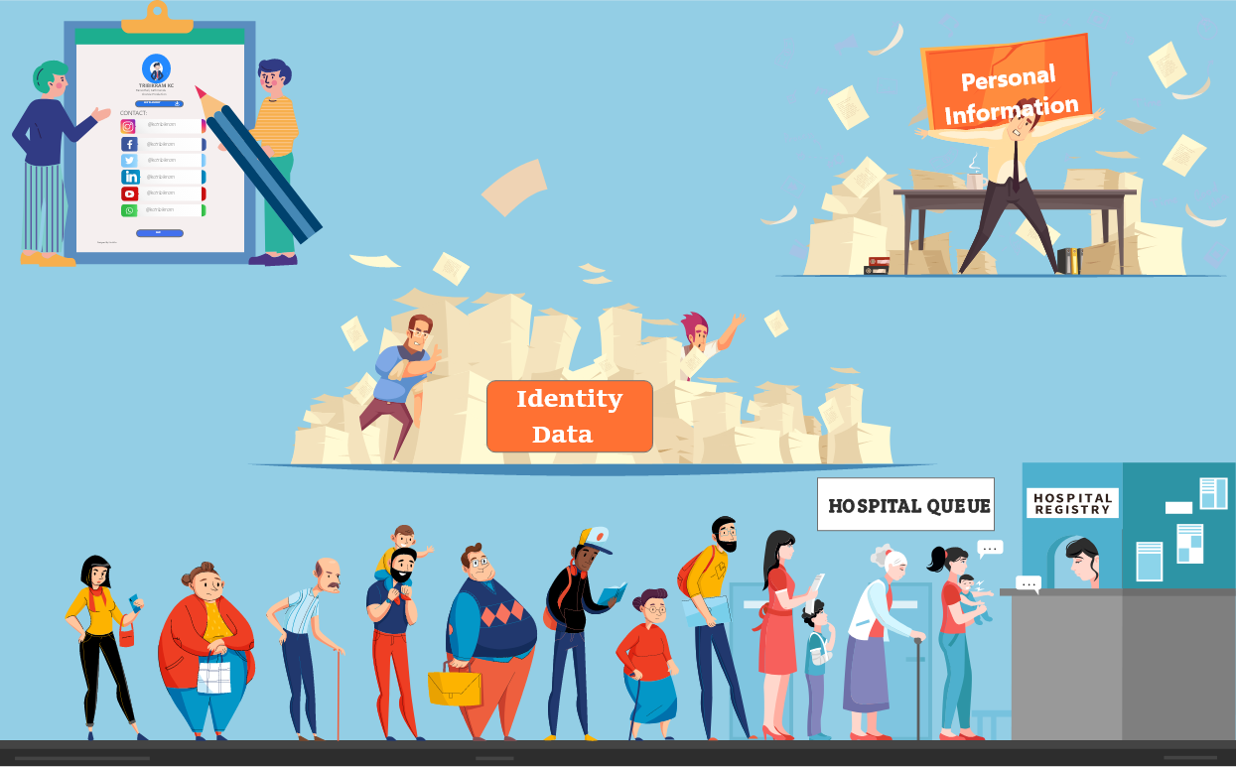

Figure : Problem Statement

Analyzing the Nepal’s context, there are not many company or individuals that uses smart visiting card. Wherever the people are visiting for the first time, the details of the peoples are asked to keep a record such as in hospitals, clinics, colleges, schools, companies and so on. And in every sector they uses paper form or computer form to fill up the details. If mass amount of people visits the hospital or company they need to stay in queue just to provide their details and receive an appointment with doctor or CEO of company. Same follows up in the other sectors too. After a form is filled the room for storing those form will be in needed which can be expensive. These problems can actually make people exhausted, not only to the customers but also to the people who works in a company or other sectors.

## Solution Statement

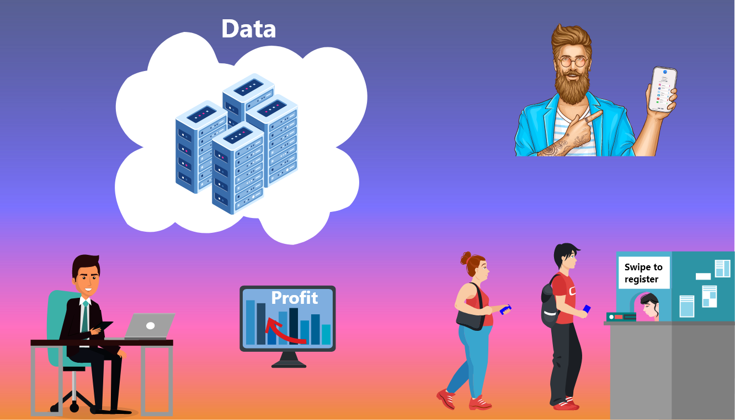

Figure : Solution Statement

It is possible to bring reform into that problems with the introduction of digitalization that is Smart Visiting Card. The purpose of these system is to avoid the real time problems and Smart Visiting Card can counter the above mentioned problem. Smart visiting card is a digital version of people’s personal details which are stored in a microcircuit chip that can be used to provide shared to other people, business organizations, hospitals, clinics, colleges and in other sectors in a reliable and secured way. If the individual person or people from any sector they are working starts to use the smart visiting card then for sure the problem of queue to provide their details and receive appointment would be far more easy and quick. With the smart visiting card the rooms which is filled with piles of paper of personal details of all the staff and customers can be replaced and stored in a single chip respectively. The chip can be scanned anywhere people visits to provide there details.

# Ethical Consideration

Ethical Consideration is one of the important part of research without it research can be failure. In this project the primary and secondary data will be used. The sources utilized in this project will be given proper credit and acknowledgement with the appropriate reference. The participants of this project will not be harm in anyways and dignity of their will be prioritized. Full consent from the participants will be taken for the use of their data. The data which is taken from the participants are of private nature. Then there should be adequate level of confidentiality. So, the project member might not use the private data of participants for their own personal benefits. In this project, ethical aspects will be followed strictly.

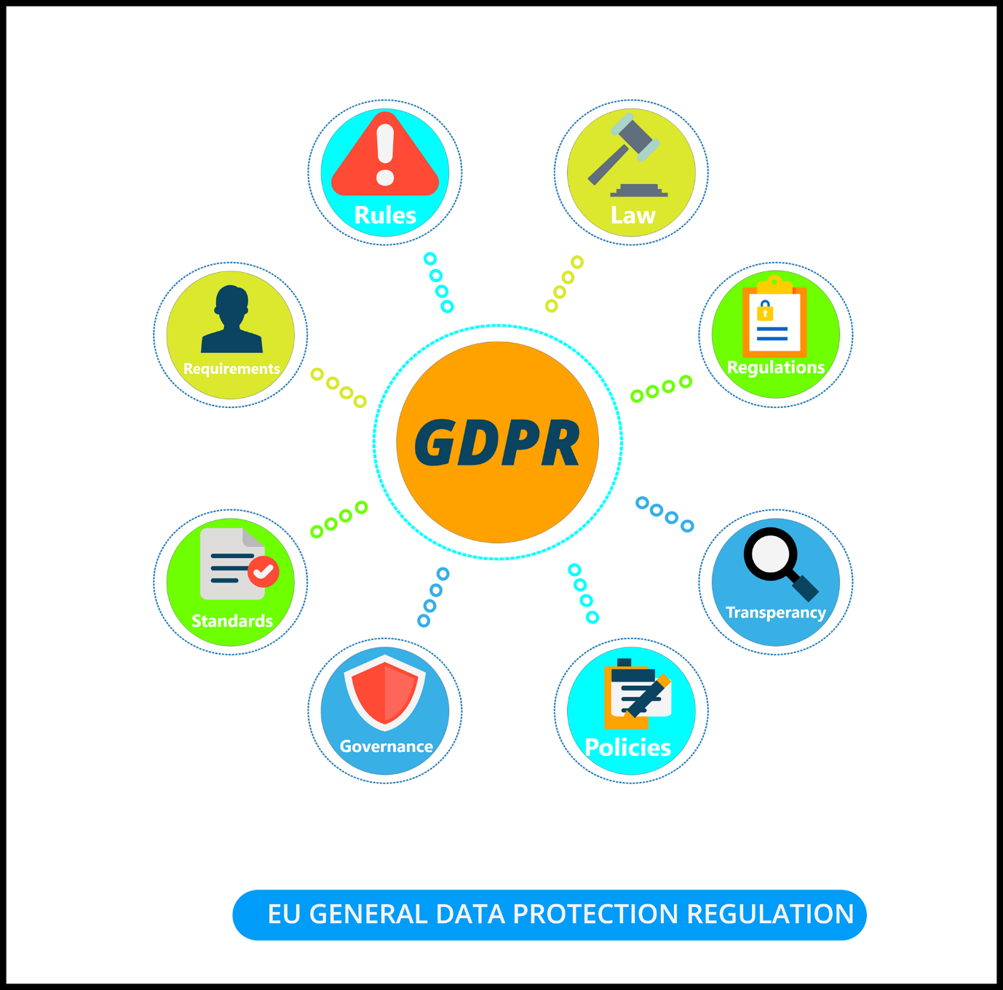

Figure : Ethical Considerations

# Literature review

Reviewing literature in a specific field is important task required to make theoretical and methodological contributions to a specific subjects. Literature review is academic paper that shows the present understanding and contains significant finding in a particular topic. Research methodology is used to find the information and data on any topic. Review studies on electronic commerce, information systems, RFID and mobile commerce that is mainly related to Near Field Communication (NFC) - are well examined to provide a literature review on NFC research. This literature review explore the existing information in the field research.

The use of NFC technology began from the early 1980’s as radio frequency identification (RFID). Analyzing the benefits that can be brought by NFC technology in the field of mobile payment services, many researches and studies have been conducted. In 2003 NFC was approved as an [ISO](https://en.wikipedia.org/wiki/International_Organization_for_Standardization)/[IEC](https://en.wikipedia.org/wiki/International_Electrotechnical_Commission) standard and later as an [ECMA](https://en.wikipedia.org/wiki/European_Computer_Manufacturers_Association) standard. <https://www.ecma-international.org/news/Ecma-340-NFCIP-1.htm> More specifications are added and the technology grew from payments services to sharing files between NFC-enabled devices. In 2010 the phone manufactured by Samsung called Nexus S announced the first Android operating phone to incorporate NFC technology. In 2013 Samsung and VISA announced their partnership to make mobile payment services. As per the agreement Samsung will put the VISA’s pay-wave application into their upcoming NFC-enabled mobile devices. <https://news.samsung.com/global/samsung-announces-expanded-strategic-partnership-with-microsoft-in-the-enterprise-mobility-market> With the NFC technology and Visa payment functionality the mobile device is ready for tap-and-go payments facility. As per the ABI Research on NFC, it has been declared as one of the secure methods for the mobile payments. There has been a challenge to bring the NFC payment services in the market, one of them is the lack of NFC enabled devices in the market. But it started to change as the more smart phones adopted NFC technology. ABI Research forecasts that there will be 1.4 billion NFC-enabled devices within 2017. And according to the research from ABI the demand of NFC ICs is set to skyrocket. More precisely they expects a shipments of NFC tag would be over 10 billion in 2023. <https://blog.nxp.com/industrial/abi-research-on-nfc-tags>

## Case Study: Google Pay

Google developed an online payment system and digital wallet platform popularly known as Google pay. It is the apps that will make a phone function the same way as a contactless debit card or credit card does. For this app to function, an NFC-enabled device is required. When making payments, Google pay app uses a virtual account number which ensures that user information are never directly shared with merchants. Some would say that this makes it easier to use this kind of application than to use a real card when making transaction.

Google says 70% of android devices are ready for pay and seven hundred thousand merchants are willing to accept it today in their shops. CEO of Spring app Alan Tisch says that orders purchased from Google pay is twice as high on average as normal credit card order. And the facts states that the users who used Google’s payment service to place their first orders are 27% more likely to use the Google pay again. <https://www.theverge.com/2015/5/28/8661867/google-introduces-android-pay-replace-wallet-app> By reviewing the stats and facts, the use of NFC technology in mobile payments will be extremely high in the future. Also by viewing the condition of the world in 2020 caused by Covid-19 pandemic the use of contactless payment is sure to be increase.

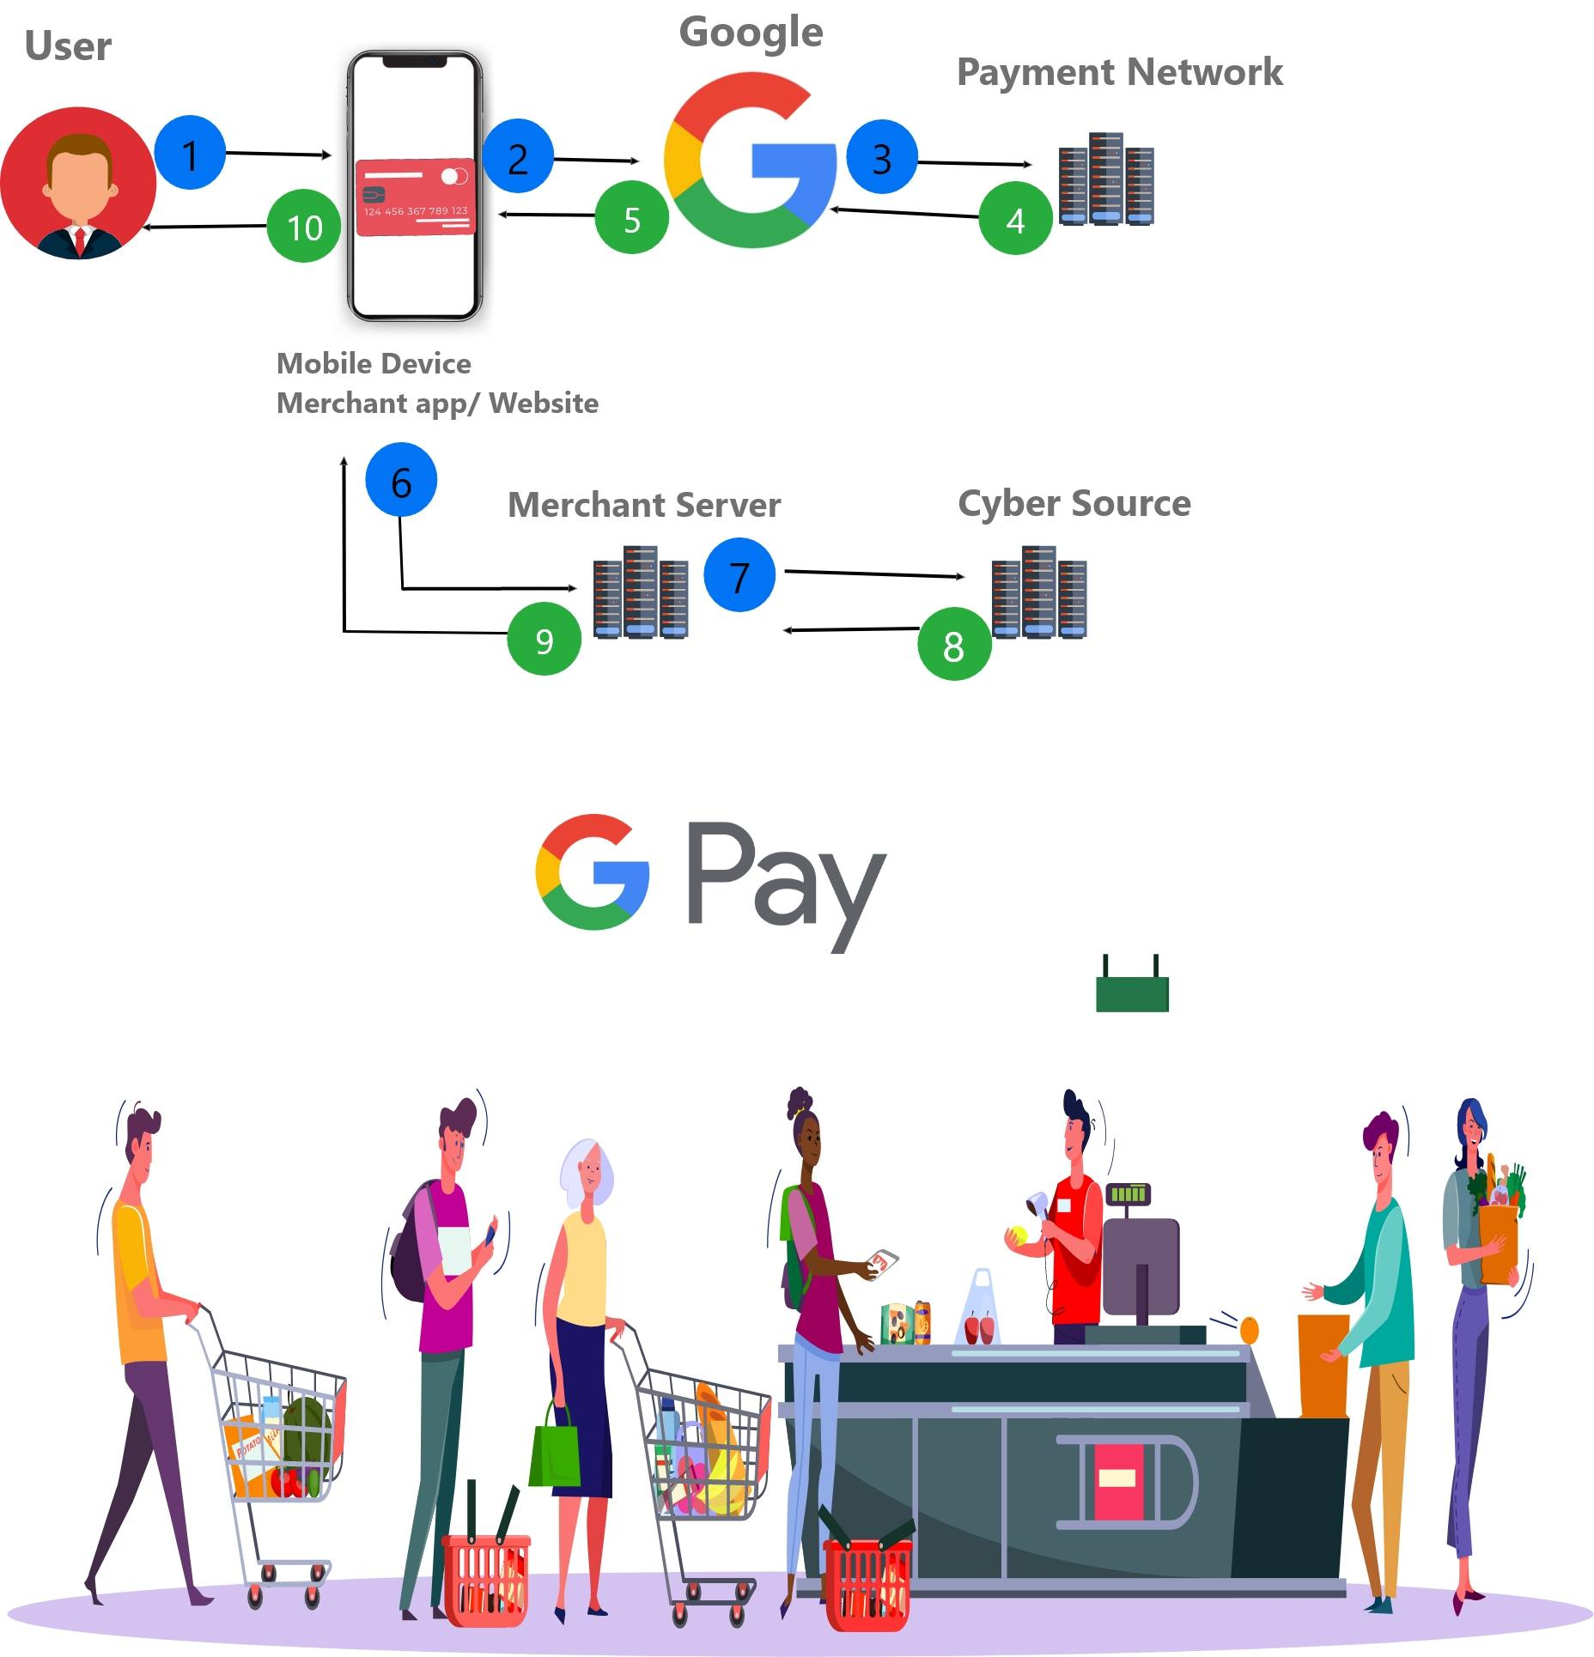

## Educational service application

Recently schools and universities have become a valuable study field for NFC technology. The surveyed studies indicates that NFC is potentially associated with education and training. Different deployment of NFC programs and innovations in universities is done to make smart environments for the students, easier administration and efficient management. Different NFC services are implanted in universities such as attendance supervision, identification, resource control and management service, payment service etc. <https://www.researchgate.net/publication/257675463_A_survey_on_Near_Field_Communication_NFC_technology>

NFC-enabled learning environment has also been developed where students directly interact with the system and download the required learning materials. <https://www.ncbi.nlm.nih.gov/pmc/articles/PMC4507650/#B195-sensors-15-13348>

The most valuable services from NFC technology in educational institutions are NFC-enabled attendance supervision system and examination system. With the services like it will be easier for both the management team and the students. One of the research done in local school shows that the number of present students has increased during the trial period. So the use of NFC technology in the educational service has been beneficial till date and can provide more services with further research and surveys.

## NFC in supply chain

NFC are used to increase the supply chain visibility. It is most important to have visibility in the supply chain while dealing with pharmaceuticals goods and perishable goods. NXP’s came with the new solution by combining the NFC and RAIN RFID which makes possible to fully trace the goods in supply chain. NFC tag is used to connect the products to IOT which helps in real time-tracking of each items. It is more convenient and secure to authenticate and identify products with NFC than the barcodes. Consumer can easily scan the products with their mobile devices and check the information like production dates and expiration dates. Inventory management can be done easily and it also provides the additional benefits for brand and consumer. ABI research predicts that to increase the customer engagement, more products will use the NFC tags, make it easier for customers to access value-added material, verify authenticity and honesty and make product usage more rewarding and interactive. ABI research expects advantage of cost using NFC tag within supply chain due to which overall demand will increase.

# PESTLE Analysis

PESTLE Analysis is also referred as PEST analysis concept in marketing principles. It is used as a strategic management tool used by the companies or organizations to identify, analyze and monitor the environment where they are operating their products or planning to launch a new project or product. It is especially useful at the time of starting a new business or moving into a foreign market. PESTLE is an acronym which in its expanded form indicates P for Political, E for Economic, S for Social, T for Technological, L for Legal and E for Environmental. It provides a bird’s eye view of the entire world from several different angles that one may want to test and keep a track of when reflecting on a specific idea/plan.

PESTLE Analysis of Smart Visiting Card using Near Field Communication (NFC) is performed below:

Political factor determine to what extent a government can influence the economy or some industry. For this project the political factors that should be considered are the tax policy, data protection law, follow the manufacturing rules of a country and must follow the import and export laws. Economic factor are determinants of the success of an economy that impacts a firm directly and has long-term effects. The economic factors to consider for this project are must target the companies and organizations where personal details are asked frequently, customers with good purchasing power, demand and supply, inflation and recession. Social factor examine the market’s social environment and assess determinants such as cultural trends, demographics, population analytics etc. The social factor to consider for this project are target each and every people from any social classes, emphasis on safety of people’s data, population growth and immigration and emigration rates. Technological factor relate to technological innovations which may favorably or unfavorably affect the operations of the industry and the market. This project is created using a finest technology, changes in the technology can be defect as well as benefits. Legal factor have external as well as internal sides. There are certain laws that affect a particular country’s business environment while there are certain policies that businesses maintain for themselves. Legal research takes these two viewpoints into account and then outlines the method in the light of these legislations. The consideration that are needed from legal factors are check availability such as in copyrights and patent in the design or logo of the project and the project name, legal business structure, employee laws and the permission from the government to operate. Environmental factor contains all those that influence the surrounding environment or are determined by it. This factor of PESTLE is really crucial for some of the industries such as tourism, farming and agriculture etc. The factors of environmental analysis for this project includes environmental policies, proximity to suppliers, regional support, local competition and recycling.