MMMyyySSStttuuuddd
PPPooorrrtttaaalll
eennnttt

Presented by: Kyla D. Cubelo
Presented to: Niel Carlo Asgar



April 28, 2026


Introduction

MyStudent Portal is an online platform designed to help students manage their academic activities in a simple and convenient way. It allows students to access important information such as grades, class schedules, enrolled subjects, announcements, and school updates anytime and anywhere.


Problem Statement
Many schools still rely on manual for managing student information such as grades, schedules, announcements, and records. This often leads to delays, difficulty in accessing updated information, and miscommunication between students, teachers, and administrators. Students may also struggle to keep track of their academic progress and school requirements in an organized way. Therefore, there is a need for a centralized and efficient system that allows easy access to academic information and improves communication within the school community.

Objectives
To develop a centralized platform where students can easily access their academic information in one place.
To provide real-time access to grades, schedules, subjects, and school announcements. To improve communication between students, teachers, and school administrators.
To reduce manual processes and minimize paperwork in managing student records.
To allow exporting of data to Excel (XLSX) format for easy record management and analysis.
To enable printing of student information such as grades, schedules, and reports for official documentation.
To enhance the overall student experience by making school services more accessible and convenient.

Scope
The MyStudent Portal is designed for two types of users: students, and teachers. It provides a centralized system where students can view their academic records such as grades, schedules, subjects, and announcements. Teachers can manage and update student grades, post announcements, and monitor class information. Administrators can oversee system data, manage user accounts, and ensure proper system functionality. The system also supports exporting data to Excel (XLSX) and printing reports for official documentation. It is accessible through devices such as computers, tablets, or smartphones with internet access.

Limitations
The system is only available to registered users (students and teachers) and cannot be accessed by unauthorized individuals. It requires a stable internet connection to function properly. The accuracy of the information depends on timely and correct encoding of data by teachers and administrators. The system is intended as a support tool for academic management and does not replace official school records completely. It also may have limited functionality when used offline.

Proposed System Overview

The proposed MyStudent Portal is a web-based system designed to centralize and simplify the management of student academic information. It serves as a digital platform where students, teachers, and school administrators can interact and access important school-related data in an organized and efficient way.

Subject
Tasks
Materials and Lessons
Students Announcement

Displays all subjects enrolled by the student, including subject details and assigned teachers.
Allows teachers to post assignments, quizzes, and activities, while students can view and track

Provides access to learning materials such as notes, files, and lesson content

Contains student profiles, academic records, and performance
Used by teachers and administrators to post important school updates, reminders, and events for students


Input
Student information (profile, enrolled subjects)
Teacher inputs (grades, tasks, materials, announcements) School data (schedules, announcements, subject lists)
Process
Storage and management of data in a centralized database Processing of information for viewing, updating, exporting (Excel), and printing
System validation and access
control for different users
Output Student academic records Task lists and deadlines
Learning materials and lesson
access
Printable and exportable reports (XLSX format)

Input → Process → Output

The MyStudent Portal transforms raw academic data into organized and accessible information, improving communication, efficiency, and record management within the school.

Database Design
Main Entities
Student - Contains student information such as student ID, name, course, year level, and enrolled subjects.
Teacher - Contains teacher details such as teacher ID,
name, assigned subjects, and classes handled. Subject - Represents the courses offered, including subject code, title, description, and assigned teacher. Grade - Stores student performance records per subject, including quizzes, assignments, exams, and final grades.
Task - Includes assignments, activities, and quizzes
posted by teachers with deadlines and instructions. Material/Lesson - Contains learning resources such as notes, files, and lesson content uploaded by teachers.
Announcement - Stores school updates, reminders,
and important information posted by teachers or administrators.

Relational Logic
A Student can enroll in multiple Subjects, and each Subject can have many Students (many-to-many relationship).
A Teacher can handle multiple Subjects, but each
Subject is assigned to one or more Teachers (one-to- many or many-to-many depending on design).
Each Subject contains multiple Tasks, Materials, and
Announcements (one-to-many relationship).
Each Student has multiple Grades, which are linked to their enrolled Subjects (one-to-many relationship).
Each Task and Material is associated with a specific Subject and accessed by Students enrolled in that Subject.
The Administrator manages all entities but does not directly participate in academic data flow.

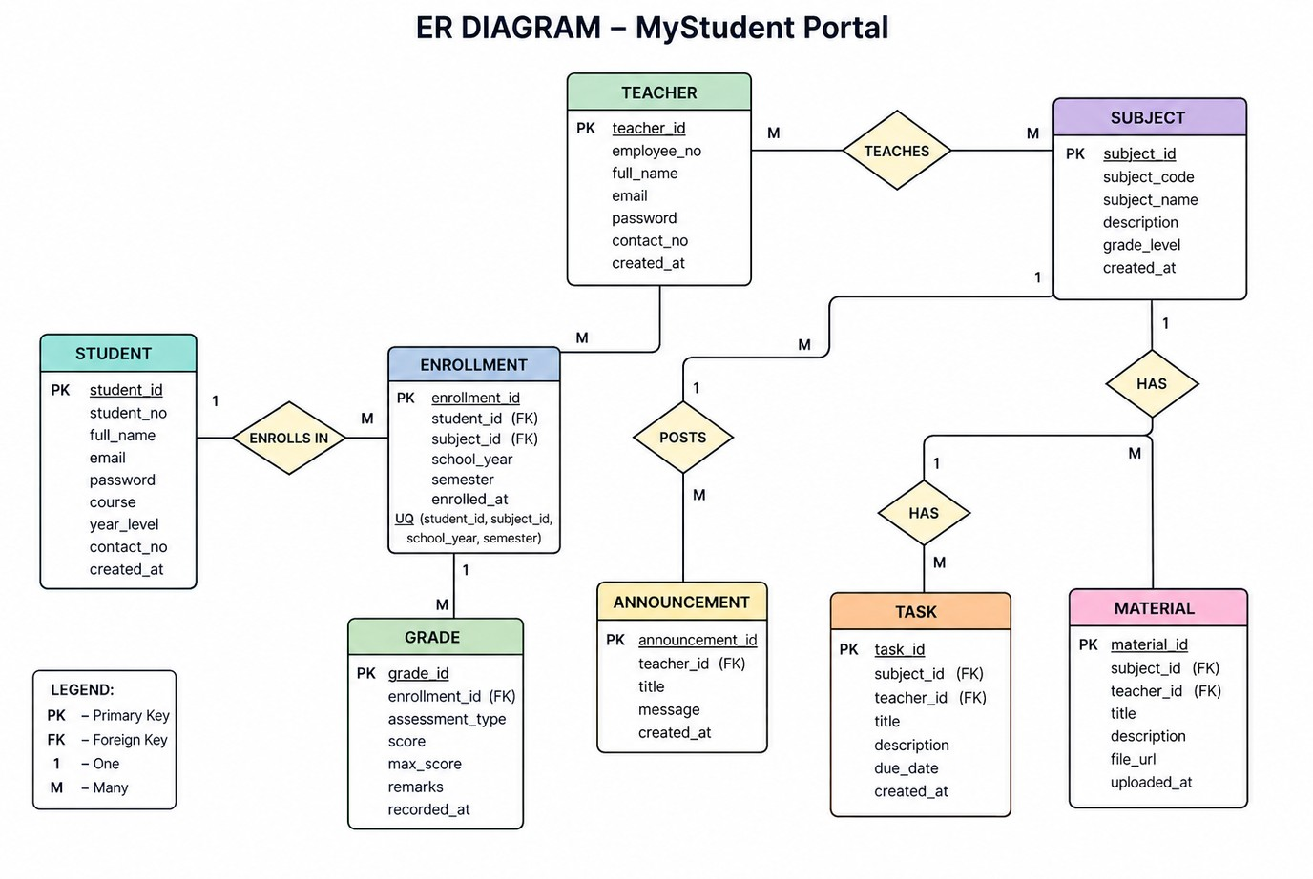
Core Entities are: Student – stores student information like ID, name, course, and year level Teacher – stores teacher details like ID, name, and assigned subjects
Subject – contains subject information like subject code, title, and description Enrollment – records which students are enrolled in which subjects
Grade – stores student scores,
assessments, and final grades
Task – contains assignments, quizzes, and activities given by teachers Material – stores lesson files, notes, and learning resources Announcement – contains school updates, reminders, and important notices

METHODOLOGY

PHASE 01
Planning Identification of system requirements and objectives to define project scope
PHASE 04
Testing Rigorous identification and correction of fuctional errors an dsystem bugs.
PHASE 02
Design Creation of database structure, UI mockups, and system architecture
PHASE 05
Deployment Final implementation, user acceptance testing and project presentation
PHASE 03
Development Backend and frontend implementation using selected technical stacks


Tools and Technologies

Database : MySQL Programming Language : Python

Tools : Visual Studio Code MySQL Workbench

Expected Results

Faster and more accurate transaction recording

Easy access to student grades, schedules, and subjects


Improved communication between students, teachers, and administrators Reduced manual paperwork and processing time

Better organization of academic records and school information

Convenient exporting and printing of reports

Increased efficiency in managing school-related activities and transactions

Conclusion
The MyStudent Portal is developed to provide a centralized and efficient system for managing academic information. It helps students, teachers, and administrators access and handle data such as grades, subjects, tasks, materials, and announcements in an organized way.
Through the use of modern web technologies and a structured database system, the portal improves communication, reduces manual processes, and ensures faster and more accurate transaction recording.

Overall, the system enhances the efficiency of school management and supports a more convenient and reliable digital learning environment for all users.


Thank you for your attention

