**Research Report Guideline**

The report has an executive summary  
The report has a brief description of background and study goals  
Key findings are the main section of the report  
The report has recommendations/next steps  
Data has been collected and analyzed in Miro or with physical sticky notes; an image (can be a photo or screenshot) showing this data is attached to the appendix section of the report  
Executive summary has a brief description of the research project  
Executive summary summarizes key findings and recommendations  
Key findings are highlighted  
Report shows data to support findings (e.g., user quotes/observations)  
Report provides recommendations based on findings

**Q) The report has an executive summary**  
A) I interviewd 3 new or early stage trainer – age 26~27. fount out their needs hass not been solved in this situation. their needs are companion who can customize their workout and solve their fear for doing workout in wrong posture. however, it is difficult to open wallet through mobile phone. there is some resistance culture that except for emoticon, people are not welcome to spend money in mobile app.

**Key Findings**-users need customized training guide.  
-interviewers all had body unbalanced problem  
-huge resistence to online training

**Q) What did we want to learn?**  
A) Our team wanted to explore new trainer’s needs for fitness app. The goal is determine what opportunities may exist for creating new fitness app.

**Key Research Questions  
-**[needs] What is essential for new trainer?  
-[behaviors] how do new trainer do exercise?

**3 Participants**we recruited 3 interviewer from college

|  |  |  |
| --- | --- | --- |
|  | exercise frequency | how they exercise |
| Participant 1 | last late summer september | bodybuilding |
| Participant 2 | 2days ago | core exercise, walking |
| Participant 3 | 2days ago | Aerobic, core exercise, squat |

key finding 1 : users need customized training guide  
-all participants want a personalized training guide. They believe their body need special method because of unbalance and lack of flexibility.  
-“i found difficulty exercising because of my lack of flexibility. there are so much constraint”  
participant 2  
-our new product could focus on general and easy exercise for users to follow  
-things to consider  
 -each learning shows prerequisite  
 -adding tips of exercising

**Q) The report has a brief description of background and study goals**A) the background of this interview is to find user’s need in mobile fitness app. Our study goals is to find users need and help them achieve their desirable body shape.

**Q) The report has recommendations/next steps**A) My next steps base on the report is digging in more user’s problem with prototype. Because i still couldn’t find detail pain points base on interview. in order to truely find out the essence of need, i believe the interview should contain a more graphical tool to brings out user’s thought and feeling.

**Q) Data has been collected and analyzed in Miro or with physical sticky notes; an image (can be a photo or screenshot) showing this data is attached to the appendix section of the report**  
A) [URL](https://miro.com/app/board/o9J_lZ7Dul8=/)

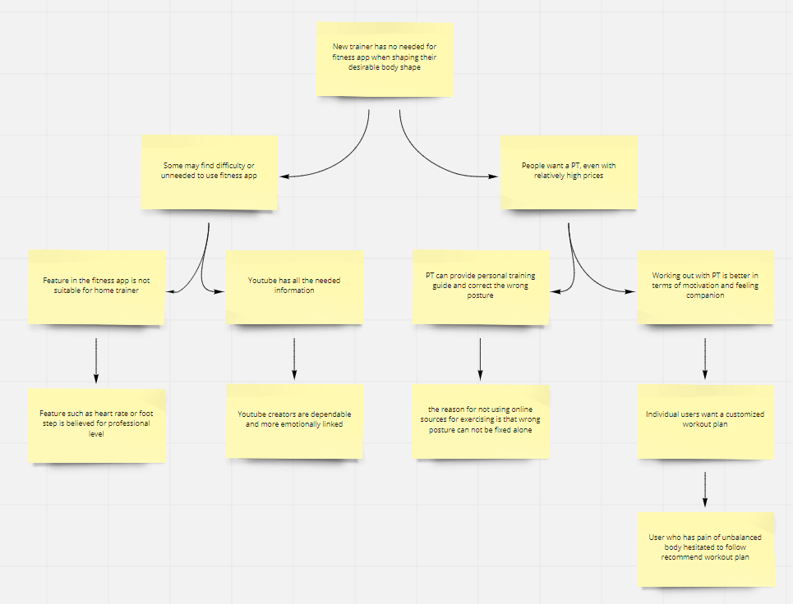

**Q) Executive summary has a brief description of the research project**A) All interviewr said “PT is the best way to get help. They have unbalanced body and have difficulty starting exercise because of lack basic knowledge and fear of forming bad habit. Furthermore, the purpose of exercise was more on maintaining healthy rather appearance.  
“i believe online trainer has many constraint in terms of customized training guideline. I want someone can manage individual health while consider my unbalanced body.”

**Q) Executive summary summarizes key findings and recommendations**A) Key findings :   
-users need customized training guide.  
-interviewers all had body unbalanced problem  
-huge resistence to online training  
Recommendations :  
-“i am interested in smartwatch for exercise, it looks pretty helpful when i do exercise”  
 -people find interested on real material rather than online  
-“i know one bodybuilding instagramer, who has great butt shape. i want to follow the exercise”  
 -people find interested on their desirable person

**Q) Key findings are highlighted**  
A) Key findings :   
-users need customized training guide.  
-interviewers all had body unbalanced problem  
-huge resistence to online training

**Q)** Report shows data to support findings (e.g., user quotes/observations)  
A) -“i am interested in smartwatch for exercise, it looks pretty helpful when i do exercise”  
 -people find interested on real material rather than online  
-“i know one bodybuilding instagramer, who has great butt shape. i want to follow the exercise”  
 -people find interested on their desirable person

**Q) Report provides recommendations based on findings**A) Recommendations :  
-find a way to trigger user’s motivation to exercise  
-user’s role model exercise routine has great value

+++++++++++++++++++++++++++++++++++++++++++++++++++++++++++++++++++++++++++++++++++

**Interview Result  
1. 26Y – man – 6m workout experience before**Q) what was last time you exercise?  
A) Last Summer about September

Q) can you tell your best body part?  
A) Arm, or clavicle

Q) how did you got to there?  
A) I used gipper to train arm, and also do arm exercise such as bicep curl

Q) what assist tool do you use for exercising?  
A) i got PT, because i believe it was fastest way to become fit. other than that i dont use app for exercise

Q) do you pay bills online?  
A) yes, pay bills on emoticon in kakaotalk(korea messenger), because it is pretty

Q) what do you find difficulty doing exercise?  
A) I found difficulty doing exercise, because of lack of facility. currently there is Covid-19, all the gym is closed.

Q) what is the best assistant for new trainer?  
A) i believe PT is best

*intersting part : when i ask what is your best body part, he said “face” in the first place.

**2. 26Y – man – got surgery for back spine**Q) what was last time you exercise?  
A) 2days ago

Q) what exercise do you?  
A) i do core exercise for physical health purpose, i also do stretch and walking alot

Q) how many times do you workout in a week?  
A) i workout 4times a week, 30m average

Q) what is the purpose of doing exercise?  
A) for my physical health and prevent back pain

Q) can you tell your best body part?  
A) clavicle

Q) what assist tool do you use for exercising?  
A) i got help from PT and Youtube. The personal trainer has master degree in sport science and do have sport medication license. so i can count on him alot. I see youtube about core strength and follow the video. I usually follow the video within my capacity.

Q) do you use any application for your exercise?  
A) no, i dont

Q) do you pay bills online?  
A) yes, pay bills on emoticon

Q) do you feel thirst on lack of exercise knowledge?  
A) usually no, i just search it then and thats it

Q) what do you find difficulty doing exercise?  
A) i found difficulty exercising because of my lack of flexibility. there are so much constraint

Q) do you prefer learning exercising on online or offline and why?  
A) i prefer offline 1on1 like PT. Because i fear i might learn wrong exercising posture from online. Not because the online teaching has bad quality, it is just me that might not follow right posture and got habit doing in wrong posture.

Q) what is something makers you interesting in terms of anything related exercise  
A) i saw apple watch that has health features like heart rates etc. i feel interested in that and might wants to have one of that.

**3. 27Y – woman – 1year workout experience**Q) what was last time you exercise?  
A) 2days ago

Q) how many times do you workout in a week  
A) i workout 3~4days in a week about 1hour, i am watching youtube video such as  
-pelvis correction exercise, youtube channel :”dankku bubu”, “tiffany” aerobic

Q) can you tell your best body part?  
A) waist, abs

Q) how did you got to there?  
A) i see breathing skill in youtube and that really help alot. i also do abs worksout

Q) what assist tool do you use for exercising?  
A) stop watch! i use it alot, also squat machine and phone to watch youtube  
i do have smartwatch but i barely use, because i dont need the functions in there. Because there are no body exercise to do in home.

Q) do you pay bills online?  
A) yes, pay bills on emoticon, youtube premium, mobile game

Q) what do you find difficulty doing exercise?  
A) most difficulty is having right posture. i still dont get right squat. i think it is because of my unbalanced waist. without expertise i think doing workout alone is hard

Q) do you have thrist for lack of exercise knowledge?  
A) no, but i do research when i have functional curiousity

Q) do you prefer offline PT or online PT if the price is same?  
A) i prefer offline PT. because i can get personalized guide for my body shape.