**Project Guideline**

Research Plan  
-A short paragraph to describe the background of the project  
-Main research goals  
-Key research questions  
-Method: a brief explanation of how to apply the method   
-Recruiting criteria  
-The list of interview/survey questions

Interview Guide  
-An introduction section  
-Questions guide  
-A brief wrap-up section

Survey

-The formats of the survey questions are flexible; they can be multiple choice, Likert scales, ranking, etc.

Study 1 : semi structured interview

**Q) A short paragraph to describe the background of the project**  
Project scope is designing an app for freshman student - new trainer & personal body design training guide.   
The app i want to design soley for new trainer, bringing into bodybuilding culture. Because new trainer usually start training for having beautiful body and i want to help them achieve their goals.

**Q) Main research goals**The main research goal is to find out opportunities and needs of new fitness app. So i can design an app for solve the needs. i believe, there are many fitness gym with low prices. My goal is to make an app for perfectly customized in korea gym.

**Q) Key research questions**[needs] what is essential for training?  
[behaviors] how do new trainer currently exercise?  
[overarching] how do users feel about existting fitness app?

**Q) Method: a brief explanation of how to apply the method**type of interview : semi-structured interview to get qualitative data  
 -ask research questions -> base on the answer ask follow up question  
 -there is script guide for interview and can ask follow-up questions

**Q)** **Recruiting criteria**3 participants   
-26~27 new or early stage trainer  
-to recruit participants, we will send emails to college club

**Interview Guide**  
1. An introduction section  
Hello my name is chaewook kim, i am UX designer, thank you participating and sharing your time. We are currently building an app to help new trainer, typically focusing on body design. We provide perfect training guide for users to achieve their desired body.

2. Questions guide  
-in the past week, how often do you exercise?(ask users about their recent experience)  
 (if never)-what was last time you exercise?  
-can you tell your best body part?(icebreaking??, ask users to show, not just tell)  
 -(depend on the part), how did you got to there?  
-what assist tool do you use for exercising?(specific & neutral questions, finding their solution)  
 -why are you using that tool?  
-do you pay bills online?(get general idea of where users pay bill)  
 -what was the last time you paid your bill on phone?  
-what do you find difficulty doing exercise?(ask specific questions to get the underlying need&pain points)  
-what do you know about the body training?(get common knowledge of what users has)  
  
3. A brief wrap-up section  
Thank you for participating on interview. we are appreciated. if you have additional thoughts and comments, i would love to hear about them at any time. i can be reached at [chaeugg@gmail.com](mailto:chaeugg@gmail.com). hope you have a wonderful day.

**+++++++++++++++++++++++++++++++++++++++++++++++++++++++++++++++++++++++++++++++++**

Study 2 : Survey

**Q) A short paragraph to describe the background of the project**  
Project scope is designing an app for freshman student - new trainer & personal body design training guide.   
The app i want to design soley for new trainer, bringing into bodybuilding culture. Because new trainer usually start training for having beautiful body and i want to help them achieve their goals.

**Q) Main research goals**The main research goal is to find out opportunities and needs of new fitness app. So i can design an app for solve the needs. i believe, there are many fitness gym with low prices. My goal is to make an app for perfectly customized in korea gym.

**Q) Key research questions**[needs] what is essential for training?  
[behaviors] how do new trainer currently exercise?  
[overarching] how do users feel about existting fitness app?

**Q) Method: a brief explanation of how to apply the method**-collective data : at least 30 trainer  
-3 volunteer from our team

**Q)** **Recruiting criteria**-send survey in online community for asking help  
 -screener has to be new or early stage trainer  
 -age should be between 20~30

**Survey Guide**

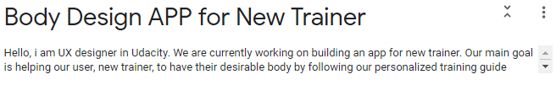(Introduction of survey, explain background)  
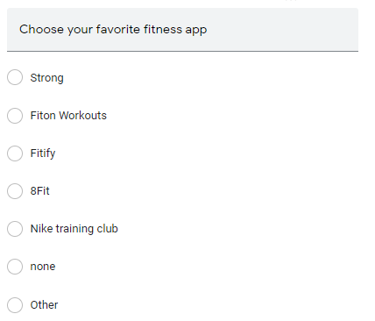  
(find out user use fitness app)

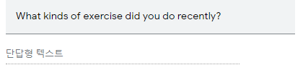(find out user’s exercise routine)

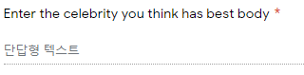(find out user desired body)

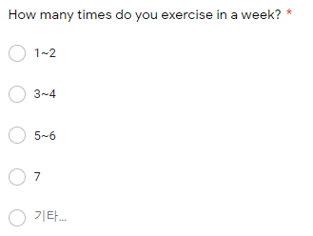(find out how much effort user want to put in training)

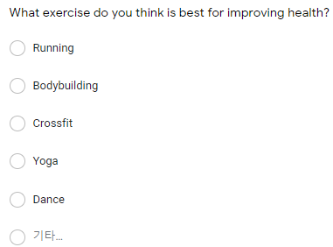

(find out what kind of exercise user want to do)

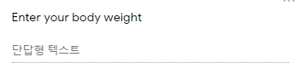(basic demography)

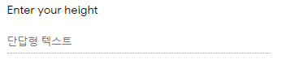

(basic demography)

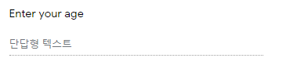

(basic demography)

+++++++++++++++++++++++++++++++++++++++++++++++++++++++++++++++++++++++++++++++++

Scoping the topic  
1. a domian/industry  
 -mobile fitness  
2. a niche market  
 -moblie fitness -> personalize training guide in physic health  
3. a user group  
 -college freshman, age 20, new trainer  
4. narrow down the users  
 -college freashman who wants knowledge and guideline for training  
5. choose a single critical user journey  
 -sign up for the app  
 -use free features  
 -subscribe for personalized guideline  
 -training with guildeline

Final scope : design an app for freshman student who are new trainer & providing peronalize training guide

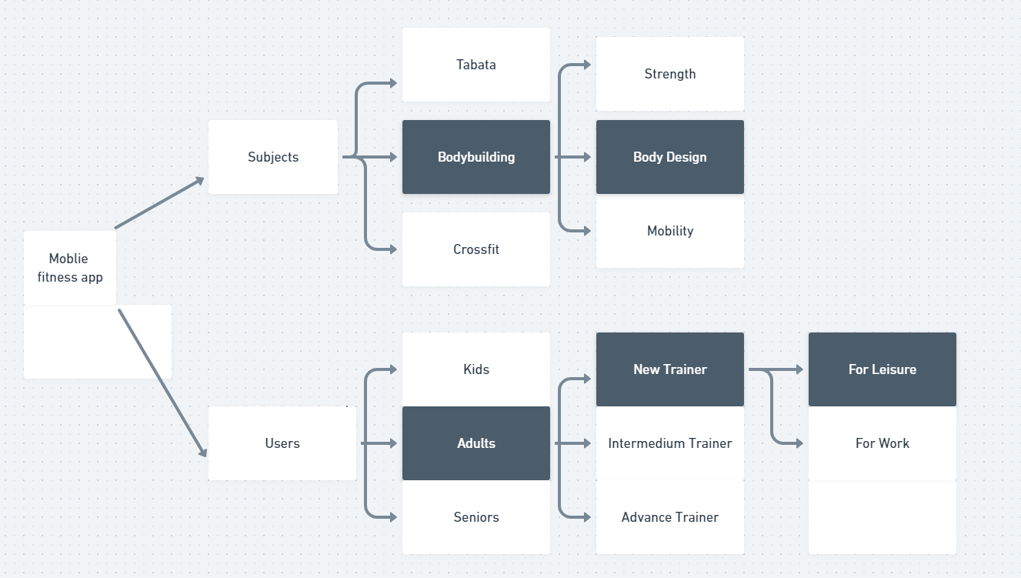  
(Above is diagram for target user)

**Competitive Analysis : fitness moblie app**

1. Direct competitive  
 -strong : freemium, 1Y/$39, 1m download, 4.8 rates  
 -free : profile, workout dashboard, history, workout routine, exercise explain  
 -subscribe : infinite routine save, chart analyze, body measurment data, workout improvement tool

-fiton workouts : 1Y/$39, 1m download, 4.8 rates  
 -free : various workout videos, advice section, meals recipe, friends invitation, sync to fitbit or google fit  
 -subscribe : Personalized meal plans, 500+ recipes, unlimited offline recipes, fitness tracker, music

-fitify : 1Y/$69, 5m download, 4.7 rates  
 -free : body level test, training guide, diverse training for home  
 -subscribe : personalized training guide

-8fit : 1Y/$73, 10m download, 4.4 rates   
 -free : basic full body program  
 -subscribe : customizable workouts, exclusive classes, meal plans, recipes, shopping lists

-nike training club : free, 10m download, 4 rates

2. Indirect competitive  
-Noom : 1Y/$50, 10m download, 4.4rates  
 -only subscribe : customize diet plan, 1on1 coach, life time habit fix

-BodyFast : 1Y/$64, 5m download, 4.6 rates  
 -free : health info, body track, trophies section, fasting plan  
 -subscribe : personal diet plan, daily coach, healthy habits