**Design Guideline**

Submission includes a design of at least one screen, which is drawn by hand or created using digital tools  
The design has annotations addressing: What is this design about? What are the key actions users can take?  
The design incorporates **at least one design principle** and **at least one key finding from the research report**  
Each screen has a short paragraph to explain the design rationale, and to explain which design principles and research findings were applied  
Optionally, two iterations of the same design may be included, one of which is the "before" version (the original design) and one of which is the "after" version (the design that has been improved).

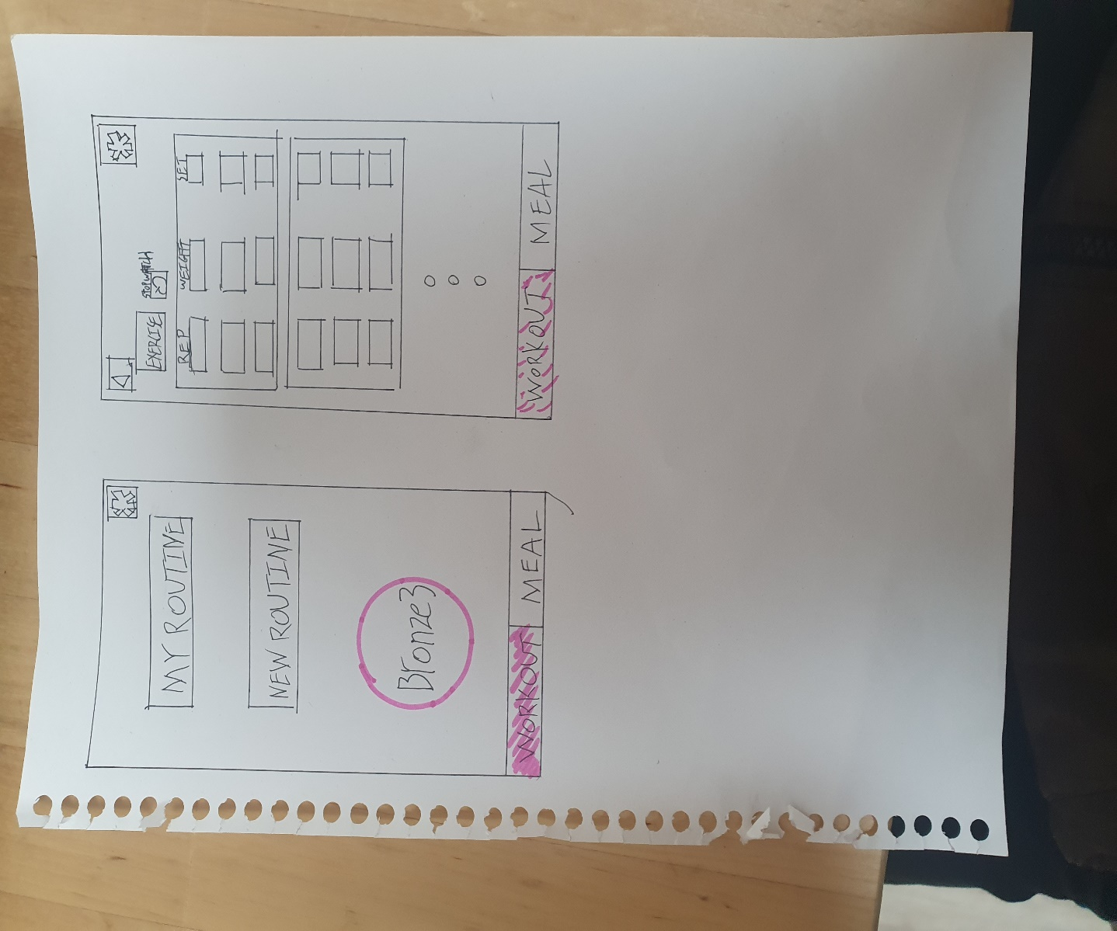What is it about :  
This is very first page after sign up. There are two sections on the bottom, workout and meal.  
Users can choose my routine if they have their personal routine or new routine for new users or doing other routine. Bronze3 is the level of user. When users workout consistently, the level goes up. It is there for motivation purpose. I try to make an app simple and visualized, so users do not have to think hard to use every features.

Actions for users to take :  
Users can choose few opinions. for workout, there are two opinions my routine and new routine.  
Design Principle : easy periherial sight  
key finding from research : clear design

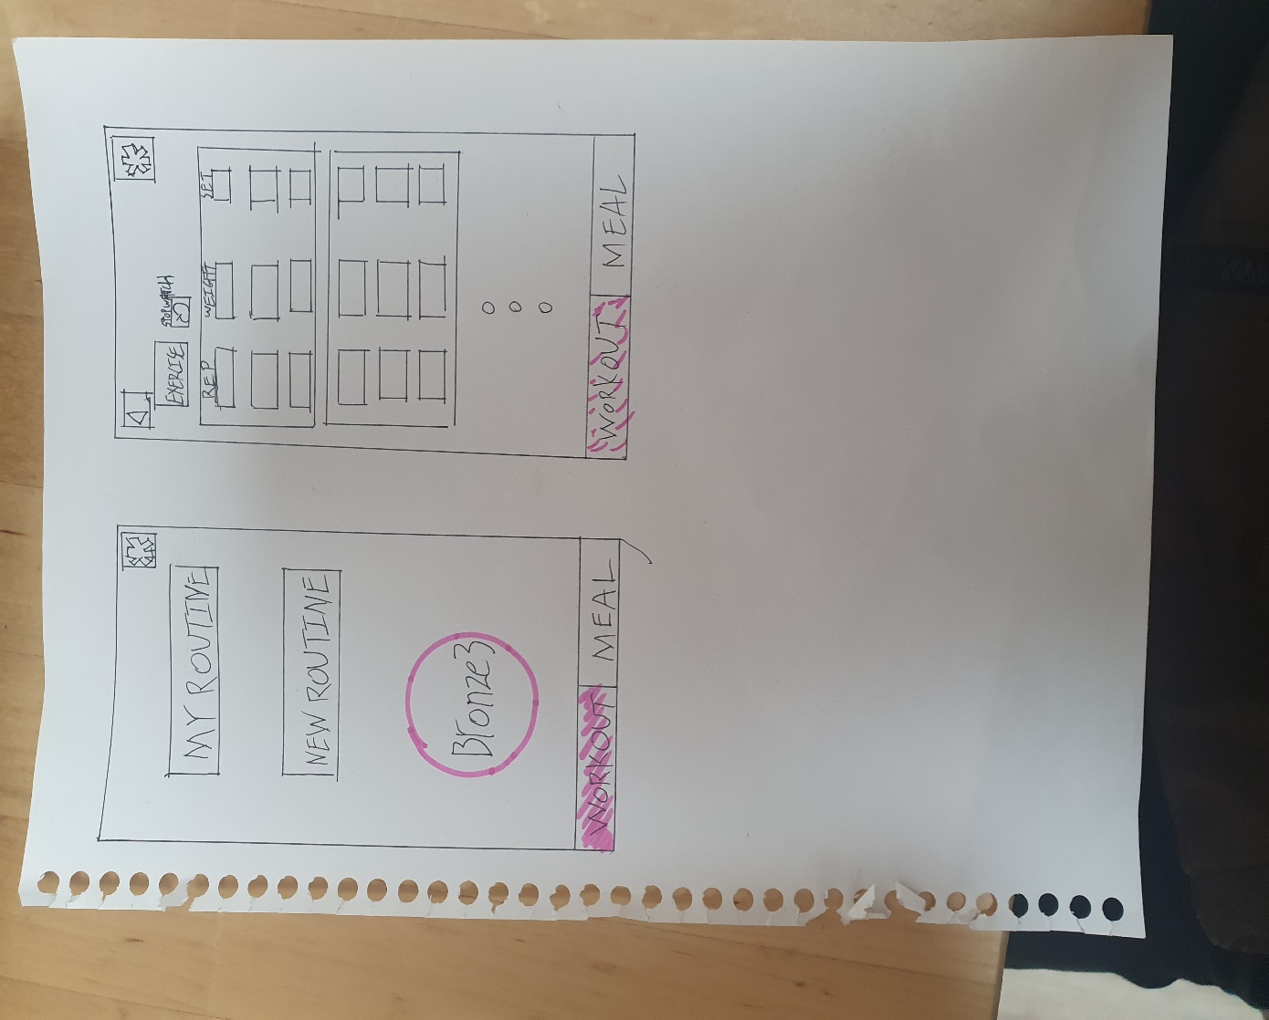What is it about :  
Rountine page comes out. there are rep, weight, set for users to put infomation. Every exercise has own section and stopwatch is right next to exercise(proximity principle).   
-setting is on the top right corner(continuity principle)  
-workout/meal sections are always on the bottom(continuity principle)

Actions for users to take :  
users can enter their exercise infomation for management.  
key finding from research : stop watch and clear design

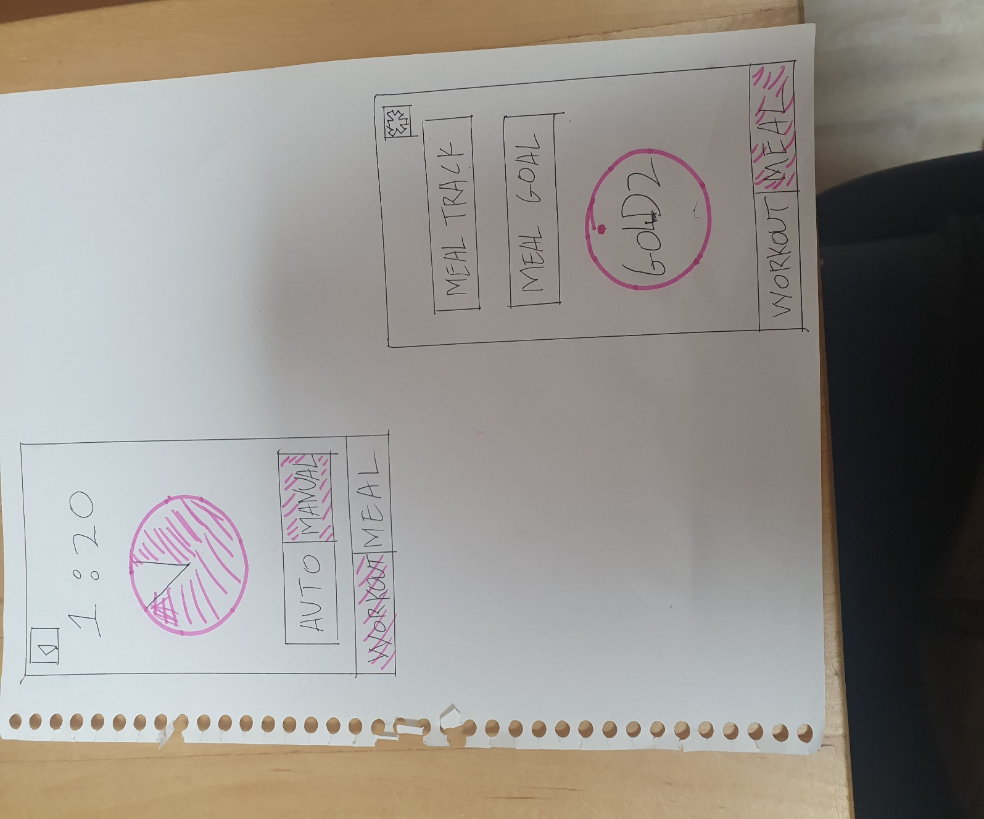

What is it about :  
Stop watch page for user. Stop watch can be either auto or manual.  
-auto : each exercise section, stop watch count rest time and workout time  
-manual : user manuallly set the time  
i put clock in the center for easy to see(peripheral vision principle)  
there are 2 choices auto, manual(choices principle)

Actions for users to take :  
users use stop watch auto or manual for manage time  
key finding from research : stop watch and clear design

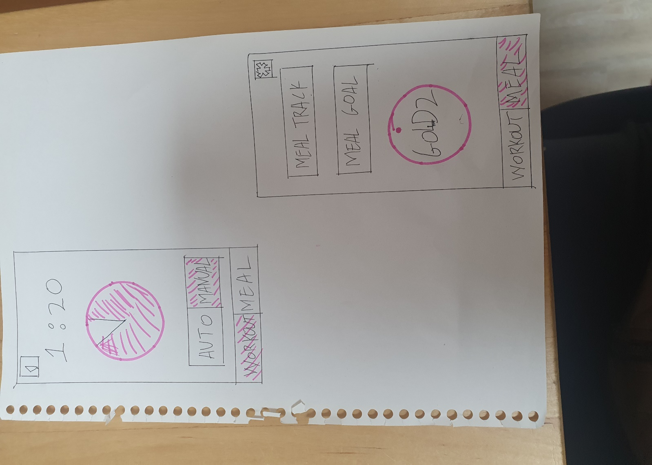  
What is it about :  
this is the first page of meal section. In this page, there are 3 features, meal track, meal goal, level.  
-meal track : It is for users to track their carolies and nutrition.  
-meal goal : it is for users to set their diet plan  
-level : it is for motivation purpose.user can level up by consisntly maintaining good diet habit.  
-all the sections are clear to see & similiar to workout section(continuity principle)

Actions for users to take :  
meal track, meal goal, level. there are 3 opinion for users  
key finding from research : clear design

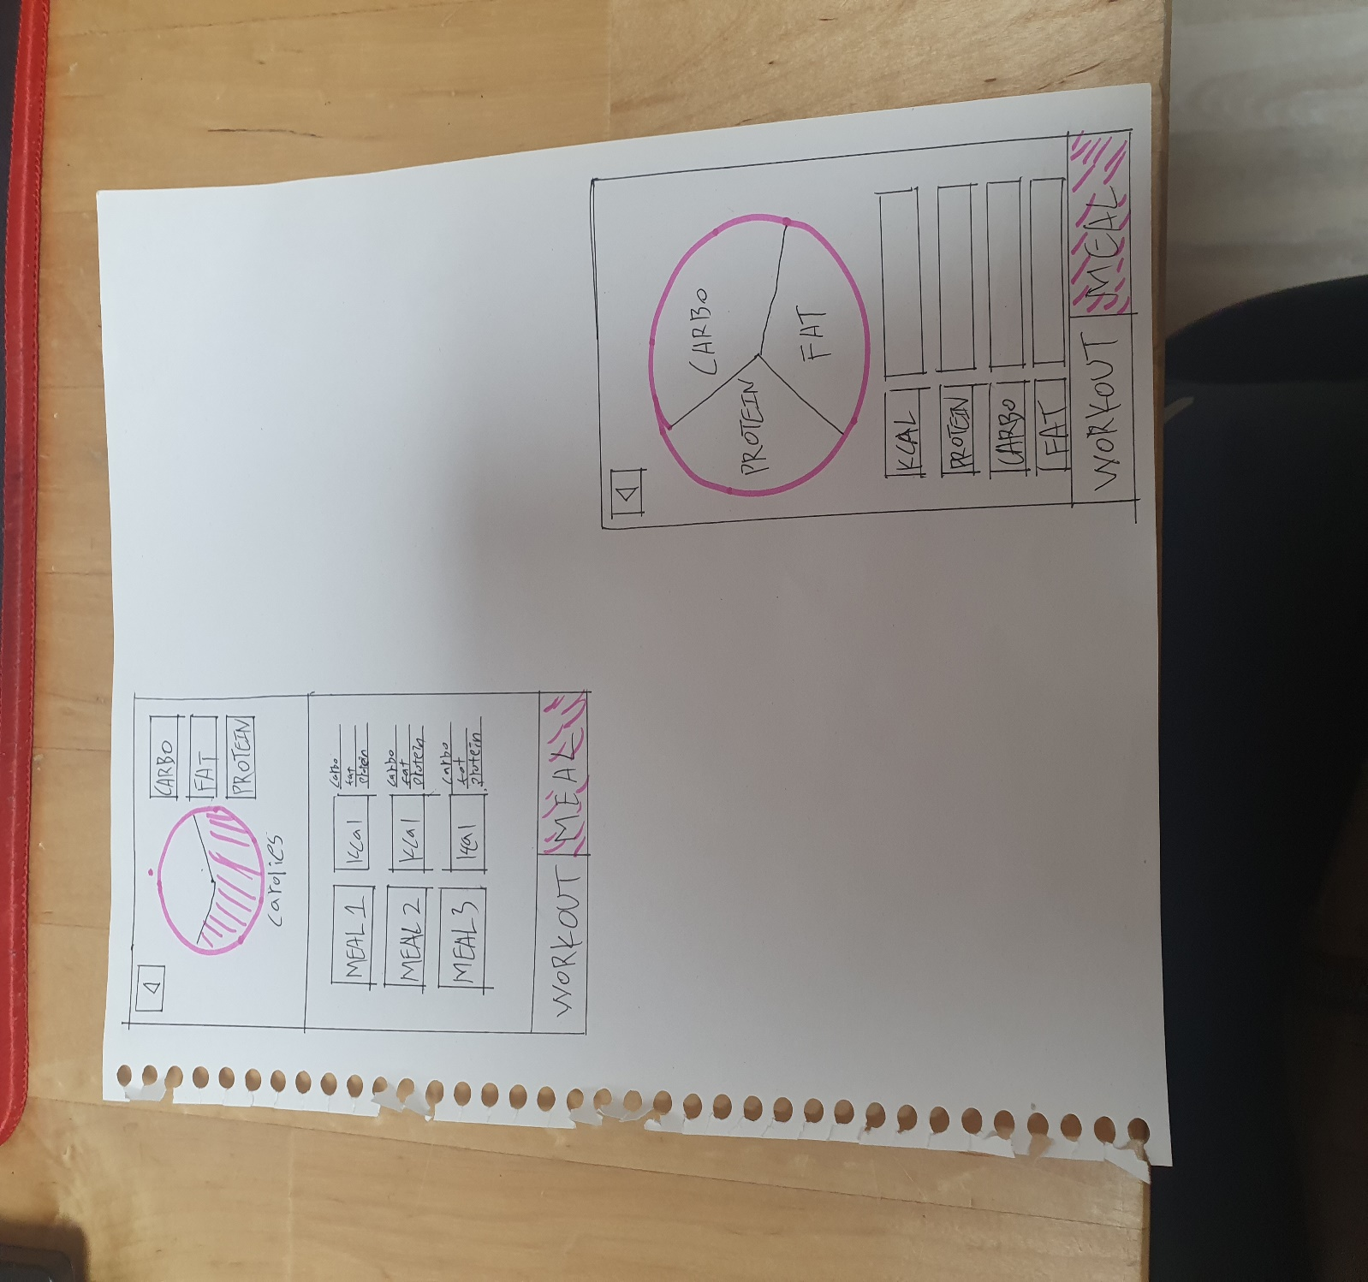  
What is it about :  
Meal Track page, user can enter intaked food. users can track carolies, carbo, fat, protein. I tried to make simple for users to clearly see their daily food intake. graphic on the top helps users to know their intake with only scan.

Action for users to take :  
users have to put food infomation, then all the complex calculation automatically done  
Design principle : essential feature in the center with graphic  
key finding from research : people have difficulty tracking their food

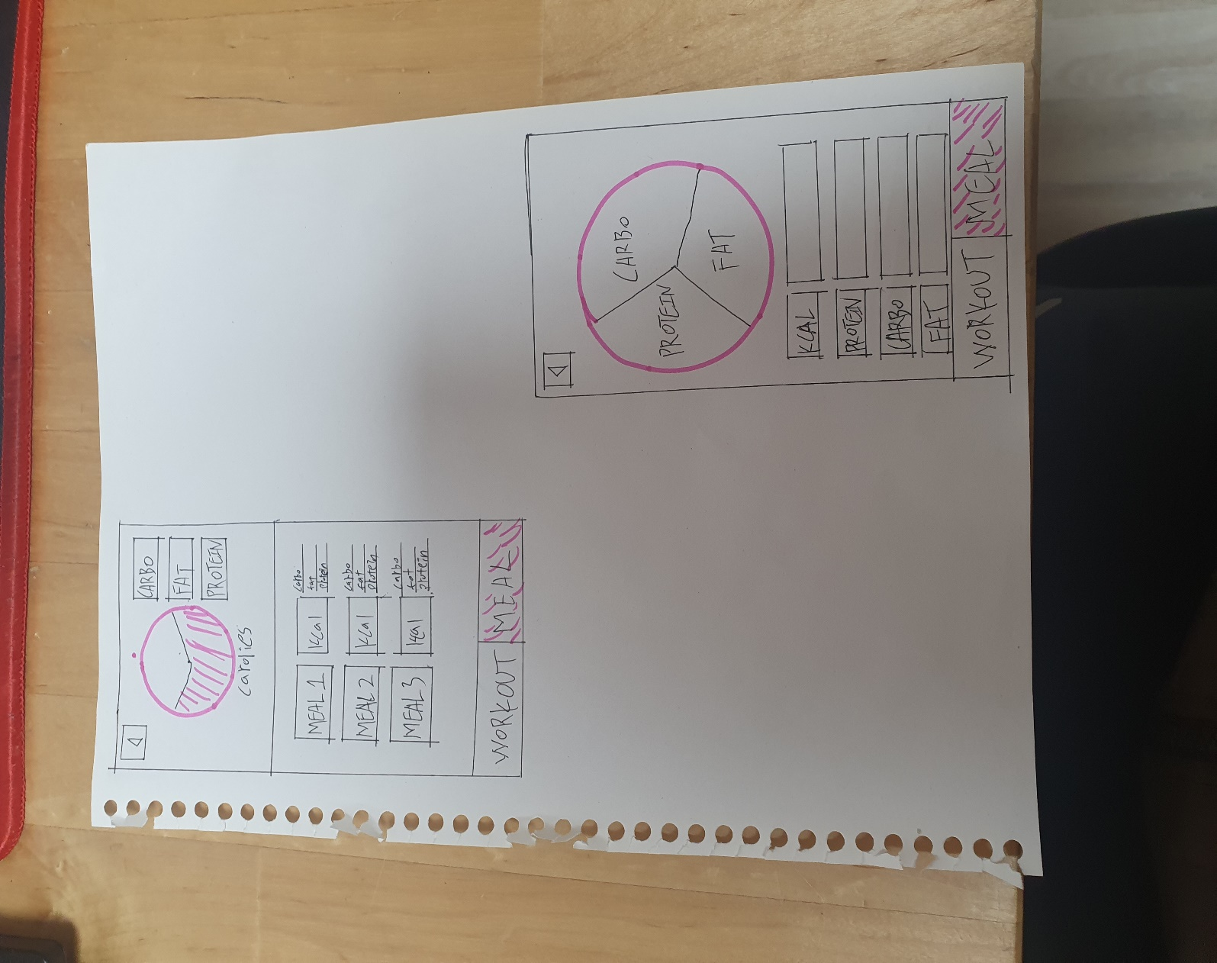  
What is it about :   
Meal track page, users can set their diet plan. kcal,protein,carbo,fat should be mandatory. there are graphic on the top center of the page for user to clearly see the goal.

Action for users to take :  
user enter the diet goal  
Design principle : essential feature in the center with graphic  
key finding from research : user want easy way to track their diet