ASSIGNMENT-4

Q1.write select command that produce order no, order amount, order date for all rows?
Ans-
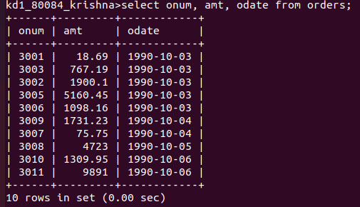
Q2.write a quries that producr all rows from customer table for which the salesperson's number is 1001?
Ans-
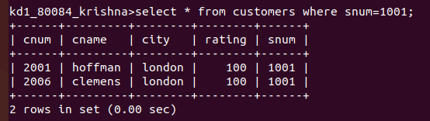

Q3.write qurey that display the salepeople table with colum in order city, sname, snum,com?
Ans-
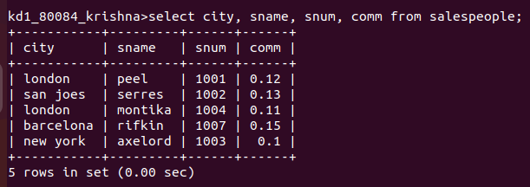
Q4.write select command that produces the rating followed by name of each customer in san jose?
Ans-
