Assignment-5

Q1.-Write query that will give all orders for more than 1000 ?
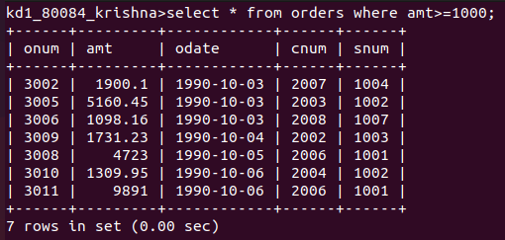
Ans-

Q2.Writr a query that will give u thae name and cities of all salespeople inlondon with commision above 0.10?
Ans-
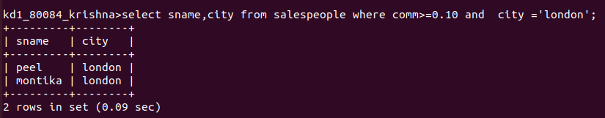
Q3.write query on customer table whose output will exclude all customer with a rating <=100,unless they are loacted in rome?
Ans-
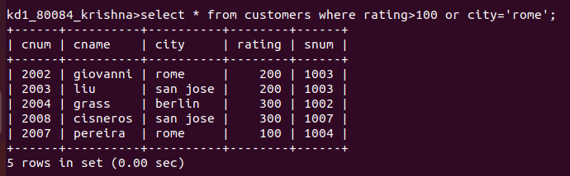
Q4.what will be the output rom the following query :
select * from orders
where(amt<1000 or not (odate = '1990-10-03' and cnum>2003)); ?

Ans-
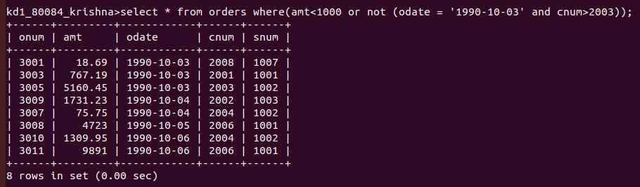
Q5.what will be the output rom the following query :
select * from orders
where not ((odate = '1990-10-03' or sum>1006) and amt >=1500)); ?
Ans-
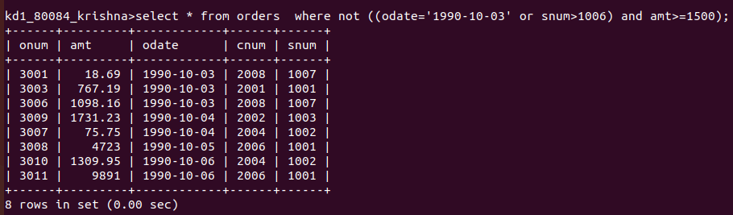
Q6.what will be a simpler way to write this query/ select snum,sname,city,comm from salespeopple where (comm>0.12 or comm<0.14)?
Ans-
