ASSIGNMENT-9

Q1.Write query that list each order number followed by the name of the cutomer who made the order?
Ans-
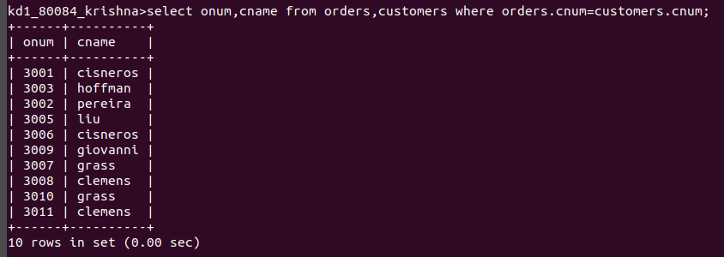
Q2.Write a query that gives the name of both the sale person and the customers for each orders allong with the order number?
Ans-
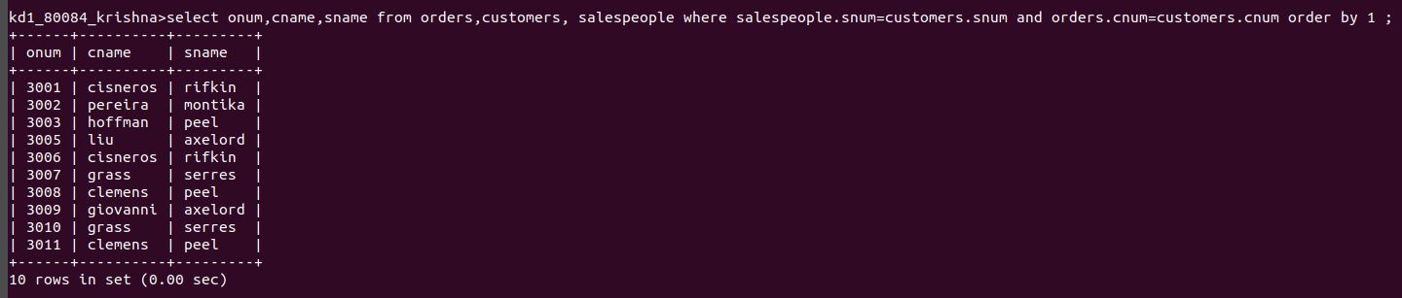
Q3.Write the query that produces all customer serviced by sales people with commision above 12%?
Ans-
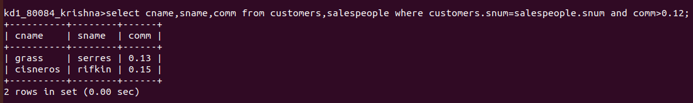

Q4.Write a query that calculate the amount of the salespeople’s commision on each orders by customers with arating above100?
Ans-
