ASSIGNMENT-13

Q1.Write a union of two queries that show the name, cities,rating of all customers.those with rating of 200 or greater will also have the words ‘high rating’ while the orders will have word ‘low rating’?
Ans-
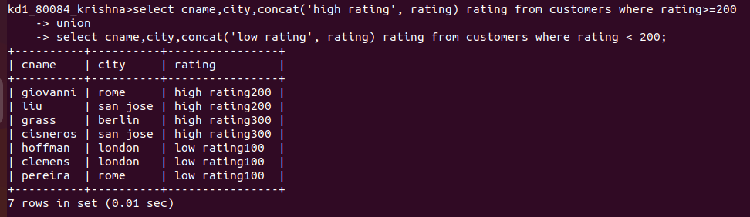

Q2.Write a command that produce the name and number of each salesperson and each customer with more than one current orders. Put results in alphabetical orders ?
Ans-
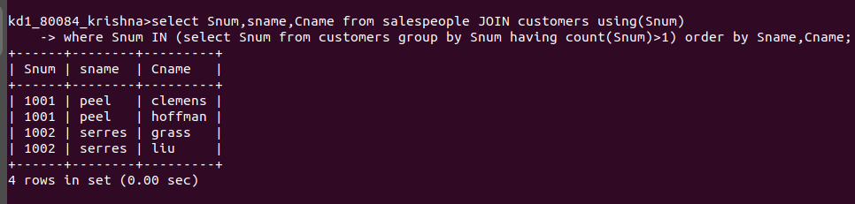
Q3. Form a union of three queries. Have the first select the snums of all salespeople in San Jose; the second, the cnums of all customers in San Jose; and the third the onums of all orders on October 3. Retain duplicates between the last two queries but eliminate any redundancies between either of them and the first.
Ans-
