ASSIGNMENT-7

Q1.write query that counts all orders from octomber 3 ?
Ans-
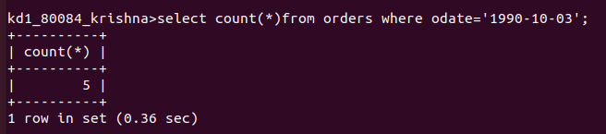
Q2.write a query that count the number of different non-null city value in customer table?
Ans-
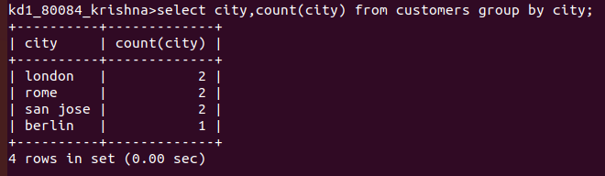
Q3.write a query that select each customers samllest order?
Ans-
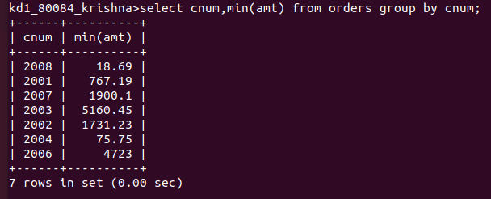

Q4.Write the query that select the first customer in alphabetic order,whose name begin with ‘G,?
Ans-
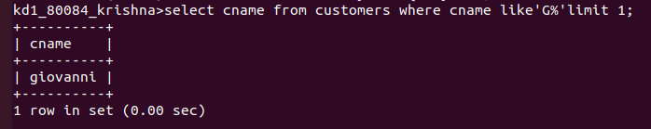
Q5.write the query that select higest rating in each city ?
Ans-
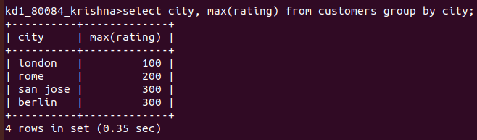

Q6.Write query that counts the no of sales people registering order for each day (if a sale person has more than one order on given day he or she should be counted only once )?
Ans-
