ASSIGNMENT-12

Q1. Write a query that selects all customers whose ratings are equal to or greater Serres?
Ans-
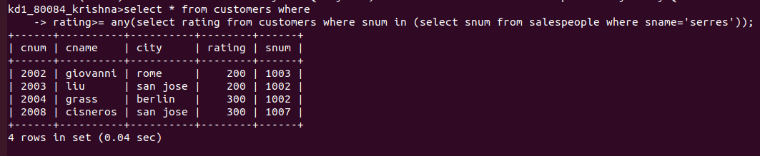

Q2. Write a query using ANY or ALL that will find all salespeople who have no customers located in their city?
Ans-
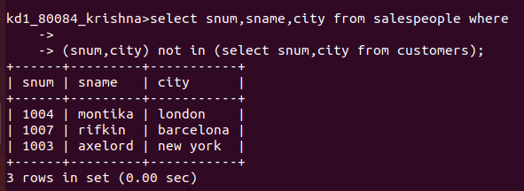

Q3. write a query that selects all orders for amounts greater than any for the customers in London?
Ans-
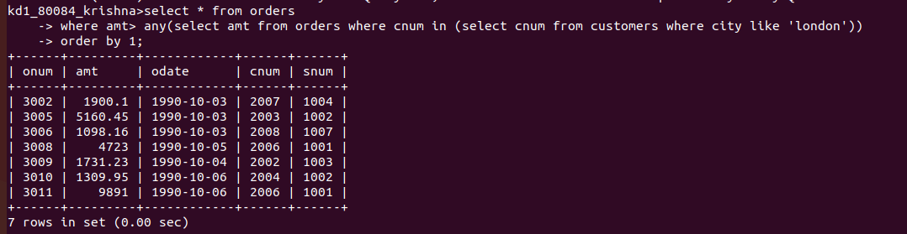

Q4.Write the above query using MIN or MAX?
Ans-
