ASSIGNMENT-10

Q1.Write query that produces all pairs of salespeople who are living in the same city exclude combination of salespeople with themselves as will as dublicate row with order reversed ?
Ans-
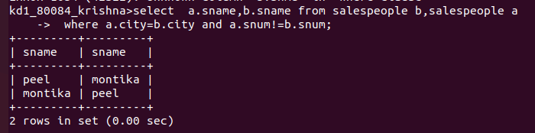

Q2.write a query that produce the names and cities of all customers with the same rating as hoffman?
Ans-
