ASSIGNMENTS-14

Q1.Write a command that puts the following values, in their given order, into the
salespeople table: city – San Jose, name – Blanco, comm – NULL, snum – 1100.
Ans-
insert into salespeople (city,sname,comm,snum)
values(‘san jose’,’bianco’,null,1100);

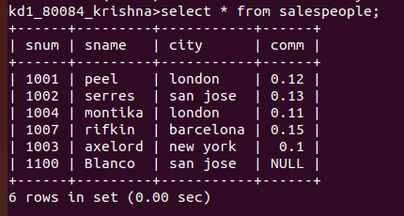
Q2.Write a command that removes all orders from customer Clemens from the
Orders table.
Ans-

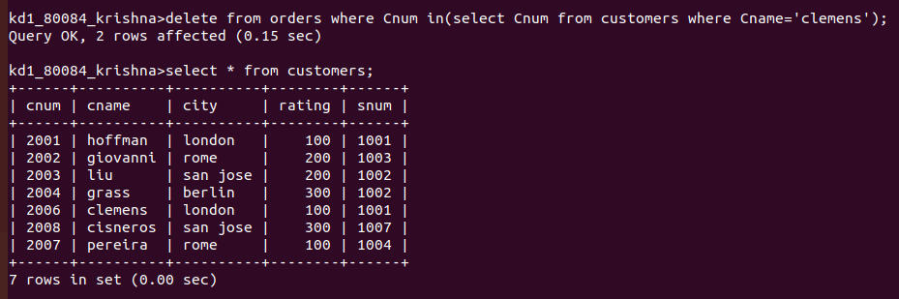
Q3.Write a command that increases the rating of all customers in Rome by 100 ?
Ans-
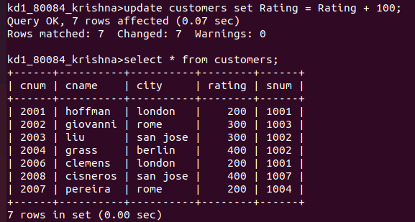

4) Salesperson Serres has left the company. Assign her customers to Motika.

