SQL ASSIGNMENT-6

Q1. Write two different quries that would produce all orderss taken on octomber 3ra or 4th 1990?
ANS-1st query
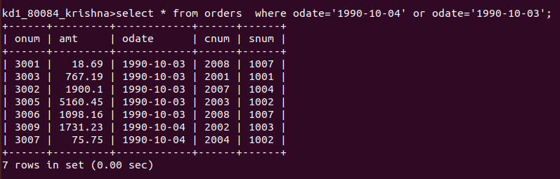
2nd query
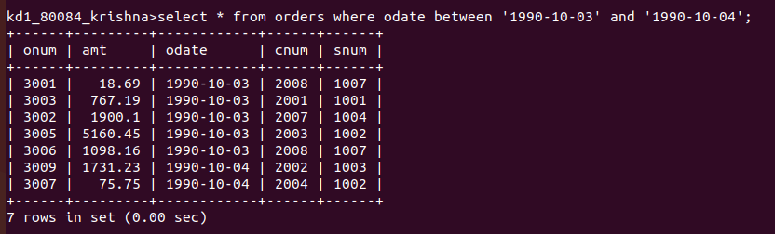
Q2.Write quries that select all customers serviced by peel or motika ?
ANS-
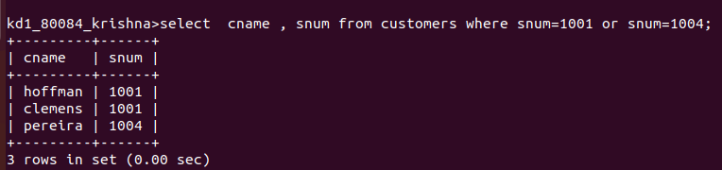

Q3.write query that will produce all the customers whose name begin with letters from’a’ or‘g’?
Ans-
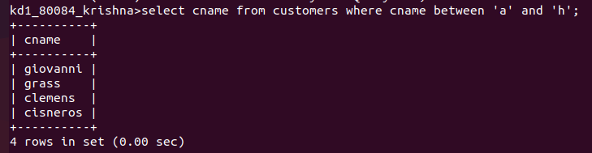

Q4. write query that select all customers whose name begin with the letter ‘c’ ?
Ans-
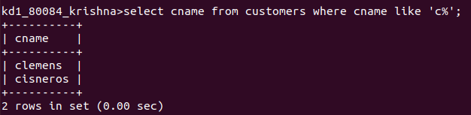
Q5.Write a query that select all orders except all those with zeroes or null in the amt filed ?
Ans-
