ASSIGMENT-11

Q1.Write a query that uses a subquery to obtain all orders from customers named cisneros.assume y do not know his customer no(cnum)?
Ans-
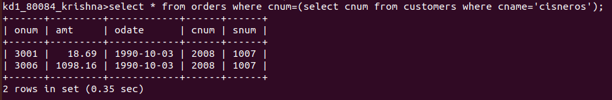
Q2.write a query that produce the name and rating of all cutomers who have above average orders?
Ans-
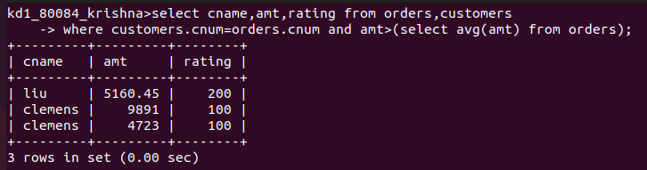
Q3.write a query that select a total amount order for each salesperson for whom this
total is greater than the amount of largest order in the table?
Ans-
