ASSIGNMENT-8

Q1.assume each sales person has 12%commision write query on orders table that will produce orderno, saleperson no and amount of sale person commision for that order?
Ans-
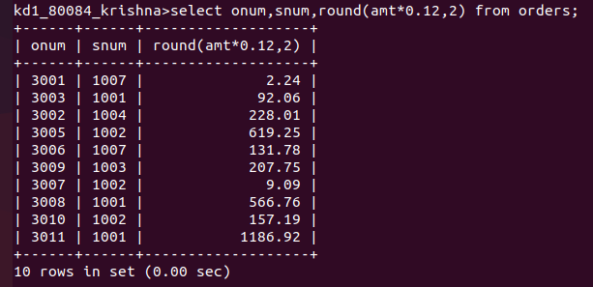
Q2.write query on customer table that will find heigest rating in each cityput output in form;
for city(city),the heigst rating is:(rating)
Ans-
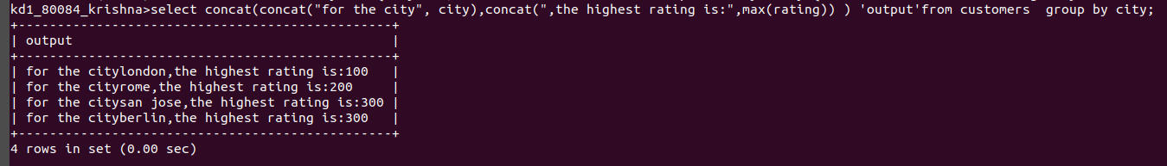
Q3. Write query that list customers in decending order of rating ?
Ans-
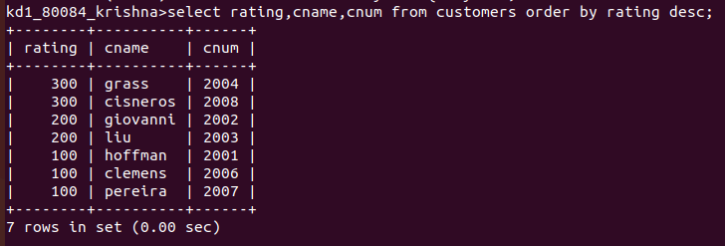
Q4.Write the query that total the orders for each day and places the result in descending?
Ans-
