Assignment-02

Q1. List the directory contents date wise sorted. ( man ls)
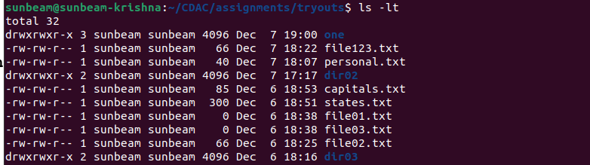
Q2. List the directory contents size wise sorted.(man ls)
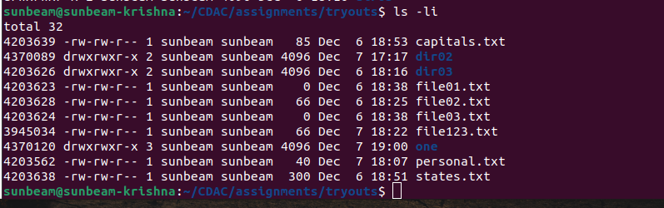
Q3. List directory contents along with their inode no

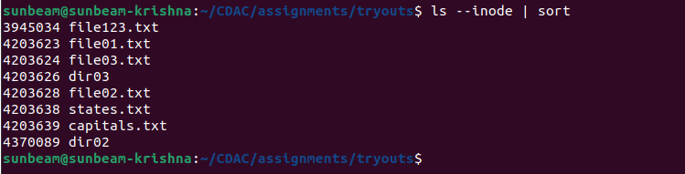

Q4. List the contents of the subdirectory

Q5. Create a file, write your surname and name in it and
save.
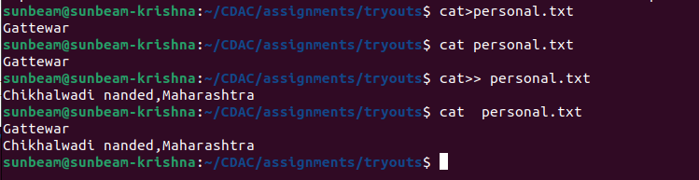
Q6. how to change the time stamp of file (man touch)
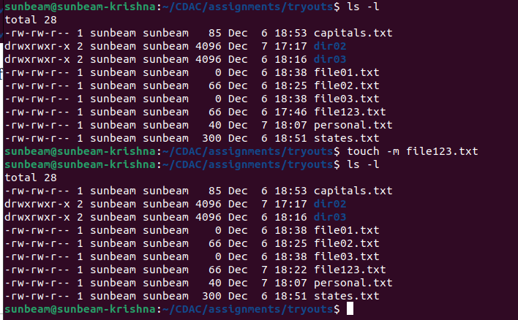

Q7. Create directory structure : Give following commands
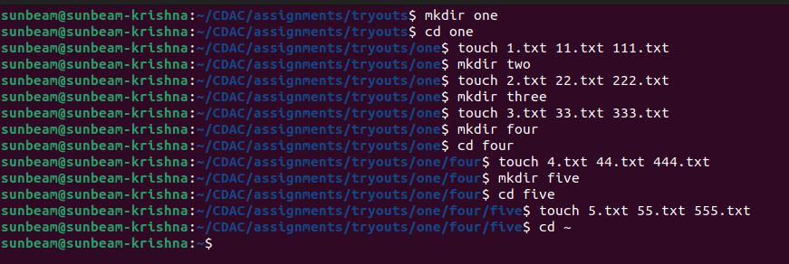
Q8.Considering above directory structure , Do following
operations

i. list the directory contents of directory named"five" from current directory (i.e. home directory).
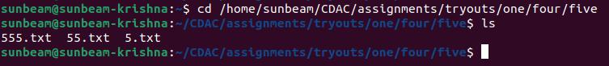
ii. write your name in a file named "44.txt" of directory "four" from current directory.
iii. remove the file named "555.txt" from directory
"five" from current directory.
iv. change directory to five( i.e. cd one/two/three/four/five/ ).

v. write your course name in file named "3.txt" which resides in directory "three" from current directory (i.e.
five).also read the same file.
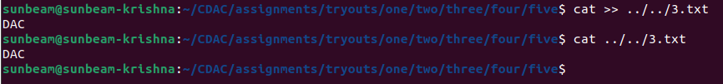

vi.list the contents of directory "two" from current
directory (i.e. five).
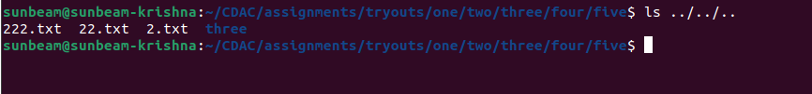
vii. remove file named "222.txt" which belongs to directory "two" from current directory (i.e. five)
viii. now change the directory to "one"
ix. remove all files only from directory named "five"
from current directory (i.e. one)
x. remove directory named "five" from current directory
(i.e. one)

xi. remove whole directory named "four" from current
directory (i.e. one)
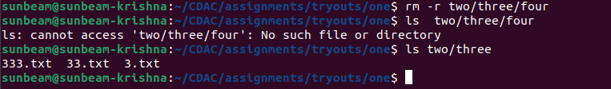
xii. change to your home director

Q9. change the time stamp of file named "3.txt" which resides
in directory named "three".(man touch)
