Assignment-03

1.ls
2.rename
3.ln -s
4.ln

5.stat
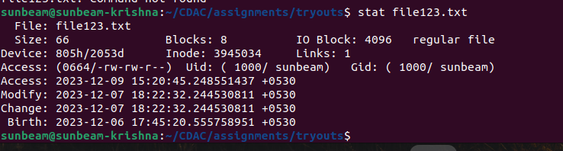
6.touch- change the time stamp
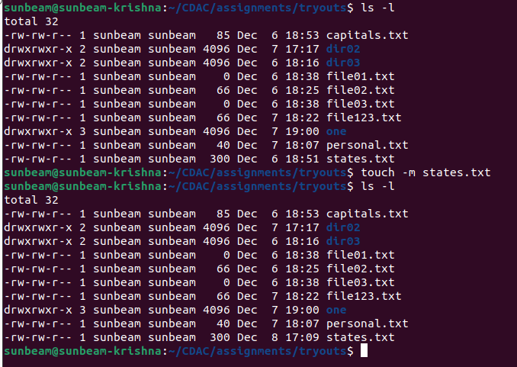
7.touch- Create empty file
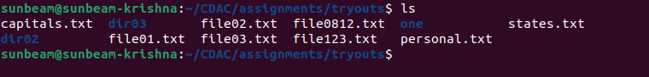
8. Tail
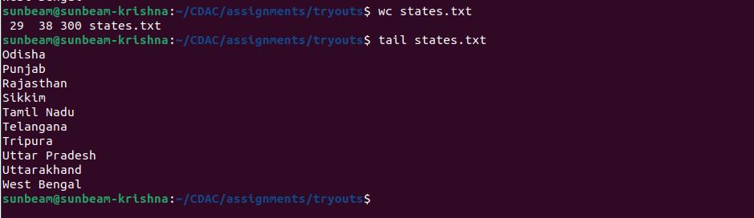
12.whoami
13.tty- find thr terminal path

12.who am i

14.who am i
15.users
16.who

17.grep, egrep, fgrep
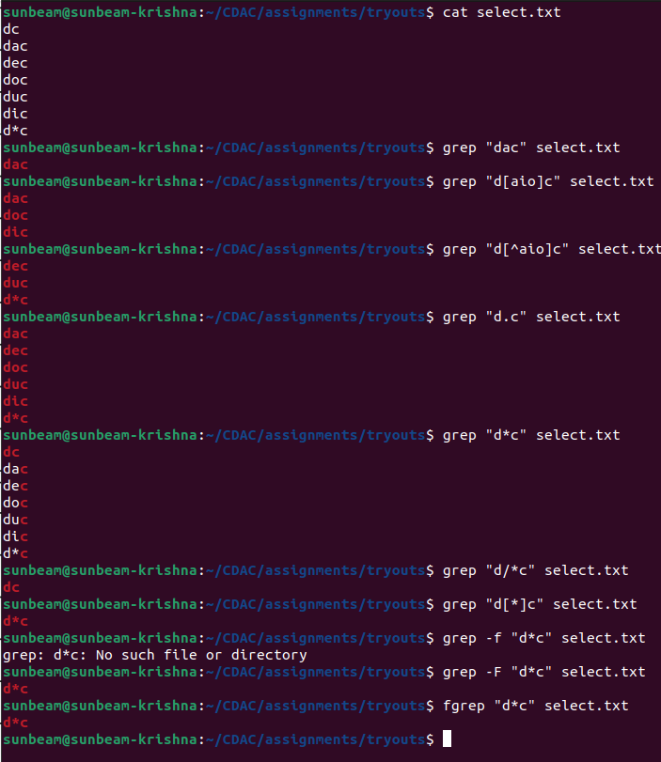

egrep
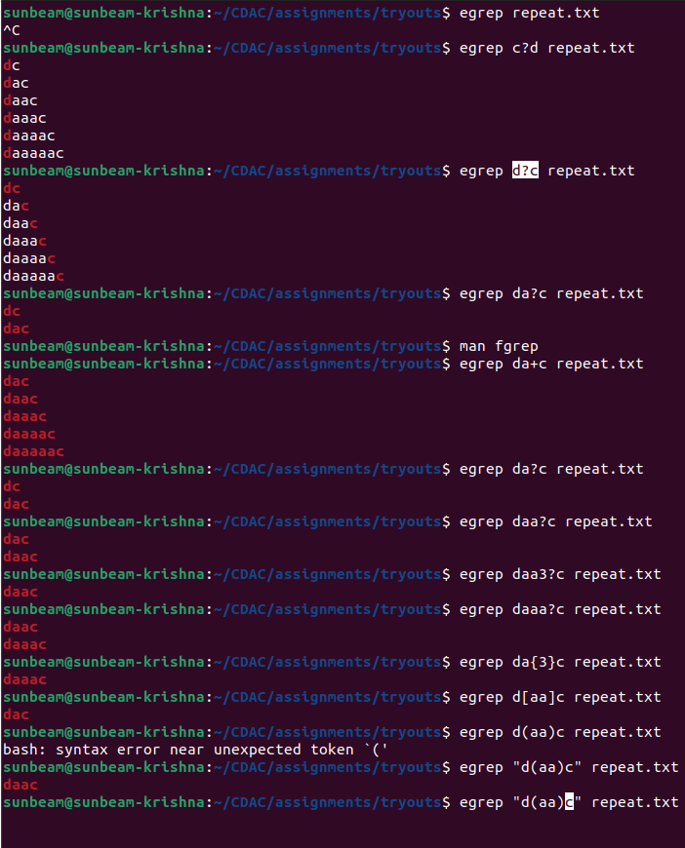

18.chmod ( chmod 444)
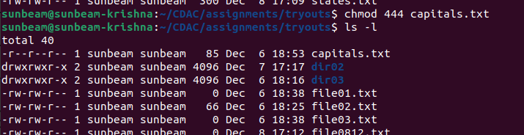
19.chmod (chmod 777)
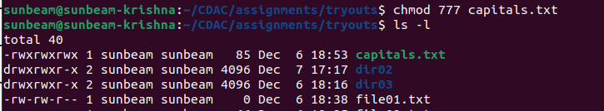
20.wc (using redirection)
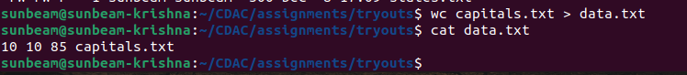
21.who| wc
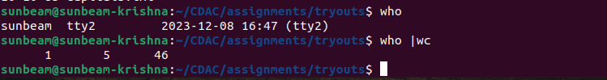
22.head, tail (using pipe)
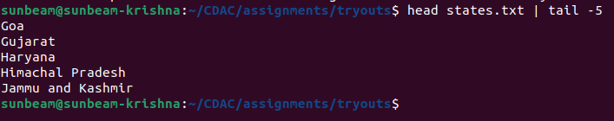

23.sort , uniq (using pipe)
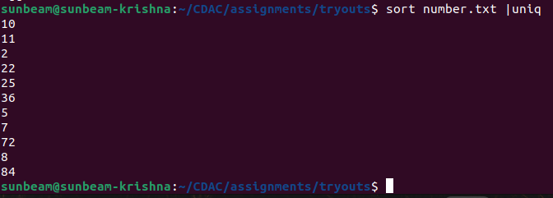

24.who, grep (using pipe)

25.ls
26.ls, grep (using pipe)
27.ls, grep (using pipe)
28.tr
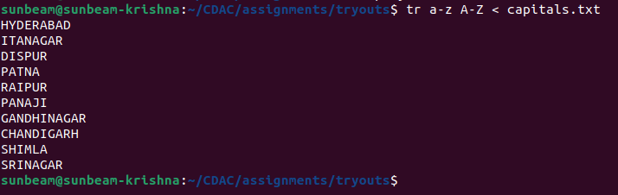
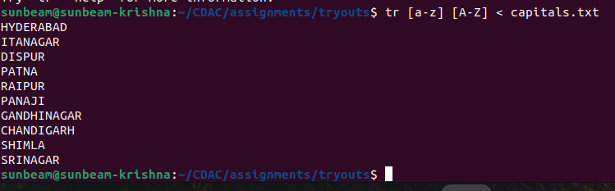

29.cut

