Assignment-01

1.Uname
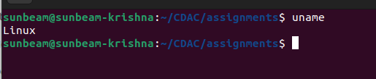

2.pwd
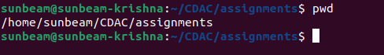

3.hostname

4.date


5.cal
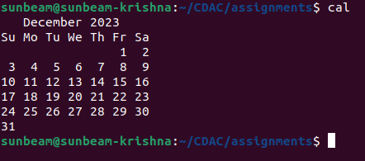

6.ls,dir
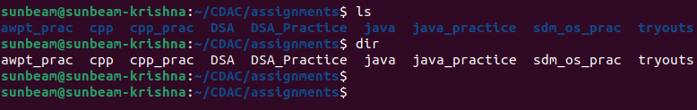
7.cat
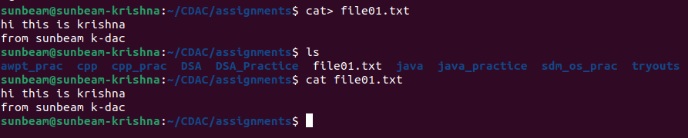
8.cat>>
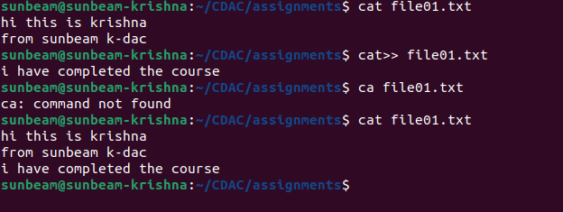
9.cp (file)

9.cp(directory)
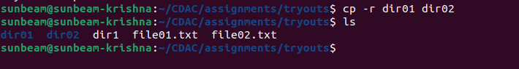
10.mv
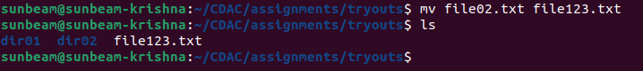
11.mv(rename)
12. tac,rev
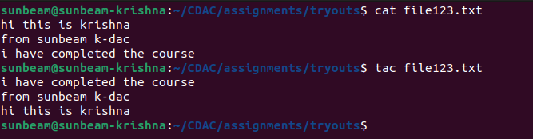
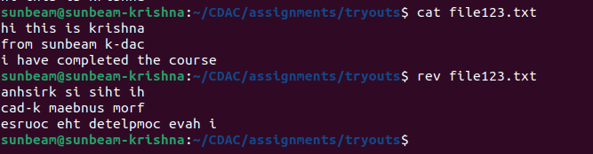
13. wc

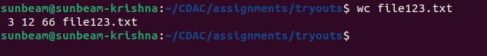
14. mkdir
15. cd
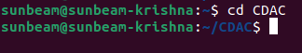

16. rm (remove file)
rm -r (removes directory which contains file)

17. rmdir (removes only empty directory)
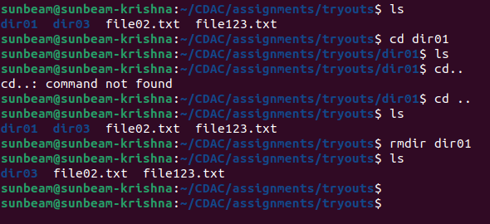

18. touch
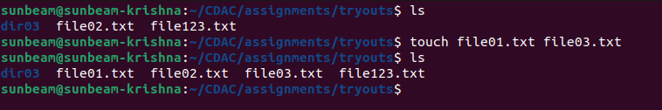

19. sotr
20.unique

21.head-shows 1st 10 lines fo the file
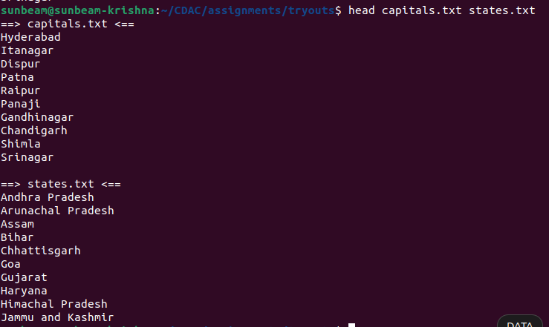
22.tail -shows last 10 lines in the file
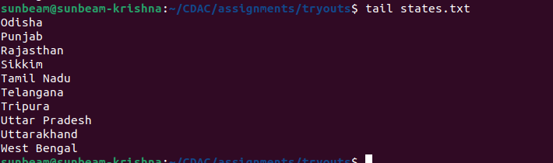
23. factor- shows all possible factor
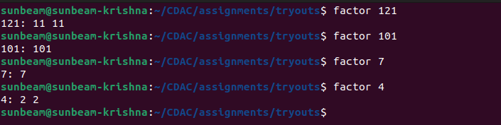

24. alias
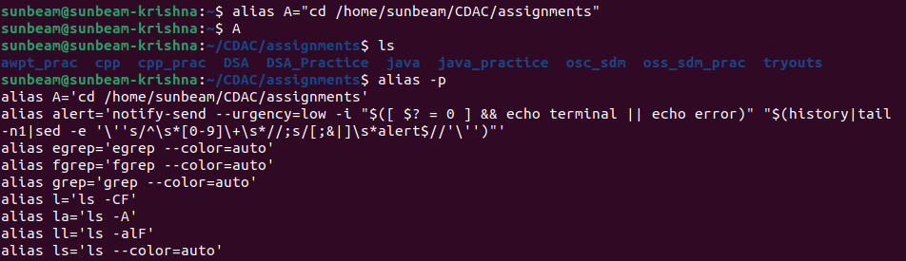
25. unalias
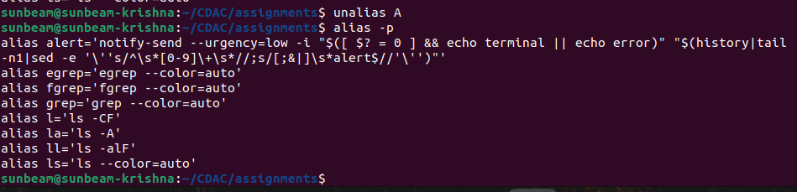
26.echo

27. ps
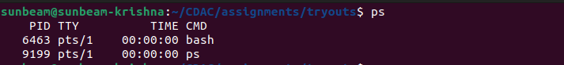
28. kill

29. env

