MYSQL Assignment-8

Q.1 Assume each salespersom has a 12% commission.

Write a query on the orders table that will produce the order number the salesperson number, and the amount of the salespersons commission for that order

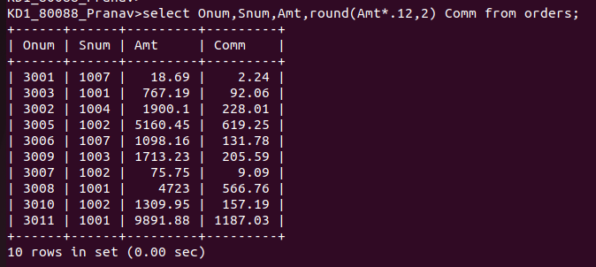

Q.2 Write a query on the customers table that will find the highest rating in each city. put the output in this foom

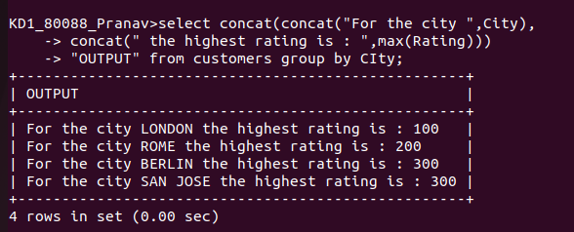
Q.3 Write a query that lists customers in descending order of rating.Output the rating field first, followed by the customers name and number

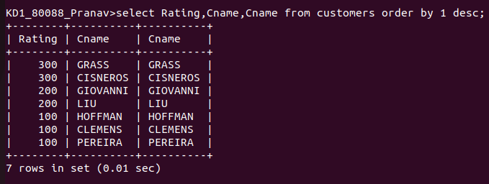

Q.4 Write a query that totals the orders for each day and places the results in descending order

