MySQL Assignment-9

Q.1 Write a query that lists each order number followed by the customer who made the order.

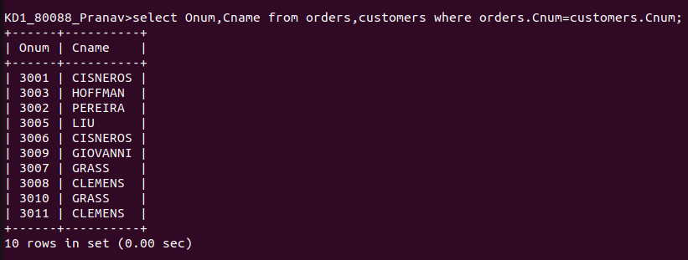
Q.2 Write a query that gives the names of both the salesperson and the customer for each order along with the order number

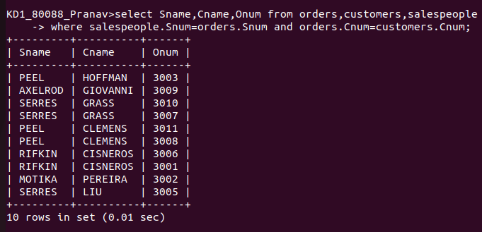

Q.3 Write a Query that produces all customers serviced by salespeople with a commission above 12%. output the customers name,the salesperson name, and the salespersons rate of commission

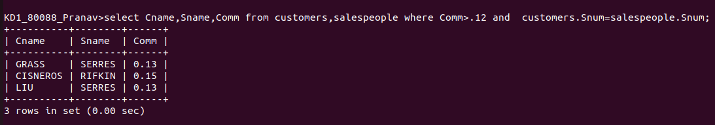

Q.4 Write a query that calculates the amount of the salespersons commission on each order by a customer with a rating above 100.

