MYSQL Assignment-7

Q.1 write a query that counts all orders for october 3.

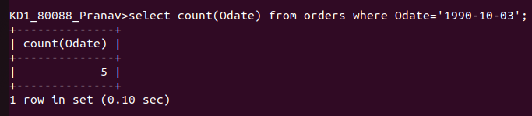

Q.2 Write a query that counts the number of different non-NULL city values in the customers table;

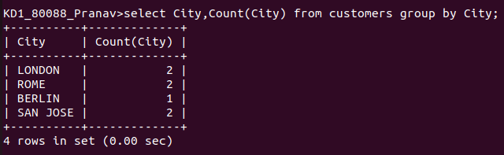

Q.3 Write a query that selects each customers smallest order.

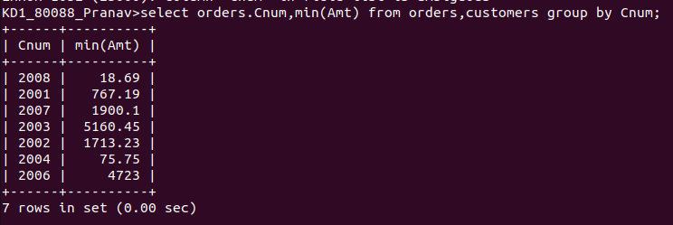
Q.4 Write a query that selects first customers in alphabetical order whose name begins with G.

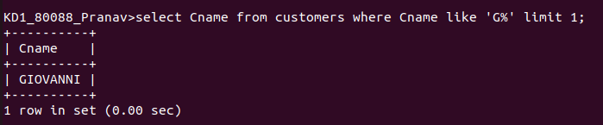

Q.5 Write a query that selects the highest rating each city.

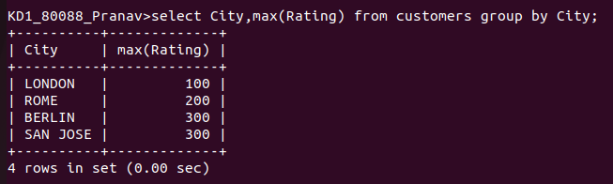
Q.6 Write a query that counts the number of salepeople registering orders for each day.

