MYSQL Assignment-5

Q.1 Write a query that will give you all orders for more than RS 1000.

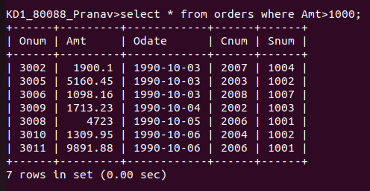

Q.2 Write a query that will give you the names and cities of all salespeople in london with commission above .10

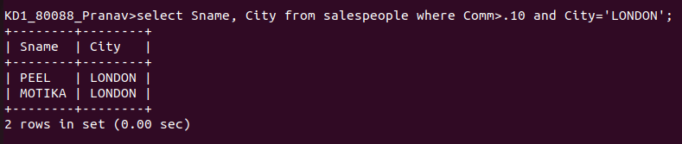

Q.3 Write a query on the customers table whose output will exclude all customers with rating <=100,unless they are located in rome.
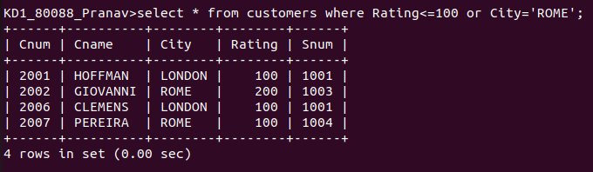

Q.4 What will be the output from the following query.

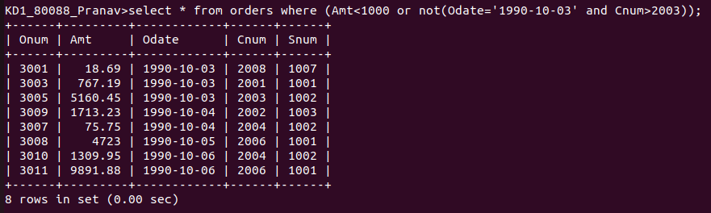

Q.5 What will be the output from the following query.

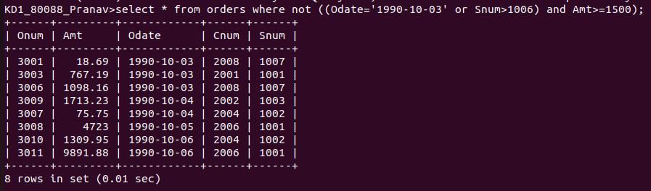

Q.6 What is a simpler way to write this query

