MySQL Assignment-6

Q.1 Write two diff queries that would produce all orders taken on october 3rd or 4th,1990.

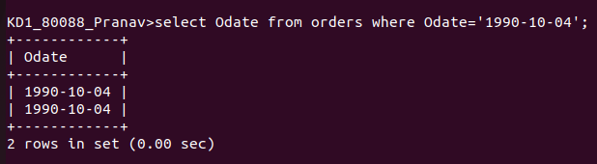
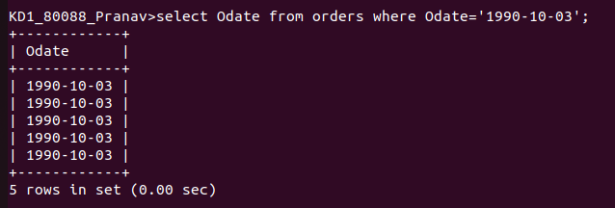
Q.2 write a query that selects all of the customers serviced by peel or motika.

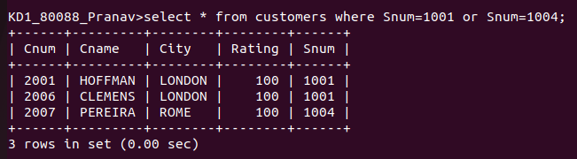
Q.3 Write a query that will produce all the customers whose names begin with a letter from ‘A’ to ‘G’.

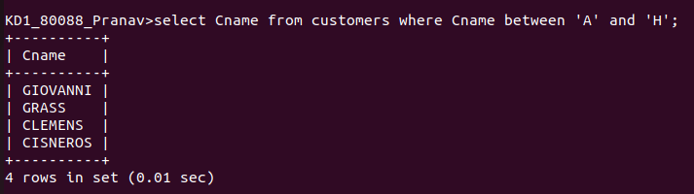
Q.4Write a query that selects all customers whose names begin with the letter ‘c’

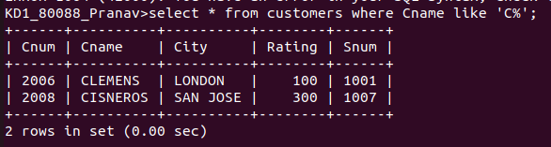
Q.5 Write a query that selects all orders except those with zeroes or NULLs in the amt field

