MYSQL Assignment-12

Q.1 Write a query that selects all customers whose ratings are equal to or greater
Serres.

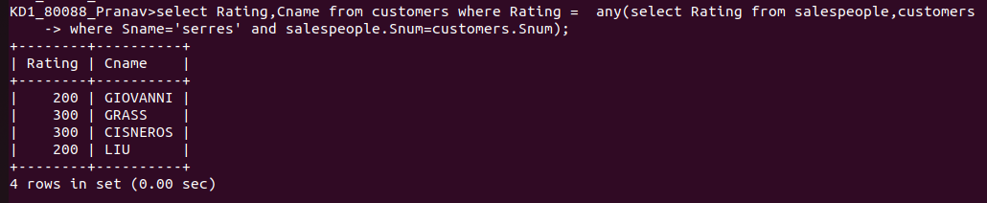
Q.2 Write a query using ANY or ALL that will find all salespeople who have no customers located in their city.

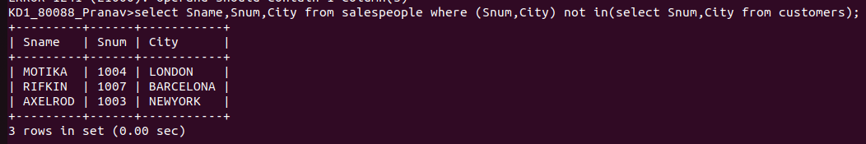
Q.3 write a query that selects all orders for amounts greater than any for the customers in London.

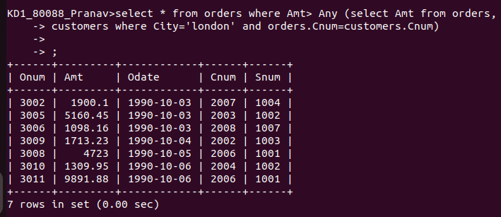

Q.4 Write the above query using MIN or MAX.

