MYSQL Assignment_1

Q.1 Create the following tables with the given structures and insert sample data as specified:
:- salespeople

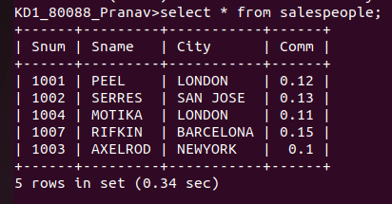

Q.2 Customers table

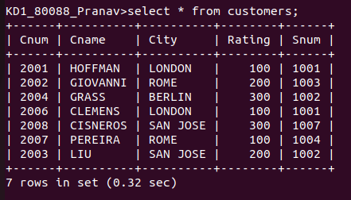
Q.3 Orders

