MYSQL Assignment-4

Q.1 Write a select command that produces the order numer,amout,and date for all rows in the orders table.
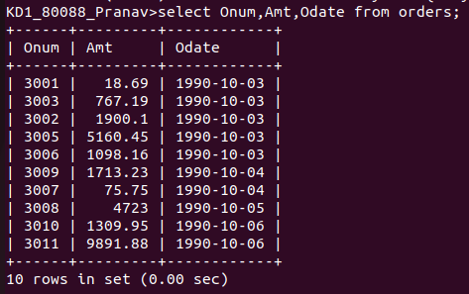

Q.2 Write a query that produces all rows from the customers table for which the salesperson’s number is 1001.

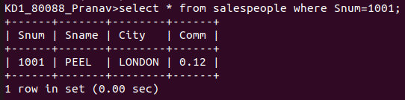

Q.3 Write a query that displays the salespeople table with columns in the following order city, sname,snum,comm

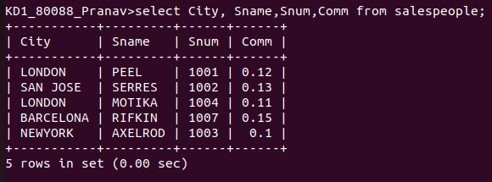

Q.4 Write a select command that produces the rating followed by the name of each customers in San jose.

