Assignment_03

1.Display hidden files

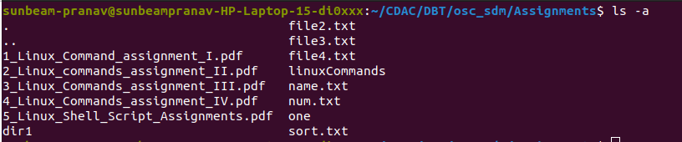
3.Create symbolic link (shortcut) for a file

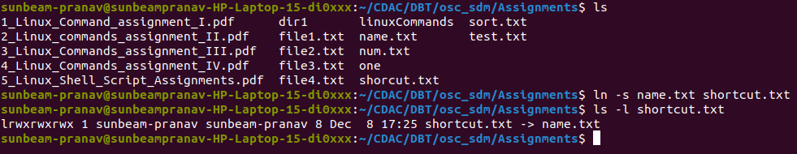
4.Create hard link for a file &
5. Display time stamp of the file

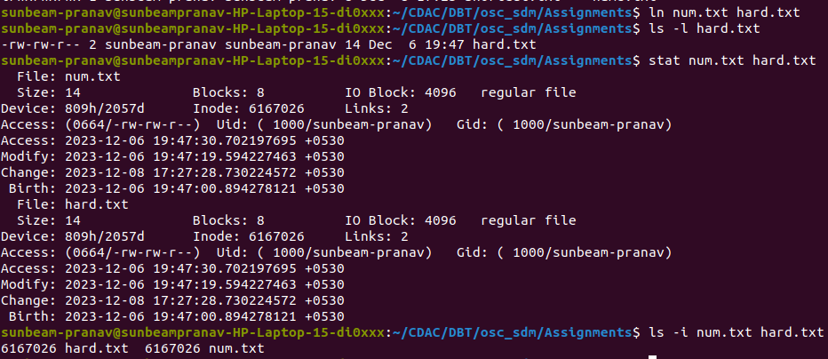

6.Change the time stamp of the file &
7.Create empty file

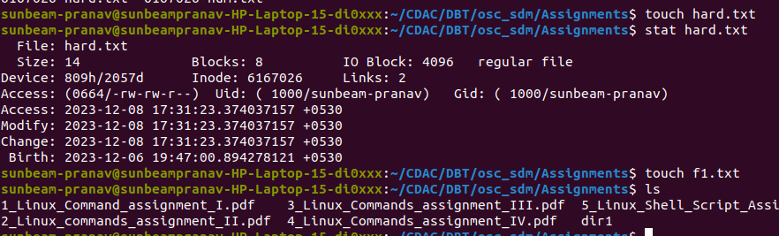
8.Print all lines in a file from fifth line onwards

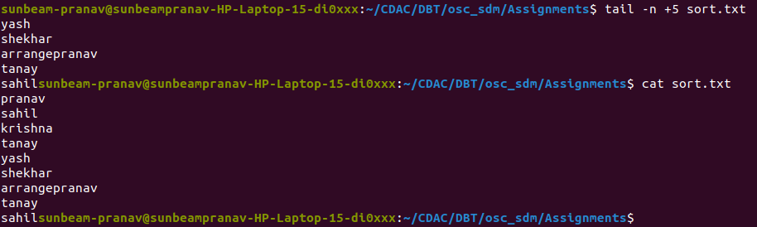
12 to 16

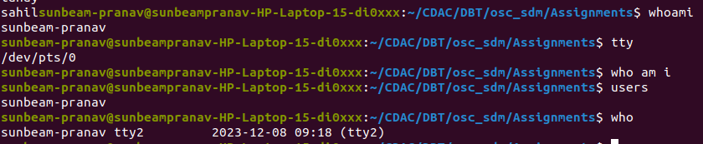
17.Find a given word/pattern from the file

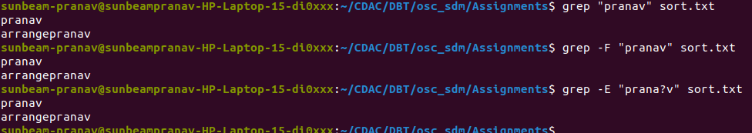
18 & 20

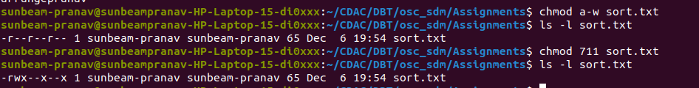
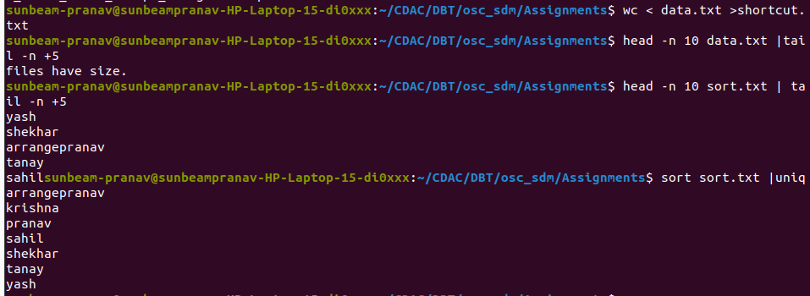
21 to 29

