ASSIGNMENT NO 12

Using the operators IN, ANY, and ALL.

Q1. Write a query that selects all customers whose ratings are equal to or greater Serres.

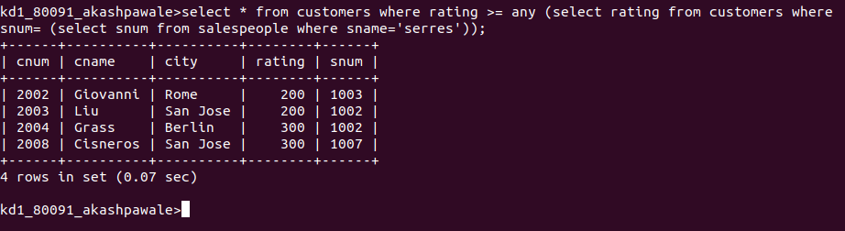

Q2. Write a query using ANY or ALL that will find all salespeople who have no customers located in their city.

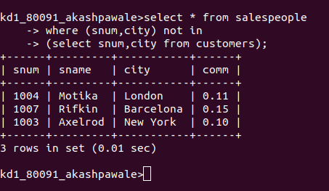

Q3. write a query that selects all orders for amounts greater than any for the customers in London.

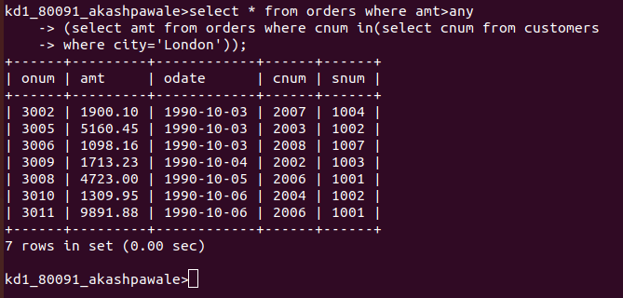

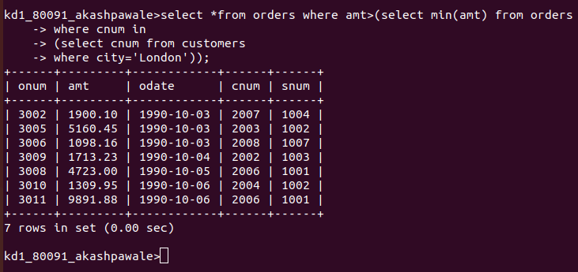
Q4. Write the above query using MIN or MAX.

