ASSIGNMENT NO 6

Q.1 Write two diff queries that would produce all orders taken on october 3rd or 4th,1990
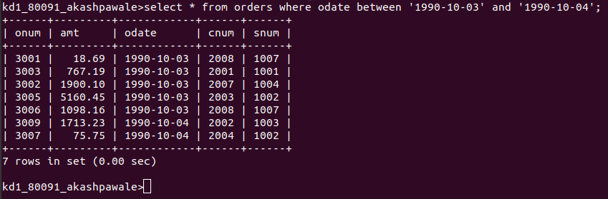

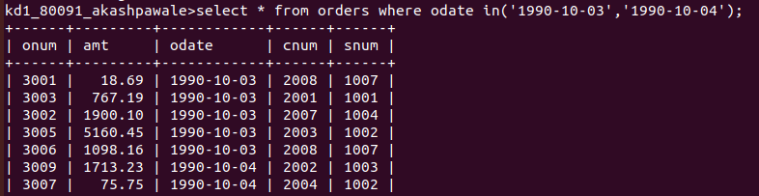

Q.2 write a query that selects all of the customers serviced by peel or motika

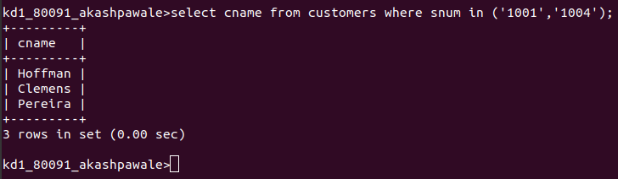

Q.3 Write a query that will produce all the customers whose names begin with a letter from ‘A’ to ‘G’.

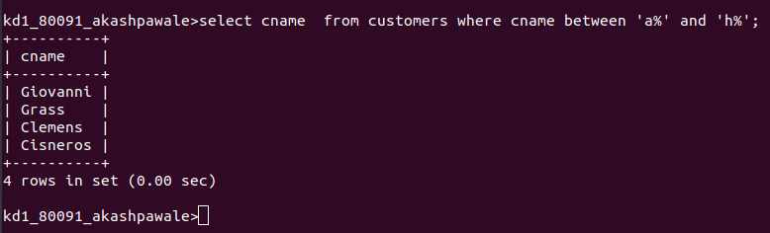

Q.4 Write a query that selects all customers whose names begin with the letter ‘c’.

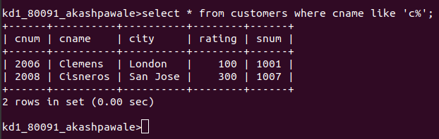

Q.5 Write a query that selects all orders except those with zeroes or NULLs in the amt field.

